Investigation of Doped (III-V) Group Elements Emissive Layer for Visible LED Applications


By
Aqsa Hashmi
CIIT/FA17-RPH-043/LHR
MS Thesis
In
Physics
COMSATS University Islamabad, Lahore Campus Pakistan
Spring, 2019

COMSATS University Islamabad, Lahore Campus

Investigation of Doped (III-V) Group Elements Emissive Layer for Visible LED Applications

A Thesis Presented to

COMSATS University Islamabad, Lahore Campus

In partial fulfillment
of the requirement for the degree of

MS (Physics)
By

Aqsa Hashmi
CIIT/FA17-RPH-043/LHR

Spring, 2019

Investigation of Doped (III-V) Group Elements Emissive Layer for Visible LED Applications
__________________________________________

A Post Graduate Thesis submitted to the Department of Physics as partial fulfillment of the requirement for the award of Degree of M.S(Physics).

Name | Registration Number
Aqsa Hashmi | CIIT/FA17-RPH-043/LHR

Supervisor

Dr. Farah Alvi
Assistant Professor Department of Physics
COMSATS University Islamabad (CUI), Lahore Campus
July 2019

Final Approval
This thesis titled
Comparative Studies of Oxide, Protonic and Hybrid Ions Conduction for Low Temperature Solid Oxide Fuel Cell
By
Zohaib Ur Rehman
CIIT/FA17-RPH-008/LHR
has been approved
For the COMSATS University Islamabad, Lahore Campus
External Examiner: _____________________________________
Prof. Dr. Riaz Ahmad
Chairman physics, GCU Lahore
Supervisor: ___________________________________________
Dr. Ghazanfar Abbas
Assistant Professor, Department of Physics, CUI, Lahore

Co-Supervisor: _________________________________________
Dr. Rizwan Raza
Associate Professor, Department of Physics, CUI, Lahore

HOD: ______________________________________________
Dr. Muhammad Ashfaq Ahmad
HoD (Department of Physics) CUI, Lahore
Declaration

I Aqsa Hashmi CIIT/FA17-RPH-043/LHR hereby declare that I have produced the
work presented in this thesis, during the scheduled period of study. I also declare that I
have not taken any material from any source except referred to wherever due that
amount of plagiarism is within acceptable range. If a violation of HEC rules on research
has occurred in this thesis, I shall be liable to punishable action under the plagiarism
rules of the HEC.

Signature of the student

Date:__________________ _____________________
Aqsa Hashmi
CIIT/FA17-RPH-043/LHR

Certificate

It is certified that Aqsa Hashmi (CIIT/FA17-RPH-043/LHR) has carried out all the workrelated to this thesis under my supervision at the Department of Physics, COMSATS University Islamabad, Lahore Campus and the workfulfills the requirement for award of MS degree.

Date: _____________________
Supervisor:

___________________________
Dr. Farah Alvi
Assistant Professor

Head of Department:

___________________________
Dr. Muhammad Ashfaq Ahmad
Associate Professor
Department of Physics
CUI, Lahore

Dedication

It is with my deepest gratitude and warmest affection that I dedicate this thesis to my dearly loved parents, Directorial teachers who have been a constant source of knowledge and inspiration and all supporting friends.

Aqsa Hashmi

Motivation from ALLAH

Surah Al-'Ankabut [29:20]
ALLAH (GOD) Says: “Travel through the earth and see how ALLAH did originate creation; so will ALLAH produce a later creation: for ALLAH has power over all things”.

Acknowledgement
I am very thankful to Allah who created us and sprinkles His blessing upon us. Allah blesses us and sends His Beloved, Last Prophet Hazrat Muhammad (ﷺ) for the guidance of human beings. We all Muslims love Hazrat Muhammad (ﷺ) who teaches us the principles of Islam. He ﷺ is our noble and ideal teacher.
Thank you, my dear Mother and Father, for your love and unconditional support. Without you, I would never have enjoyed so many opportunities.
I express my sincerest gratitude to my supervisor Dr. Farah Alvi and Co-supervisor Dr. Abdul Sattar for leading me through research. Their positive attitude towards research and zest for research work has prompted me for the timely completion of the work. Thank you for continually inspiring me to do my best, you help me strive for goals. I found guidance, discipline and love everything in one person. Instead of leading me by holding my hands, you asked me to walk ahead while you caringly observed from behind.
I am especially thankful to Dr. Rizwan Raza and Dr. Hammad Aziz for generous help and guide during my research work .
I am especially very, very thankful to my friend Qaisar Abbas for his generous help and keen guidance during my whole MS degree program.

Besides, I can never ever forget my colleagues, Amina Sarfraz, Muhammad Saqib, Zohaib-ur-Rehman, Fawad Masood and Asif Hassan who have helped me in a numerous ways. I cherish the years spent in the department of Physics, Comsats University Islamabad,Lahore Campus.

Aqsa Hashmi
CIIT/FA17-RPH-043/LHR

ABSTRACT

This study Sb₂S₃ was prepared by applying hydrothermal technique with different concentration of Ag as a doping impurity to improve its optical and electrical properties to be used in optoelectronics for LED applications. FTIR spectra was used to analyze the vibrations of chemical bonds present in the different groups in the sample. The intensity of the peaks is reduced with the increase in doping concentration, this is because the strength of chemical bonds decreases because of intermolecular transition of groups present in the sample. Optical properties were studied by UV-Vis and PL spectroscopy. UV-vis spectra was used to calculate bandgap that comes out between 2.5-1.9 eV. The bandgap was reduced with the increase in doping concentration of Ag which indicate its good compatibility for LED applications. IV measurements were used to analyze IV characteristics of the samples and to find out the turn on voltage of the device. SEM results were helpful in analyzing the surface morphology of the samples and measuring the particle size. The device was characterized by electroluminescence spectra which confirmed the red emission from LEDs having emissive layers of undoped and doped Sb₂S₃. So the materials have bright future for visibe LED applications.

Table of Contents
Chapter1.0Introduction.…….….………………………………...……1
1.1 Introduction to Nanotechnology:…………………………….………..3
1.2 Nano-materials………………………….……………………...………4
1.3 III-V Group Semiconductors……….…………..………………………6
1.5 Doping of Semiconductors………………………………………..…....7
1.6 Optoelectronics…………………………………………………………8
1.7 Light Emitting Diode (LED)………………………………………...…9
1.8 Quantum Dot LEDs………………………………………………….....9
1.9 Thin Films…………………………………………………………….11
1.10 Antimony Sulfide (Sb₂S₃)……………………………………………11
1.10.1 Structural Properties of Sb₂S₃………………………………….12
1.10.2 Optical Properties of Sb₂S₃………………………………….....13
1.10.3 Electrical Properties of Sb₂S₃...………………………………..13
Chapter 2.0 Literature Survey…………………………………………...14
2.1 Jiang Zhu reported that………………………………………………..15
2.2 A-G- Vedeshwar reported that………………………………………..15
2.3 R.Sinaoui reported that………………………………………………..16
2.4 Jorge Rodriguez Castro reported that…………………………………16
2.5 Na PI reported that……………………………………………………16
2.6 P O Nwofe reported that……..………………………………………..17
2.7Siham. M. Salim reported that..………………………………………17
2.8 C. J. Diliegros-Godines reported that………………………………...18
2.9L. Y. Tang reported that………….…………………………………18
2.10Xingliang Dai reported that………………………………………….19
2.11 R. Boughalmi reported that………………………………………….19
2.12 F.Aousgi reported that……………………………………………….19
2.13 Emma Cardenas reported that……………………………………….20
Chapter 3.0 Experimental Work…………………………………...…..21
3.1 Experimental Setup…..……………………………………………...22
3.1.1 Reagents……..…………………………..…………..………………...22
3.1.2 Hydrothermal Technique…………..………….………………………22
3.3 Synthesis of Ag Doped Sb2S3………………………………………..27
3.4 Synthesis of 5% Ag Doped Sb₂S₃…………………………………….28
3.7 Formation of thin Films of Sb₂S₃……………………………………..28
3.8 Device Fabrication……………………………………………………28
3.8.2 Synthesis of NiO………………………………...………………29
3.8.3 Synthesis of ZnO………………………………………………...29
3.8.4 LED Fabrication…………………………………………………30
3.8.4 Thin Film deposition…………………………………………….31
3.8.4.1 Spin Coating…………………………………………………...31
3.9 Experimental work of LED Formation……………………………….32
Chapter 4.0 Characterization techniques……………..……………….34
4.0 Characterization techniques…………………………………………..35
4.1 X-ray Diffraction……………………………………………………...35
4.2 UV-Vis Spectroscopy………………………………………………...38
4.3 Fourier Transform Infrared (FTIR) Spectroscopy…………………….40
4.4 Photoluminescence (PL) Spectroscopy……………………………….42
4.5 Scanning Electron Microscopy (SEM)……………………………….43
Chapter 5.0 Results and Discussion……………………………………45
5.1 Fourier Transform Infrared Analysis…………………………………46
5.2 UV-Vis Spectroscopy…………………………………………………47
5.3 Photoluminescence Spectra Analysis…………………………………49
5.4 IV-Measurements……………………………………………………..50
5.5 SEM Analysis…………………………………………………………52
5.6 Electroluminescence Spectra Analysis……………………………….53
Conclusion…...…………………………………………………………….54
References…………….…………………………………..……………….54

List of Figures
Fig 1.1 Applications of Nanotechnology……………………………………...3
Fig 1. 2 Nanomaterials…………………………………………………………5
Fig 1. 3 Mostly used Semiconductors………………………………………….7
Fig 1.4 Effect of doping on Semiconductors…………………………………..8
Fig 1. 5 Light Emitting Diode…………………………………………………..9
Fig 1. 6 Effect of QD size on Color…………………………………………...10
Fig 1.7 Emissive Layer deposited in LED……………………………………11
Fig 1.8 Crystal structure of Sb₂S₃……………….……………………………12
Fig 3.1 Chemical used for thesis……………………………………………...22
Fig 3.2 Ultrasonic Treatment…………………………………………………23
Fig 3.3 Addition of Na2S.5H2O in SbCl₃…………………………………….24
Fig 3.4 Addition of Tartaric Acid in SbCl₃……………………………………24
Fig 3.5 Autoclave……………………………………………………………...25
Fig 3.6 Thermal treatment of sample…….……………………………………25
Fig 3.7 Filteration of Sample………………………………………………….26
Fig 3.8 Drying of Sample……………………………………………………..27
Fig 3.9 Synthesis Process……………………………………………………..28
Fig 3.10 Synthesis of NiO………………………………………………………29
Fig 3.11 Synthesis of ZnO……………………………………………………...30
Fig 3.12 Schematic of LED…………………………………………………….30
Fig 3.13 Thin Film deposition techniques……………………………………...31
Fig 3.14 Spin Coating of NiO…………………………………………………..32
Fig 3.15 Thin Film Deposition of ZnO…………………………………………33
Fig 4.1 XRD Diffraction Pattern………………………………………………36
Fig 4.2 XRD Setup…………………………………………………………….37
Fig 4.3 FTIR Spectroscopy schematic………………………………………...41
Fig 4.4 PL Spectroscopy Setup………………………………………………..42
Fig 4.5 Scanning Electron Microscope………………………………………..43
Fig 5.1 FTIR Spectra………………………………………………………….46
Fig 5.2 UV-Vis Spectra……………………………………………………….47
Fig 5.3 Optical Bandgap of (a) Sb₂S₃ (b) 3% Ag-Sb₂S₃ (C) 5% Ag-Sb₂S₃…….49
Fig 5.4 Photoluminescence Spectra…………………………………………….49
Fig 5.5 IV Characteristics………………………………………………………50
Fig 5.6 SEM Images …………………………………………………………..52
Fig 5.7 Electroluminescence Spectra Analysis….……………………………..53

Chapter 1.0

Introduction
1.0 Introduction

1.1 Introduction to Nano-technology:
Nanotechnology could be a celebrated field of analysis since last century. Since ‘‘nanotechnology” was conferred by laureate Richard P. Feyn- man throughout his well famed 1959 lecture ‘‘There’s lots of space at the Bottom” (Feynman, 1960), there are created numerous revolutionary developments within the field of engineering[1].Nanotechnolgy is defined as one to one hundred nanometer range ; making structures that have novel properties attributable to their little size; and also the ability to regulate or manipulate on the atomic scale [2]. Nanotechnology is playing very important role in every field of science i.e medicine, physiology, fuel cells and optoelectronics etc [3].
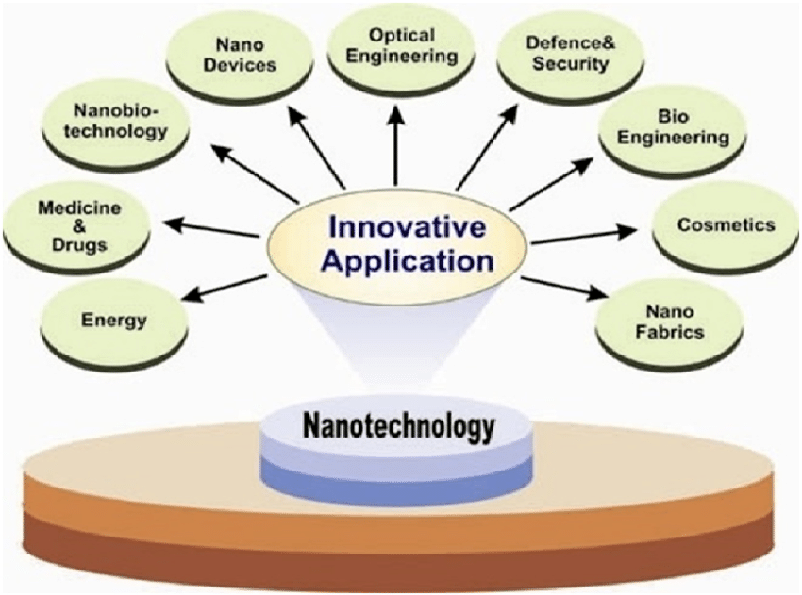
Fig 1.1 Applications of Nanotechnology

Nanotechnology is taking progress day by day very quickly due to its ability to develop materials of unique properties [4]. Semiconductor materials play very important role in nano-technology as a part of many fields of interdisciplinary sciences like bio-technology, cell biology, medicine, information technology, material sciences, environmental sciences, energy production and nano-electronics [5], [6].

1.2 Nano-materials
The chemical substances that are synthesized at nano scale are called nano-materials. Nano-materials are fabricated to expose unique properties that are not present in the same material which is not fabricated at nano scale such as high chemical reactivity,conductivity and strength. The difference of the properties of material at nano level and macro level is due to very small size of the particles at nano level that gives the material different characteristics such as less lattice imperfections, high surface energy and spatial confinement [7]. The quantum mechanical effect occurs in the nano-materials when their size is almost equal to Debye wavelength λ_{d,} then the surface properties of the material change. When the size of the particle is decreased and the size approaches to the size where particles are separated in the order of the wavelength . This is called quantum confinement as the phenomenon of particle in a box [8].Due to their distinctive geometry , nanomaterials are being used in optoelectronic devices, e.g LEDs, laser diodes, solar cells and photoelectrodes. 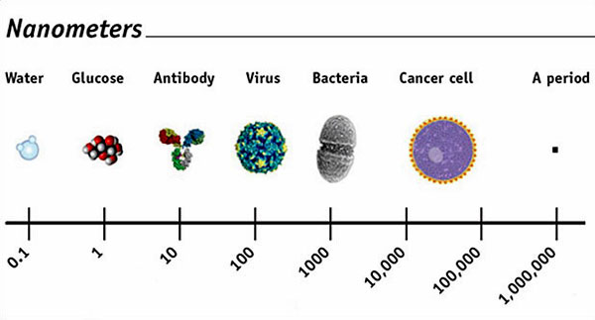
Fig 1.2 Nanomaterials

1.3 Semiconductor Materials
The materials whose electrical properties lie between insulators and conductors are called semiconductors . Semiconductors have a very small bandgap between valence shell and outer empty band. Semiconductors offer conductivity when electrons excite into conduction band by crossing the band gap .semiconductor materials find most applications in the manufacture of light emitting diodes [9]. Semiconductors are also the essential part of solar cells for energy conversion process because their band gap energy is comparable to the visible region of spectrum[10]. Semiconductors are being used widely in many applications due to its controlled electrical properties. The electrical conductivity of semiconductors can be improved as per requirement of the device by changing the temperature or by applying magnetic fields etc [11].Different categories of semiconductors can be depicted by following flow diagram:

Ionic
Electronic
Elemental
Compound
Single crystal
Polycrystalline
Intrinsic
Extrinsic
Non
-
Crystalline
Crystalline
Semiconductors

On the basis of structure, arrangement semiconductors are divided into two types, i.e. non crystalline and crystalline. Atoms of crystalline semiconductor are arranged in a three dimensional way in a periodic manner[12]. Due to this whole sample has uniform structure and well defined properties e.g Silicon (Si) and Germainium (Ge). Monocrystalline semiconductors have long range structure and are periodic in nature while polycrystalline solids do not have periodicity in their atomic structure and have short range structure of atoms e.g. Glass and amorphous Si and Ge [13].
The semiconductors that are composed of more then one element are known to be as compound semiconductors e.g. GaN , GaAs, SiC, Sb₂S₃ while those consisting of single element are named as elemental semiconductors for example Si and Ge.The pure semiconductor that has no other atom added in its structure are called intrinsic semiconductors. An ideal intrinsic semiconductor is the best tool to understand the basic concepts of semiconductor physics. The basic properties include conduction andvalence band properties, bandgap , electrical conductivity and chemical properties as well [14].These properties can be improved by adding some impurities to its structure , such semiconductors are called as extrinsic semiconductors.Semiconductor nanomaterials are being used in numerous applications due to their novel electrical, optical and chemical properties [15]. These properties of semiconductor nano materials make them to be used in catalysis, sensors, optoelectronics etc [16].

1.4 III-V Group Semiconductors

Mostly semiconductors are from group IV of the periodic table and are prepared by the grouping of elements of group III & V that are known as III-V semiconductors. Silicon is most widely used semiconductor as it is used in integerated circuits of electronics and also in optoelectronics like solar cells [17]. The nitrides of group III (GaN, AlN) give best semiconductors because of their direct bandgap which covers the whole visible range 1.9-6.2 eV and also extending in UV region [18].
Most commonly used semiconductors are shown from periodic table in the figure
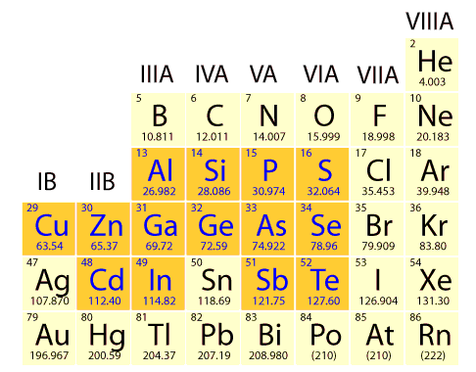
Fig 1.3 Mostly used Semiconductors

1.5 Doping of Semiconductors:
Doping means to add impurities to intrinsic semiconductors to change its properties. Normally semiconductor is doped with trivalent or pentavalent impurity to form p-type or n-type semiconductors respectively. The pattern towards expanding scaling down of electronic devices, to get higher pressing densities and expanded speed, puts ever more prominent requests on the control of materials planning and device manufacture forms. With device measurements being decreased to length scales in which quantum mechanical impacts can be watched and abused, it has moved toward becoming important to create readiness strategies proficient of delivering semiconductor structures controllably on the atomic scale[19] . Controlled properties in semiconductors can be attained by doping. The insertion of impurities in the crystal structure of bulk semiconductors was discovered in 1940 and it is the basis of vast use of semiconductors in electronics and optoelectronics. To control the dimensions of crystal structure of semiconductor is another way to tune its properties[20]. Alteration in semiconductors improves separation between charges and enhance the interfacial charge transfer in nanocomposites [21]. Doping of semiconductor reduces its resisitivity and increases electrical conductivity and hence making it compatible for optoelectronic devices.
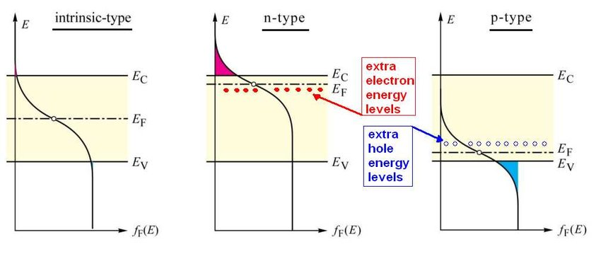
Fig 1.4 Effect of doping on Semiconductors

1.6 Optoelectronics
It is the branch of engineering which deals with the collective role of electronics and light.It is a field of electronics that has its basis on light emitting and light detecting devices. Optoelectronics is basically the quantumeffects of light onsemiconductors. Latestsemiconductor devices have changed the vast technologies such as electronics, lighting, solar energy, and communication, etc. Silicon is used to fabricate electronic circuits, and GaAs, GaN, and other III–V semiconductor materials for optoelectronics with suitable substrates composed of wafers fabricated at high temperature. In short controlled thin films can be deposited on the substrate to add more functionality, for example by CVD or MBE[22].
Photovoltaic effect is used in
- Photodiodes (solar cells)
- Phototransistors
Radiative recombination is used in
- Light Emitting Diodes

1.7 Light Emitting Diode (LED)

An LED is a semiconductor based lighting device. It is the latest lighting technology that has high performance and cost effective for controlled light environment.LEDs are p-n-junction semiconductor devices that emit spontaneous, visible, infrared, and ultraviolet radiation. LEDs are the frequently used compound semiconductor device [10]. Instead of conventional incandescent luminescence points, LEDs are being used mostly due to its color tuning ability,longer lifespan,less power consumption and less heat dissipation losses [11]. Its properties can be improved by adding impurities (doping) to the semiconductor material of the device.

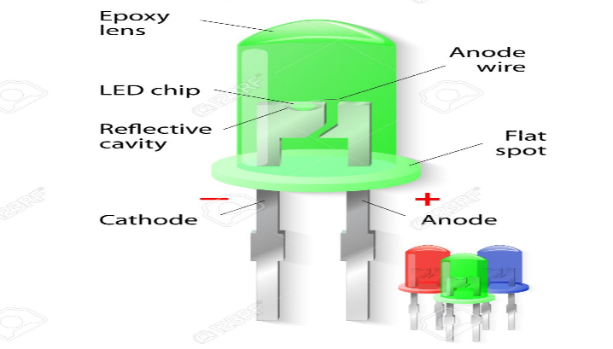
Fig 1.2 Light Emitting Diode

1.8 Quantum Dot LEDs:
Quantum dots are the crystals smaller than the de Broglie wavelength in the order of nanometer in all three dimensions surrounded by a material of large band gap [24]that emit light in excited state.Quantum dots are used as an active layer between p-type and n-type semiconductors of a diode.Quantum dot LEDs are being used widely for two applications i.e lighting and displays due to their high brightness , color tuning and saturation and low manufacturing cost[25]–[27]. There have been many reports about liquid state photonic materials used in light emitting diodes used for control of spatial radiation [28], color blending [29], and flexible devices [30] and these have being used as an alternative for efficient lighting [31], [32]. So colloidal quantum dots are attracting attentions for its use in light emitting diodes due to high quantum efficiency , narrow emission bandgap andluminescence [33]–[36].

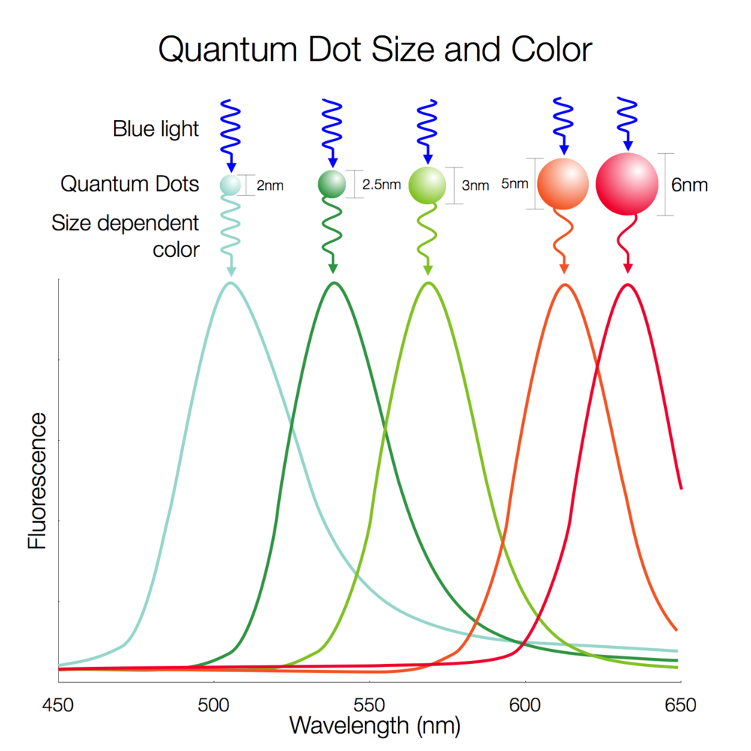
Fig 1.6 Effect of QD size on Color

Conventional LEDs made of organic materials were too expensive. The invention of quantum dot LEDs has put forward a step in reducing the cost of LED production. The fabrication of quantum dot LED is carried out at room temperature instead of a controlled environment. This is another positive feature of QLED to be used for efficient lighting. The quantum dots employed in LEDs are mostly of organic semiconductors but the organic materials are less stable specially for large amount of current density [37]–[39].

1.9 Thin Films
Thin film means very thin layer of the range from nanometers to micrometers of a substance on a substrate. The progress in quantum based thin films have revolutionized the field of electronics, optics and optical electronics. Thin film technology is being applied in solar cells to make it cost effective. Thin films are also being employed to lithium polymers to be used in batteries of specialized characteristics.Tunable and switching properties of semiconductor thin films make them efficient for use in these fields [40].
In QLED a semiconductor based quantum dot layer is deposited between electron transport layer (ETL) and hole transport layer (HTL).
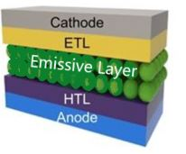
Fig 1.7 Emissive Layer deposited in LED[41]

1.10 Antimony Sulfide (Sb₂S₃)
sIn latest research a wide range of studies has devoted to the properties of chalcogenides thin films because of their vast use in optoelectronic devices[42], [43]. Of all available chalcogenides pure and doped Sb₂S₃ is being used in solar cells, thermoelectric cooling effect and photoconductive television camera etc [44], [45]. This is because of direct band gap of Sb₂S₃ which lie in the range 1.78-2.5 eV [46] and high value of absorption coefficient (10⁵ cm⁻¹) . due to these applications it is useful to explore electrical , optical, and structural properties of Sb₂S₃. But regardless of these properties the resistivity ofSb₂S₃ is very high(~10⁸–10⁹ W.cm)[47].
There are two requirements for optoelectronic and photovoltaic devices namely normal resistivity and high optical transmittance [48]. But resistivity of pure Sb₂S₃ thin films is very high of the order of (~10⁸–10⁹ W.cm) which limits its application as an active layer in optical devices. The best way to attain desireable properties in a material is to add impurity atoms which has less or more electrons than the pure host atom [48]. So the optical, electrical, and structural properties of pure Sb₂S₃ can be improved by adding impurities in it [49].

1.10.1 Structural Properties of Sb₂S₃
Sb₂S₃ and other members of the family, i.e. Sb₂Se₃ and B₂S₃ are isostructural. The crystalline structure of Sb₂S₃ is orthorhombic.Sb₂S₃ has an orthorhombic crystal structure with a = 1/4(1.20) nm, b = 1/4(1.128) nm and C = 1/4(0:38) nm. In Sb₂S₃ crystal structure one half of antimony atoms is surrounded by five sulfur atoms.
Sb₂S₃ thin films are of two types i.e. crystalline and amorphous. They are of different colors depending upon their size, deposition method and impurities. Crystalline Sb₂S₃ is of grey color and in amorphous phase it may exist in grey, black, yellow, red, and purple. Mostly thin films of Sb₂S₃are amorphous and become polycrystalline when annealed[50]–[52]. The figure 1.6 shows the crystal structure of Sb₂S₃ in which bigger circles indicate antimony (Sb) atoms whi le smaller circles indicate sulfur (S) atoms [53].
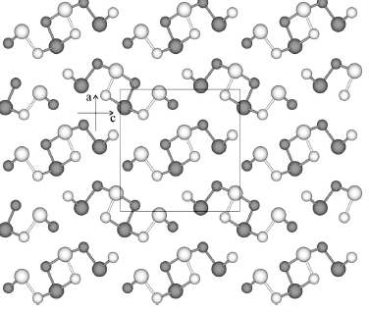

Fig 1.8 Crystal structure of Sb₂S₃

1.10.2 Optical Properties of Sb₂S₃
Sb₂S₃are used widely in optical devices such as mirror coatings, absorption polarizers, antireflection coatings, interference filters and optical and thermal detectors.
Thin films of Sb₂S₃ are used as light absorbing materials in photovoltaic applications. The optical bandgap of Sb₂S₃ is 1.7 eV. The absorption coefficient for Sb₂S₃ is 10⁴cm⁻¹ . The values of the optical constants n is very high in the crystallized form of material. The highest and lowest values of n in the amorphous form of the material are 3.3 and 1.83 while in the crystalline form these values are 3.8 and 2.83 respectively[54].
The UV–Vis analysis of Sb₂S₃ thin filmsshows that high value of bandgap is concerned with decreasing the thickness of the film. The increase in energy band gap with a small size of particle may be because of the quantum confinement [55]. Here we will expand our work by doping the Sb₂S₃with the appropriate metals like silver (Ag) and copper (Cu) to enhance the optical properties of material that will make it compatible for its use in optoelectronics.

1.10.3 Electrical Properties of Sb₂S₃
The calculation of electrical parameters of a semiconductor thin film is necessary to test its suitability for its use in optoelectronic devices. The basic criteria for a best thin film photoelectrode is low resistivity and large size of particle. The large size of grains plays an important role in decreasing the grain border of thin film that results in productive energy conversion [56]. Low reisitivity of the thin film of photoelectrode is needed to reduce the resistance of the cell[57]. At normal conditions the electrical conductivity of pure Sb₂S₃is low because of high value of resistivity i.e. (~10⁸–10⁹ W.cm)[49]. It is aimed to use Sb₂S₃as an emissive layer for light emitting diodes. For this purpose the resistivity of the material must be low enough to conduct electricity. Here we will explore our work to reduce the resistivity of the material by doping it with appropriate metals like silver (Ag) and Copper (Cu).

Chapter 2.0

Literature Survey

2.1 Jiang Zhu reported that
Sb₂S₃ has been used in optical devices for some years but there`s some unproductive information about preparation of Sb₂S₃ quantum dots because of the issues in the synthesis method. He synthesized water soluble Sb₂S₃QDs by hot injection method with hexadecyltrimethylammonium bromide (CTAB) and sodium dodecyl sulfate (SDS) mixture as anionic-cationic surface active agent, alkanol amide (DEA) as stabilizer, and ethylenediaminetetraacetic acid (EDTA) as a dispersant. UV-Visible, infrared and PL spectroscopies were employed to find out absorbance and emission characteristics. At 880 nm, he noticed an extensive PL emission which tells that Sb₂S₃QDs have a very bright outlook in near-infrared LED and in near infrared opticalappliances. The Sb₂S₃QDsthin films were synthesized by self-assembly growthand that films have bandgap in the range from 1.82 to 1.09 eV which indicates its good optical properties[58].

2.2 A-G- Vedeshwar reported that
He formed amorphous and polycrystalline films of antimony sulfideSb₂S₃ orStibnite at temperature (90-320)K. He noticed that the band gap of these thermally evaporated films was changing with the temperature. The amorphous Sb₂S₃ has low value of band gap than the crystalline Sb₂S₃. In above mentioned both the cases, the band gap is fully accordingto Varshni formula. At 0 K, the band gap of crystalline and amorphous thin films of Sb₂S₃was (1.95-2.13) eV. It was observed that band gap is highly sulfur dependant.The films having thickness greater than 2000 A⁰ indicate pattern ofinterference in the transmission spectra [59].

2.3 R.Sinaoui reported that
Thermal eveaporation technique was used to prepare thin films of antimony sulfide. The characteristics of the sample were analyzed by xrd, AFM spectroscopy and UV-Vis spectroscopy. The substrate was fixed at a = 0 ⁰, 20⁰, 40⁰, 60⁰, 70⁰,and 85⁰ and the whole deposition process was carried out at 185ºC. The XRD results of thin films revealed the amorphous structure of Sb₂S₃. Direct band gap of 1.87 eV was confirmed by UV-Vis spectroscopy results. It was also revealed that refractive index decreases slowly from 2.98 to 2.28 for a = 0⁰ and a = 85⁰respectively [60].

2.4 Jorge Rodriguez Castro reported that
He employed hydrothermal and solvothermal methods to form nanoparticles of Sb₂S₃by using xanthanate, dithiophosphate and dithiocarbamate as parent elements. Solvothermal method helps to control the morphology by controlling the precursor and size of the particles by the time of reaction. This method produced uniform and large sized particles. Hydrothermal method showed little effect of precursor and reaction time on morphology and size. However for this method reaction temperature played important role in purity and morphology of particles. Xanthanate precursors are more better than dithiophosphate as they produce Sb₂S₃free of oxides. Hydrothermal and solvothermal techniques provided pure stibnite by using xanthanates, dithiophosphates and dicarbomates precursors at temperature of 200ºC for 36h or 2h respectively. He observed that temperature has greater effect on crystallite size. Hydrothermal technique could not produce crystals of stibnite at lower temperature but solvothermal is more environmentally friendly as it produced Sb₂S₃nanocrystals as small as approximately of 27nm. AACVD (Aerosol assisted Chemical Vapor Deposition) is efficient in providing films of Sb₂S₃of good quality [61].

2.5 Na PI reported that
Quantum dots of water-soluble Sb₂S₃ were synthesized by aqueous-phase precipitation method by using thioacetamide (TAA) as sulfur precursor and mercaptoacetic acidwas used as a capping agent.Morphologicalproperties were studied under the effect of variation in temperature (65-85)⁰C and time of reaction (3-7) h. The prepared QDs of antimony sulfide were characterized by UV-Vis, EDS, XRD, SEM, photoluminescence (PL), and TEM. The results displayed unique optical properties of Sb₂S₃ QDs and also it was observed that these QDs are of uniform size [62].

2.6 P O Nwofe reported that
He formed thin films of antimony sulfide on soda-lime glass subtrates by using solution-growth method. The time of deposition was varied between 1h to 5h keeping other deposition parameters constant. The result of the experiment showed that the thickness of film increasedwith time and maximum thickness reached at the 4h. The optical properties of the films was measured by UV-Vis spectroscopy. The results revealed that in the wavelength range 400-1250 nm, optical properties like bandgapoptical density and extinction coefficient changed with deposition time. The value of extinction coefficient varied in the range 0.01-0.27 and optica density was in range 0.01-0.34. the bandgap energy was between 2.05-2.10 eV. These values are compatible for use of the films in optoelectronic devices mostly as window layers in solar cell application [63].

2.7 Siham. M. Salim reported that
He prepared pure and 0.02, 0.04, 0.06, 0.08 and 0.1 wt % Ag-doped Sb₂S₃ thin films deposited onto a glass substrate at low temperature (283 K) by using CBD technique. The doping was done by adding different wt% of aqueous solution having Ag + ions. The pure and Ag-doped Sb₂S₃deposited films were characterized by XRD. from XRD analysis of the powder form of samples shows that no separate peaks of Ag compounds were identified which ensures that the addition of Ag+ ions in the pure Sb₂S₃ does not change the crystalline form of the Sb2S3 host lattice, this result was due to the lower doping concentration. The transmission spectra of the films was founded in the range 400-2500 nm. The film thickness and refractive indices were determined in the transparent region by envelope method. It was observed that refractive index increases with the increase in silver content.The absorption coefficient was also determined to analyze the optical properties of the films. Strong absorption was recorded at 580 nm. It was observed that red shift occursatthe absorption edge as the content of Ag increases in the pure Sb₂S₃[49].

2.8 C. J. Diliegros-Godines reported that
His work was about the effect of silver doping on Sb₂S₃ on electrical, optical, and structural properties on Sb₂S₃ films formed by CBD method. The Ag was added by 7.5 mol% of Sb³⁺ ions. The films were dipped into cold water for 4h and then undergone for heat treatment at 300ºC for 1h. XRD analysis revealed the polycrystalline nature of Sb₂S₃ in orthorhombic phase. SEM images indicated the irregular shaped particles in undoped films while small spherical grains in Ag-doped films. The optical properties of films were recorded by UV-Vis spectrometer. The UV-Vis results showed the red shift in the bandgap of Ag-doped Sb₂S₃ from 1.75-1.66 eV. The resistivity of Sb₂S₃ was also decreased by incorporation of Ag atoms into its structure [64].

2.9 L. Y. Tang reported that
He prepared inorganic QD LED in which NiO was used as hole transport layer which was prepared by sol-gel method. It is a low cost and simple method. The device displayed the rectification behavioour in current-voltage and light emission. The device had very low turn on voltage i.e 2V and negligible leakage current. Although further work is required to improve the performance of LED however the use of sol-gel materias and spin coated layers of NiO and ZnO makes LED cost effective and easy for massive production. Surface morphology determined by SEM confirmed the size of NiO particle to be 30nm, and opticalbandgap observed by UV-Vis spectroscopy was 3.69 eV. The device performance was characterized by electroluminescence (EL) spectra which displayed only QD emission at 605 nm giving orange electroluminescence. The intensity increases as the value voltage increases [65].

2.10 Xingliang Dai reported that
He prepared the solution processed quantum dots LED of best performance. the device exhibit deep red color emission, 1.7volt as turn on voltage and high EQE of 20.5 % and longer lifespan of 100,000 hours at 100cdm⁻². These properties make this device excellent performing solution processed LED as compared to vacuum deposited LED. This outstanding performance was achieved due to inclusion of an insulating layer between quantum dots and ETL to modify charge balance and maintain the emissive properties of QDs. The electroluminescence (EL) spectra showed highest externalquantumefficiency (EQE), 20.5%, is attained at a current density of ,7mAcm⁻² and a brightness of 1,200 cdm⁻².The maximum EQEof the device,20.5%,is the highestvalueforQLEDs till now [26].

2.11 R. Boughalmi reported that
Thin films of Sb₂S₃ were formed by spray pyrolysis method on a glass substrate keeping the temperature at 250⁰C. XRD results showed that these films are crystalline in nature and have orthorhombic structure. The Bandgap calculated by optical analysis of the films was 1.72 eV which indicates its good compatibility to be used in photovoltaic applications [66].

2.12 F.Aousgi reported that
Vaccum thermal evaporation method was used to deposit thin films of Sn doped Sb₂S₃ thin films on glass substrares keeping the temperature of substrate to be 240ºC. The optical parameters were measured by the reflectance and transmittance spectra over broad range of wavelength 300-1800 nm. The refractive index data followed the Wemple-DiDomenico model.The dispersion constants were measured by using this model. These parameters help in the application of Sn dopedSb₂S₃thin films in the technology. It was observed that by increasing the content of Sn the amount of charge carriers increases and it was concluded that thin content of Sn can be increased in the Sb₂S₃thin films will increase the conductivity [47].

2.13 Emma Cardenas reported that
Electrical properties of thin films of Sb₂S₃deposited by CBD technique were enhanced by introducing the carbon diffusion. The reagents used for formation ofSb₂S₃ thin film on substrate were SbCl₃ and Na₂S₂O₃. The films were deposited by CBD method. A thin film of carbon was deposited over the film of Sb₂S₃by vacuum evaporation method. This new film was then subjected to heat treatment at 300ºC. The resistivity of undoped Sb₂S₃was 10⁸ Ὼcm which was reduced to 10²Ὼcm for doped material. By changing the carbon content in the Sb₂S₃, its resistivity can be controlled which make it compatible for the use in optoelectronics [67].

Chapter 3.0

Experimental Work

3.1 Experimental Setup:

3.1.1 Reagents:
Sodium sulfide pentahydrate(Na₂S.5H₂O),Antimony III chloride (SbCl₃), Tartaric acid (C₄H₆O₆), Silver nitrate (AgNO₃), Nickle (II) acetate tetrahydrate (C₄H₁₄NiO₈),ethanol(C2H5OH),diethanolamine (C₄H₁₁NO₂), zince acetate dihydrate (C₄H₆O₄Zn ·2H₂O) 2-methoxyethanol (C₃H₈O₂), ethanolamine (C₂H₇NO)FTO and microscopic glass slides were purchased from Sigma- Aldrich. All of above mentioned chemicals were used without any further purification.

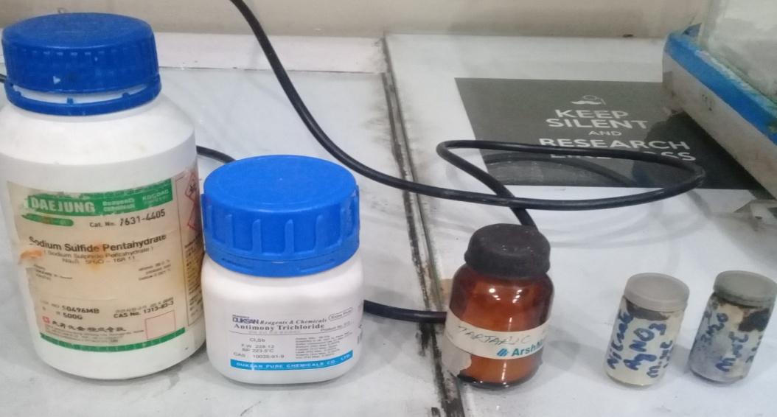

Fig 3.1 Chemical used for Synthesis

3.1.2 Hydrothermal Technique:
The hydrothermal method is mostly used method by technologists and scientists of various fields, considerably since last fifteen years. The word hydrothermal consists of two words, i.e. “hydro” means water and “thermal” means heat. Hydrothermal is a technique in which reaction takes place in the presence of water under high temperature and pressure applied [68].
The basic principle of hydrothermal is that the material which is insoluble in water is put in oven at high temperature and high pressure to make it soluble in water. This process is carried out in steel vessel formed of steel which is called as autoclave. The aqeuous solution of sample precursors is poured into autoclave and it is placed in oven at suitable temperature for appropriate reaction time. This gives us powder by precipitating the solution [69].
3.2 Synthesis of Sb₂S₃ :
Sb₂S₃was prepared by hydrothermal technicque. In 1st step 0.323g (10mM) of antimony trichloride(SbCl₃)was dissolved in 70ml of D.I water in a glass beaker, 0.58g (25mM) of sodium sulfide pentahydrate(Na₂S.5H₂O) was dissolved in 50ml of D.I water in another beaker and 0.42g (20mM) of tartaric acid was dissolved in 20ml in a separate beaker of D.I water.
In 2nd step the three beakers containing solutions were put in a sonicator for ultrasonic treatment for 15 min.
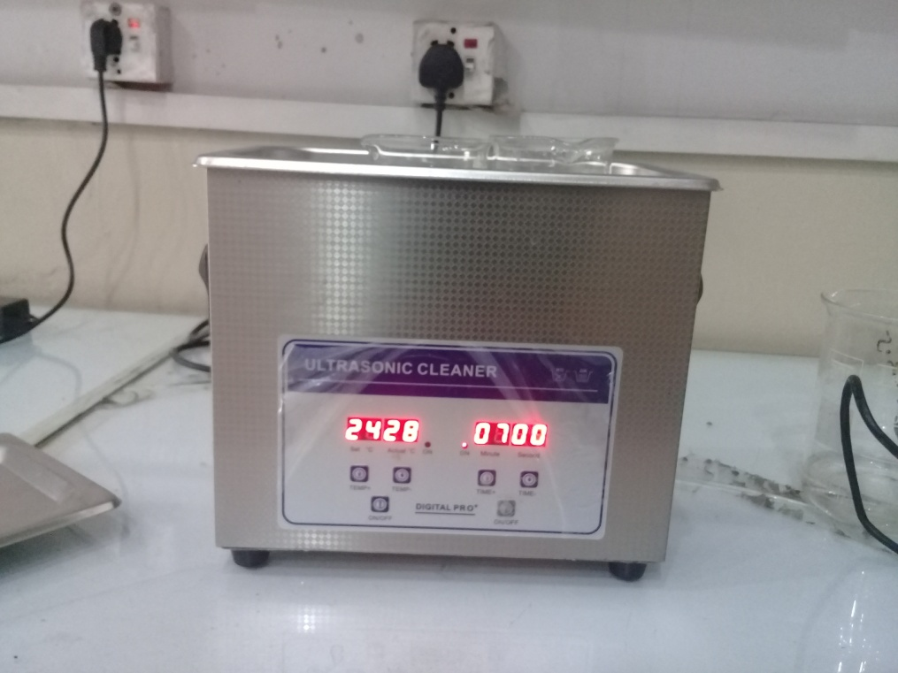
Fig 3.2 Ultrasonic Treatment

3rd step was the stirring of the solutions for 15 min by the help of magnetic stirrer .
In 4th step the solution of sodium sulfide and tartaric acid were poured dropwise in the SbCl₃respectively, and further stirred for 15 min. Tartaric acid was used as a precipitating agent.
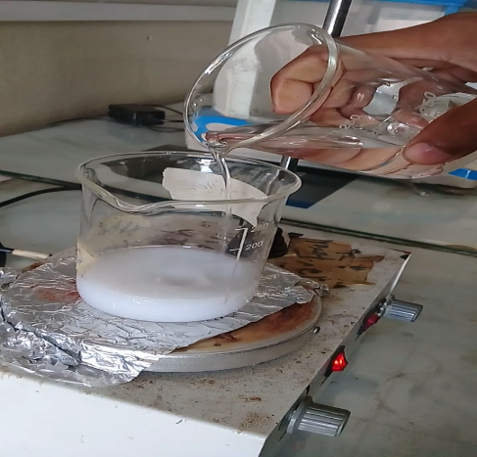
Fig 3.3 Addition of Na₂S.5H₂O in SbCl₃

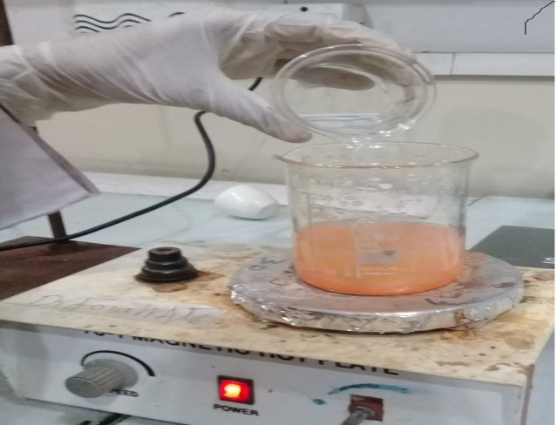
Fig 3.4 Addition of Tartaric Acid in SbCl₃

In 5th step this combined solution of SbCl₃, Na₂S.5H₂O and C₄H₆O₆in 140ml of D. I water was transferred to an autoclave.
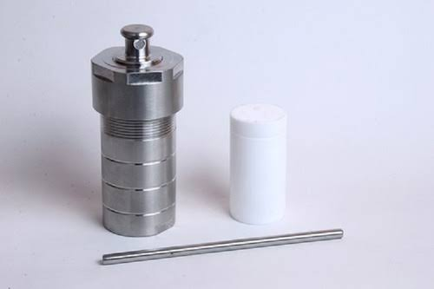
Fig 3.5 Autoclave

Then autoclave was placed in the oven for 1h and temperature maintained at 160ºC.Then autoclave was put to be cooled down to room temperature .
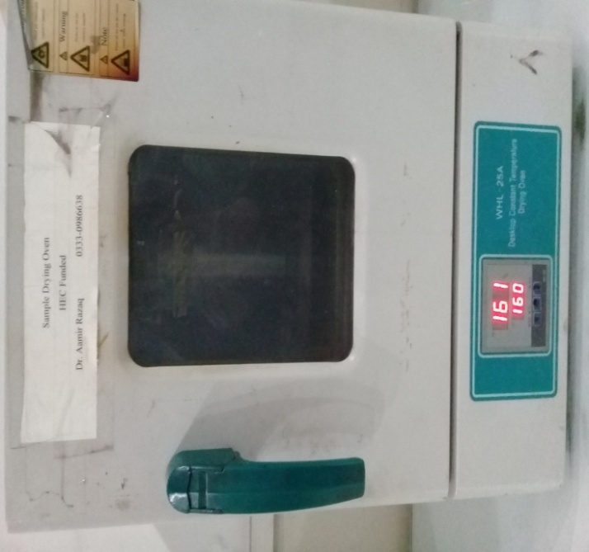
Fig 3.6 Thermal treatment of sample

The next step was the filtration of the solution by using filter paper placed on the funnel and flask. The precipitate of Sb₂S₃was obtained by successive washing of sample by D. I water, acetone, methanol, ethanol, and D. I water.
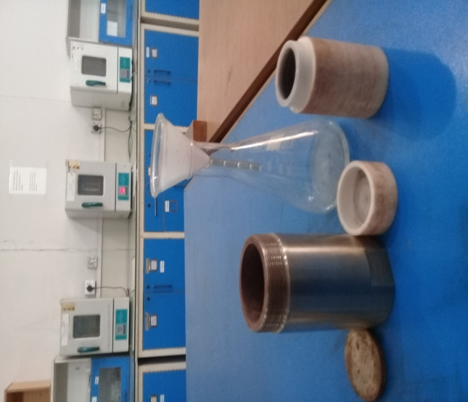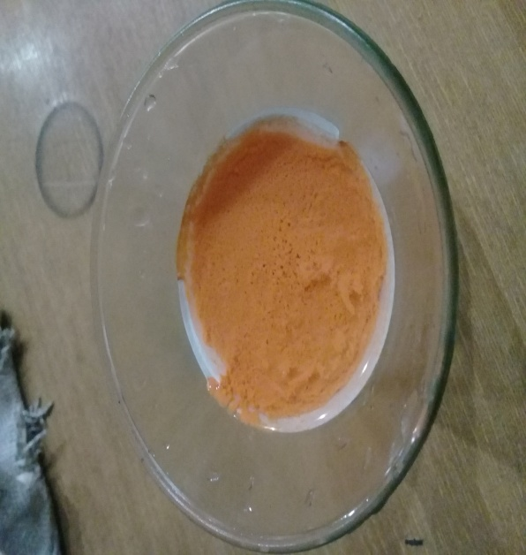
Fig 3.7 Filteration of Sample

The precipitate of Sb₂S₃was dried at 100ºC for 1h in oven to get the powder. The required sample is prepared now.
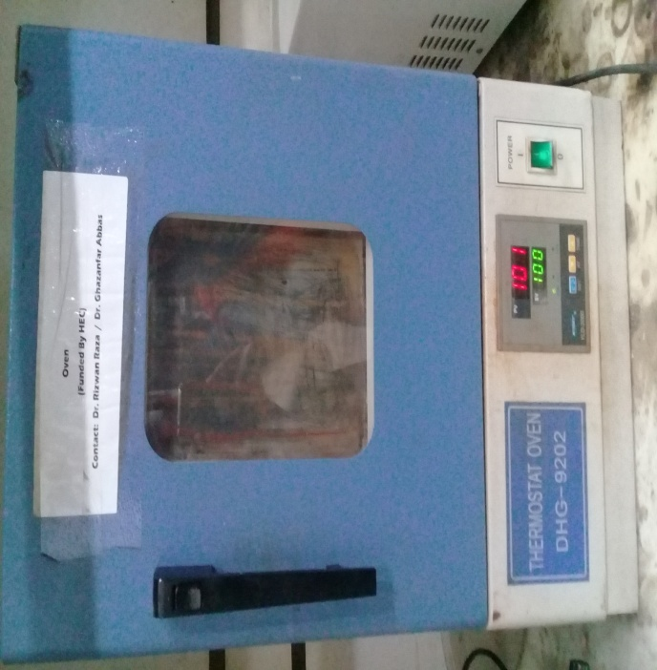
Fig 3.8 Drying of Sample
In the whole research experiment five samples were prepared. 1st sample is pure Sb₂S_{3,} 2nd and 3rd samples of Sb₂S₃ were doped by 3 wt%Copper (Cu) and Silver(Ag)while 4th and 5th samples of Sb₂S₃ were doped by 5 wt %copper (Cu) and Silver (Ag).

3.3 Synthesis of Ag Doped Sb₂S₃:
The same procedure was carried out for the synthesis of Ag doped Sb₂S₃. The SbCl₃ (10mM) was dissolved in 70ml of D.I water . Na₂S.5H₂O (25mM) was dissolved in 50ml of D.I water. Tartaric acid (20mM) was dissolved in 20ml of D.I water in a glass beaker. All beakers were undergone for ultrasonic treatment for 15 min. After this all samples were stirred on a magnetic stirrer for 15 min.Next step was to mix up all the solutions. Sodium sulfide was added dropwise into the antimony chloride solution. Then tartaric acid was added in the solution of antimony chloride and sodium sulfide . For the doping of Sb₂S₃, 0.009g (3% of SbCl₃) of Silver nitrate (AgNO₃) was added to the solution and stirred for further 10 min.
After this the solution was enclosed in an autoclave and put in oven at 160ºC for 1hr. After cooling down of autoclave, the sample was filtered by the wattman filter paper using a flask and funnel. Then precipitate of 3% silver doped Sb₂S₃was washed by D. I water, acetone, methanol, ethanol, and D. I water respectively.

3.4 Synthesis of 5% Ag Doped Sb₂S₃ :
Same procedure and reagents were used for synthesis of 5% silver doped Sb₂S₃. However, 0.016g of AgNO₃ was added to parent reagents instead of 0.009g.

Fig 3.9 Synthesis Process

3.7 Formation of thin Films of Sb2S3:
To form the thin films first of all powder was converted in solution form by dissolving in dimethylformamide (DMF). The solution was made by taking the ratio of solute to solvent as 40mg/ml . FTO substrates were adopted for film formation. These substrates were cleaned by successive treatment of D. I water, acetone, methanol, ethanol, and again D. I water for 15 min. After this,the film was deposited on a substrate by the drop casting method. A thin film was prepared by putting drops of solution on the substrate which was dried on a hot plate at 60ºC.

3.8 Device Fabrication:
In fabrication of a Light emitting Diode (LED), nickel oxide (NiO) was used as a hole transport layer (HTL) and zinc oxide (ZnO) as an electron transport layer (ETL) and Sb2S3 was employed as the emissive layer between ETL and HTL. Silver (Ag) paste was used to make contacts with p-type layer and n-type layer. FTO glass was used as substrate to support the device.
3.8.1 Sol-gel Method:
In materials science, the sol–gel procedure is a technique for manufacturing solid materials from little atoms. The strategy is utilized for the manufacture of metal oxides, particularly the oxides of silicon (Si) and titanium (Ti). The procedure includes transformation of monomers into a colloidal arrangement (sol) that goes about as the forerunner for a coordinated system (or gel) of either discrete particles or system polymers. There are many methods but sol-gel is best method to fabricate ceramic materials for thin films because it have many advantages such as low temperature requirements for film formation, easy to handle for coating even of large area[70].We have opted this technique for NiO and ZnO formation.

3.8.2 Synthesis of NiO:
0.35M solution of nickel acetate tetrahydrate was prepared in ethanol, then an equal morality of diethanolamine was added to increase the stability of the solution. This solution was put on magnetic bar stirrer for stirring of 2 hrs at 60ºC.
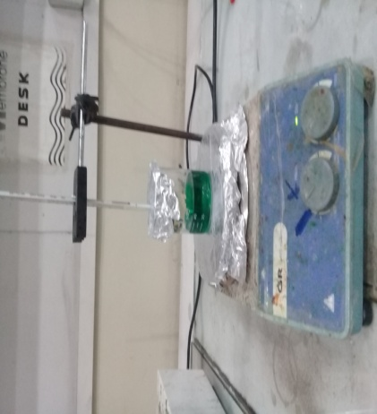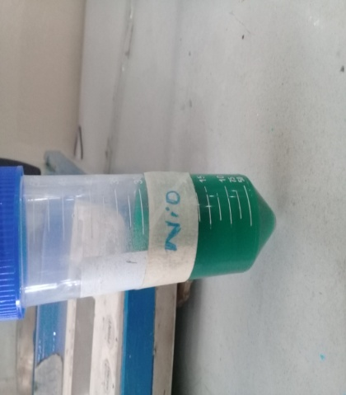
Fig 3.10 Synthesis of NiO

3.8.3 Synthesis of ZnO:
0.4M solution of zinc acetate dihydrate was prepared in 2-methoxyethanol. The stability of the solution was increased by adding an equimolar ratio of ethanolamine. This solution was stirred at room temperature for 12 hrs
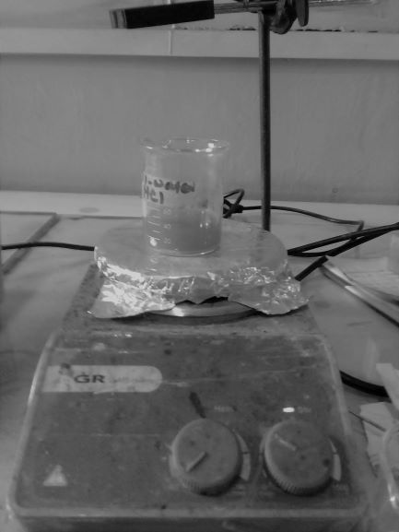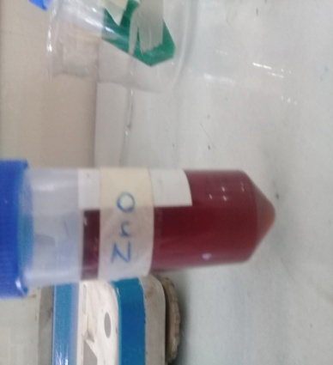
Fig 3.11 Synthesis of ZnO

3.8.4 LED Fabrication:

LED is a device that emits light when activated. A quantum dot LED is two junctions LED which consists of three layers, electron transport layer, quantum dot layer and hole transport layer. FTO glass was opted to support these three layers.

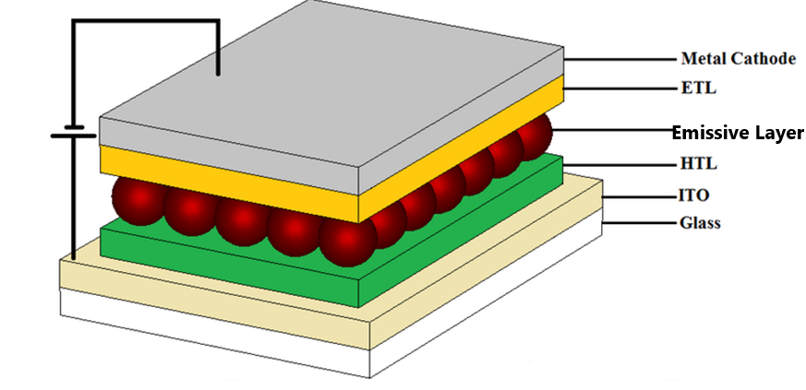
Figure 3 Schematic of LED

3.8.4 Thin Film deposition:
The thin film is a layer of thickness of the orders of nanometers. Deposition of thin films is a fundamental process in many applications. There are many techniques for thin film deposition.

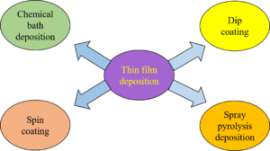

Fig 3.12 Thin Film deposition techniques

3.8.4.1 Spin Coating:
Spin coating is a technique used to store uniform thin films onto smooth substrates. It is mostly used in field of microelectronics and optoelectronics for preparation of photoresists films. In the spin process, solution is first dropped on the substrate, and the substrate is then accelerated quickly to the ideal spin rate. Fluid streams radially, under the the activity of centrifugal force and the extra is ejected off the edge of the substrate. The film keeps on reducing thickness gradually until detaching weight impacts cause the film to achieve a uniform thickness or until it turns solid like because of increase in viscosity from evaporation of solvent. thickness of the film is due to the solvent evaporation[71]. Generally a very small quantity of covering material is connected at the center point of the substrate, which is either spinning at low speed or not spinning. Then spinning rate and spinning time is selected and then spinning starts in the presence of vacuum. The Chalcogenide thin films formed by spin coating technique can be useful for their use in microlithography as a photoresist layer or as UV-absorbing layer[72].

3.9 Experimental work of LED Formation:
First of all a some drops of NiO solution gel were dropped on the center of FTO after placing it on the plate of spin coater with the help of double tape. The coater was set to on for coating of thin film of NiO on at 2000rpm for 20s. VTC-200 Vacuum Spin Coater was used for this purpose. The process was repeated for making three thin films on different FTO substrates.
All the films were then annealed at 450ºC in a furnace for 1 hr.
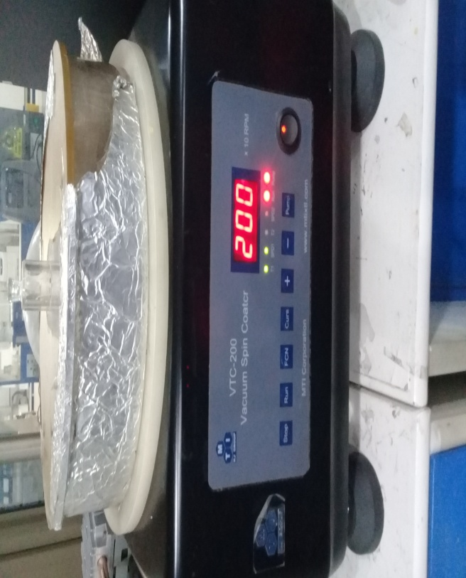
Fig 3.12 Spin Coating of NiO
The second task was to deposit emissive layer on HTL of NiO. For this purpose some drops of solution of Sb₂S₃and that of 3% and 5% Ag doped Sb₂S₃ formed in dimethylformamide (DMF) were dropped on different FTO’s having layer of NiO as prepared before. The coater was set on 2000 rpm for 10s. after that the films were baked on hot plate.Third step was the deposition of the electron transport of ZnO on the emissive layer For this ZnO was spin coated on films of emissive layer at the rate of 2000rpm for 20s. then this film of ZnO was baked on a hot plate at 115ºC for 40 min. Silver paste was used for making contacts.

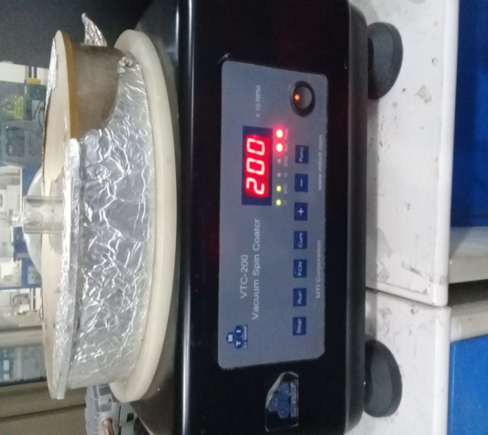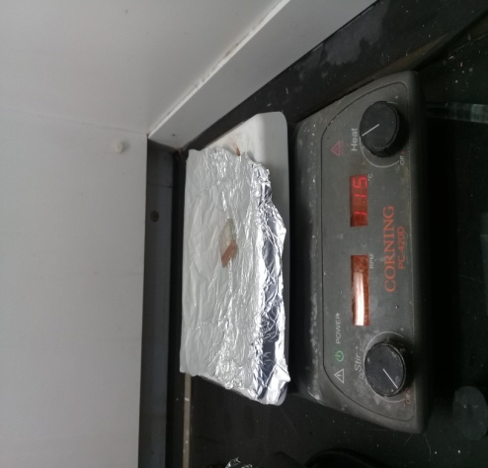
Fig 3.13 Thin Film Deposition of ZnO

Chapter 4.0

Characterization techniques

4.0 Characterization techniques
There are five characterization techniques used in this thesis explained below

4.1 X-ray Diffraction:
Xrd is a useful technique to investigate the structural properties of nanomaterials. It is a tool for measuring the atomic spacing. X-ray diffraction analysis gives information about phase composition, crystallite size, crystallographic orientation etc[73].
Following are given the parts of XRD setup
- Laser
- Sample surface
- Photo diode
Principle of XRD:
XRD working principle is constructive interference which obeys Bragg's law. Crystal structure of substance acts like a 3-Dimensional diffraction grating for X-ray wavelength. Crystal structure builds up a constructive interference for monochromatic X-rays. Bragg's law concerns diffraction edge and inter planar distance to the wavelength of falling radiations [74].
X-ray Data Analysis
Xrd analysis of functional thin films is explained here. A Grazing Incidence XRD method is used to explore the crystalline structure of thin films. X-ray beams strike on the sample at very thin angles. A 2D detector is used to collect the data from diffracted beams[75].

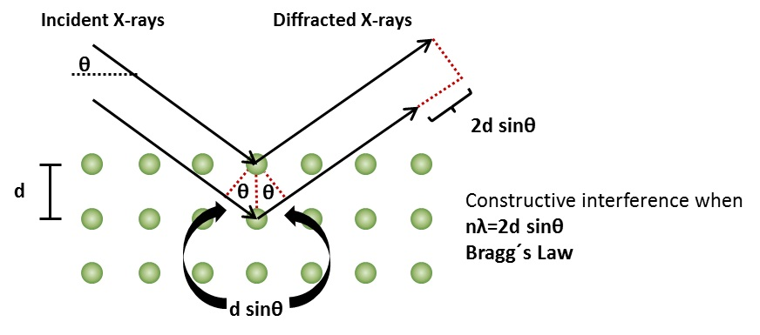
Fig 4.1 XRD Diffraction Pattern
An X-ray beam of wavelength of the order of 0.5-2 Ǻ is incident on the sample. X-rays are diffracted from the planes of the crystals. According to Bragg’s law
λ=2dsinϴ (1)
the intensity of diffracted beams are measured as a function of 2ϴ . Here d is the spacing between planes of crystal phase of sample and ϴ is the angle between diffracted beam and planes of the crystal. X-ray diffraction pttern is used to measure the crystallite size, phase , atomic orientation and thickness of films.
Lattice parameter are calculated by following equation a=d$\sqrt{h^{2}{+k}^{2+}l^{2}}$ (2)
Crystallite size is measured using Debye- Scherer formula D=$\frac{0.9λ}{βcosϴ}$ (3)
WhereD= crystallite size
β = FWHM (full width half maxima)
$λ$= Wavelength of X-ray used

ϴ = angular width of peak [76]
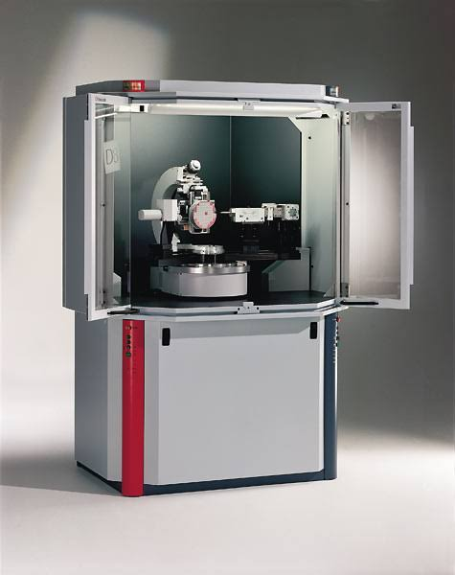
Fig 4.2 XRD Setup
Structural Parameters
Following structural parameters can be measured by using xrd data:
- Inter-planar spacingIt is the distance between two consecutive planes in the crystal structure represented by “d”. It’s the perpendicular distance.

- Lattice ParametersLattice parameters a, b, and c are the intercepts of the plane along x,y and z-axes respectively. They depend upon miller indices (hkl) and inter-planar spacing.

4.2 UV-Vis Spectroscopy:
It is a technique to calculate the attenuation when light of ultraviolet and visible range falls on the sample.
Principle of UV-Vis Spectroscopy
It obeys Beer-Lambert’s law which states that “ absorption of the light by the sample is directly proportional to the path length and concentration of the sample”[77]
$A=\log\left(\frac{I_{o}}{I_{x}}\right)$ (4)
Where A is absorbance
I_{o} is Intensity of incident light on the sample
Ixis Intensity of light, leaving the sample
Optical Parameters
There are a few optical parameters, for example, absorbance (A), transmittance (T), and reflectance (R) can be determined by utilizing the consequences of UV-Visible spectroscopy. These all parameters are the key instruments to utilize a material in the field of optoelectronic. There are some others parameters which can likewise determine by utilizing that information, for example,absorption coefficient (α) and band gap energy (Eg) etc.
Absorbance
The capacity of a material to absorb light of a particular wavelength. It is equivalent to the logarithm of the inverse of the transmittance
$$A=\log\left(\frac{I_{o}}{I_{x}}\right)=log\left(\frac{1}{T}\right) (5)$$
It can also be used to calculate transmittance as by above equation [78]. Absorbance can be measured directly from uv-vis spectrometer by adjusting it in logarithmic unit.
Transmittance
It is defined as the ratio of incident light on the sample to the light transmitted out through the sample. It explains that how much light transmits through sample unaffected
T= $\frac{I}{I˳}$(1) (6)
Where I= Incident intensity of light
Io = Intensity of light transmitted out
Reflectance
A measure of Amount of light that strikes the sample and reflects back from its surface is called reflectance.
R+T+L=1 (7)
Here , R= Reflectance
T= Transmittance
L =A+S= Absorbance + Optical Loss
Absorption Co-efficient
The light absorption is measured by its absorption co-efficient α can be defined as the fraction of power absorbed by unit length of the material
α = 2.303 A / t (8)
Here A = absorbance
t = thickness of the film
Optical Bandgap Calculations: (E_{g})
Bandgap is the difference of energy between conduction band and valence band. It is a remarkable property which can be measured by using the data of UV-Vis spectroscopy. It determines which portion of light will be absorbed by the sample. It can be calculated by following formula
${\left(αhv\right)}^{1/n}=A\left(hv-E_{g}\right)$ (9)
This equation can be rewritten as follows to calculate E_{g}
$${ E}_{g}=hv-\frac{{\left(αhv\right)}^{1/n}}{A} (10)$$
Where n depends upon transition it is ½ for direct transition and 2 for indirect transition
A is a constant value
hv= Energy of photon
α = absorption co-efficient
Extrapolation of graph plotted between hv and (αhv)²gives the value of Bandgap.

4.3 Fourier Transform Infrared (FTIR) Spectroscopy
IR spectroscopy is a method which depends upon the atomic vibrations of the molecules of sample under consideration. The IR spectrum is obtained by falling the IR rays on the sample and it is determined that how much IR rays are absorbed by the sample at specific energy. The energy at which peak of IR spectrum is observed keep up a correspondence to the frequency of vibration of a fraction of sample molecule.The interaction of IR radiation with sample might be comprehended as far as changes in atomic dipoles related with rotations and vibrations. The atoms can move with respect to one another, that is, bond lengths can differ or one molecule can move out of its present plane. This is a depiction of bending and stretching that are commonly referred to as vibrations. Vibrations can include a change either in bond angle (bending) or in bond length (Stretching).
There are two types of stretching
Symmetrical StretchingBonds stretch in phase
Asymmetrical StretchingBonds stretch out of phase
If the atoms of molecules are different then the vibrations of bonds will bedifferent. So within a sample atoms exhibit different modes of vibrations [79].

Instrumentation of FTIR Spectroscopy
It is based on a Michelson interferometer and a mathematical procedure of Fourier Transformation. The working principle of IR spectroscopy is based upon the interference of two beams to make an interferogram. The schematic of TIR is shown in fig below
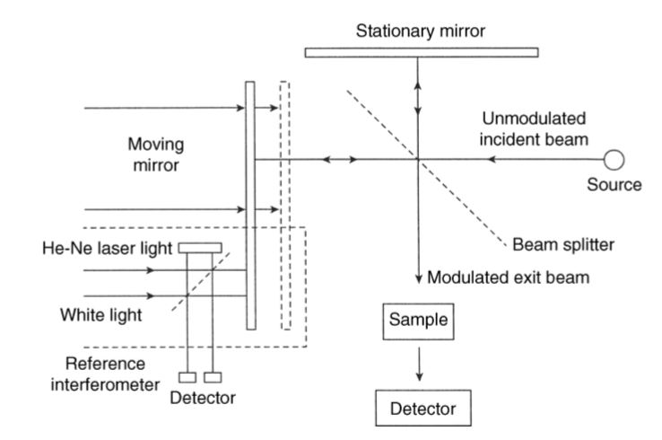
Fig 4.3 FTIR Spectroscopy schematic

It analyzes the vibrations of atoms in a molecule. Atomic vibrations are influenced by the many factors such as atomic masses, arrangement of atoms and bond strength.Vibration of bonds (stretch, bend, wag and twist) occur due to interaction of infrared radiations with sample molecules. These bonds of atoms vibrate at specific frequencies according to functional groups present in the sample[80].

4.4 Photoluminescence (PL) Spectroscopy
PL is a technique in which a sample is luminated usually with laser light and the luminescence of the sample is recorded as the graph of emitted light and wavelength of incident light. PL is used to analyze the atomic features like optical defects and optical centers . PL givess a very perceptiveinstrument for identifyingvariations in atomic arrangement and defects[81].
The procedure of emission of light from the sample consists of following steps
- Creation of electron-hole pair after absorption of light
- Radiative recombination of electron-hole pair
- Emission of light after recombination.
Photoluminescence occurs on the side of sample which is irradiated by light so that is why it is called front photoluminescence. In case of thin films, if film is not deposited well on the substrate then emission can be occur from other side of the substrate. It is an informative tool for measuring the optical properties of any material. 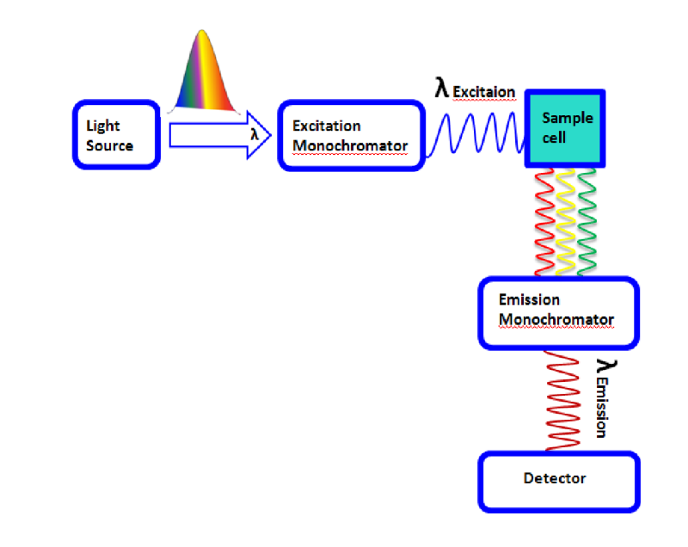
Fig 4.4 PL Spectroscopy Setup

4.5 Scanning Electron Microscopy (SEM)

SEM can give us information about the crystalline structure, surface morphology, electrical properties and chemical composition of specimen. Many specialized stages ( cold,hot etc) are used in SEM to examine the material in various conditions e.g.emission of light is observed at absolute zero because at this temperature it is strong as compare to at room temperature. SEM gives advantage in analyzing the surface morphology whatever the roughness of the material may be. Higher magnifications up to 1,000,000x can be achieved using SEM, with the resolution of 1 nm. It provides non-destructive calibration of the sample [82].
Scanning Electron microscope consists of following parts
- Electron guns
- Condensing Lenses
- Scanning Oil
- Chamber for sample
- Detector
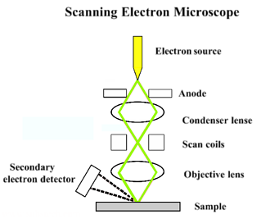
Fig 4.5 Scanning Electron Microscope

An accelerated beam of electrons is ejected from an electron gun and is focused on the sample by condensing lenses. These electrons disperse away as secondary electrons after striking the sample. These secondary electrons are converted into high voltage signals which are used to create images of the sample.

Chapter 5.0

Results and Discussion

5.1 Fourier Transform Infrared Analysis:
FTIR spectroscopy was used to determine the bond vibrations of different functional groups present in the antimony sulfide Sb₂S₃with different concentrations of doping of Ag. Following figure gives the FTIR spectra of Sb₂S₃, 3%Ag-Sb₂S₃ and 5%Ag-Sb₂S₃

Fig 5.1 FTIR Spectra

The peaks of absorption observed at 3333 cm⁻¹ and 2324 cm⁻¹ indicate O-H stretching and C-O stretching, which highlight the presence of large amounts of active hydroxyl and methyl group. The absorption peaks observed at 1616 cm⁻¹and 1607cm⁻¹confirms the occurrence of C=C and C-H functional group. The absorption peaks observed at 1035 cm⁻¹ shows the presence of S=O group. The absorption peak observed at 1104 cm⁻¹ show O-H stretching vibration. The absorption peak at 797 cm⁻¹depicts Sb-O stretching vibration.
The graph shows that the intensity of the sb2s3 increases with the increase in the wt% of doping of Ag in the host atoms.

5.2 UV-Vis Spectroscopy
Fig 5.2 gives the uv-vis spectra of Sb₂S₃ and doped with silver with different quantity such as 3%Ag-Sb₂S₃ and 5%Ag-Sb₂S_{3.} The sharp fall of the absorption curve is at the band edge which indicates the direct Bandgap .The spectra have an absorption peak at 340nm which indicates the ℼ - ℼ*transition nd another peak is observed at about 610nm which indicates the n - ℼ* transition.
Fig 5.2 UV-Vis Spectra
Moreover it also can be observed from the graph that absorbance for 3% Ag doped Sb₂S_{3.} Following figures show the bandgaps of all samples. Fig 5.3 gives the bandgap of Sb₂S₃ that is 2.01eV and fig 5.4 is showing bandgap of 3%Ag- Sb₂S₃ which is 1.87eVand the band gap of 5%Ag- Sb₂S₃is 1.64eV as by fig 5.5. the decrease in the Bandgap can be attributed to the increase of content of doping material which confirms that the doped materials have bright future in the optoelectronic applications. The Bandgap of 3%Ag- Sb₂S₃lies within the visible range so it can be best to be used as emissive layer for visible LED application.
(a)

Fig 5.3 Optical Bandgap of (a) Sb₂S₃ (b) 3% Ag-Sb₂S₃ (c) 5% Ag-Sb₂S₃

(b)
(c)

5.3 Photoluminescence Spectra Analysis
PL spectra of Sb2S₃ , 3%Ag-Sb2S₃ and 5% Ag-Sb₂S₃ is shown by Fig 5.6.As it is obvious that the material exhibit visible emission wide bands with maximum peak at 649nm for Sb₂S₃, at 683nm for 3%Ag-Sb₂S₃ and at 698nm for 5% Ag-Sb₂S₃showing the red emission spectra. These peaks begin due to structural defects .

Fig 5.4 Photoluminecence Spectra
The maximum emission peak shift 649nm to 683nm to 698 is same for all samples which indicate the red shift in the materials. As it is clear from the graph that the thin film of Sb₂S₃shows the most intensive peak while the thin films of doped Sb₂S₃ exhibit less intensive peaks. This can be dedicated to the doping induced quenching effect. Due to doping deep centers create which inhibit the electrons to excite and lead to the development of non-radiative recombination processes that may be accountable of quenching of PL intensity. Shift in intensity is may be due to the deviation of position of defect level in the bandgap.

5.4 IV-Measurements:
Fig 5.5(a) is showing the current and voltage relationship for Sb₂S₃, 5.5(b)shows the results for 3% Ag-Sb₂S₃and 5.5(c) shows results for 5% Ag-Sb₂S₃.

(a)

(b)
(c)

Fig 5.5 IV Characteristics (a) Sb₂S₃ (b) 3% Ag- Sb₂S₃ (c) 5% Ag- Sb₂S₃

From the graph of Sb₂S₃, it can be seen that IV curves shows the diode characteristics. From the fig 5.5(a) we can see that the turn on voltage of the device having emissive layer of Sb₂S₃ is about 3V which reduced for 3% Ag- Sb₂S₃ to 2V as can be seen from fig 5.5(b) . The turn on voltage for 5% Ag- Sb₂S₃ is reduced to 1V. And also the current is increased after doping.
5.5 SEM Analysis
Fig 5.6(a) and 5.6(b) indicates the results of scanning electron microscopy of Sb₂S₃. As it can be seen that fig (a) is the SEM image of the sample at less resolution as compared to fig (b) which is performed at high resolution.The scale of the first figure is in the micrometer range while the second figure of the same sample is in the nanometer range. In both figures we can see that the particles are distributed uniformly and the distribution of particles as well as particle formation becomes more uniform when we move towards the higher resolution range and small scale. By using the small scale a focused image of the material will be obtained from which average particle size can be calculated easily. From SEM it is clear that the material mostly possess the dense structure and the average particle size calculated to be 93.5nm.
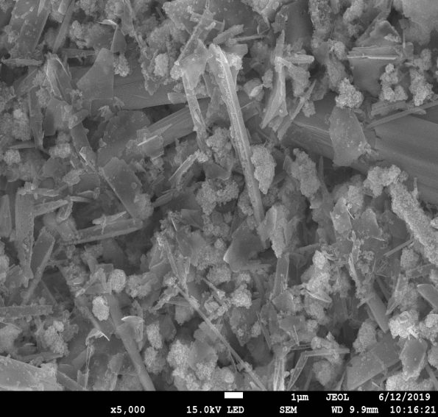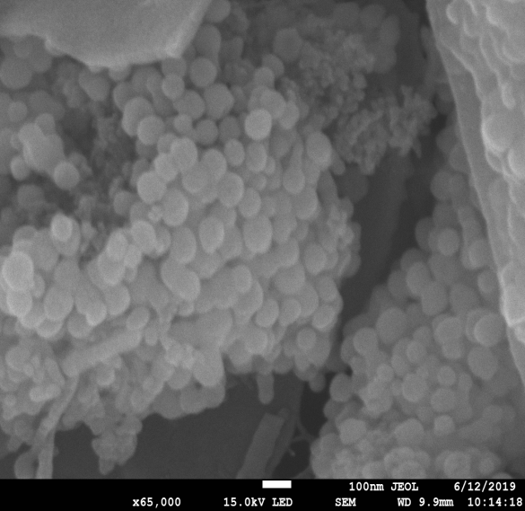
(b)
(a)

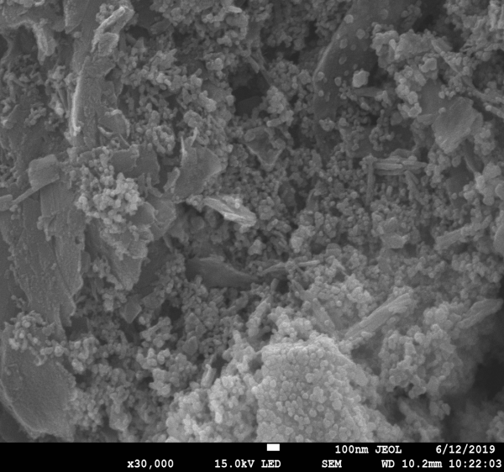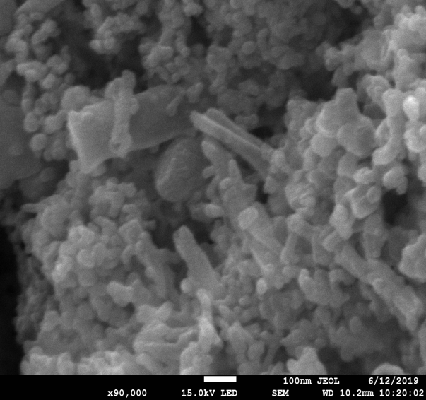
(d)
(c)
Fig 5.6 (a,b) SEM of Sb₂S₃ (c,d) SEM of 5% Ag-Sb₂S₃
Fig (c) and (d) indicate the results of SEM for 5% Ag-Sb₂S₃. The fig(a) gives the image at lower resolution while fig(b) gives the image at higher resolution as obvious from the figure . We can see that the particle size has been reduced from 93.5nm to 88.3nm due to doping of Ag in the pure Sb₂S₃. The material have denser structure as can be seen from the image. It is clear from the image that as we increase the doping concentration the particles more lie in form of bunches and colonies.

5.6 Electroluminescence (EL) Spectroscopy

The EL spectra of the devices is shown in the Fig 5.7. Stabe EL is observed at 650nm for Sb₂S₃ ,673nm for 3% Ag- Sb₂S₃ and at about 697nm for 5% Ag- Sb₂S₃ which is in good agreement with the PL results. EL displays only emissive layer emission. It demonstrates that the electrons and holes recombine within emissive layer which is the requirement to optimize device operation

Fig 5.7 Electroluminescence spectra

Conclusion:
In this work hydrothermal technique was used to prepare Sb₂S₃ and doped with different wt% of Ag and thin films were made on glass substrates by the drop casting method. Environmentally friendly materials were used to make Sb₂S₃ . To prepare 3%Ag-Sb₂S₃ and 5%Ag-Sb₂S₃, all the parameters pressure, temperature, reaction time were kept constant only the different concentration of AgNO₃ was added to the Sb₂S₃ to tune its optical and electrical properties for visible LED applications. Different characterization techniques were used to analyze its properties. UV-Vis Spectroscopy was used to calculate the bandgap of the materials. The bandgap of Sb₂S₃ calculated was 2.01 eV which was reduced to 1.87eV for the 3% Ag doped Sb₂S₃and 1.83 eV for 5% Ag doped Sb₂S₃ which indicate the enhancement of optical properties. FTIR spectra was used to analyze the vibrations of bonds of different functional groups present in the sample. PL spectra reveals the strong emission peak at 649nm for Sb₂S₃, 683nm for 3% Ag-Sb₂S_{3,} 698nm for 5% Ag-Sb₂S_{3.} these results show the emission in the visible range and slight redshift for different concentration of doping. The intensity of the Sb₂S₃ is decreased after doping due to doping induced quenching effect. LEDs were fabricated with the samples prepared and characterized by I-V measurements and electroluminescence IV measurements of the sample expressed the current and voltage relationship of Sb₂S₃. IV characteristics of 3% Ag-Sb₂S₃ indicate its compatibility for LED applications.turn on voltage of the device has been decreased with the increased doping concentration of Ag in emissive layer of Sb₂S₃. EL spectra was in good accordance with PL results and indicate red light emission from LEDs. Results of all the materials show bright future of their use in visible LED applications.

Chapter 6.0

References

Bibliography

1. I. Khan, K. Saeed, and I. Khan, “Nanoparticles : Properties , applications and toxicities,” Arab. J. Chem., 2017.
2. V. T. J. Jr, L. Col, and M. Afb, “NEXT GENERATION NANOTECHNOLOGY ASSEMBLY FABRICATION METHODS : A TREND FORECAST,” no. 64.
3. G. A. Silva, M. Sc, and D. Ph, “Introduction to Nanotechnology and Its Applications to Medicine,” 2004.
4. V. Etacheri, R. Marom, R. Elazari, G. Salitra, and D. Aurbach, “Challenges in the development of advanced Li-ion batteries: a review,” Energy Environ. Sci., vol. 4, no. 9, pp. 3243–3262, 2011.
5. P. Di Sia, “Present and future of nanotechnologies: Peculiarities, phenomenology, theoretical modelling, perspectives,” Rev. Theor. Sci., vol. 2, no. 2, pp. 146–180, 2014.
6. S. K. Prasad, Modern concepts in nanotechnology, vol. 5. Discovery Publishing House, 2008.
7. B. Weintraub, Z. Zhou, Y. Li, and Y. Deng, “Solution synthesis of one-dimensional ZnO nanomaterials and their applications,” Nanoscale, vol. 2, no. 9, pp. 1573–1587, 2010.
8. H. Lee, “Quantum dots of Group IV semiconductor materials.” Google Patents, 10-Apr-2003.
9. A. B. Ellis, K. J. Nordell, T. F. Kuech, S. A. Stockman, G. C. Lisensky, and S. M. Condren, “LEDs: new lamps for old and a paradigm for ongoing curriculum modernization,” J. Chem. Educ., vol. 78, no. 8, p. 1033, 2001.
10. E. P. Wagner, “Investigating bandgap energies, materials, and design of light-emitting diodes,” J. Chem. Educ., vol. 93, no. 7, pp. 1289–1298, 2016.
11. F. Stern and W. E. Howard, “Properties of semiconductor surface inversion layers in the electric quantum limit,” Phys. Rev., vol. 163, no. 3, p. 816, 1967.
12. H. Gleiter, “Nanocrystalline materials,” in Advanced Structural and Functional Materials, Springer, 1991, pp. 1–37.
13. C. Becker et al., “Polycrystalline silicon thin-film solar cells: Status and perspectives,” Sol. Energy Mater. Sol. Cells, vol. 119, pp. 112–123, 2013.
14. M. C. Capizzo, “Electric conduction in semiconductors : a pedagogical model based on the Monte Carlo method,” vol. 451.
15. V. Lahariya and S. Kumar, “Study on Structural and Optical Properties of Sb2S3 and CdI2 Composite Thin Films Deposited by Thermal Vapor Deposition,” Int. J. Nanosci., vol. 17, no. 04, p. 1760033, 2018.
16. P. Na, H. Yan, Y. Pingping, W. Qinmei, L. Yicheng, and Y. Yuxiang, “Synthesis and Characterization of Water-soluble Sb 2 S 3 Quantum Dots,” vol. 01008, pp. 0–6, 2016.
17. S. Adachi, Properties of semiconductor alloys: group-IV, III-V and II-VI semiconductors, vol. 28. John Wiley & Sons, 2009.
18. O. J.W and C. . Foxon, “Group III nitride semiconductors for short wavelength light-emitting devices - Abstract - Reports on Progress in Physics - IOPscience,” vol. 61, p. 1, 1997.
19. P. C. Road, “I iooc,” vol. 4, pp. 93–105, 1993.
20. D. Mocatta, G. Cohen, J. Schattner, O. Millo, E. Rabani, and U. Banin, “Heavily doped semiconductor nanocrystal quantum dots,” Science (80-. )., vol. 332, no. 6025, pp. 77–81, 2011.
21. P. Thakur, S. S. Joshi, S. Kapoor, and T. Mukherjee, “Fluorescence behavior of cysteine-mediated Ag@CdS nanocolloids,” Langmuir, vol. 25, no. 11, pp. 6377–6384, 2009.
22. M. Bernardi, C. Ataca, M. Palummo, and J. C. Grossman, “Optical and Electronic Properties of Two-Dimensional Layered Materials,” vol. 6, no. 2, pp. 479–493, 2017.
23. I. Light-emitting and M. Leds, “LIGHT-EMITTING DIODES,” 2014.
24. F. Flory, Y. J. Chen, and H. J. Lin, Optical thin films containing quantum dots. Woodhead Publishing Limited, 2013.
25. X. Li et al., “Bright colloidal quantum dot light-emitting diodes enabled by efficient chlorination,” Nat. Photonics, vol. 12, no. 3, p. 159, 2018.
26. X. Dai et al., “Solution-processed, high-performance light-emitting diodes based on quantum dots,” Nature, vol. 515, no. 7525, p. 96, 2014.
27. H. Zhang, S. Chen, and X. W. Sun, “Efficient red/green/blue tandem quantum-dot light-emitting diodes with external quantum efficiency exceeding 21%,” ACS Nano, vol. 12, no. 1, pp. 697–704, 2017.
28. R. Melikov et al., “Silk-hydrogel lenses for light-emitting diodes,” Sci. Rep., vol. 7, no. 1, p. 7258, 2017.
29. C.-W. Sher et al., “A high quality liquid-type quantum dot white light-emitting diode,” Nanoscale, vol. 8, no. 2, pp. 1117–1122, 2015.
30. S. Y. Lee et al., “Water-resistant flexible GaN LED on a liquid crystal polymer substrate for implantable biomedical applications,” Nano Energy, vol. 1, no. 1, pp. 145–151, 2012.
31. M. Lu et al., “Liquid-type AgInS2/ZnS quantum dot-based warm white light-emitting diodes,” Chem. Phys. Lett., vol. 661, pp. 228–233, 2016.
32. Y. Wang et al., “Efficient near-infrared light-emitting diodes based on liquid PbSe quantum dots,” Nanotechnology, vol. 28, no. 21, p. 215703, 2017.
33. M. A. Hines and P. Guyot-Sionnest, “Synthesis and characterization of strongly luminescing ZnS-capped CdSe nanocrystals,” J. Phys. Chem., vol. 100, no. 2, pp. 468–471, 1996.
34. B. O. Dabbousi et al., “(CdSe) ZnS core− shell quantum dots: synthesis and characterization of a size series of highly luminescent nanocrystallites,” J. Phys. Chem. B, vol. 101, no. 46, pp. 9463–9475, 1997.
35. X. Peng, M. C. Schlamp, A. V Kadavanich, and A. P. Alivisatos, “Epitaxial growth of highly luminescent CdSe/CdS core/shell nanocrystals with photostability and electronic accessibility,” J. Am. Chem. Soc., vol. 119, no. 30, pp. 7019–7029, 1997.
36. J. S. Steckel, J. P. Zimmer, S. Coe‐Sullivan, N. E. Stott, V. Bulović, and M. G. Bawendi, “Blue luminescence from (CdS) ZnS core–shell nanocrystals,” Angew. Chemie Int. Ed., vol. 43, no. 16, pp. 2154–2158, 2004.
37. M. Tian, J. Luo, and X. Liu, “Highly efficient organic light-emitting devices beyond theoretical prediction under high current density,” Opt. Express, vol. 17, no. 24, pp. 21370–21375, 2009.
38. H. Zhang et al., “Ultrastable quantum-dot light-emitting diodes by suppression of leakage current and exciton quenching processes,” ACS Appl. Mater. Interfaces, vol. 8, no. 45, pp. 31385–31391, 2016.
39. W. Ji, S. Liu, H. Zhang, R. Wang, W. Xie, and H. Zhang, “Ultrasonic spray processed, highly efficient all-inorganic quantum-dot light-emitting diodes,” ACS Photonics, vol. 4, no. 5, pp. 1271–1278, 2017.
40. E. Fortunato, P. Barquinha, and R. Martins, “Oxide semiconductor thin‐film transistors: a review of recent advances,” Adv. Mater., vol. 24, no. 22, pp. 2945–2986, 2012.
41. M. K. Choi, J. Yang, T. Hyeon, and D.-H. Kim, “Flexible quantum dot light-emitting diodes for next-generation displays,” npj Flex. Electron., vol. 2, no. 1, p. 10, 2018.
42. K. Petkov, R. Todorov, D. Kozhuharova, L. Tichy, E. Cernoskova, and P. J. S. Ewen, “Changes in the physicochemical and optical properties of chalcogenide thin films from the systems As—S and As—S—TI,” J. Mater. Sci., vol. 39, no. 3, pp. 961–968, 2004.
43. E. Marquez, A. M. Bernal-Oliva, J. M. Gonzalez-Leal, R. Prieto-Alcon, and T. Wagner, “Optical properties and structure of amorphous (As0. 33S0. 67) 100− xTex and GexSb40− xS60 chalcogenide semiconducting alloy films deposited by vacuum thermal evaporation,” J. Phys. D. Appl. Phys., vol. 39, no. 9, p. 1793, 2006.
44. Q. Lu, H. Zeng, Z. Wang, X. Cao, and L. Zhang, “Design of Sb2S3 nanorod-bundles: imperfect oriented attachment,” Nanotechnology, vol. 17, no. 9, p. 2098, 2006.
45. Z. S. El Mandouh and S. N. Salama, “Some physical properties of evaporated thin films of antimony trisulphide,” J. Mater. Sci., vol. 25, no. 3, pp. 1715–1718, 1990.
46. J. Campos and V. M. Garcia, “Chemically Deposited 5b253 and 5b253-CuS Thin Films,” no. June, p. Mushtaq, S., Ismail, B., Raheel, M., Zeb, A. (20, 1998.
47. F. Aousgi and M. Kanzari, “Study of the optical properties of Sn-doped Sb2S3thin films,” Energy Procedia, vol. 10, p. Mushtaq, S., Ismail, B., Raheel, M., Zeb, A. (20, 2011.
48. P. Roy and S. K. Srivastava, “In situ deposition of Sn-doped CdS thin films by chemical bath deposition and their characterization,” J. Phys. D. Appl. Phys., vol. 39, no. 22, pp. 4771–4776, 2006.
49. S. M. Salim, M. B. Seddek, and A. M. Salem, “Low-temperature Synthesis of Ag-doped Sb 2 S 3 Thin Films and its Characterization,” vol. 6, no. 9, p. Mushtaq, S., Ismail, B., Raheel, M., Zeb, A. (20, 2010.
50. F. Perales, G. Lifante, F. Agulló-Rueda, and C. De Las Heras, “Optical and structural properties in the amorphous to polycrystalline transition in Sb2S3 thin films,” J. Phys. D. Appl. Phys., vol. 40, no. 8, pp. 2440–2444, 2007.
51. Y. C. Choi et al., “Sb2Se3-sensitized inorganic-organic-heterojunction solar cells fabricated using a single-source precursor,” Angew. Chemie - Int. Ed., vol. 53, no. 5, pp. 1329–1333, 2014.
52. N. Tigau, “Influence of temperature on the microcrystalline structure of thermally evaporated Sb2S3 thin films,” Cryst. Res. Technol., vol. 43, no. 9, pp. 964–969, 2008.
53. L. F. Lundegaard, R. Miletich, T. Balic-Zunic, and E. Makovicky, “Equation of state and crystal structure of Sb2S3between 0 and 10 GPa,” Phys. Chem. Miner., vol. 30, no. 8, pp. 463–468, 2003.
54. C. Ghosh and B. P. Varma, “Optical properties of amorphous and crystalline Sb2S3 thin films,” Thin Solid Films, vol. 60, no. 1, pp. 61–65, 1979.
55. B. Krishnan, A. Arato, E. Cardenas, T. K. D. Roy, and G. A. Castillo, “On the structure, morphology, and optical properties of chemical bath deposited Sb 2 S 3 thin films,” Appl. Surf. Sci., vol. 254, no. 10, pp. 3200–3206, 2008.
56. S. Shaji et al., “ Chemically deposited Sb 2 S 3 thin films for optical recording ,” J. Phys. D. Appl. Phys., vol. 43, no. 7, p. 075404, 2010.
57. S. Nadzirah, U. Hashim, and N. Malihah, “Structural and Electrical Properties of Titania Thin Films,” Adv. Mater. Res., vol. 925, no. 2, pp. 300–303, 2014.
58. J. Zhu, X. Yan, and J. Cheng, “Synthesis of Water-Soluble Antimony Sulfide Quantum Dots and Their Photoelectric Properties,” pp. 4–9, 2018.
59. A. G. Vedeshwar, “Optical properties of amorphous and polycrystalline stibnite (Sb2S3) films,” J. Phys. III, vol. 5, no. 8, pp. 1161–1172, 1995.
60. A. Sinaoui, I. Trabelsi, F. C. Akkar, F. Aousgi, and M. Kanzari, “Study of structural, morphological and optical properties of Sb2S3 thin films deposited by oblique angle deposition,” Int. J. Thin Fil. Sci. Tec, vol. 3, no. 1, pp. 19–25, 2014.
61. J. R. Castro et al., “Formation of antimony sulfide powders and thin films from single-source antimony precursors †,” p. Mushtaq, S., Ismail, B., Raheel, M., Zeb, A. (20, 2008.
62. N. Pi, Y. Huang, P. Yao, Q. Wei, Y. Liu, and Y. Yang, “Synthesis and Characterization of Water-soluble Sb2S3 Quantum Dots,” in MATEC Web of Conferences, 2016, vol. 67, p. 1008.
63. P. A. Nwofe, “Effect of deposition time on the optical properties of antimony sulphide thin films grown by the solution growth technique,” vol. 6, no. 3, p. Mushtaq, S., Ismail, B., Raheel, M., Zeb, A. (20, 2015.
64. J. S. Cruz, N. R. Mathews, and M. Pal, “materials Effect of Ag doping on structural , optical and electrical properties of antimony sulfide thin films,” J. Mater. Sci., 2018.
65. X. W. S. b L. Y. Tanga, X. L. Zhanga, H. T. Dai*a, J. L. Zhaoa, c, S. G. Wanga, NiO as Hole Transport Layers for All-inorganic Quantum Dot LEDs. .
66. R. Boughalmi, A. Boukhachem, M. Kahlaoui, H. Maghraoui, and M. Amlouk, “Physical investigations on Sb2S3 sprayed thin film for optoelectronic applications,” Mater. Sci. Semicond. Process., vol. 26, pp. 593–602, 2014.
67. A. Arato, E. Perez-tijerina, T. K. Das Roy, G. A. Castillo, and B. Krishnan, “Solar Energy Materials & Solar Cells Carbon-doped Sb 2 S 3 thin films : Structural , optical and electrical properties,” vol. 93, p. Mushtaq, S., Ismail, B., Raheel, M., Zeb, A. (20, 2009.
68. M. Ohring, “Materials Science of Thin Films 2nd edn (New York: Academic),” 2002.
69. S. Ruzic, N. Rajakovic, and A. Vuckovic, “A flexible approach to short-term hydro-thermal coordination. I. Problem formulation and general solution procedure,” IEEE Trans. Power Syst., vol. 11, no. 3, pp. 1564–1571, 1996.
70. R. C. Suciu, M. C. Roşu, T. D. Silipaş, A. R. Biriş, I. Bratu, and E. Indrea, “TiO2 thin films prepared by spin coating technique,” Rev. Roum. Chim., vol. 56, no. 6, pp. 607–612, 2011.
71. D. B. Hall, P. Underhill, and J. M. Torkelson, “Spin Coating,” vol. 38, no. 12, pp. 2039–2045, 1998.
72. A. You, M. A. Y. Be, and I. In, “Spin-coated amorphous chalcogenide films,” vol. 6979, no. June 1982, 2008.
73. R. Sharma, D. P. Bisen, U. Shukla, and B. G. Sharma, “X-ray diffraction : a powerful method of characterizing nanomaterials,” vol. 4, no. 8, pp. 77–79, 2012.
74. J. E. Churilla, “X-ray diffraction studies of strontium iron molybdenum oxide thin films.” Northern Illinois University, 2008.
75. S. Kobayashi and K. Inaba, “Introduction to XRD analysis of modern functional thin films using a 2-dimensional detector — ( 1 ) GI-XRD,” no. 1, pp. 1–5.
76. K. Lin, H. Cheng, H. Hsu, and L. Lin, “Band gap variation of size-controlled ZnO quantum dots synthesized by sol – gel method,” vol. 409, pp. 208–211, 2005.
77. A. S. Journal, “Molecular Nanotechnology Understanding the UV-Vis Spectroscopy for Nanoparticles,” pp. 8–10, 2019.
78. E. E. ORTEC, “Principles and Applications of Timing Spectroscopy,” Appl. Note AN-42, Oak Ridge, Tennessee, p. 24, 2000.
79. “Infrared spectroscopy 1.,” pp. 1–17, 2015.
80. Theophandies, Fourier Transfonn Infrared Spectroscopy Industrial Chemical and Biochemical Applications, vol. 53, no. 9. 1984.
81. S. Eaton-maga, “A N I NTRODUCTION TO P HOTOLUMINESCENCE S PECTROSCOPY FOR D IAMOND AND,” no. April, pp. 1–17, 2016.
82. “Microscopy : an introduction,” vol. 13, no. 4, pp. 40–44, 2000.

