INTERNSHIP REPORT 2023
Title: ATIF RIAZ PRODUCTIONS

Time Period: 6 weeks
(July 15, 2023 – August 31, 2023)

Supervised by: Ma’am Ayesha Mirza
Submitted by: Sharafat Ali
Registration Number: SP20-BMC-016
Submission Date: 30th September, 2023



Media and Communication Studies, Department of Humanities
COMSATS University Islamabad, Lahore Campus
Internship Undertaking

INTERNSHIP UNDERTAKING

I, Sharafat Ali, student of media and communication studies department of COMSATS University Islamabad Lahore Campus, under the student ID SP20-BMC-016, solemnly declare that I have completed my internship as a compulsory part of my BS program in my seventh (7th) semester. I completed my six-week internship from Atif Riaz Productions in the Production and Editing department. I was keen to absorb new experiences and tried to learn and explore new things.

I hereby submit this report that primarily focuses on my learning from workshop with different departments, working environment of the organization and observation regarding to the organization that I look during my internship period. I’ve tried to elucidate all important aspects I’ve experienced during my internship.

I assure that my report is free from plagiarized content except of the important information that was related to the organization. The source material used in the report is mentioned in reference list at the end of this report. In case of any requirement, I will provide further details.

……………….
Sharafat Ali
ID: SP20-BMC-016
BS in Media and Communication Studies
COMSATS University Islamabad,
Lahore campus.

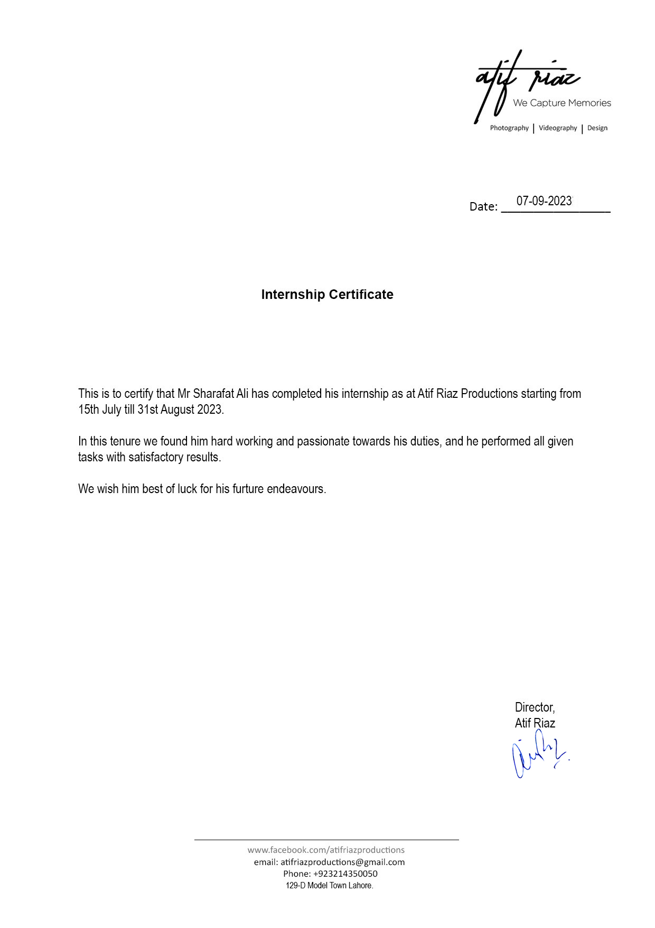

ACKNOWLEDGEMENT
All praise is due to Allah, the Almighty. I would like to express my sincere gratitude and appreciation for the invaluable experience I gained during my time as an intern Associate Director of Photography and Editor at Atif Riaz Productions. This opportunity has been transformative, both personally and professionally, and I am incredibly thankful for the support and guidance provided by the team at Atif Riaz Productions.
First and foremost, I want to extend my heartfelt thanks to the management at Atif Riaz Productions for entrusting me with this role. Their belief in my abilities and willingness to provide me with hands-on experience in the field of directing and editing is truly commendable. I am grateful for the opportunity to work on diverse projects under their mentorship, which has significantly contributed to my growth and development as a professional.
I am also deeply grateful to the entire team at Atif Riaz Productions for their unwavering support and collaboration throughout my internship. The collaborative and inclusive work environment fostered a sense of camaraderie, allowing me to learn from experienced professionals in the field. Their guidance, feedback, and willingness to share their expertise have been instrumental in expanding my skill set and enhancing my understanding of the industry.
I would like to express my gratitude to the Associate Directors, Photographer, Videographers, Editors and other staff who served as my mentors during this internship. Their patience, knowledge, and willingness to teach me the intricacies of the role have been invaluable. I am truly grateful for their dedication to nurturing talent and their commitment to ensuring that I gained hands-on experience in various aspects of directing and editing.
Furthermore, I want to acknowledge the entire Atif Riaz Productions team for their passion and dedication to their craft. Witnessing their creativity and professionalism has been inspiring, and I am fortunate to have been a part of such a talented group. The collaborative efforts, attention to detail, and commitment to delivering high-quality work have left an indelible impact on my approach to directing and editing.
Lastly, I want to express my gratitude to Atif Riaz Productions for providing me with a platform to apply my creativity and ideas. The opportunity to work on real projects and contribute to the production process has been invaluable. I am confident that the skills and knowledge I have gained during this internship will continue to guide me in my future endeavors.
In conclusion, I am deeply grateful to Atif Riaz Productions for providing me with a remarkable internship experience as an Associate DOP and Editor. The support, mentorship, and opportunities for growth have been instrumental in shaping my career path. I will always cherish the lessons learned and the relationships built during my time at Atif Riaz Productions. I am confident that this experience will serve as a solid foundation for my future professional endeavors.
Thank one once again for the opportunity to work with Atif Riaz Productions, and I extend my best wishes for the continued success and growth of the company.

EXECUTIVE SUMMARY
During my Internship at Atif Riaz Productions, I got a chance to work in Production and Editing department of the Company. Production and Editing Department at Atif Riaz Productions specializes in producing music videos, short films and other visual content like photoshoots, wedding Stories and so on and planning and post production of visual content. Throughout my internship experience in the department, I had the opportunity to gain valuable insights into the world of pre-production, planning, production and post-production contributing to various projects. This report aims to document my learnings, experiences, and the significant role that the Production and Editing Department plays in delivering exceptional visual content.
Production and Editing Department at Atif Riaz Productions is a highly creative and collaborative division focused on bringing artistic visions to life through the power of visual content. With a team of talented filmmakers, photographers, cinematographers, directors, editors, and technicians, the department is dedicated to producing visually captivating and compelling content that resonates with clients’ needs.
During my internship, I had the privilege of working alongside professionals who are passionate about storytelling and visual aesthetics. The department's expertise extends to both music videos and short films as well as still content, catering to the unique requirements and objectives of each project. The team collaborates closely with artists, musicians, record labels, and clients to ensure that their vision is translated into visually stunning and impactful productions.
The process of producing content involves various stages, including concept development, storyboarding, casting, location scouting, cinematography, and post-production. The department meticulously handles each aspect, ensuring that the final product reflects the essence effectively communicates the desired message. The team excels in scriptwriting, pre-production planning, filming, editing, and post-production, creating thought-provoking narratives and immersive experiences.

Throughout my internship, I had the opportunity to contribute to these projects, working alongside experienced professionals and gaining hands-on experience in various aspects of production and post production. I was involved in tasks such as assisting with pre-production preparations, coordinating logistics, operating equipment, participating in filming sessions, and supporting the post-production process. These experiences provided me with valuable insights into the intricacies of the industry and enhanced my technical skills and creative abilities.
The Production and Editing Department at Atif Riaz Productions stands out due to its commitment to delivering exceptional results and its ability to align visual storytelling with clients' objectives. The department understands that every project is unique, and their collaborative approach ensures that the final product resonates with the target audience and achieves the desired impact. By staying up-to-date with industry trends and utilizing state-of-the-art equipment and technology, the department maintains a high standard of quality and innovation.
This internship report serves as a testament to the significant role played by the Production and Editing Department at Atif Riaz Productions. It highlights the department's dedication to producing visually captivating music videos and short films and emphasizes the valuable learning opportunities provided during my internship. I am grateful for the experiences, skills, and knowledge gained, and I believe that my time in the department has laid a strong foundation for my future endeavors in the field of Production and Editing.

Table of Contents
ACKNOWLEDGEMENT 5
EXECUTIVE SUMMARY 6
INTRODUCTION TO ORGANIZATION 8
JOB DESCRIPTION 9
LEARNING OUTCOMES 10
SKILLS LEARNED 11
FRAMING AND COMPOSITION TECHNIQUES 16
SHOTS, CAMERA ANGLES, AND MOVEMENTS 24
POST-PRODUCTION 30
SHOOT SAMPLES 64
65
SWOT ANALYSIS 105
CONCLUSION 106

INTRODUCTION TO ORGANIZATION
Atif Riaz Productions, a leading Studio and Production House that specializes in creating captivating TV commercials (TVCs) and compelling short film projects as well as commercial, corporate and individual event coverage and management. With a passion for storytelling, a keen eye for visual aesthetics, and a deep understanding of marketing and promotional strategies, Atif Riaz Productions is dedicated to bringing brands to life through the power of video and photo.
At Atif Riaz Productions, we understand that visual content is an incredibly effective medium for capturing attention, conveying emotions, and leaving a lasting impact on viewers and importance of memories in once life. With our expertise in marketing and visual production, we combine artistic creativity with strategic thinking to produce content that resonates with audiences and drive engagement as well as emotionally appealing to our clients.
Our team of talented professionals is adept at transforming brand messages and clients’ emotions into visually stunning narratives. We work closely with our clients to understand their requirements like brand identity, target audience, and marketing goals, ensuring that every AV content we create aligns seamlessly with their overall requirement and likeability.
Whether it's a TVC for broadcast, a promotional video for digital platforms, or a short film to tell a captivating brand story, or a wedding story or its some kind of Product or Fashion Shoot, we approach each project with meticulous attention to detail. From concept development to pre-production, filming, editing, and post-production, we handle every aspect of the production process to deliver high-quality, visually striking videos and photos that leave a never-ending impression.
What sets Atif Riaz Productions apart is our commitment to producing content that not only captivates viewers but also delivers measurable results. We understand the importance of striking the right balance between creativity and objectives. Our team leverages their expertise in strategies to ensure that each piece of content effectively communicates the brand message, captures the client’s attention, and ultimately drives desired actions or results.
With access to state-of-the-art equipment, cutting-edge technology, and a network of talented industry professionals, we have the resources and capabilities to bring even the most ambitious creative visions to life. From crafting compelling scripts to scouting locations, casting talent, and delivering stunning visual effects, we go above and beyond to exceed our clients' expectations.
At Atif Riaz Productions, we believe that visual content has the power to make a lasting impression, inspire emotions, and connect with audiences on a deeper level. We are passionate about harnessing the storytelling potential of content to create impactful marketing campaigns for our clients. With our expertise in marketing strategies and our dedication to excellence in visual production, we are proud to be a trusted partner for businesses and individuals across the industry.
Welcome to Atif Riaz Productions, where creative storytelling meets effective marketing. We look forward to collaborating with one to create content that not only captivate audiences but also elevate the brands and drive success in the competitive marketplace.

JOB DESCRIPTION
- Edit video footage: Seamlessly edit raw footage, ensuring smooth transitions, visual coherence, and storytelling flow. Trim and rearrange clips to create a compelling narrative and deliver high-quality final products.

- Enhance visual elements: Apply effects, color correction, audio adjustments, and other enhancements to elevate the overall quality and impact of the content.

- Collaborate with the creative team: Work closely with filmmakers, directors, and other team members to understand the project goals, artistic vision, and desired outcomes. Collaborate in brainstorming sessions and contribute ideas for visual storytelling.

- Maintain technical proficiency: Stay updated with the latest trends, software, and editing techniques to ensure efficiency and high-quality output. Continuously improve technical skills and workflow efficiency.

- Follow project guidelines and deadlines: Adhere to project guidelines, timelines, and client specifications. Meet project deadlines and manage multiple assignments simultaneously, ensuring timely delivery of high-quality edited stills and videos.

- Communicate effectively: Collaborate with team members, including filmmakers, directors, and clients, to understand their feedback and incorporate necessary revisions. Maintain open and clear communication to ensure smooth workflow and project success.

LEARNING OUTCOMES
- Proficiency in Video Editing Software: By working as a Video Editor, I gained hands-on experience and develop proficiency in industry-standard video editing software such as Adobe Premiere Pro, Final Cut Pro, or DaVinci Resolve. I become familiar with the various features, tools, and capabilities of these software programs.

- Understanding of Video Formats and Codecs: Through my work as a
Video Editor, I learn about different video formats and codecs and their impact on video quality, file size, and compatibility. I gain knowledge of how to optimize video settings for different platforms and delivery requirements.

- Mastery of Editing Techniques: As a Video and Photo Editor, I learned various editing techniques to enhance the visual storytelling of videos and pictures. This includes cutting and trimming footage, adding transitions, applying effects, color grading of stills, and incorporating audio elements to create a cohesive and engaging final product.

- Time Management and Efficiency: shooting and Editing requires efficient time management skills to meet project deadlines. Through practice and experience, I learned how to organize my workflow, streamline the editing process, and utilize keyboard shortcuts to work more efficiently and save time.

- Collaboration and Communication: Working as an Associate DOP involves collaborating with directors, filmmakers, and other team members. I enhanced my communication skills by effectively understanding and incorporating feedback, discussing creative ideas, and ensuring that the final product aligns with the desired vision.

- Attention to Detail and Quality Control: Video, photo and editing requires a keen eye for detail to ensure visual and audio consistency, smooth transitions, and a polished final product. Through practice and experience, I developed a strong attention to detail and learn how to spot and correct errors or inconsistencies in the process.

- Problem Solving and Adaptability: In the field, unexpected challenges may arise during the process. I developed problem-solving skills and learned to adapt to changes or revisions required by clients or the creative team. This adaptability will contribute to my growth as a Professional.

- Creative Expression and Artistic Vision: Creating content whether it is videography, photography, direction or whether it is editing process, all of it is a creative process that allows to express my artistic vision. I had the opportunity to develop and refine my creative abilities, experiment with different editing styles, and bring my unique perspective to each project.

- Understanding of Storytelling Techniques: content creation is intricately tied to storytelling. By working as a Videographer, photographer and an Editor, I learnt how to effectively convey narratives, emotions, and messages through the arrangement framing, color toning, angles, dialogs, footage, pacing, and sequencing. I gained a deeper understanding of storytelling techniques and their impact on audience engagement.

- Continuous Learning and Professional Development: The field of content creation is constantly evolving, with new software updates, techniques, and trends emerging regularly. By engaging in field work, I cultivated a mindset of continuous learning and professional development, staying up-to-date with the latest advancements and honing my skills to adapt to industry changes.

- By actively engaging in video and photo shoots and editing them and leveraging the software and shortcuts available, I acquired these valuable learning outcomes, paving the way for a successful career in the field of video production and editing.

SKILLS LEARNED
During my internship in Atif Riaz Productions, I got a chance to improve my skills in the field of Photography, Videography, planning and pre-production as well as Post Production, During this internship I got to use and practice new things in Photoshop, Lightroom, premiere Pro as well as Adobe Auditions and also got the chance to improve my Photography and videography skills. All the skills learned during the internship period are elaborated with samples

THE EXPOSURE TRIANGLE
Understanding and balancing light is a crucial element of photography, and I learned how to do so during my internship by learning HOW TO GET THE CORRECT EXPOSURE FOR MY PHOTOS and by learning the meanings of the terms exposure, aperture, and ISO. Understanding how these controls work together and how to compensate for changes in one setting with another is essential for getting the right exposure.
Shutter speed, aperture, and ISO make up the three points of the exposure triangle.
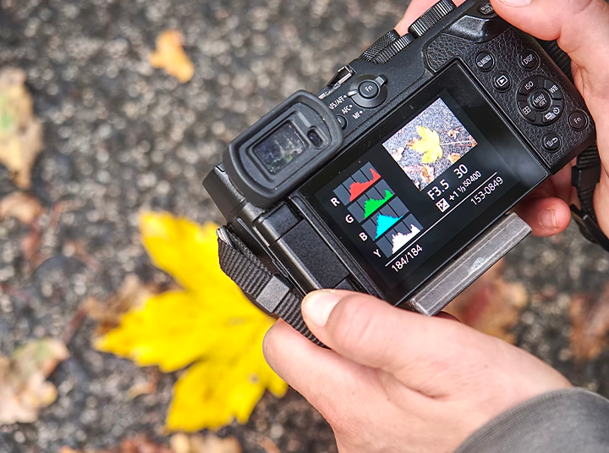
HOW TO GET THE CORRECT EXPOSURE?
The first week of my internship focused on learning about the exposure triangle and how its three sides work together to create stunning photographs in which no details are lost.
A faster shutter speed: Using a histogram and exposure meter to strike a balance and prevent any blurring of detail.
Too much light causes the image to be too bright, also known as "blowing" the highlights; too little light causes the image to be too dark, with no details visible in the shadows, resulting in an underexposed, black image.
A well-exposed photograph is one in which details appear both in the highlights and the shadows.
Below are examples of what an underexposed, an overexposed, and a properly exposed image's histogram could look like.
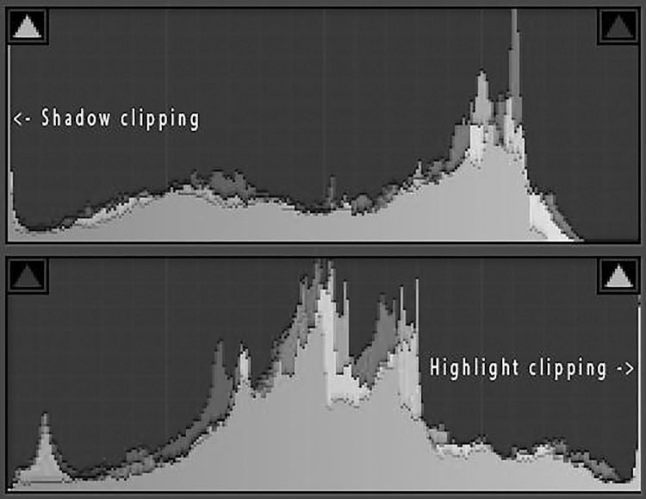
Graph 1 is Underexposed while the Graph 2 is Overexposed.
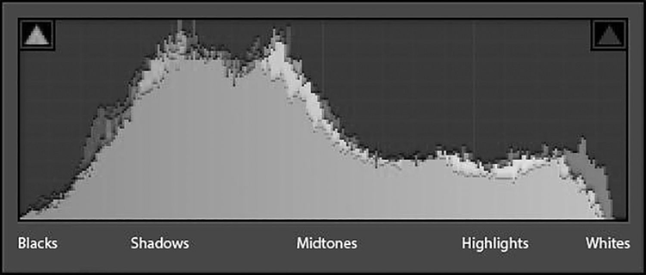
Graph 3: Perfect exposure.
Aperture Controls light and depth of field
F-stops represent the aperture. A higher F-stop number indicates a smaller aperture, whereas a lower F-stop number indicates a larger aperture. The fact that an F2.8 lets in more light than an F22 is misleading to amateurs. This is because F-stops indicate not the actual aperture size but rather the ratio of the aperture size to the focal length.
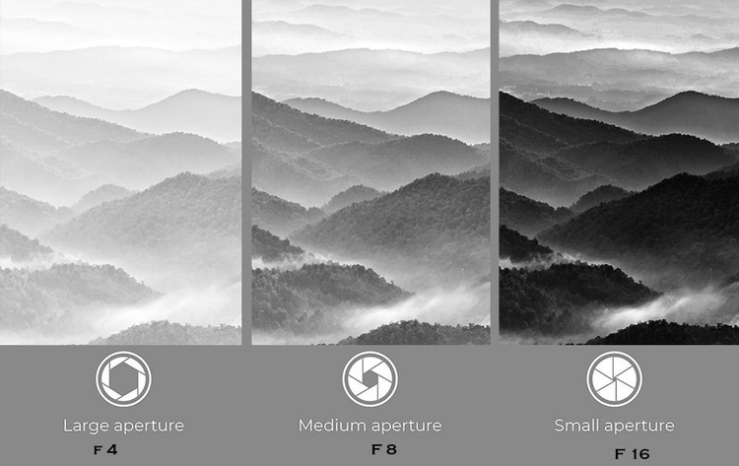Image contrast is set by the lens's aperture.
The depth of field can also be adjusted by changing the lens's aperture; using a wide aperture (such as F1.4, 1.8, or 2.8) will cause the background to be blurred and out of focus, while using a small aperture (such as F8, F12, F16, etc.) will bring the majority of the frame into sharp focus.
Here's an example showing how higher aperture can be used to generate a shallow depth of field while photographing the finer details of a single blossom. It quiets down the environment so that one can concentrate on what's being spoken.
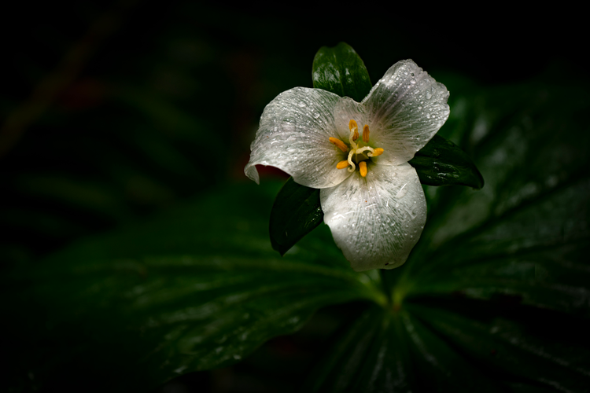Shallow depth of field created by use of aperture of F2.8.
ISO is the camera’s sensitivity to the available light
Without adjusting the shutter speed or aperture, increasing the ISO of a camera produces a brighter image. When the available light is insufficient to take a well-exposed shot, photographers often resort to a higher ISO. When photographing during the daytime under clear sky, an ISO of 100 is recommended, whereas at night or in low light, a higher ISO of 1,000-5,000 is recommended. When the ISO is raised, the image becomes noisier and grainier.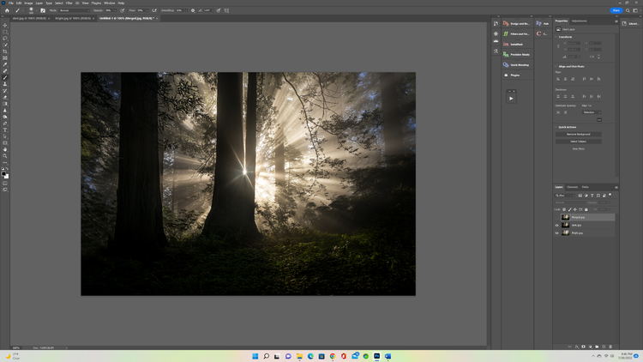
Sample 1: Underexposed for highlights.
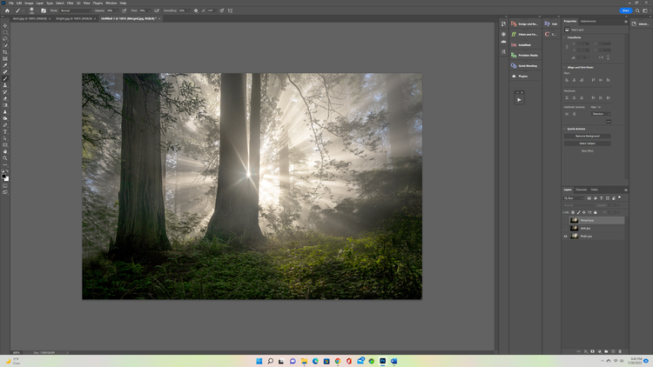
Sample 2: Overexposed for shadows.

FRAMING AND COMPOSITION TECHNIQUES

COMPOSITIONAL TECHNIQUES TO IMPROVE PICTURES AND VIDEOS
If one wants to get better at photography, he or she may need to spend some time getting to know the camera's settings and learning about things like aperture and shutter speed. But the truth is, the camera isn't as crucial as people think it is when it comes to photography or videography.
Composition is a great illustration of this, as knowing how to compose a shot will help take better pictures or shoot videos with any camera, from a professional DSLR or Mirrorless to a simple smartphone. And This is what I was taught during my internship at Atif Riaz Productions.
Although the rule of thirds is the most well-known method for composing images, there are many additional options available. Here are some ways to enhance photography and videography which I learned and practiced during my internship and it broadened my artistic horizons through composition.
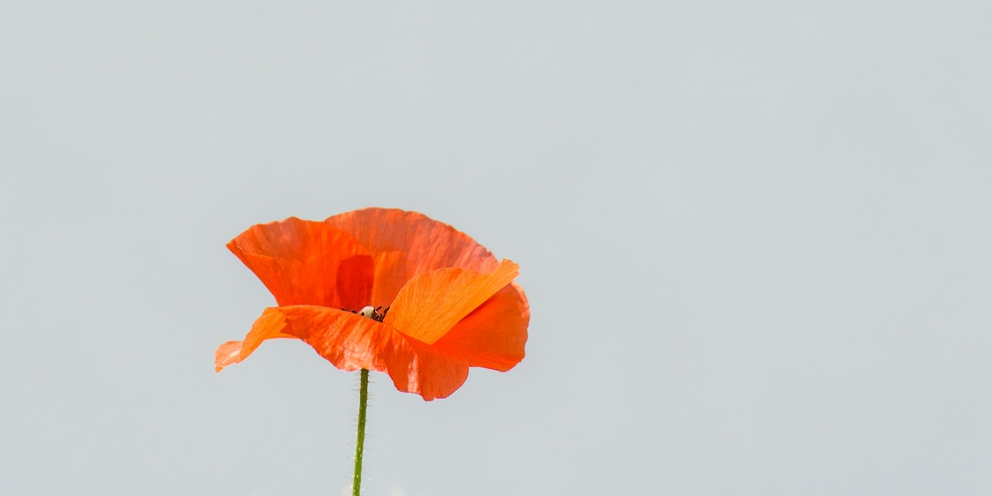
1. Framing
One common method of composition is to "frame" the subject with other components in the scene. This can assist tell a tale through the photograph while also highlighting the topic.
If one were to take a picture of the view from the bedroom window, but crop off the window frame and the rest of the room, the resulting image would look like any other landscape or cityscape picture. This is just a simple illustration, but the opportunities are vast. A doorway, a bookshelf, a mirror, or the branches of a tree or bush would all work similarly.
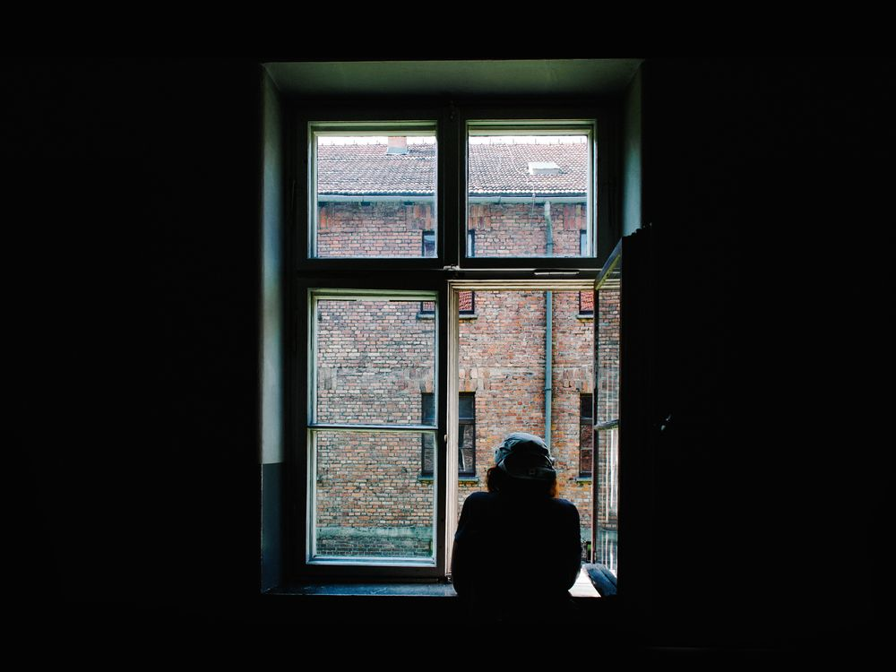
2. Leading lines
Lines are a wonderful method to create depth and move the viewer's eyes through an image while also drawing attention to the main subject of interest in the photograph.
A leading line might be straight, angled, slanted, or otherwise positioned. A window pane, a flight of stairs, or a lengthy table are all examples of leading lines that one might find in the own home. Take a second to survey the subject and look for interesting lines one may incorporate into the composition before one press the shutter. It might be anything from a pencil pointing to a certain phrase on the paper to a corridor with a partially open door.
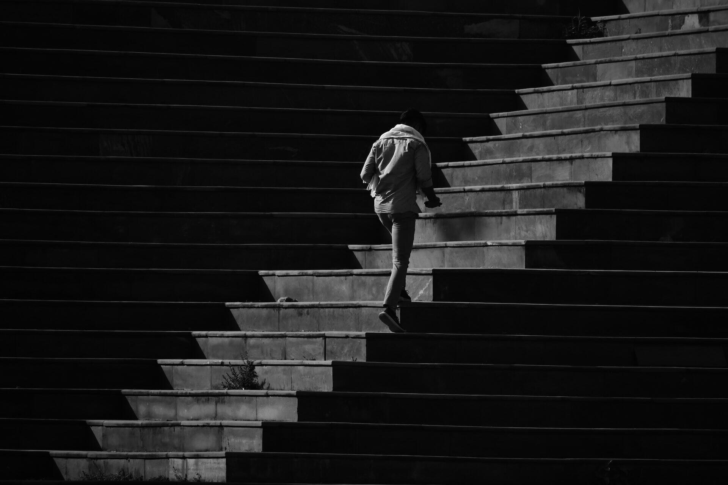
3. Symmetry
Humans have an innate preference for symmetry and balance, making symmetry a potent compositional tool. A still lake reflecting the surrounding scenery is an excellent illustration of this principle, as the two parts of the image are virtually indistinguishable from one another while being separated by the lake.
However, symmetry can be used in a variety of ways to improve visual appeal. One could take a picture of someone next to their reflection in a window or mirror, or one could cut an apple in half lengthwise and take pictures of both sides next to each other.
4. Negative space
When talking about photographs, "negative space" refers to the vacant parts that aren't filled in, such as the sky or a blank wall or lengthy expanse of floor. Whether one's going for a serene or mysterious vibe with the shot, leaving some empty space around the subject might help it stand out.
Even while leaving plenty of white space isn't always the best or only option, it's still useful to be familiar with it so one can use it effectively when the situation calls for it.
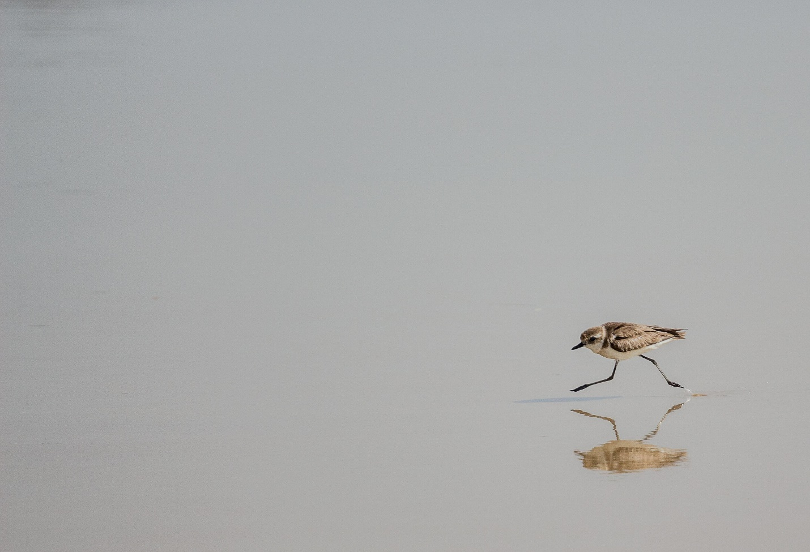
5. Fill the frame
To fill the frame, on the other hand, one must move in closer to the subject than when using negative space. When photographing in a busy or chaotic environment, such as a kitchen or living room, this method can be used to eliminate any potential distractions in the image.
It's also a terrific choice for portrait photography because it lets one get close to the subject without distracting from their eyes and other facial characteristics.
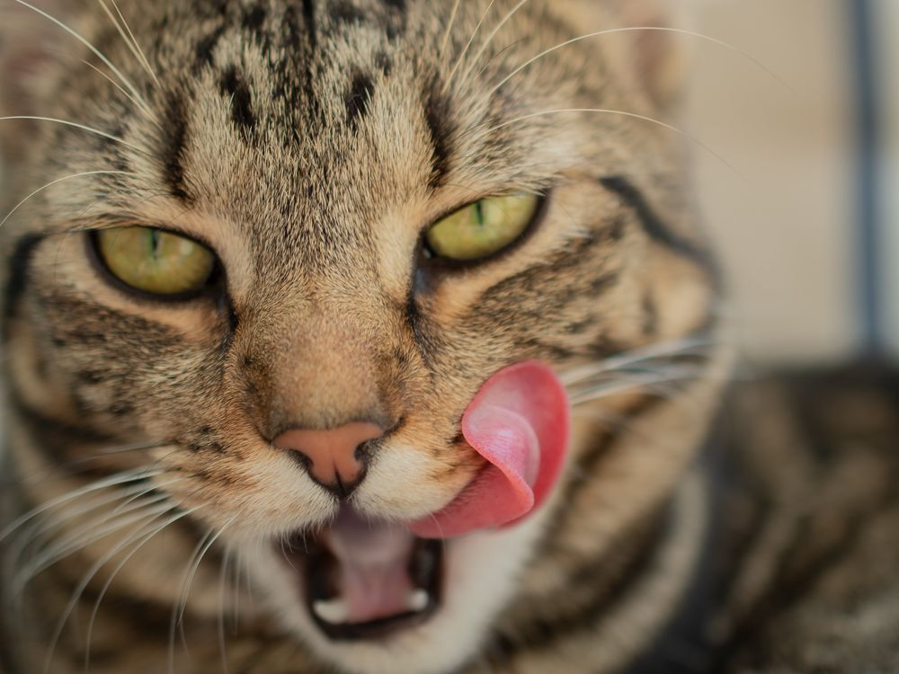
6. Use contrast
The employment of contrasting components in a photograph's composition can increase the image's visual impact. Tonal contrast and color contrast are the most prominent forms of contrast in photography, although texture and shape contrast can also be used to great effect.
In contrast, conceptual difference is idea-based and hence more open to individual interpretation. Combining seemingly disparate elements, such as the natural and the manmade, into a single image is an example of this technique.

7. Use repetition and pattern
In the hands of a skilled photographer, even the most ordinary of everyday scenes or things may become works of art through the use of patterns and repetition.
Patterns and repetition are everywhere, but we rarely pay attention to them. But even something as seemingly mundane as a series of identical chimneys on a row of houses or the rungs of a ladder can be quite beautiful when captured from just the right angle. Typical examples of domestic patterning are exposed brickwork and tiled kitchen backsplashes. As, our eyes are drawn to what is missing or seems out of place when a pattern isn't flawless, breaking the pattern can also have a very dramatic effect.
8. Depth of field
An ordinary snapshot can be transformed into a work of art by experimenting with depth of field. By manipulating depth of field, one may delineate foreground and background elements and direct the viewer's attention.
When photographing a person in a busy or disorganized setting, for instance, a shallow depth of field lets one isolate the subject while blurring the background. But if one wants to highlight the chaos in the photo's setting, a shallower depth of field is the way to go.

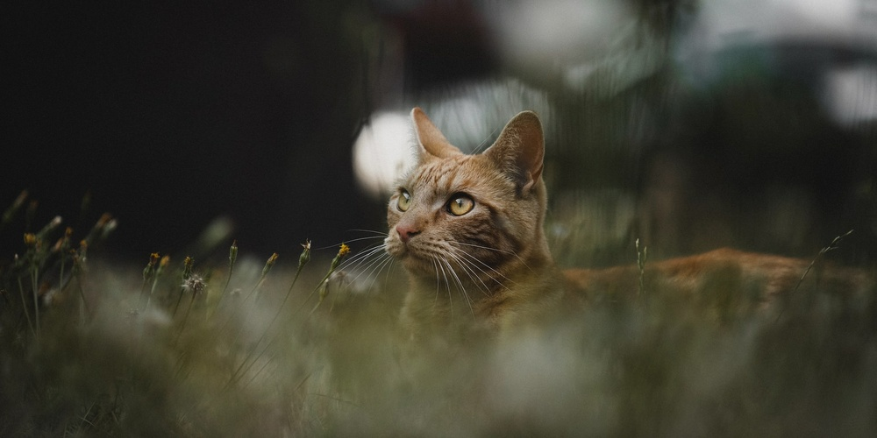
9. Use shadows
Photographers can use shadows in a variety of ways, including to increase the depth, texture, and contrast in their images. They can also be used to emphasize certain features of a photograph or to increase the sense of drama or mystery in a shot.
Learn to observe a scene for a few seconds before snapping a photo if one wants to incorporate shadows into the composition. Consider the source of the illumination and how one might best exploit it. One example would be a person sitting nearby whose clothing displays unique patterns due to the sunlight streaming in through open shutters. Perhaps silhouettes would look great in the harsh light pouring in through the window.
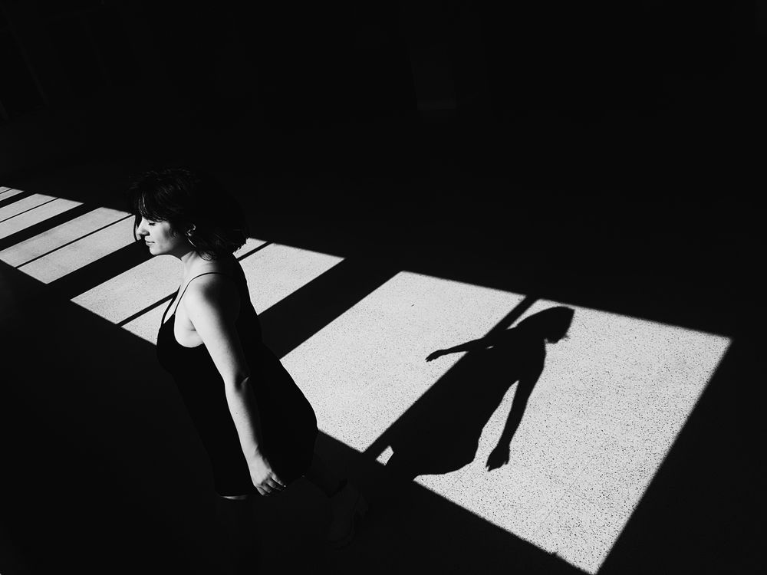
10. Blend Together
Once mastered these compositional methods to the satisfaction, one might start seeing multiple narrative threads in a single setting. One shot could, for instance, feature all three elements of contrast, depth of field, and symmetry.
There is no one correct technique to construct a photograph; all that matters is that the photographer gave some thought to the composition and attempted to generate visually appealing photos. Having five separate photographers capture the same sight will likely yield five quite distinct photographs, as each photographer will focus on different details. If one wants to take the photography to the next level, one shouldn't be scared to experiment with different compositional strategies.

SHOTS, CAMERA ANGLES, AND MOVEMENTS
Being creative takes effort since one must always seek new methods of realizing the visions. Although creative thinking is crucial, one'll also need reliable methods for bringing the ideas to life. There are few things more disappointing than failing to achieve the goals. One should get good at the fundamentals before one set the sights on attracting millions of internet visits or making an Oscar-worthy picture.

The scene's interpretation is profoundly affected by the photographer's technique. Everything matters in a video, from how one frame the subject to how far away they are, from what angle one sees them, to the movement that shows their actions. If one doesn’t manage these factors, one can end up with unusable film, or even worse, a gorgeous video that portrays a tale one didn't want. If someone is new to video production or just want to brush up on the abilities, this compilation of different shots, camera angles, and movements will be invaluable.
01. Establishing shot
At the outset of a scene, a wide shot is utilized to set the scene. It's there to set the stage for everything that follows. Aerial views are typically used for these kinds of landscapes since they provide an unrivaled perspective.
02. Long shot
A long shot gives the viewer a panoramic perspective of the scene. This style of image is frequently used to introduce the setting. Perspective is provided by the subject's relationship to the surrounding space.
The complete shot is a medium-to-close-range alternative to the long shot. The topic occupies the entire frame in a full shot. This depicts the individual in their natural environment while yet capturing their likeness.
03. Medium shot
The medium shot captures the subject from the waist up and is used to provide additional information about them. It's the most comprehensive technique to record an action while still keeping the big picture in mind, as it takes into account the subject's hands and some of the surrounding space. For this reason, the medium shot is frequently used.
This shot can be performed in two basic variations: the medium long shot and the cowboy shot. In between the long shot and the medium shot is the medium long shot. The picture is framed at the thighs up. The cowboy shot, in which the frame is sliced in half at the thigh, was commonly utilized in westerns to highlight the fact that gun holsters were worn by the cowboys.
04. Medium close-up shot
The figure is in focus from the chest up in this medium close-up. It's commonly utilized to get a good likeness of a person's face while yet having them appear natural in their environment. To maintain some emotional distance between the individuals, medium close-up views are used during dialogues.
05. Close-up shot

To emphasize the expressions on the subject's face, a camera moves in close. These close-ups help the viewer relate to the subject since they focus entirely on the individual's facial expressions and body language.
06. Extreme close-up shot
The entire frame of an extreme close-up is devoted to a single detail of the subject. It's a tool for drawing attention to something specific. The most common application of this picture is to record a key movement of a character's eyes, mouth, or fingers.
07. Two Shot
When there are two or more people in the frame, we call it a two shot. They need not be in close proximity to one another or be treated equally. It is common practice to place one subject in the foreground of a two shot and the other in the background.
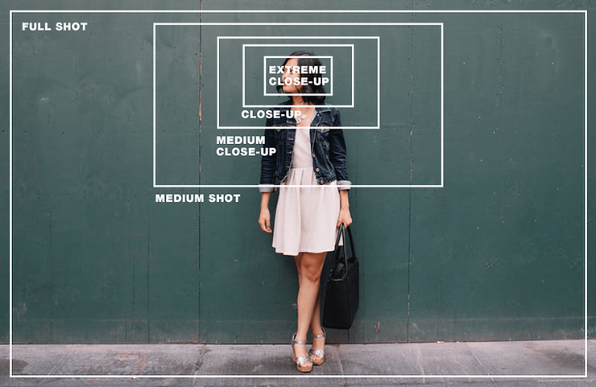
08. Bird’s-eye view
A bird's-eye view is a form of photograph that is taken from a great height. Its very name suggests that the view it provides is analogous to that of a bird in flight, and that is indeed the case. This perspective was used to emphasize the scope and velocity of the action.
The widespread availability of drones has opened up previously inaccessible filmmaking opportunities to filmmakers of all skill levels.
09. High angle
When shooting from above, the camera is pointed straight down at the subject. This renders the person weak and defenseless in the eyes of the audience. The camera position in this style of image can range from immediately overhead to just above the subject's eye level.
10. Eye level
The most natural camera position is at eye level. When one takes the picture, try to keep the eyes level with the subject. This camera position can help the viewer relate to the subject since it more closely resembles the way they actually experience the world.
11. Low angle
When shooting from below the subject's eye line, the camera points upwards to capture a low angle shot. The topic comes across as dominant and overpowering when shot from this vantage point. Since it's not a typical viewpoint, this perspective can distort the image in close-up pictures. This is why broader frames, such as medium or medium close-up images, are typically photographed from a low perspective.
12. Worm’s-eye view
The worm's-eye perspective is a low, underneath-the-surface viewpoint. It is frequently employed to put into context tall objects in a scene, like as trees or skyscrapers. This sort of photograph or video is typically taken from within the viewpoint of the subject.
13. Over the shoulder (OTT)
The topic is framed above the shoulder of another person. The secondary character's head and shoulder will typically be in the frame. Since this shot keeps both individuals in frame while zeroing in on one, it is frequently employed during dialogues.
14. Point of view (POV)
A point-of-view image reveals the subject's line of vision. Particular incidents or acts are emphasized, such as being threatened or observing one's own reflection. A viewer can feel what it's like to be the subject of this shot. Therefore, it deepens their involvement with the story and the setting.

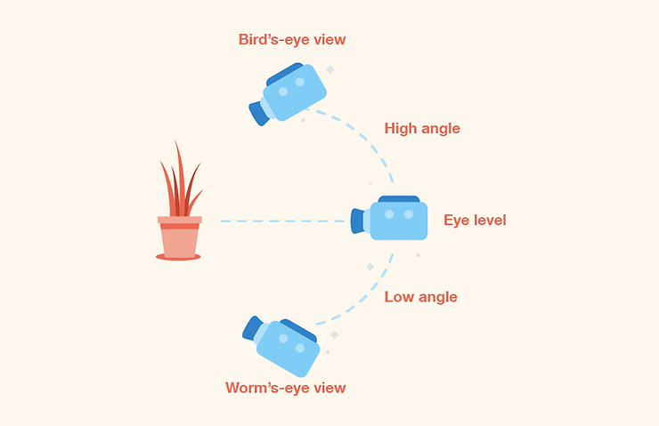

15. Pan
When panning, one moves the camera horizontally along a stationary axis. During a pan shot, the camera moves horizontally rather than vertically. This camera angle is frequently employed to track an action or provide context for the scene's location.
16. Tilt
Filmmakers use a technique called "tilting" to move the camera vertically on a stationary base. It's common practice to utilize this technique when introducing new characters or associating an action with a certain actor. Tilt shots can provide a panoramic perspective of the setting in which a character is situated.
17. Dolly
In a dolly shot, the camera is mounted on a rolling platform and panned back and forth fluidly. A camera dolly is the term for the actual device. Dolly shots typically follow a subject as they move about the scene, either before or after the subject.
18. Truck
When the camera is mounted on a truck and moved down a horizontal track, the resulting shots are known as "truck shots." The purpose of these shots is usually to follow the action or to show the spectator the laonet of a scene. The viewer is given the impression that they, together with the camera, are traversing the scene.
19. Pedestal
To achieve a pedestal shot, the camera is moved vertically while remaining stationary. These adjustments allow for a shift in the audience's sigh level while keeping the viewing angle constant. Since the camera is not fixed in one place, the focus shifts throughout the entire frame, gradually revealing previously unseen elements.
20. Roll
The camera is rolled along its vertical axis during a roll camera action. In these photographs, the camera remains fixed on a single subject throughout the shot. As a result, the video is rotated by 180 degrees. This is a frequent technique used to convey motion sickness or dizziness in action situations.
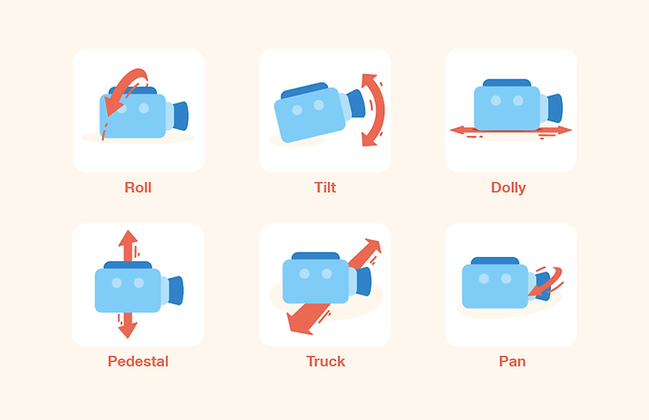

POST-PRODUCTION

PHOTOSHOP
A lot of work can be done in Photoshop. It can be scary at times. I had no idea how simple it would be to make it function until I was shown how.
Training and practical experience are provided during the internship. Education about this crucial piece of photo editing software was bolstered via trainings.
What I picked up included: • Retouching tools • Digital picture file management • Photoshop retouching • Using the burn and dodge tools • Retouching photography techniques for product, fashion, beauty, wedding, and landscape photographs • Integrating Photoshop and Lightroom • Make selections set.
Knowing where to start
When importing a render into Photoshop for further editing, one may find the self at a loss on where to begin. As far as my own process goes, knowing the specific purpose of each pass is crucial.
After stacking the passes until they are all the same, I use the toggle switches to examine the image with and without the beauty pass. When one has a firm grasp on how these factors interact, one'll be more equipped to spot problematic regions of an image (those that are too dark, too bright, too shiny, etc.).
Is my image too bright or too dark?
Using a curves adjustment level is a quick technique to check if the image has any spots that are too far into the black or white spectrum. To check for regions that extend beyond white, move the histogram's bottom point to the right. In contrast, anything beyond the black area can be seen by dragging the top point of the graph to the left. Adding adjustment layers to the render passes can potentially save the image if one discovers that it has portions that go beyond these clipping points
Editing in small steps
Beginning with minor adjustments to the render passes (lighting, refraction, specular, reflection) is a good idea because Photoshop is a precision tool. The next step is to make localized color alterations, after which one can move on to making global changes to the image.
Blend, don’t just mask
It's helpful to know how to use the WireColor pass and the Wand tool to choose areas of a picture for use as masks, but sometimes it isn't enough. These masks need to be blended in for the final image to look more realistic. Use either the Black Brush or Gradient tools to do this. The edits will blend more seamlessly into the picture if one does this.
Paint volumetric lights
there are instances when it's easier to simply paint something in than to simulate it. However, this must be done delicately and in layers for it to be credible. If it works, I enjoy painting in volumetric lighting to a scene. In this particular illustration, I began at the farthest window and worked my way closer to the camera. In this way, I was able to direct the flow of each 'light' into the room. These volumetric lights are just feathery forms with an Overlay opacity of around 20%, as shown in the image
Separate the background

Trying to incorporate the background into a studio render is a regular problem I see artists run across. This method can be effective, but it's far quicker to use Photoshop to make a custom background. One can remove the background and isolate the car by using a WireColor or an Alpha channel. Then, one can modify the setting based on what one learns about the lighting and shadows.
Why one should stack render passes
One can adjust the look of the image by making adjustments to the colors, but the actual render won't shift. If the render passes are properly layered, one can use them again to improve certain regions.
Top adjustments
To have an overall impact on the image, adjustment layers need to be at the very top of the layer stack. Alter the image's overall lighting with these final adjustments.

LIGHTROOM
Lightroom is a powerful photo editing program that is also incredibly user-friendly. The photographs one capture will look very different after one play about with the color wheels. The ideal level of subtly would be achieved. However, Color Grading can add character to photos in the same way that dramatic toning does. Lightroom’s adjustment of colors is one of its most useful features. That's what gives the picture its vibe.
Color Grading in Lightroom
Image coloration can be altered in numerous ways. Color Correction in Lightroom can eliminate glare around objects. White balance modifies the warmth or coolness of a picture. Colors can also be adjusted individually using the HSL/Color panel. A more purple or orange version of blue or red. Lightroom's many color-fixing functions affect the entire image. Color grading is a photography process in which various hues are added digitally. Shadows might be shaded in one color while highlights hint at a different one. Many of the Lightroom presets for color grading evoke very specific feelings.
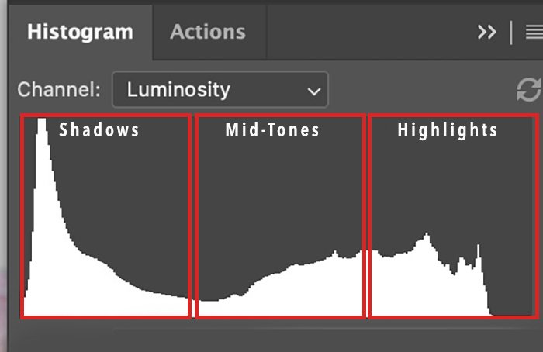
Color grading individual tints in shadows, midtones, and highlights
It's common practice to use yellow for highlights and blue for shadows. On the color wheel, blue and yellow are opposite each other. The color scheme works.
The colors yellow, orange, and red predominate in the light of sunrises and sunsets. The adjacent hues have a lot in common with one another. They're also a great pair. Color Grading will allow us to highlight certain tones. can increase the yellow in the highlights, the orange in the midtones, and the red in the shadows. To bring out the hues, we need not add anything.
Using the HSL/Color panel is helpful if one wants to change the hue, saturation, and lightness of a certain color in the image. Light can be adjusted in hue with the Color Grading filter.
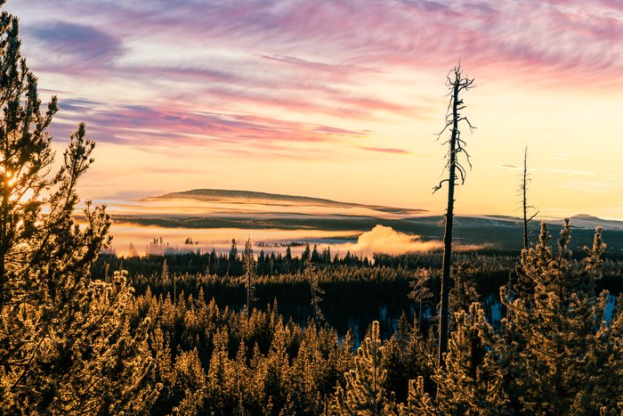
Lightroom's Color Grading Guide
Let's begin with an introduction to Lightroom's Color Grading filter. Once we have that, we can use it to color in a picture.
First, access the Color Grading Panel.
Lightroom CC, Lightroom Classic, and Adobe Camera Raw (ACR) all share the same Color Grading feature.
Lightroom CC's Color Grading tool may be found in the Color panel, while in Lightroom Classic it can be found in the Develop module's HSL/Color panel.
• The Color Mixer in ACR is where Color Grading can be found.
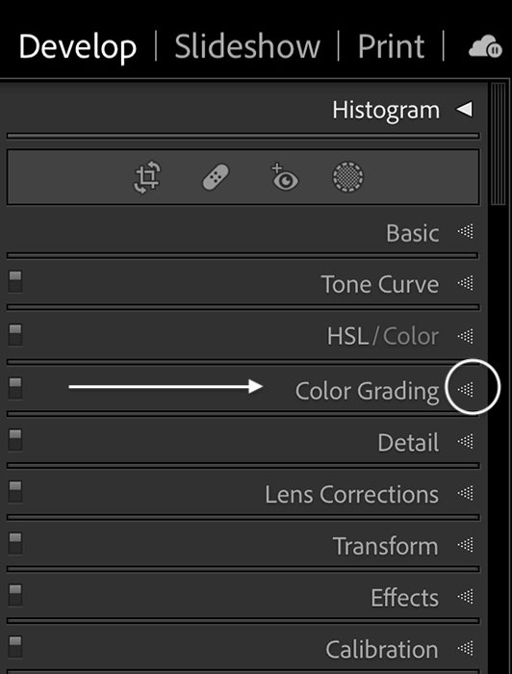
Lightroom Classic Color Grading in the Develop module under HSL/Color
Color Grading Panel
There are a total of five spherical icons at the top of the Color Grading window, in addition to three primary color wheels and a few sliders.
Using the tabs along the top, one can customize individual color wheels. The three icons represent shadows, midtones, and highlights, moving from left to right. In addition, a global color wheel can be selected. The expanded palette allows for more exact color selection.
The shade of the shadows, midtones, and highlights can be adjusted independently using the color wheels down below. Intensity can be adjusted with sliders located directly below the color wheels. Toggle color grading on and off with the eye button. This allows one to observe the effect on the appearance. The Blending and Balance sliders determine the relative strengths of the three brightness levels.
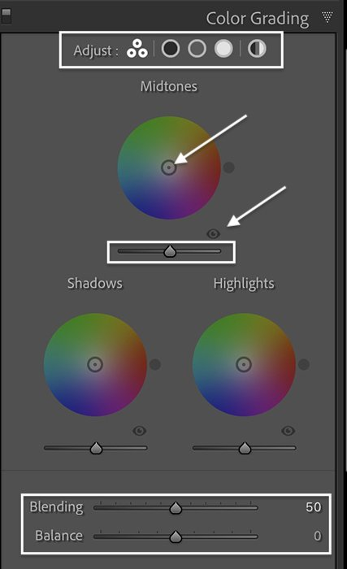
Step 2. Choose a Color Grade
One can choose any colors one wants to tone the image. For this sunrise, I used color grading to emphasize the tones already in the scene. I made the sun rays warmer by adding yellow and cooled down the forest shadows with a little blue. I added a little more pink to the clouds and brought the color into the foreground by adding it to the midtones. The subtle changes make the tones pop.
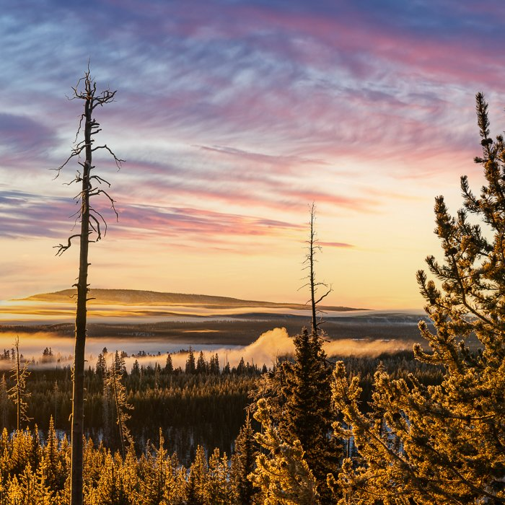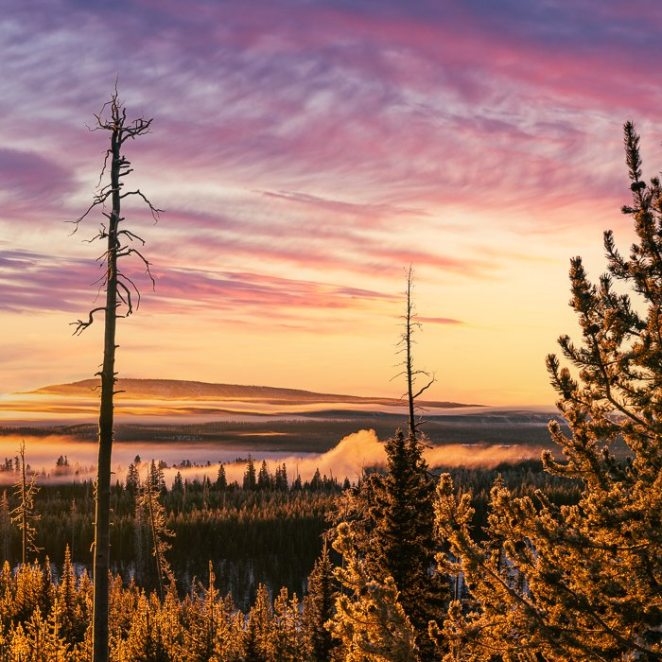
Setting Colors
Grasp the center circle to select a color from the wheel. Pull it close to the side. The hue becomes more intense as one moves further from the center.
Colors will shift as the target is moved around the wheel. The color chosen will be shown by a dot that appears just beyond the wheel. The hue can be reset by double-clicking the wheel's center.
This is a fast-moving, highly-sensitive target. To slow it down, press and hold the Option key (the Alt key on a PC). Colors can also be selected with sliders. To use a specific color wheel, select it by clicking on its symbol in the panel's header. To access the Hue and Saturation controls, select the triangle.
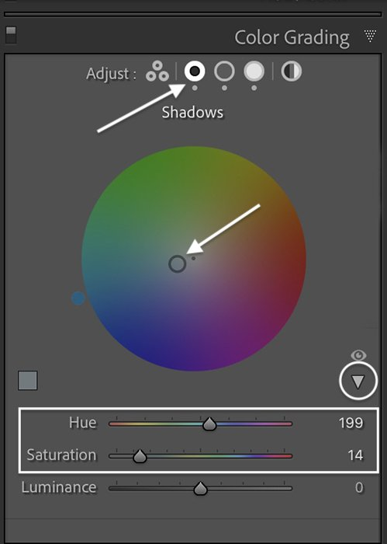
Hold the Shift key to change only the saturation. The Command key (Ctrl on a PC) locks onto saturation to let one change only the hue.
Keep Shift pressed to affect solely the color intensity. To restrict the color editing to just the hue by pressing Command (Ctrl on a PC), the saturation will be locked.
To better observe the color, try shifting the target to the rim of the wheel. Once, settled on a shade, move the target closer to the center to dull the effect. Subtly adjusting the colors can have a big impact.
In selecting colors for the image, one can be as exact as possible by applying principles of color theory. One can also rely on the eyesight alone.
Step 3. Adjust Luminance Sliders
After settling on a color, one can tweak its brightness using the corresponding controls under the wheels. Color Grading's radiance controls are brand new.
The luminance control emphasizes or downplays tones in the chosen brightness range. The brightest highlights, for instance, can be made brighter by sliding the bar to the right under the Highlights wheel. The brightest parts can be made darker by sliding the bar to the left. Highlights are unaffected by the Luminance slider located under the Tone Wheel. The color is weakened after being lightened.
The color scheme of these two pictures is identical. I increased the contrast between light and dark areas in the image on the right. But this is not the end. More options exist to tweak the appearance...
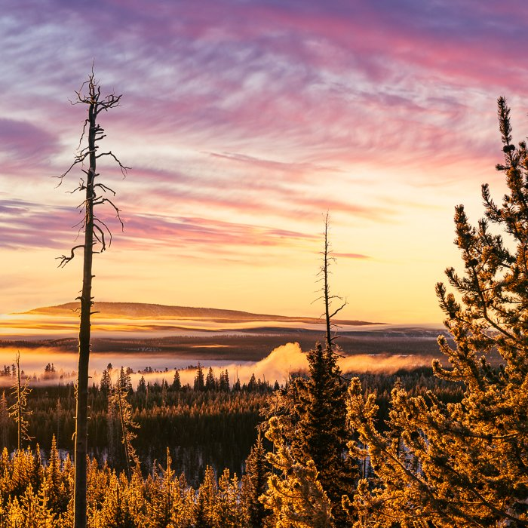
Step 4. Adjust the Blending Slider
By blending, one can modify the smoothness or sharpness of the color transitions. The default setting of the slider is 50. The distinctions between the various tonalities are not always clear-cut.
The slider's rightward movement results in a more subtle color transition. As a result, a wider spectrum of light is attracted to the colors. Drag the slider to the left to lessen the mix effect.
To illustrate the shift, below is an extreme case. The original is shown on the left. I used 100% blue saturation in the shadows and 100% yellow in the highlights when I color graded the image on the right. The settings I used were Blending 50 and Balance 0.
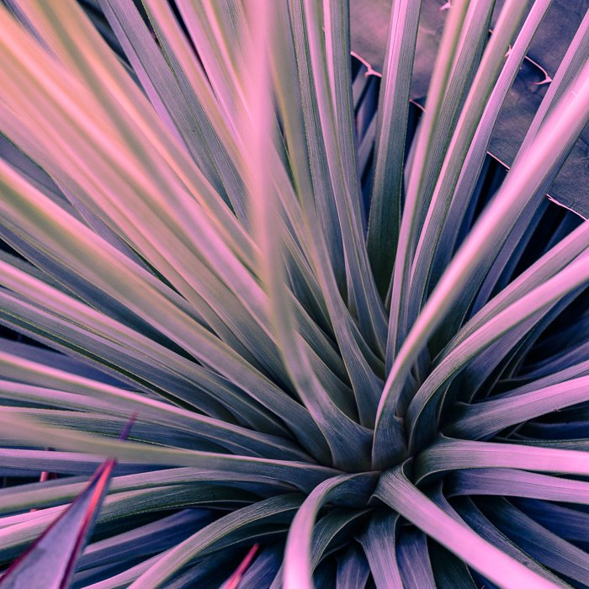

The time has come to adjust the Blending slider. The tonal balance is unaltered. To bring up the colors more clearly in the first picture, I set the Blending slider to 0. In the second, I bumped up the color overlap by setting the slider to 100. Take note of the purple that results when blue and red are mixed.

Step 5. Adjust the Balance Slider
The Balance slider modifies how light and dark areas are distributed throughout the picture. To emphasize high points, shift the slider to its rightmost position. The hue one chooses in the Highlights wheel is applied to a larger number of pixels. To have more pixels be considered shadows, shift the slider to the left.
For the first picture, I set the balance to -100. The blue hue of the shadows spreads to more tones. The second one has more pixel highlights because I cranked the slider to +100.
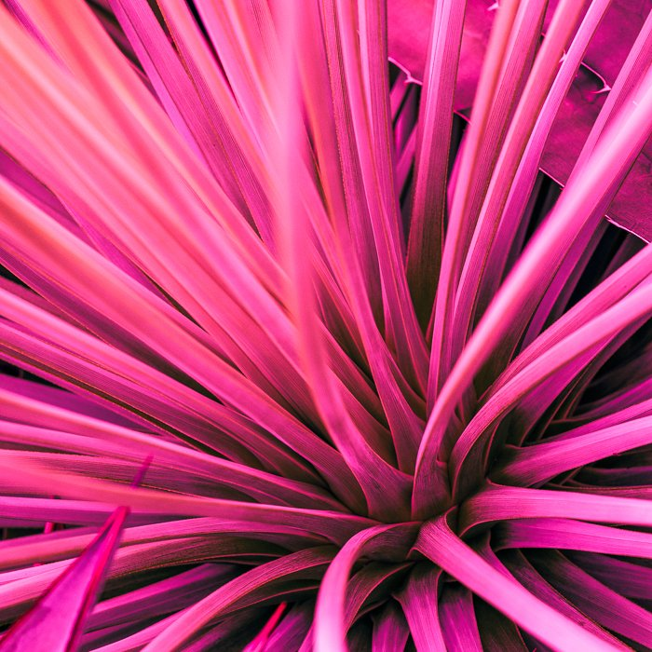
Step 6. Adjust Global Color Grading
Isolating the color wheels is done with the icons along the top of the Color Grading screen. One more, though. Global color grading can be accessed via the symbol on the far right. One can use this to give the entire image a tinge of color. To give a black and white photo a vintage feel, for example, one may use a sepia filter.
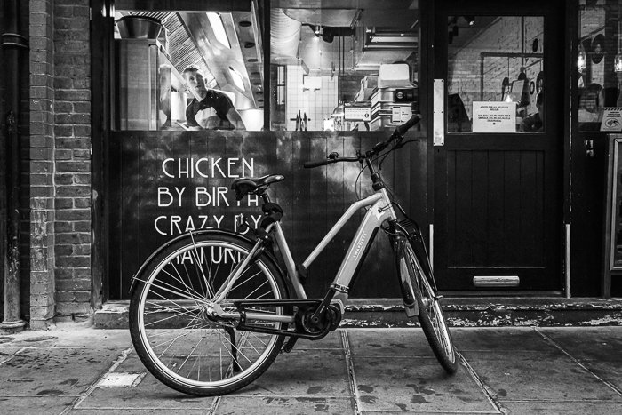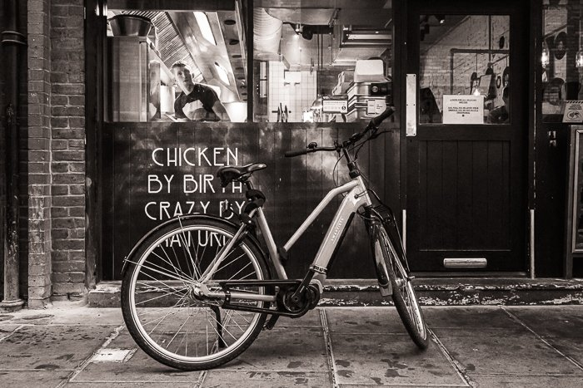

PREMIERE PRO

1. Change playback resolution
Altering the video's playback resolution is only one of the many tricks one may learn with Premiere Pro. The "Select Playback Resolution" box can be found in the "Program Monitor" menu. HD video offers the "1/2" and "1/4" options, while 4K and higher offers the "1/8" and "1/6" options. One shouldn't choose anything lower than "1/4" if the video resolution is 1080p. The load on the system can be reduced by lowering the preview quality.
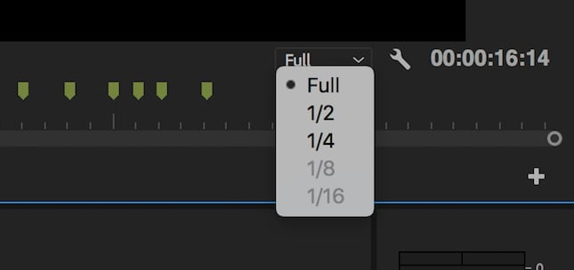
2. Remember to use proxy
Since I have been using premiere pro for a while now and I used to encounter rendering issues while previewing the videos but following this tip almost solved my problem 100 percent, I've got another Premiere Pro tip during my internship. This suggests that employing proxy is an effective method for achieving a more fluid editing and rendering process for the video. One can boost the computer's performance by temporarily lowering the video quality when one creates proxies. The same high standard will be maintained during the final rendering of the footage.
Select "Proxy" > "Create Proxies" from the context menu that appears after right-clicking the video to set the proxy's file format and storage location. Select "OK" after selecting "GoPro Cineform" or "Apple ProRes" as the output format. Launching "Adobe Media Encoder" will now convert the files to editable proxy files. Then one'll want to include a toggle switch for proxies. One can access the "Program Monitor Toolbar" by clicking the button located underneath the video player.
To move the "Toggle Proxies" button, go to the "Button Editor" and then drop it where one'd like it to appear. Please close the Button Editor. When one presses the Proxy button from now on, it will glow blue. The original media can be reused if a repressing is performed.
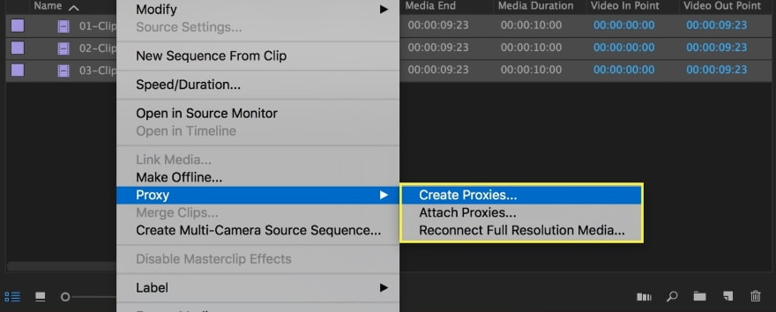
3. Use shortcuts
The truth is, hardly nobody dislikes quick cuts. Not really short cuts, but everyone appreciates a quick turnaround time, especially when editing. If one's familiar with Premiere Pro's keyboard shortcuts, can swiftly apply effects, make edits, and more. Go to "Premiere Pro CC" and then "Keyboard Shortcuts" to implement this Premiere Pro hint. A virtual keyboard will appear, and one can study its shortcuts there.
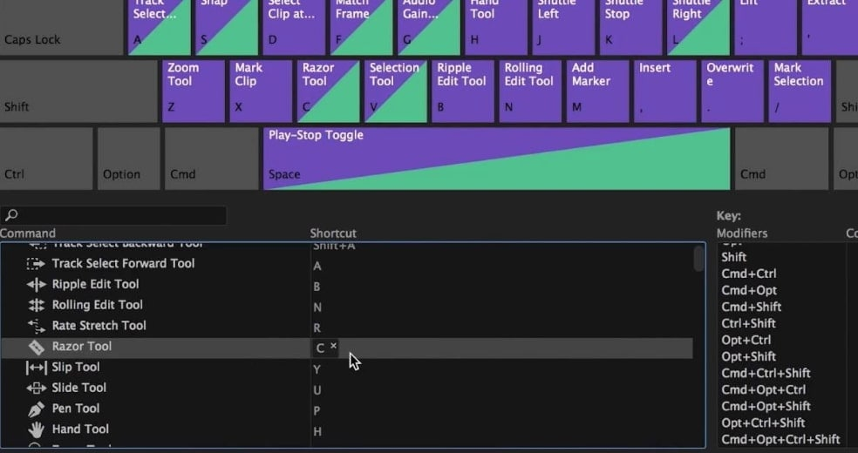
4. Enable Ripple Sequence Markers
For me as an editor the next piece of Premiere Pro advice is to make use of the sequence marker (accessed via the letter M) in order to keep track of what edits need to be made and for how long. Nonetheless, make sure that Ripple sequence markers are turned on. If one drags the clips in the timeline to sync up with the markers, the markers will change locations.
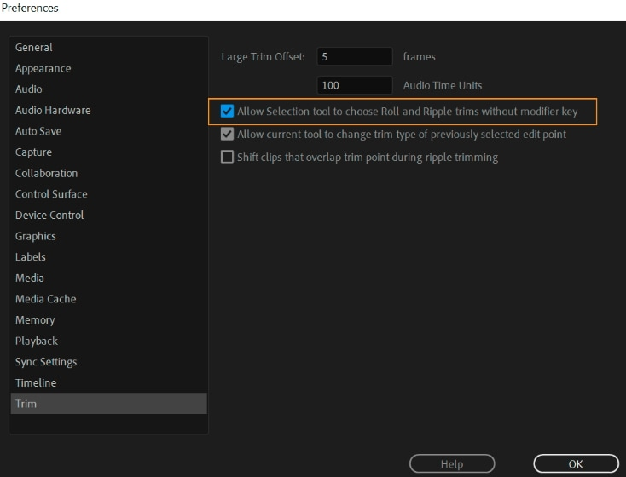
5. Use Voiceover wisely
A video is missing something crucial without a voiceover. A voice-over will be used in the video. Sometimes the ideal take of that voice-over hasn't been recorded yet. While one wait, try recording a voiceover demo right on top of the Timeline to pass the time. In the meantime, one can get through the clip editing (trim, crop, etc.) with the help of a sample voice over.
Putting a voiceover on a video is a simple process. To do this, select "Settings" from the "Timeline" menu and then edit the audio track headers to include a "Voice-over Record" button. All that's left to do now is press the Voice-over Record button.
6. Synchronize Audio
Using an external recorder and transferring the audio file frame by frame, synching the audio and video can be a real pain. This Premiere Pro trick, which h I got to know recently during working on a project is a gamechanger, it will allow one to quickly and easily sync the audio track. Just right-click on the audio files one wants to sync, and choose them. Tick the "Synchronize" box. Choose "Audio" from the drop-down menu, and the software will take care of the rest.
7. Lag
Everyone hates it when video is slow. When one adds plugins to the system, it can use up system memory and slow things down. However, there is a workaround in Premiere Pro that might help. Simply keep the "RAM reserved for other applications" setting at its minimum by clicking "Edit," "Preferences," and "Memory." The lag time will decrease as a result of this. One can use the advice to eliminate the sluggishness.
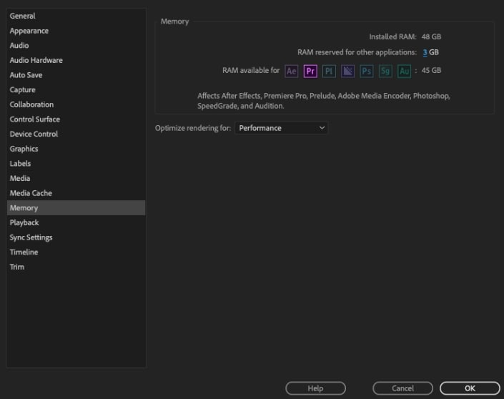
8. Use Adjustment Layers
There's no harm in giving the footage a cinematic vibe. If one wants the video to seem better, use this Premiere Pro trick instead of simply using "Lumetri Color" for color grading. The LUT packs offer a variety of options, including free and low-cost bundles. The more advanced pack known as Magic Bullet Looks can be used to achieve a more polished end result. One may now set up the adjustment layer and change the opacity to the liking.
9. Dynamic Trimming
Occasionally, one'll need to make a few tweaks to the clips. Also, one need to give it the complete attention if one wants to trim precisely. This Premiere Pro tip will help one make clean edits. Frame-by-frame editing of videos is possible with dynamic cutting.
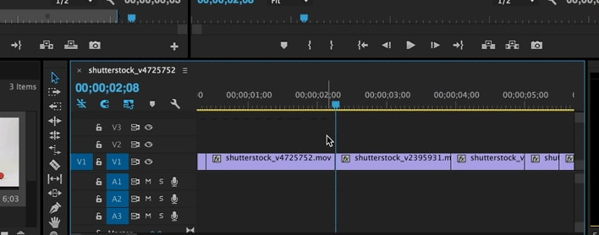
10. Use reverb to end audio track
Add some reverb to the footage for a more dramatic impact. Pick the video that needs the change made. Add a new series of black video and nest it (by right-clicking). The reverb effect can now be implemented.
11. Set In and Out Points
Setting the in and out points of a video in Premiere Pro is a breeze, and it doesn't require the time-consuming, standard procedures (import, trim start and finish point to get the final in and out clip). In addition, when watching a preview of the shots in Source Monitor, one can place IN and OUT markers.
Using this method, Premiere Pro can cut the editing time in half. One can finish the clip by simply noting where it begins and ends. Furthermore, the video is not removed. Instead, only the portion of the clip that falls between the beginning and end points will be shown.
12. Use Ripple Edit
Ripple Edit Tool in Premiere Pro is a useful instrument for automatically closing the gap after trimming the clip. Cutting, deleting, and rearranging the clip to fill the void is standard procedure when trimming a video. The time-consuming process of moving the clip to enlarge or reduce it can be avoided with the help of the Ripple Edit tool (keyboard shortcut B). After that, the software will automatically import the other clips and complete the sequence.
13. Edit While Exporting
The video cannot be edited during the export process. To accomplish this, use this Premiere Pro tip. Just add the exporters to Adobe Media Encoder's queue. This advice has also been widely discussed on the website Quora. The Media Encoder will handle the exporting while one concentrate on editing in Premiere Pro.

ADOBE AUDITION
TIPS and Methods to Clean up Audio in Adobe Audition

There will always be some flaws in the sound throughout production. One can fix it up in Adobe Audition with these suggestions instead of throwing it away.
There will always be problems in the recording, no matter how skilled the audio crew. These things are inevitable. Don't immediately jump to ADR if one has audio problems; it's possible that the existing recordings can be fixed.
I've compiled a list of things to keep in mind when editing audio in Adobe Audition which I learned recently during my internship where we shot a documentary and we had to face severe audio issues due to wind and other inevitable factors.
1. Fix Distorted Audio
Occasionally, it's not until post-production that one realizes the field recorder was set too high. This is an issue that regularly arises in documentary filmmaking, especially when only one individual is involved in the production. When the temperature of the audio system gets too high, distortion is inevitable. It's repairable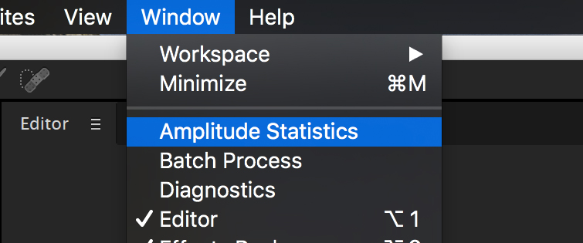
Simply double-clicking the audio track will take one to its Waveform.
Next, select Window > Amplitude Statistics from the menu bar.
Third, a new tab will pop up. The Scan button can be found in the menu's bottom left corner.
After the scan is complete, go to the section labelled "Possibly clipped samples. Select the number, and then click the diamond-shaped node that appears. Wherever one click, the audio will clip.

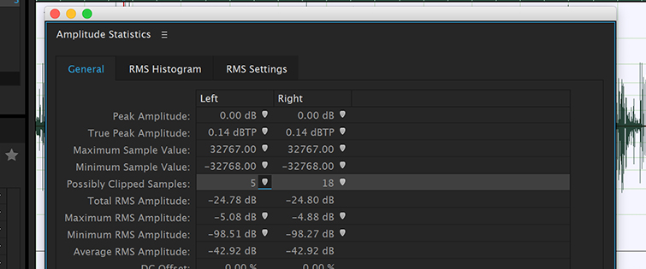

2. Use the Spectral Frequency Display
Has one ever been recording on location when one had issues with the audio due to secondary interference? Perhaps a cough was heard on set, or a phone rang. Perhaps a jet passed by overhead. The Spectral Frequency Display can help one eliminate unwanted sounds like these from the recordings.
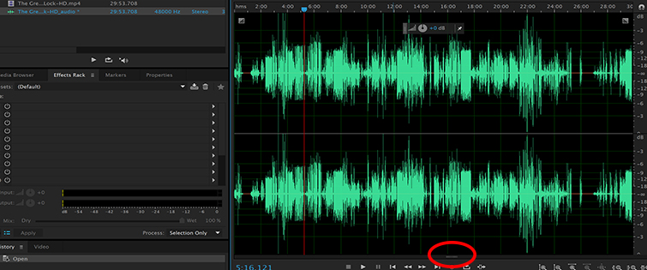
Double-clicking the Waveform icon in the Files panel will launch the audio editor.
To find the Waveform, look towards the bottom of the Editor Panel after opening the Waveform.
A partition separates the space. One may access the Spectral Frequency Display by clicking and holding the divider.
One may now use this visual guide to pinpoint the distracting sounds and eliminate them.
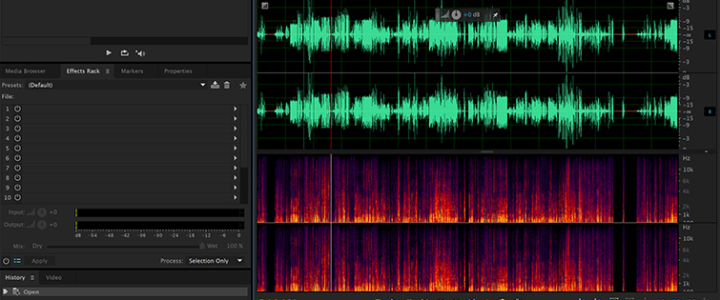
3. Use Adaptive Noise Reduction
The Adaptive Noise Reduction effect is another tool one may use to clean up the audio. This effect is excellent in cancelling out wind noise and other forms of background noise. The Multitrack Editor makes it easy to apply this effect in real time. How to activate the Adaptive Noise Reduction feature is detailed below.

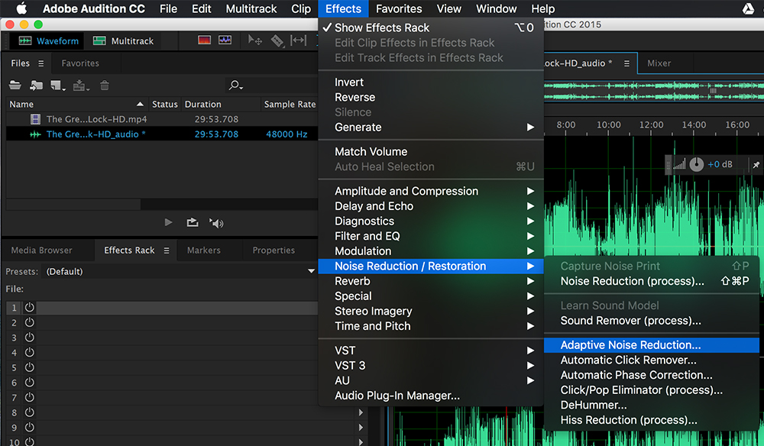
Double-click the audio file in the Files panel to activate the Waveform.
Next, choose an effect for the Waveform by clicking the Effects Rack or the Effects Top Menu.
Third, select Adaptive Noise Reduction under the Noise Reduction/Restoration menu.
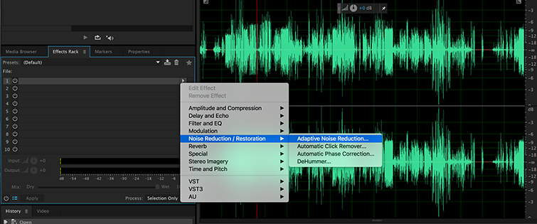
4. Cut the Echo
It's also possible that the audio will suffer from echo. It's common when shooting in an area with plenty of shiny surfaces. Concrete, tile, brick, and metal are all examples of surfaces that will reflect and bounce sound, creating an unpleasant reverberation.

Unfortunately, there aren't any well-polished effects in Audition that can deal with this kind of thing. There are two excellent plugins which we used to use in the studio during my internship and they are very handy while dealing with such situation. Use: DeVerberate by Acon Digital and SPL De-Verb by Plugin Alliance.

DOCUMENTARY FILMING PROCESS
Documentary filmmaking encompasses all the necessary steps of a qualitative enquiry, including: Location (where to film, how to position the camera and microphone), Subject (who to film, obtaining consent via a consent form or media release form), and Collection (recording audio and video using equipment, designing protocols for interviews and observations during filming) are the three main components of a successful data collection strategy. There are six stages to the data analysis process: 4) reviewing and selecting video and audio clips during editing; 5) findings, discussion, and recommendations; 6) sharing results—disseminating the results via documentary film.
Camera setup
Determining whether or not to film outside or indoors is a crucial decision. When filming outside, it's important to think about how much illumination is needed and at what times of day one can get the best shots. When shooting in a local setting, it's often necessary to move production outside. The camera rig is the next factor to think about. Unless one need to cover more ground to highlight the context of the subject's immediate surroundings, using a tripod will assist one avoid having to move around too much. The researcher must also make a judgement on where to put the camera. Researchers can video from several perspectives, including directly at the participant with the camera, or from the side or above. The decision depends on the aesthetic preferences of the researcher and the subject matter of the study.
The camera's focus can be set manually or automatically. Initiating the Procedure

If one focusses the camera on something, that object will stay at the same distance from the lens. When filming fast-moving subjects, automatic focus comes extremely handy. It's really challenging to manually keep a subject in focus as they approach the lens. The camera's focus can be automatically readjusted using autofocus. The researchers can choose how to frame the photographs depending on personal taste and artistic considerations. When filming an interview, it's OK to crop the shot so that the subject's eyes take up roughly a third of the screen. In-classroom sessions, event observations, and group interactions can all benefit from being filmed from a variety of zoomed-in and out camera angles that capture the non-verbal expressions and emotions that assist convey the context and real-world settings.
Getting good sound is also crucial when shooting footage. In most cases, a clip-on microphone attached to a camera records the audio of an interview with a single subject. Classrooms, hallway conversations, and other events can all be recorded with the help of shotgun microphones.
Participant Recruitment
After explaining the study's goals and the documentary filmmaking technique, participants give their agreement to be videotaped. The Media Release form is used to get informed consent from participants over the age of 18, or from parents or legal guardians of minor participants, in the participant's native language. Given that video is typically more intrusive than still images or even audio recordings of interviews, it is crucial for the researcher to ensure that the participants are aware of and comfortable with being filmed.
Producing the Documentary Film
During the editing process of making a documentary, the footage is dissected and examined. Adobe Premiere Pro or Apple Final Cut Pro, two popular editing programs can be used to arrange and modify the footage. The researcher's aesthetic sensibilities and the requirement to present an authentic tale inform the decision of which clips to include in the final film, which is edited at the same time as the data analysis.
The analysis begins with a viewing of all raw video footage, followed by careful note-taking on what is observed in order to generate preliminary, high-level categories and associations. Analyzing the data (video) while it is being gathered allows researchers to see trends and hypotheses worth testing with additional participants in follow-up interviews. It's easier to select relevant film and zero in on interesting patterns and themes if one review the footage and look for themes right away. The video can be sorted into inductively created groups based on the actions and statements of the participants, as well as deductively based on the general topics that the study aims to understand.
As themes arise in the video, they are organized into distinct buckets.
Clips from the video material are taken that are relevant to a specific category, then placed in the appropriate containers. Video recordings of interviews, focus groups, discussions, and field notes are all stored in these containers. After meditating on and processing the message, the clips are looked at again and organized into a subsequence. The goals of the study, the theories guiding the research, and the researcher's own biases and positions all factor into the selection of topics for the subsequence. Videos from within a sequence are picked again to make a sequence of themes within themes. Next, the master sequence for the documentary is compiled by reviewing the series of small sub-sequences and choosing the final segments to be featured.
The clips were chosen because they depicted pivotal points in the investigation.
Clips within each subject are chosen for the film's master sequence based on their aesthetic quality as depictions of the setting and characters' actions in those settings. Documentary film editing begins with assembling the many clips into a larger master sequence. There are a lot of thorny choices to be made regarding which clips to include and which to leave out while assembling the master sequence. A compelling, relevant, and educational film is at the heart of the selection process. Since it's crucial that the film keeps the audience engaged while making sure the meaning emerging from the analysis is kept, the length of the video is also a crucial issue. To guarantee the accuracy of their findings, researchers must also exercise extreme caution during sample selection and perform frequent self-checks and introspection. To create the film's rough cut, a master sequence of clips depicting the film's primary themes is assembled. After the interview footage and any other supplementary film gathered for context has been shot, b-roll footage is added to the video creation process.
The usage of voice overs, titles, and background music are also crucial choices that must be made. When employing subtitles, it's important to keep readability in mind. Limitations on screen real estate and an audience's expected reading speed must be taken into account before subtitles can be finalized. In cases where the researcher believes that hearing the inflections in the original audio of the participant is crucial to understanding the participant's feelings, a voice over can be used instead of subtitles. In arts-informed research, the researcher's presence is valued. Researchers have the option of taking on the role of narrator or interviewer in the documentary, providing viewers with a deeper and more personal look into the study. Narration can also be utilized to connect the documentary's sections and to impart the researcher's personal insights and observations. Putting in the final touches like music, titles, and credits is the last part of the editing process. The distilled documentary provides a look at the patterns revealed by the data analysis.
Making documentaries can influence how scientists gather, analyses, and share their findings. When the process of making a documentary film follows the same path as any research procedure, it has the potential to mobilize information just like any other traditional research paper. Similar to traditional research, aesthetic choices should be constantly reflected upon in light of the study questions and framework. Finally, documentary films can help disseminate research beyond the academic community.
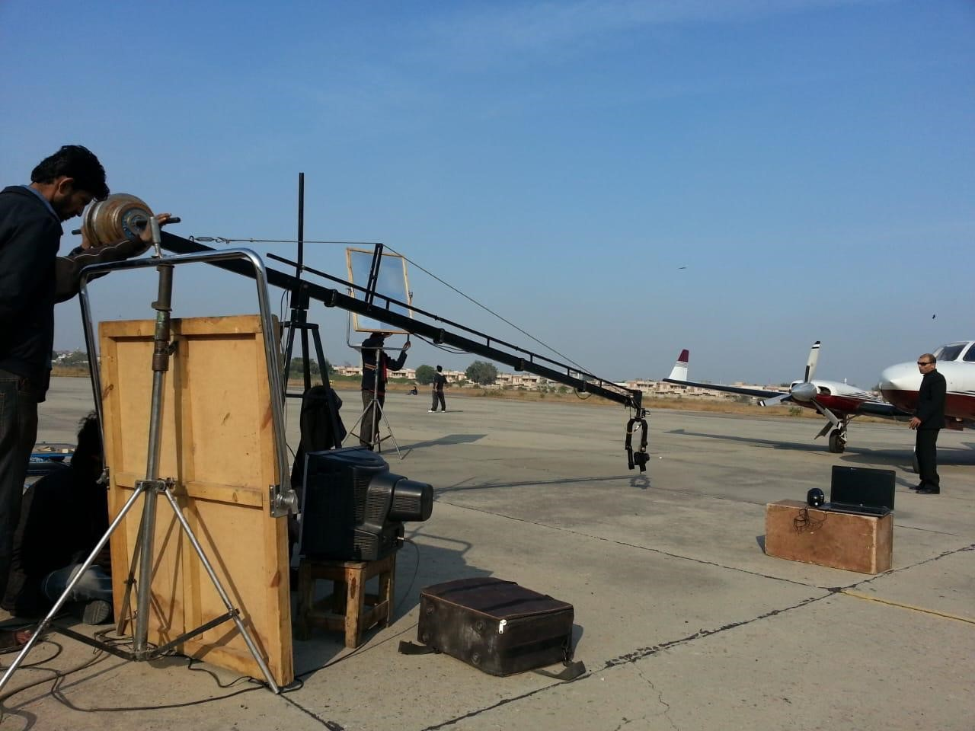

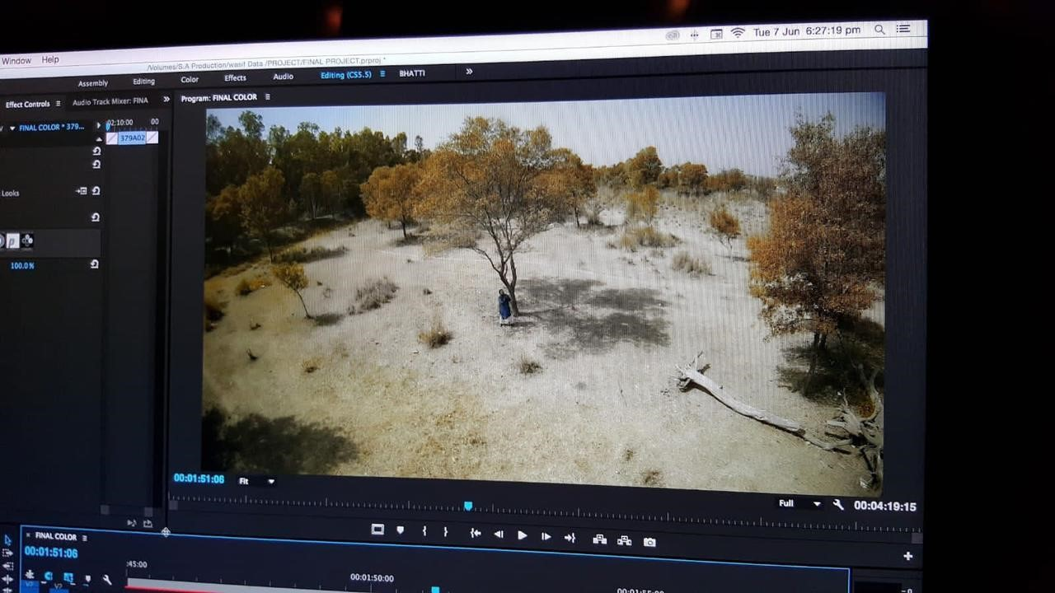

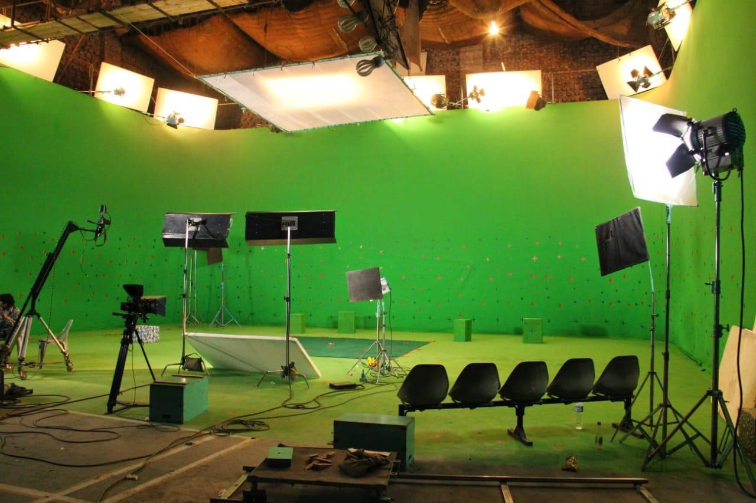

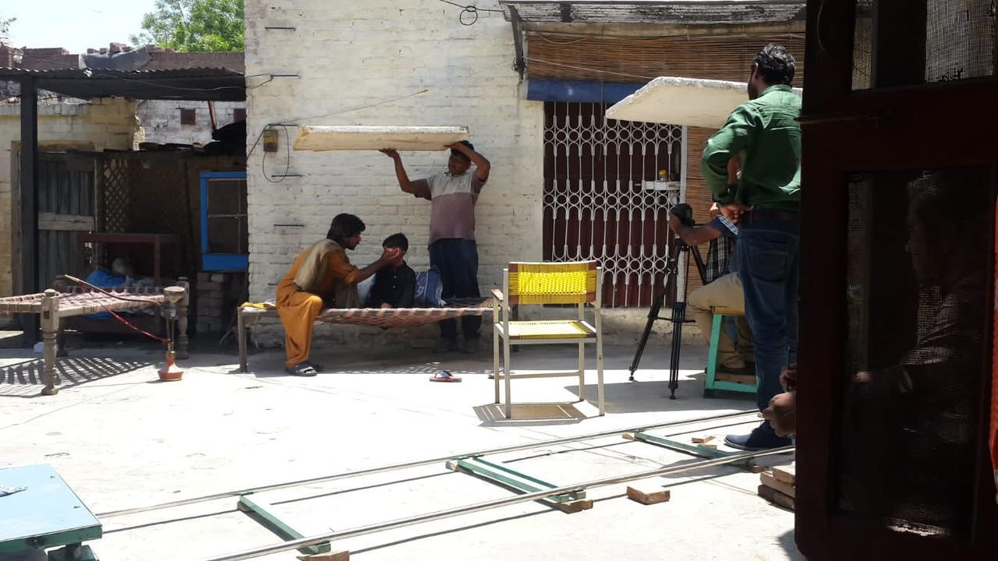

SHOOT SAMPLES
Some samples from the Shoots of different niches have been attached and I had gained great experience and it helped enhance my capabilities in terms of skills, communication, team work overall I got a great chance to learn from skilled and talented people around me.

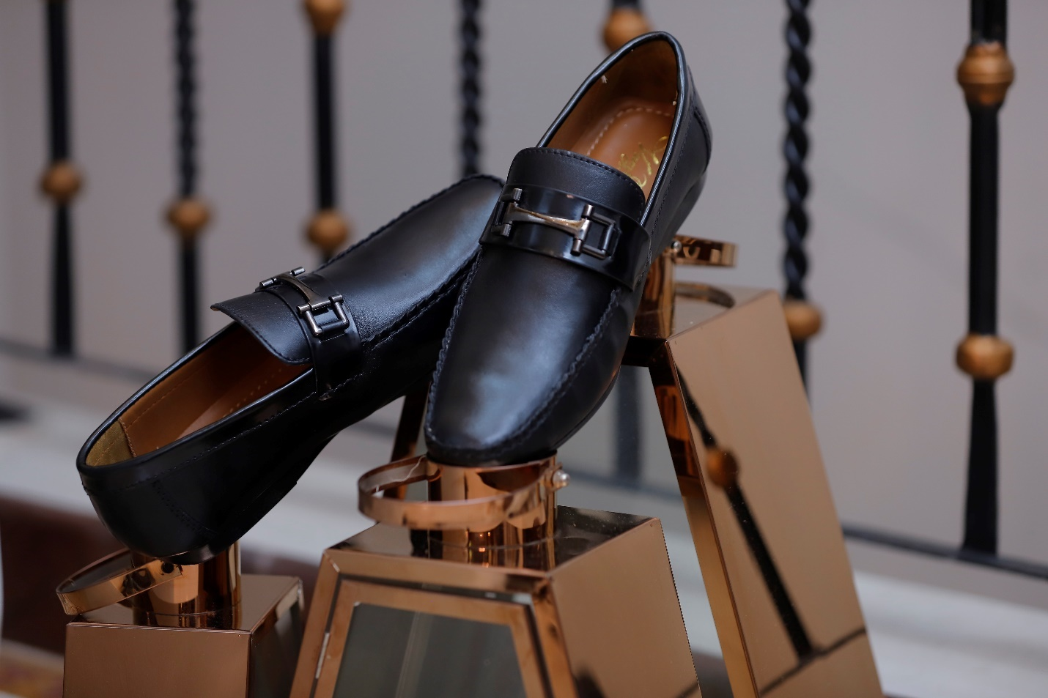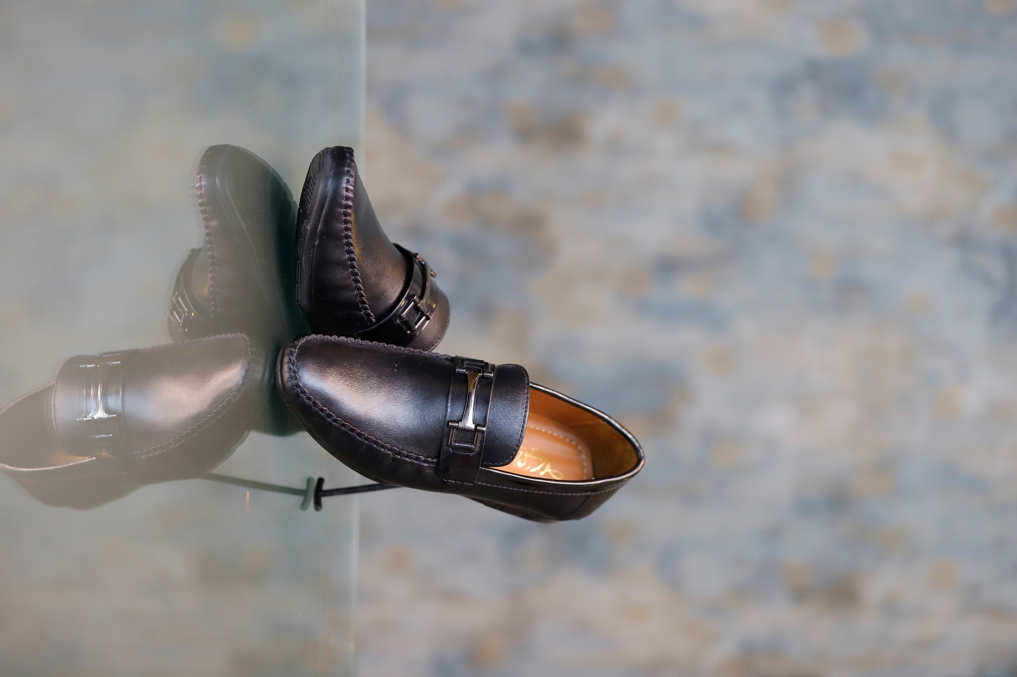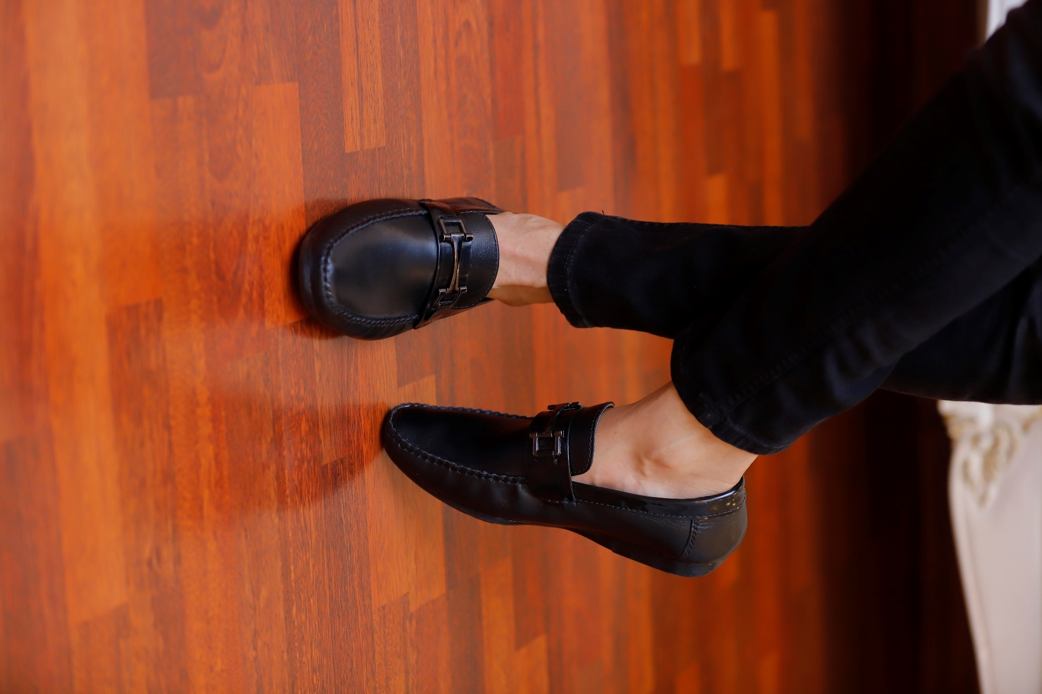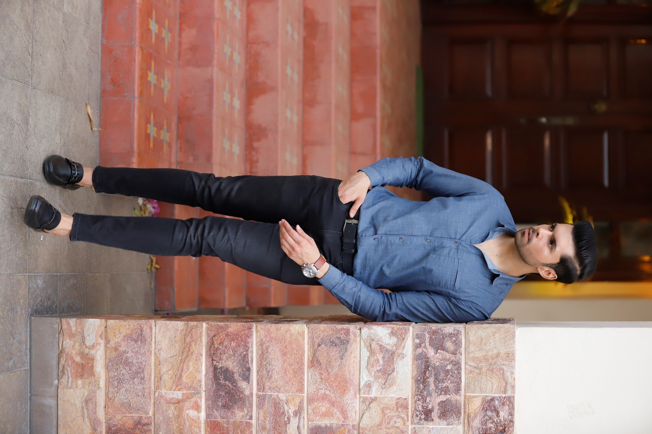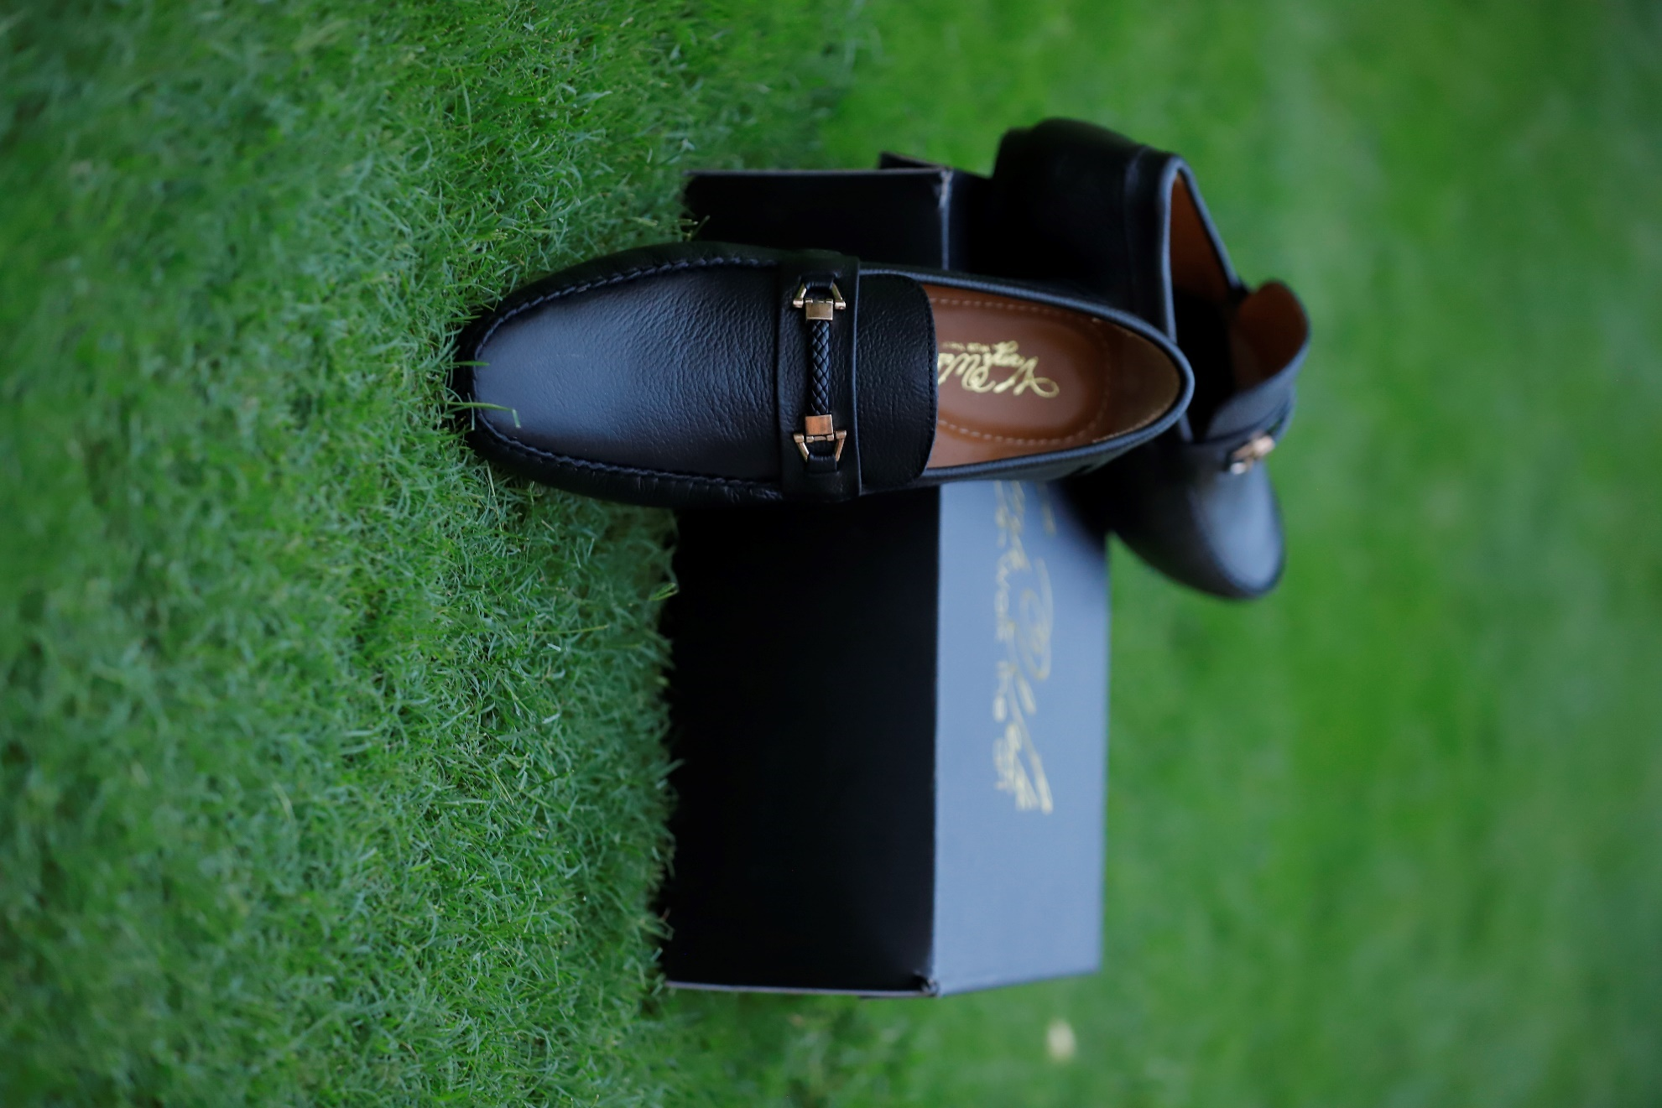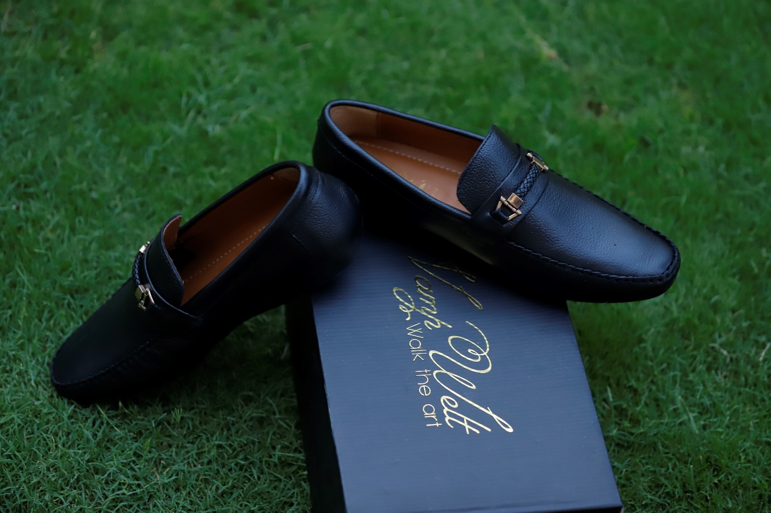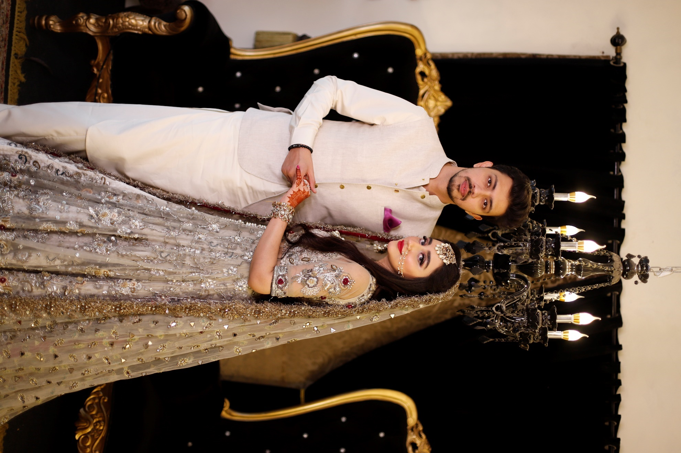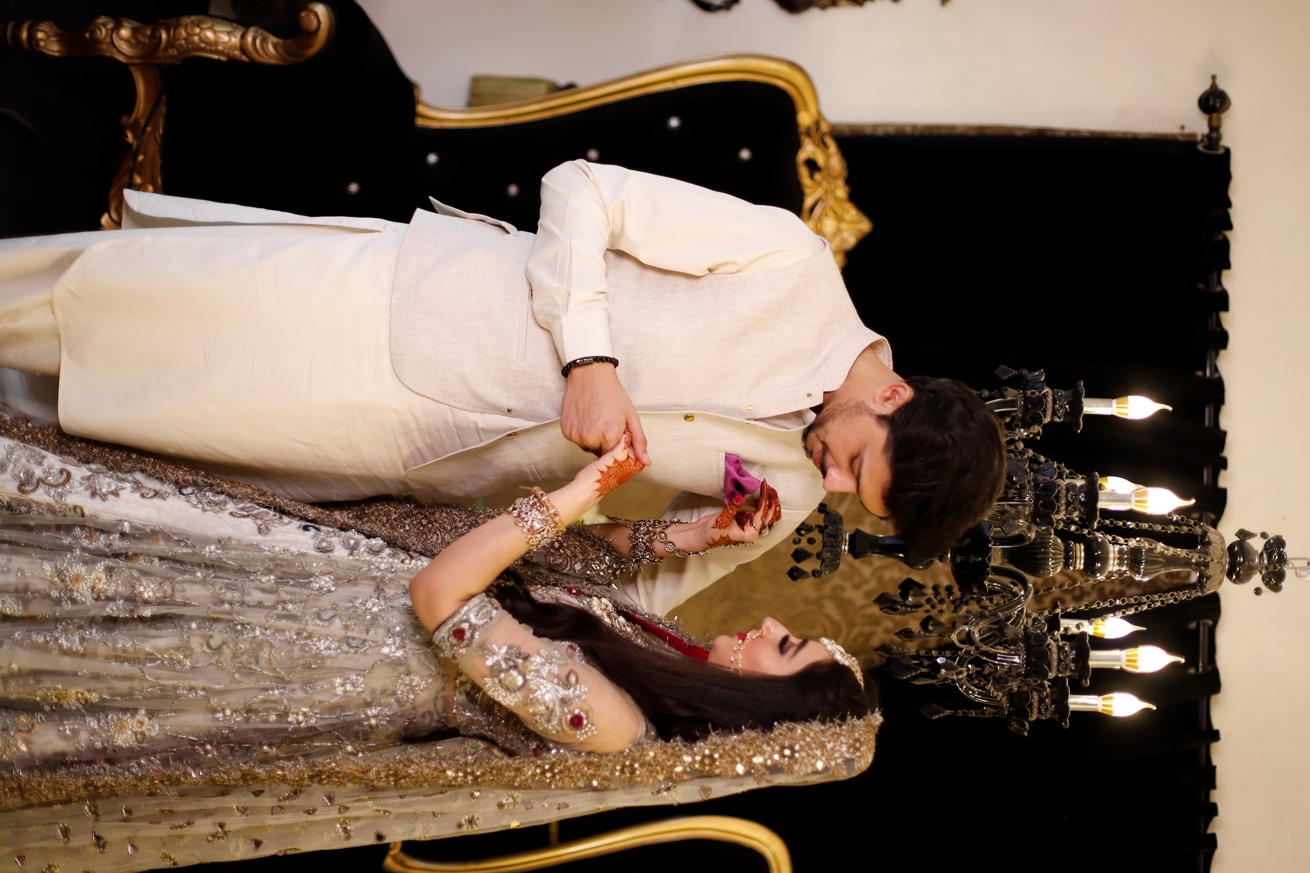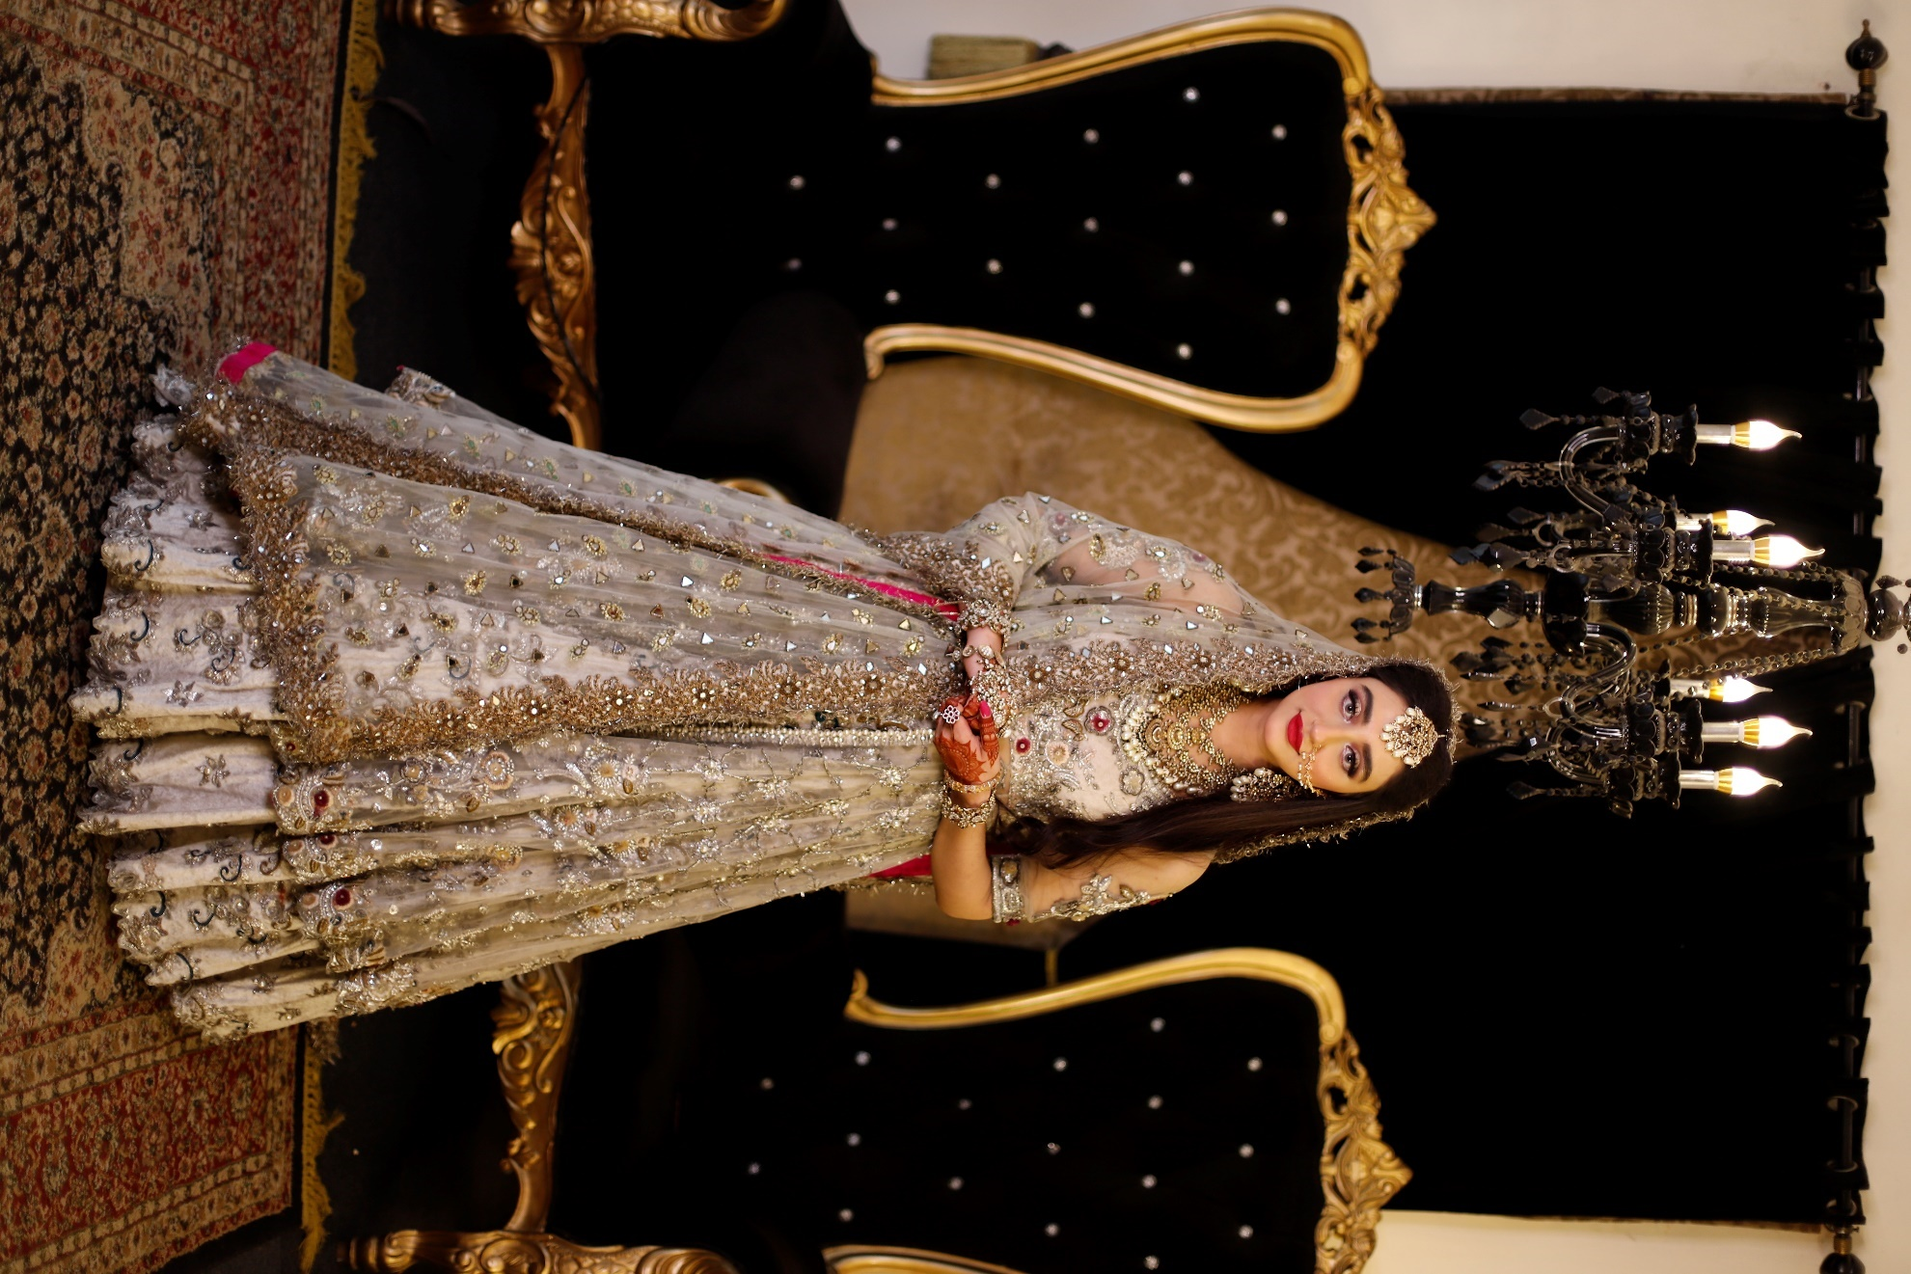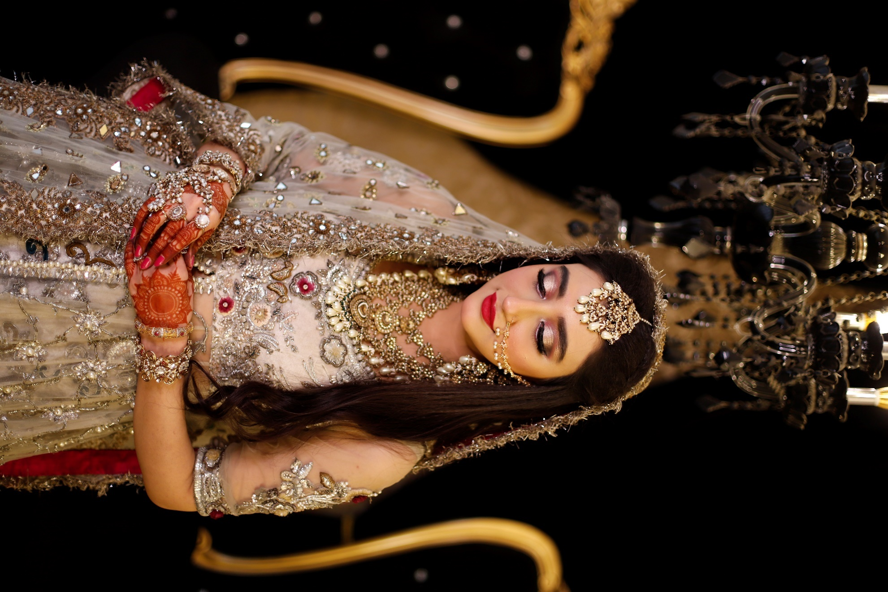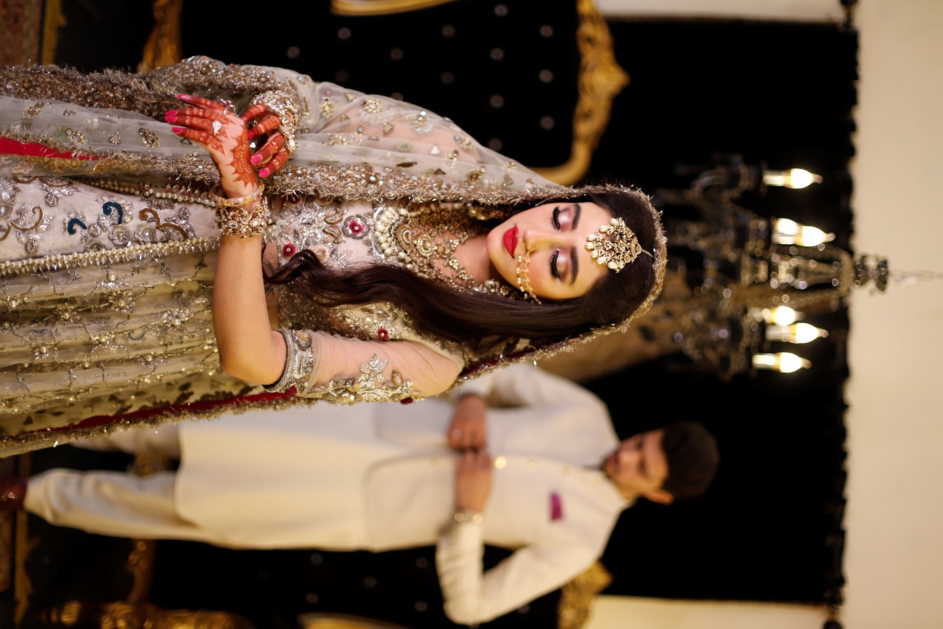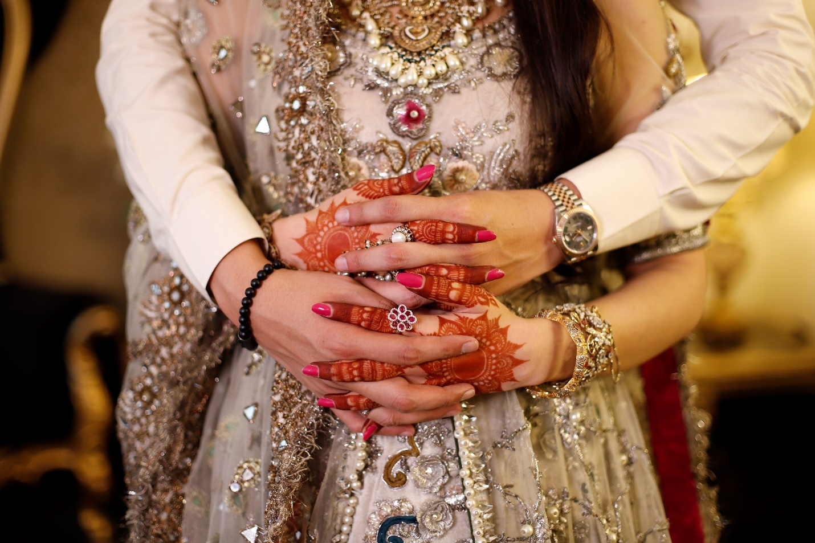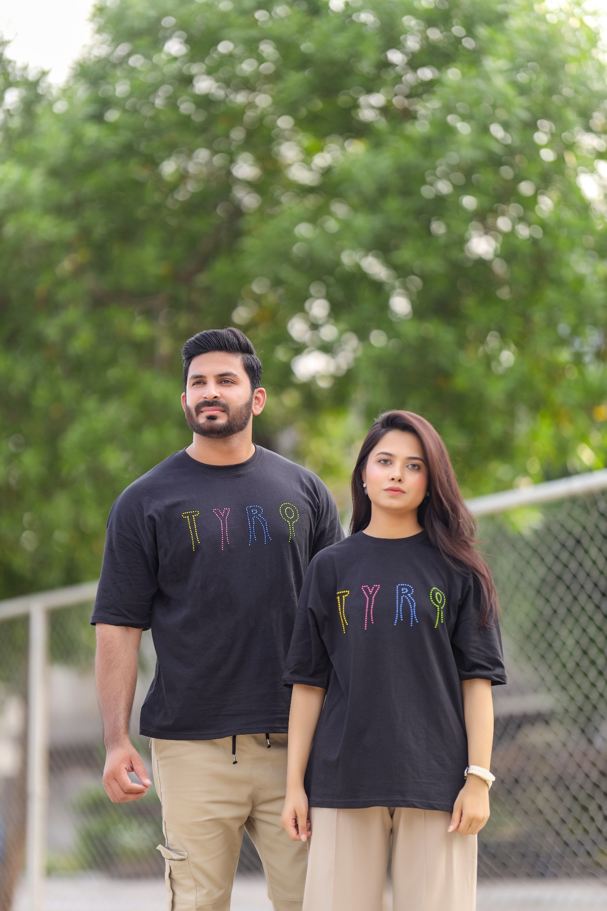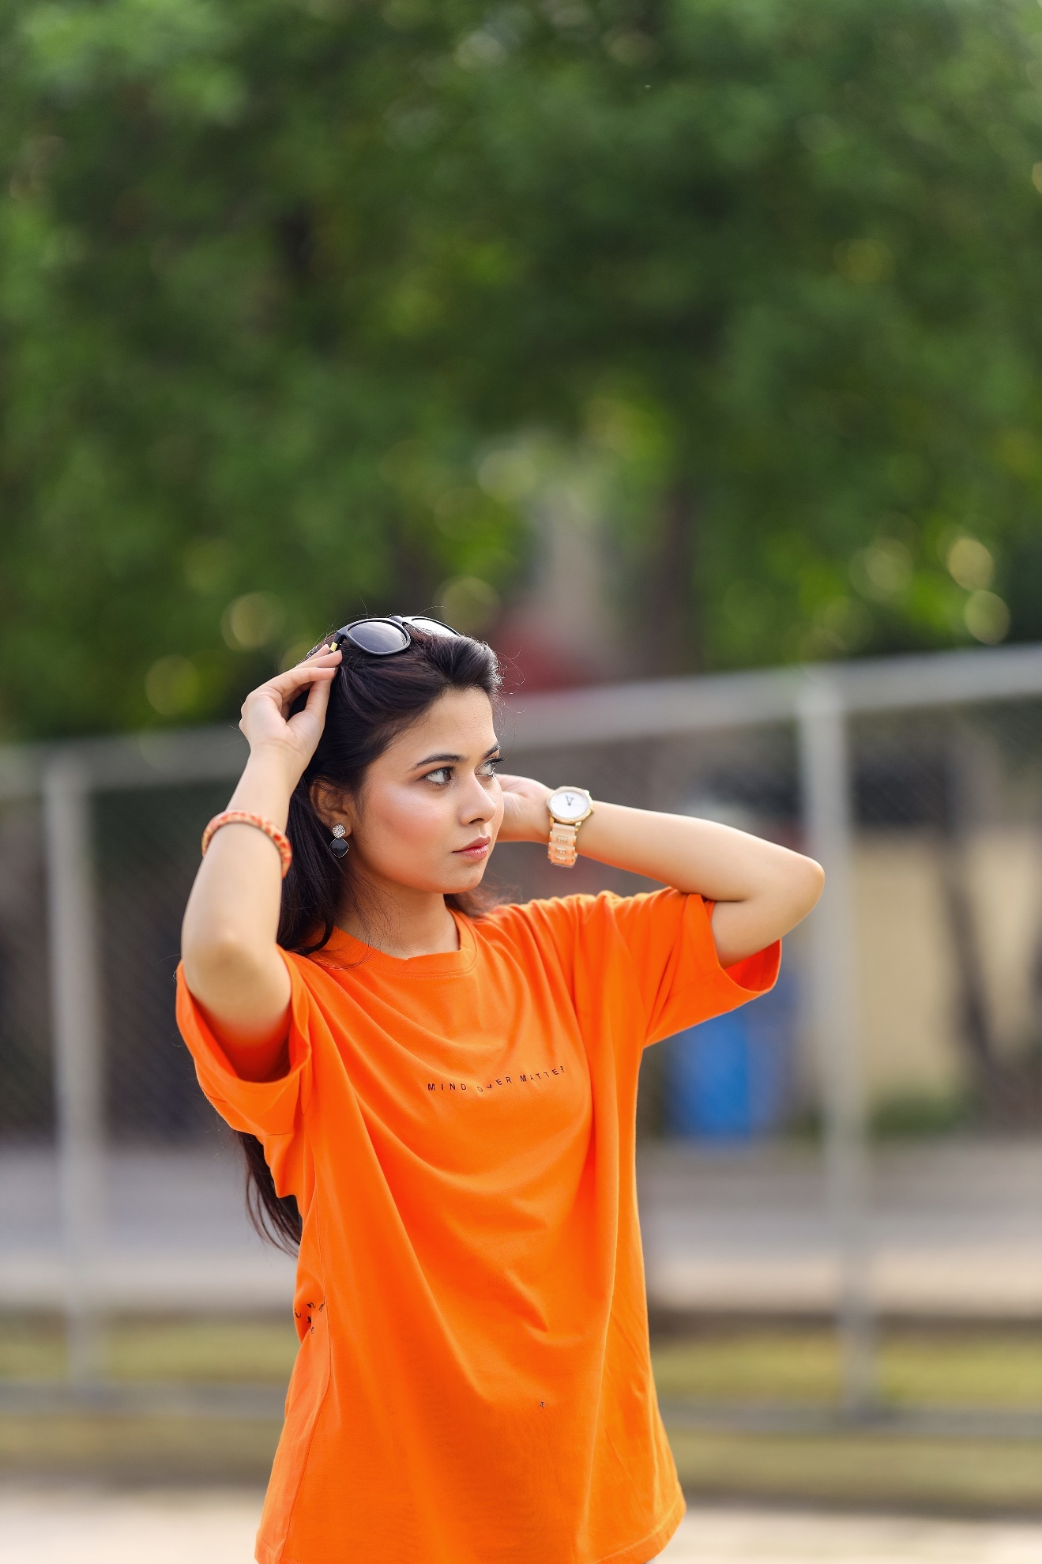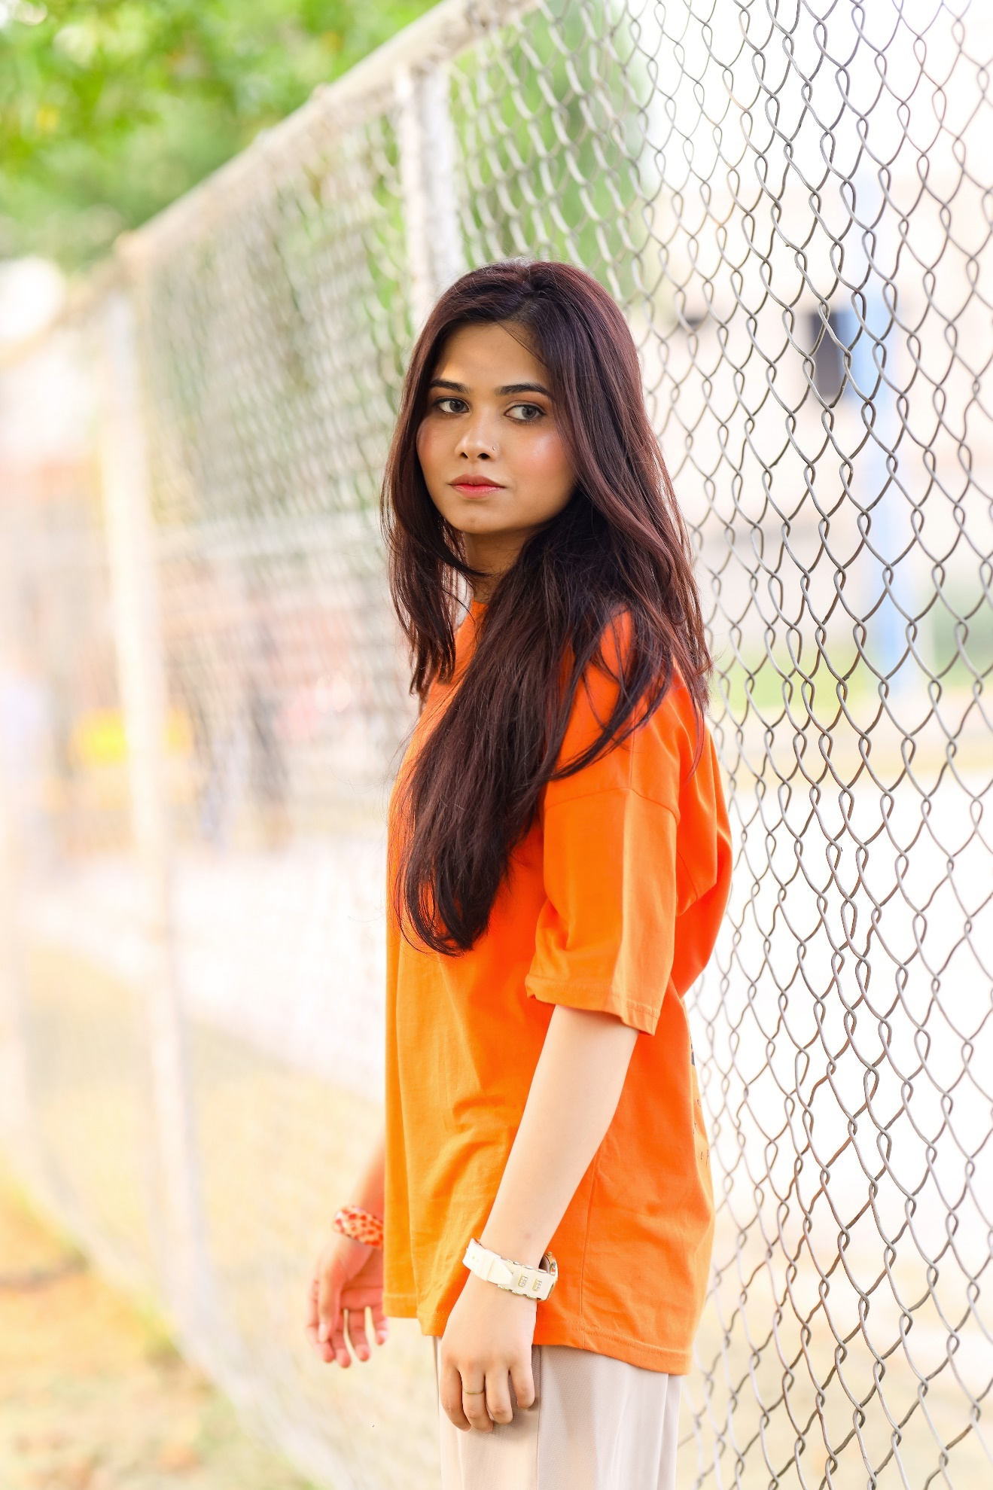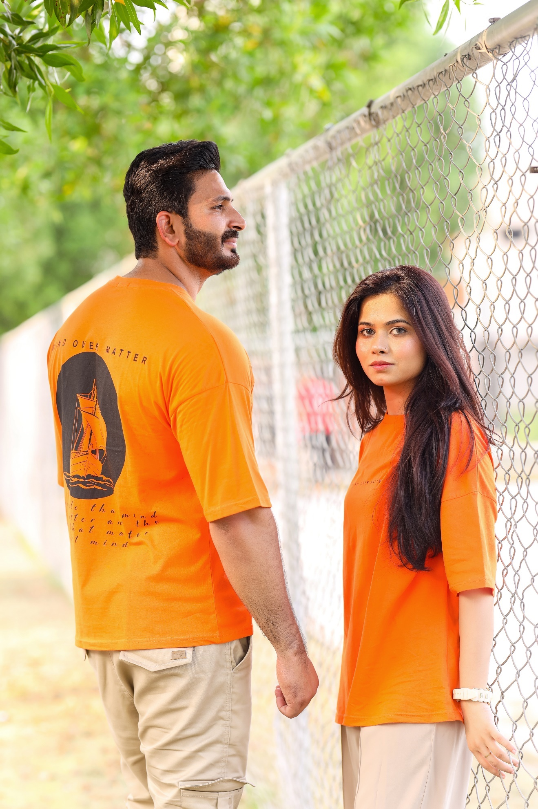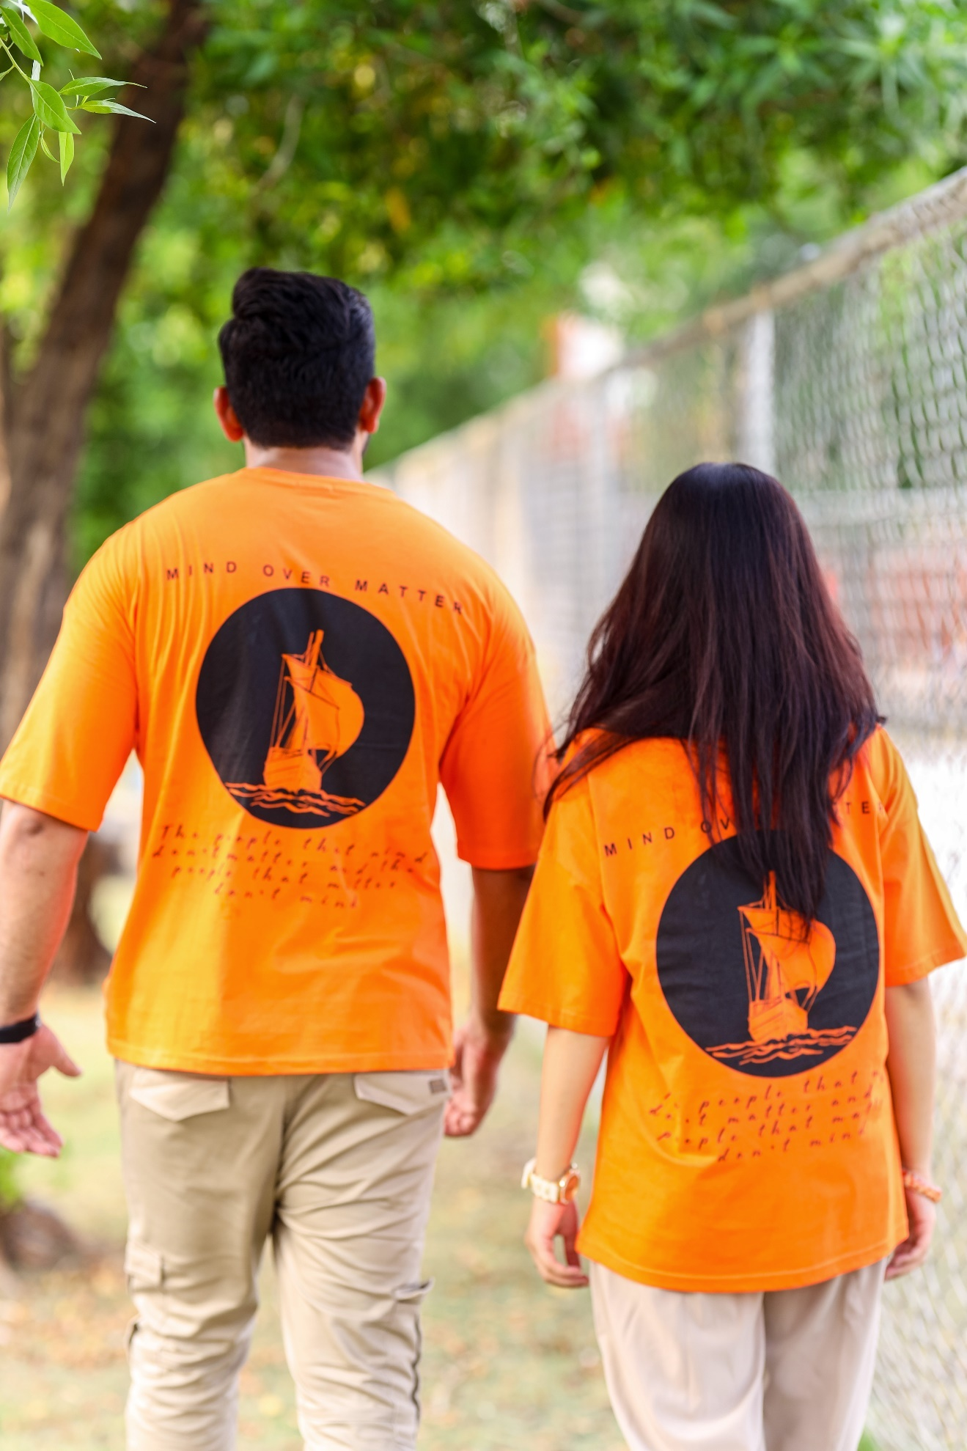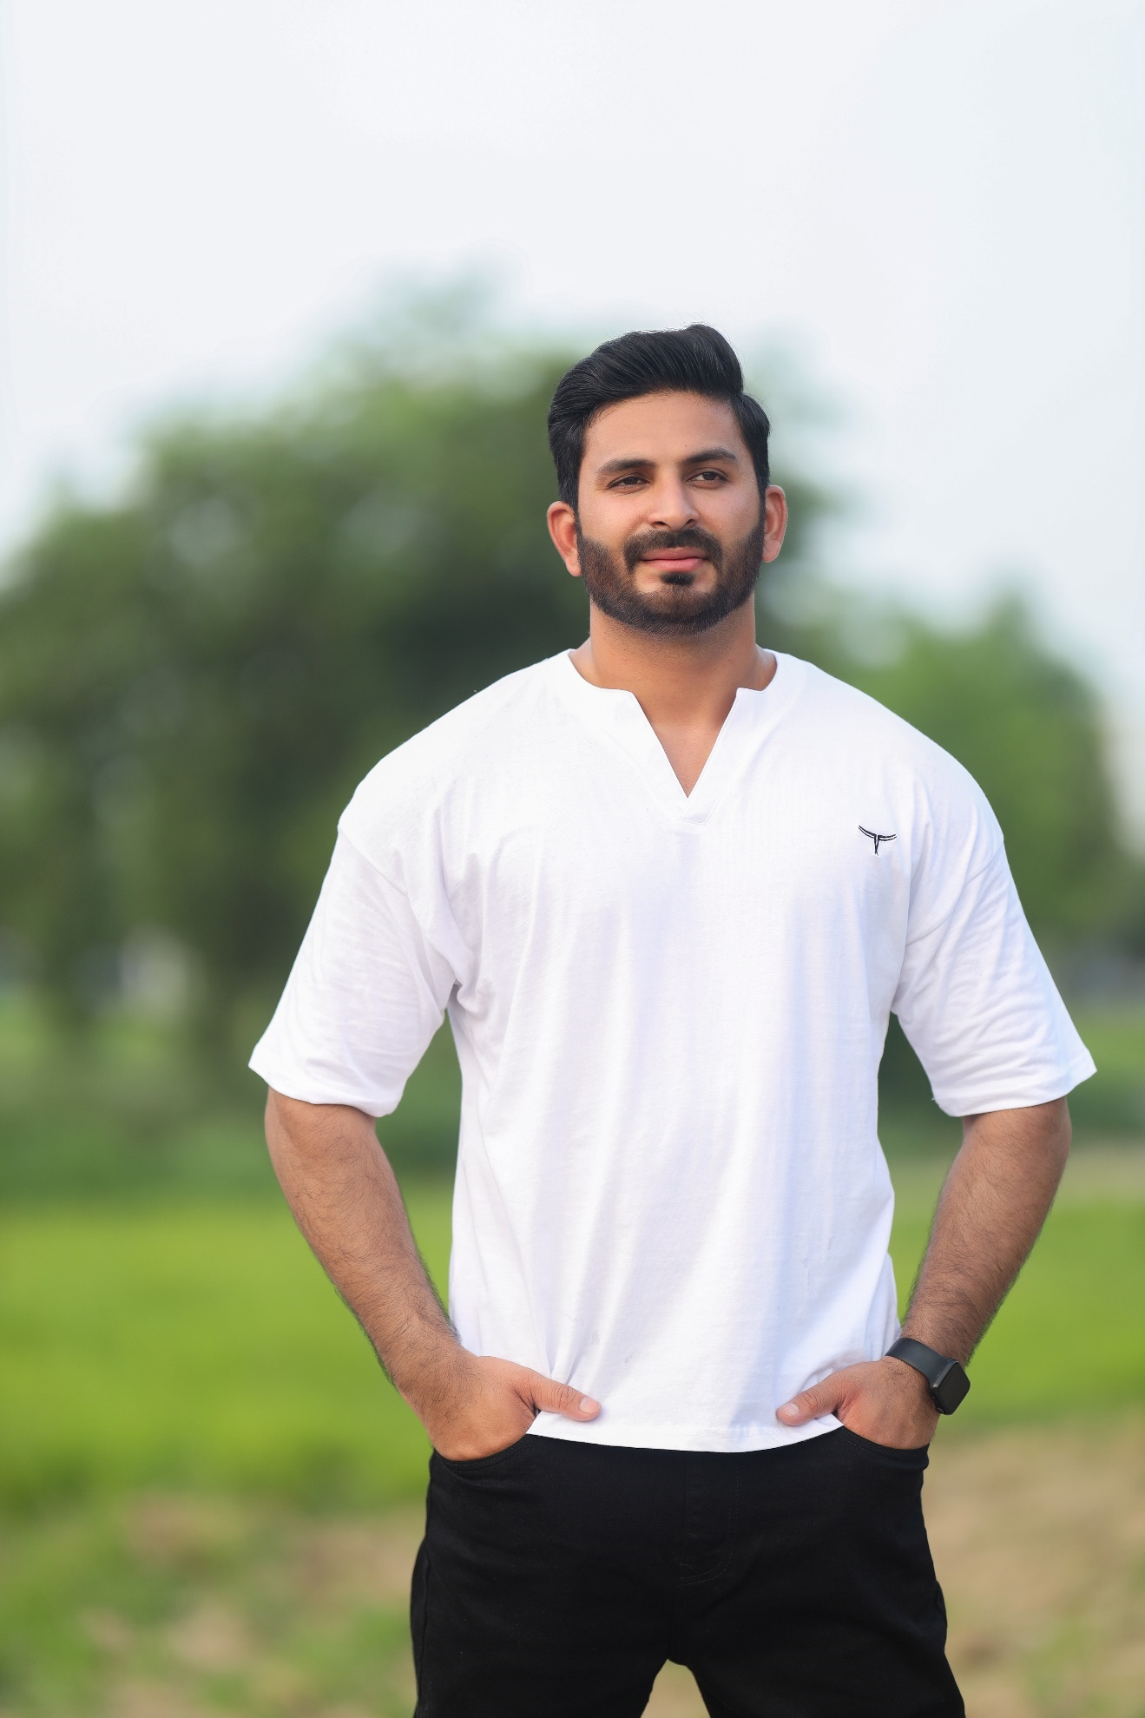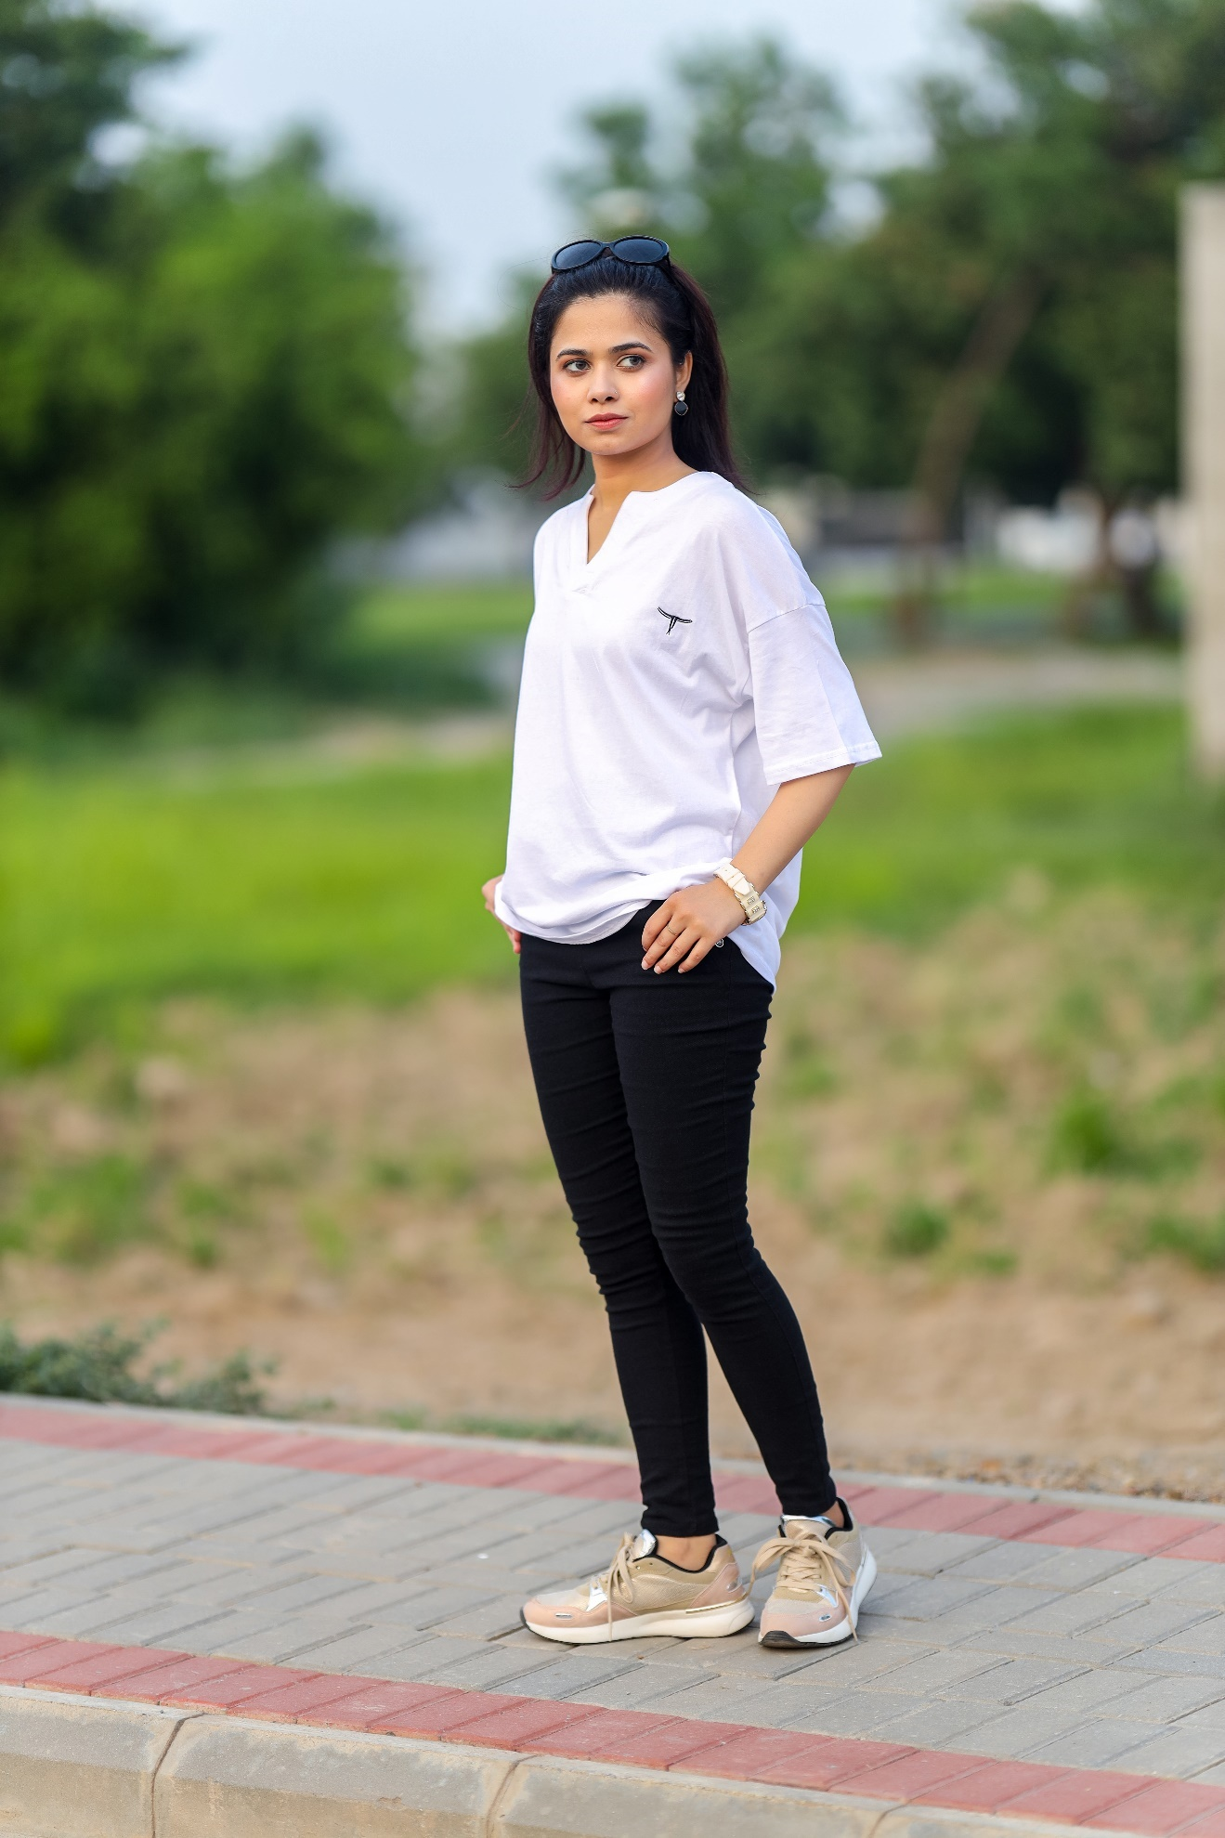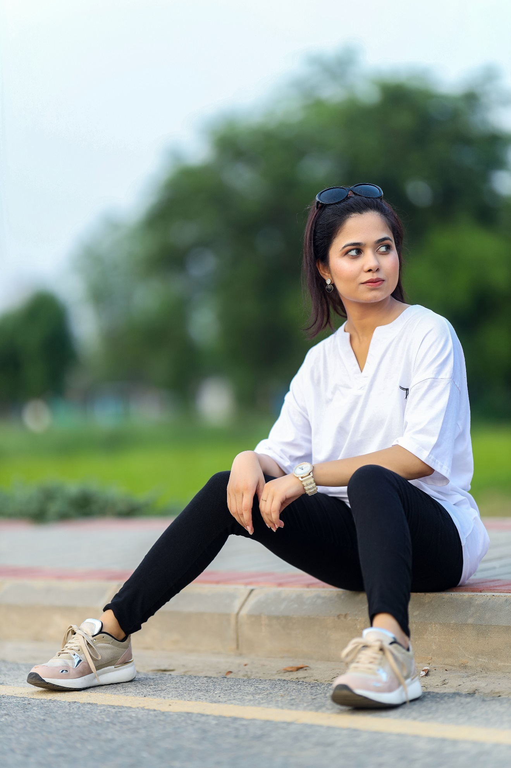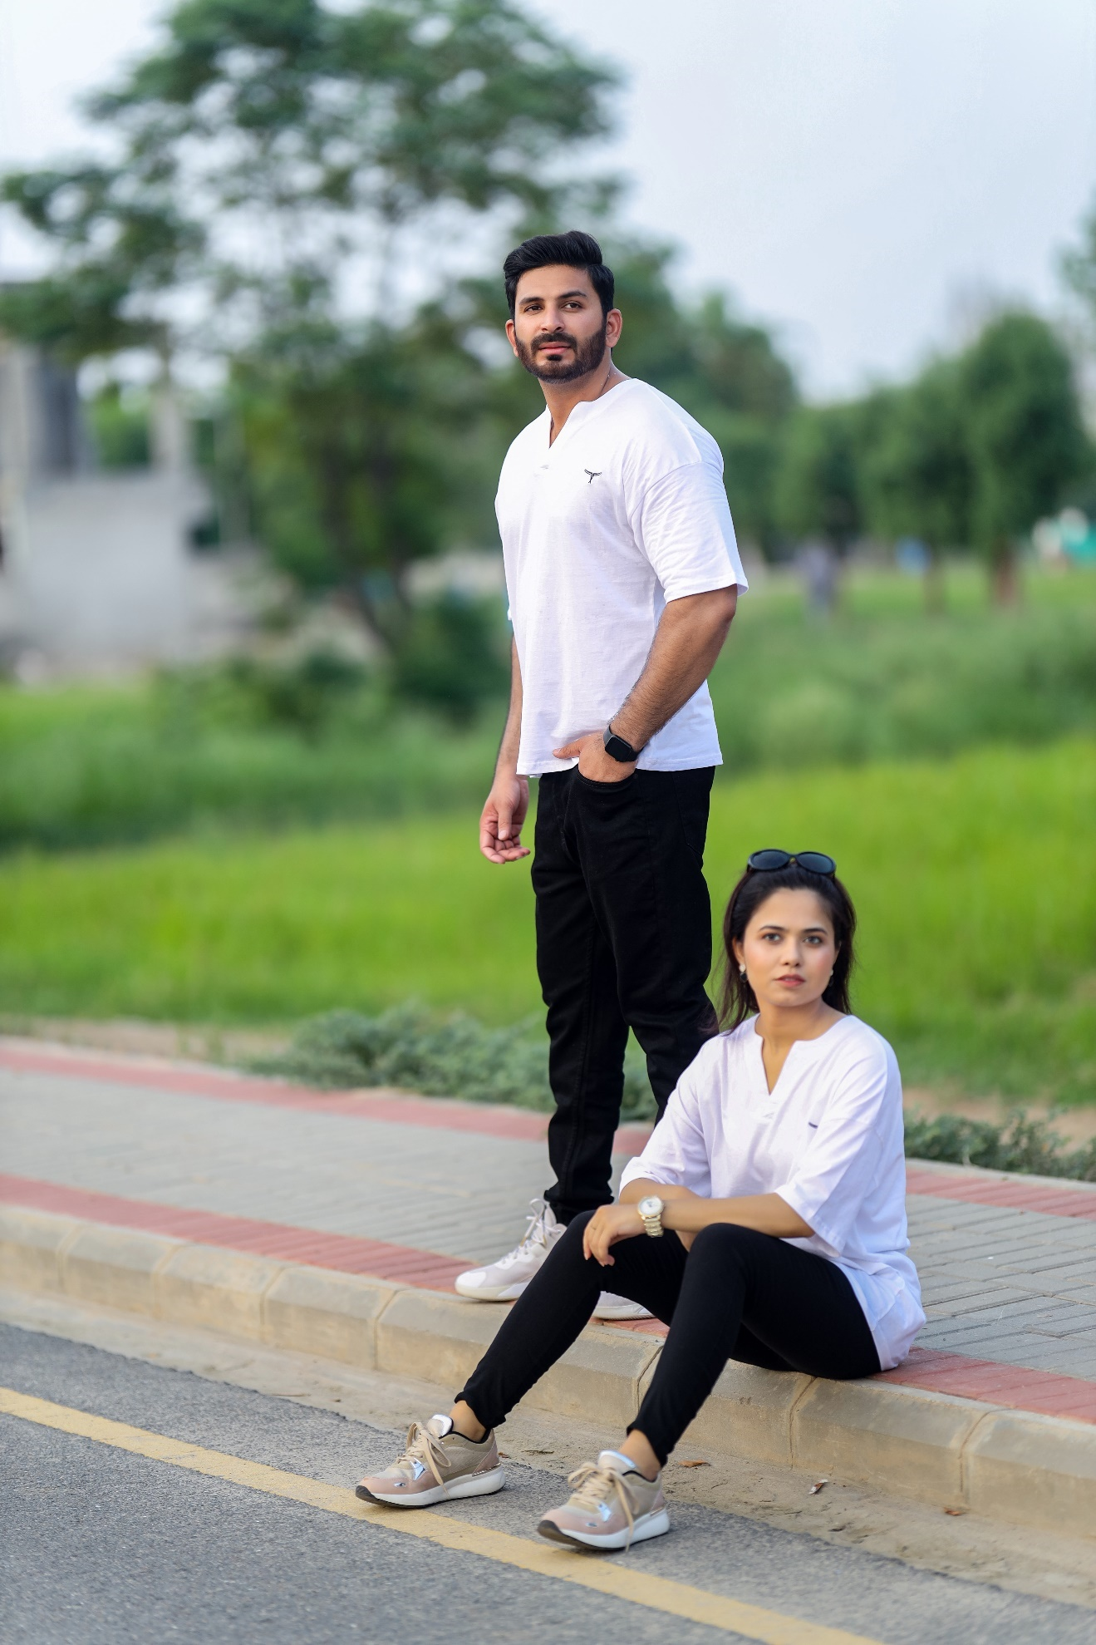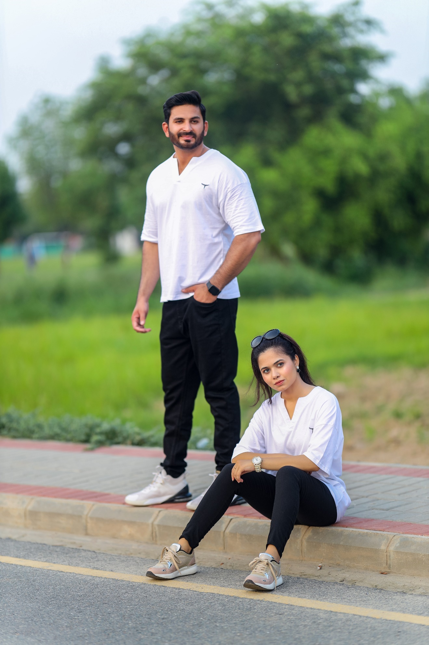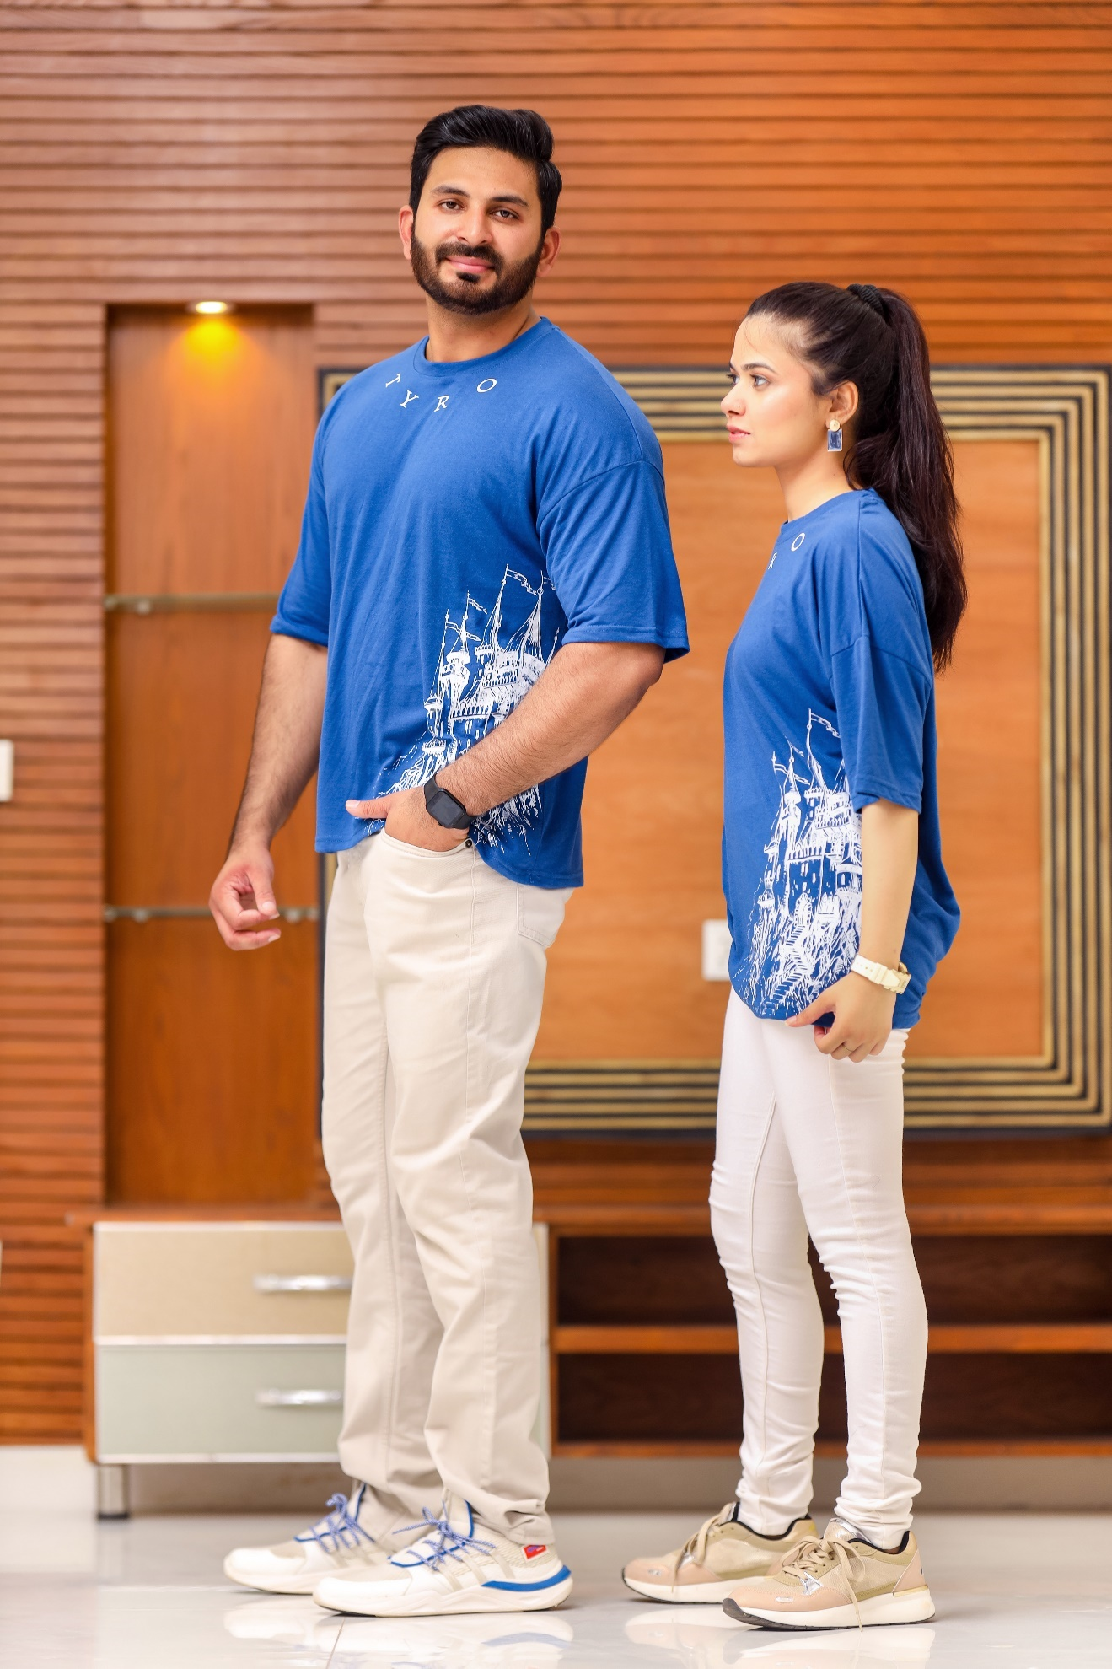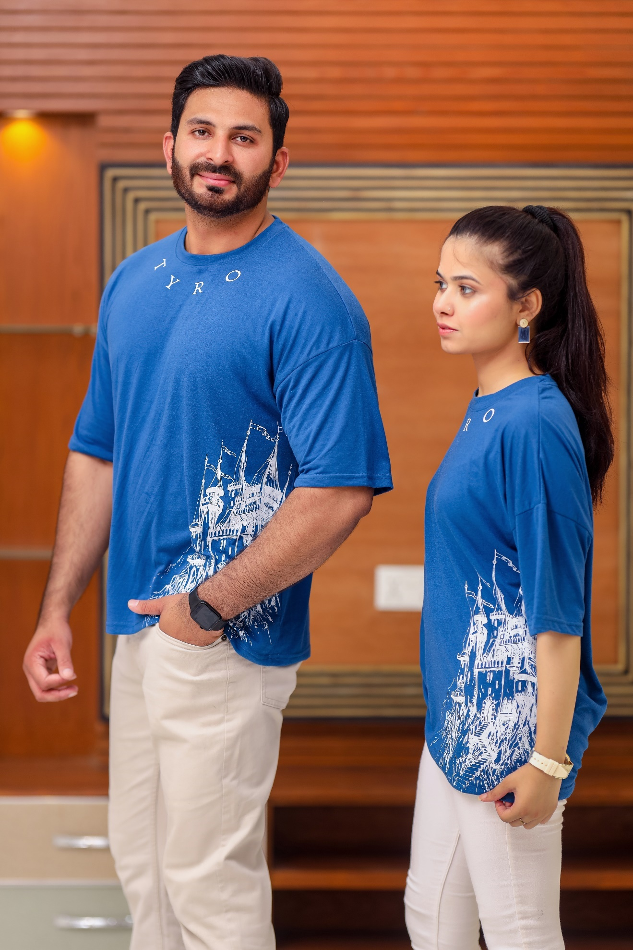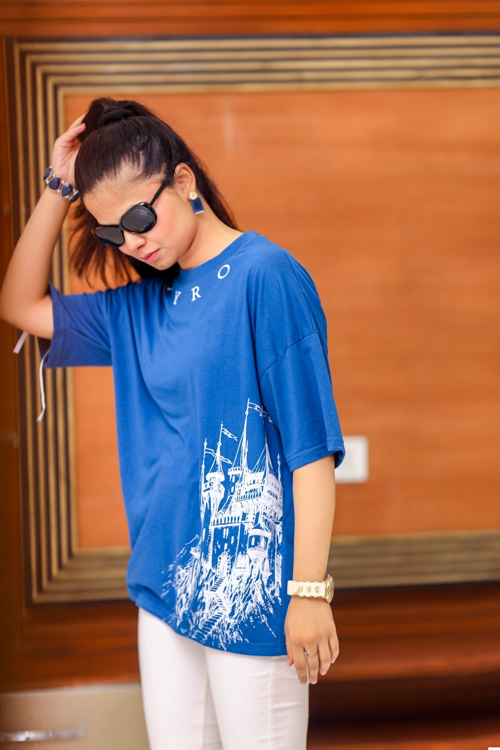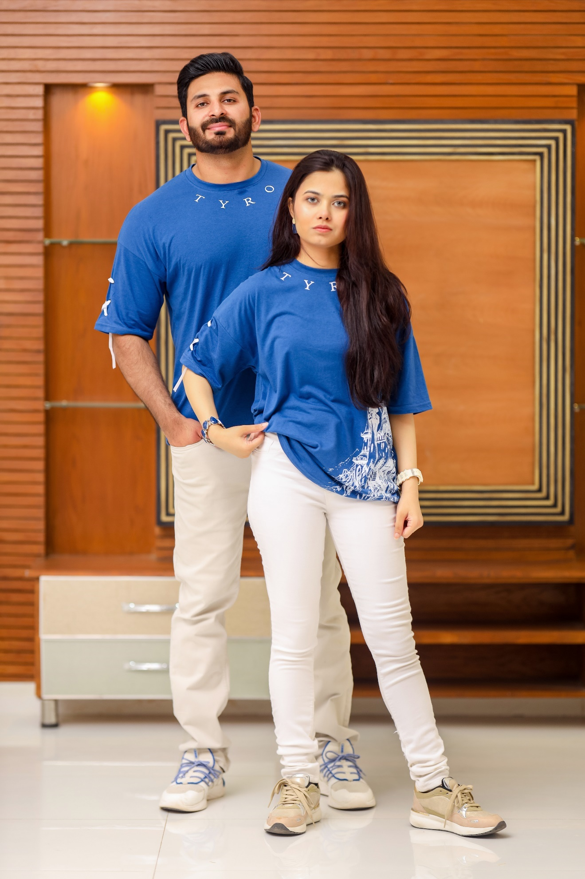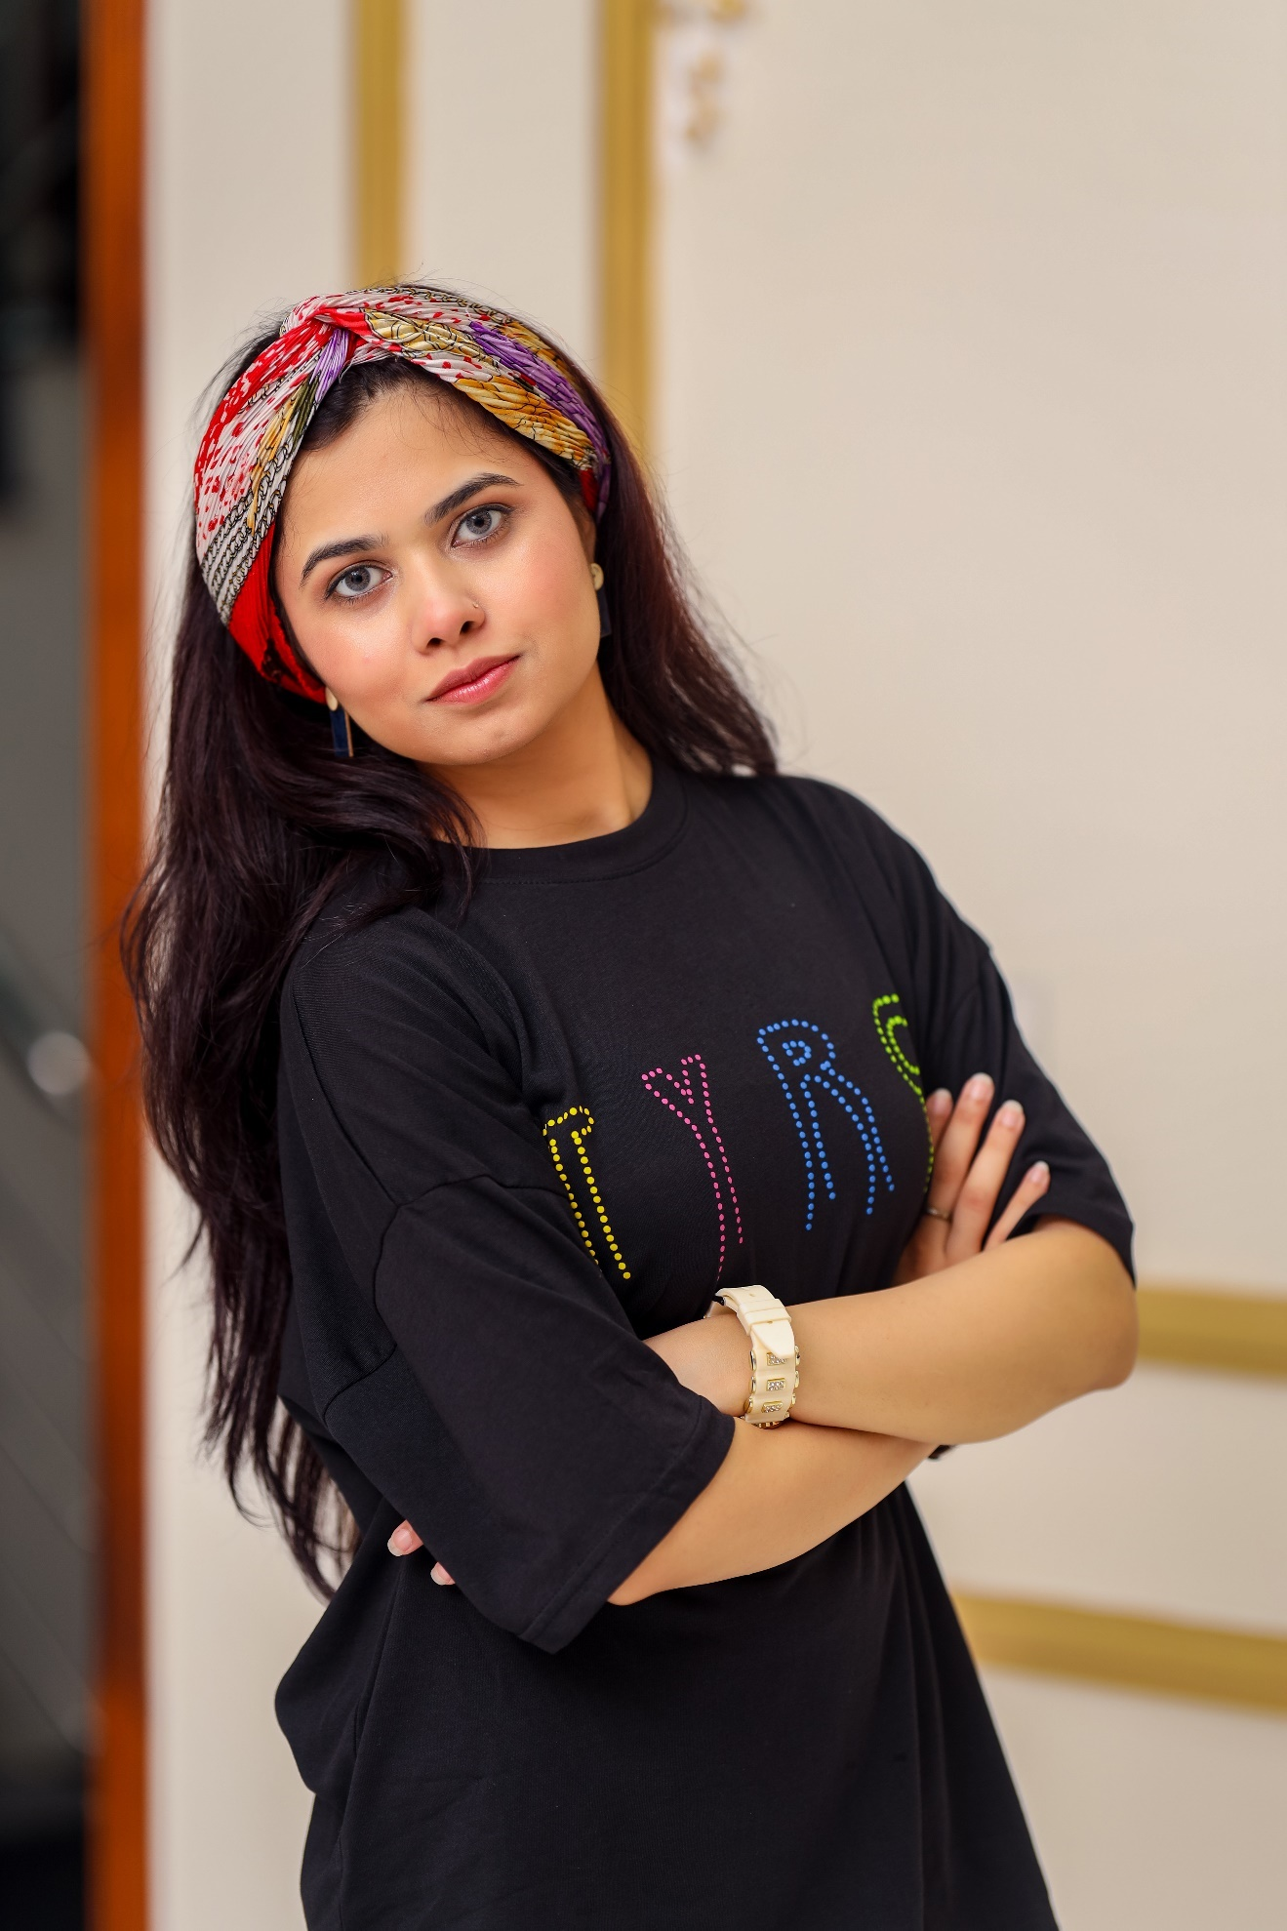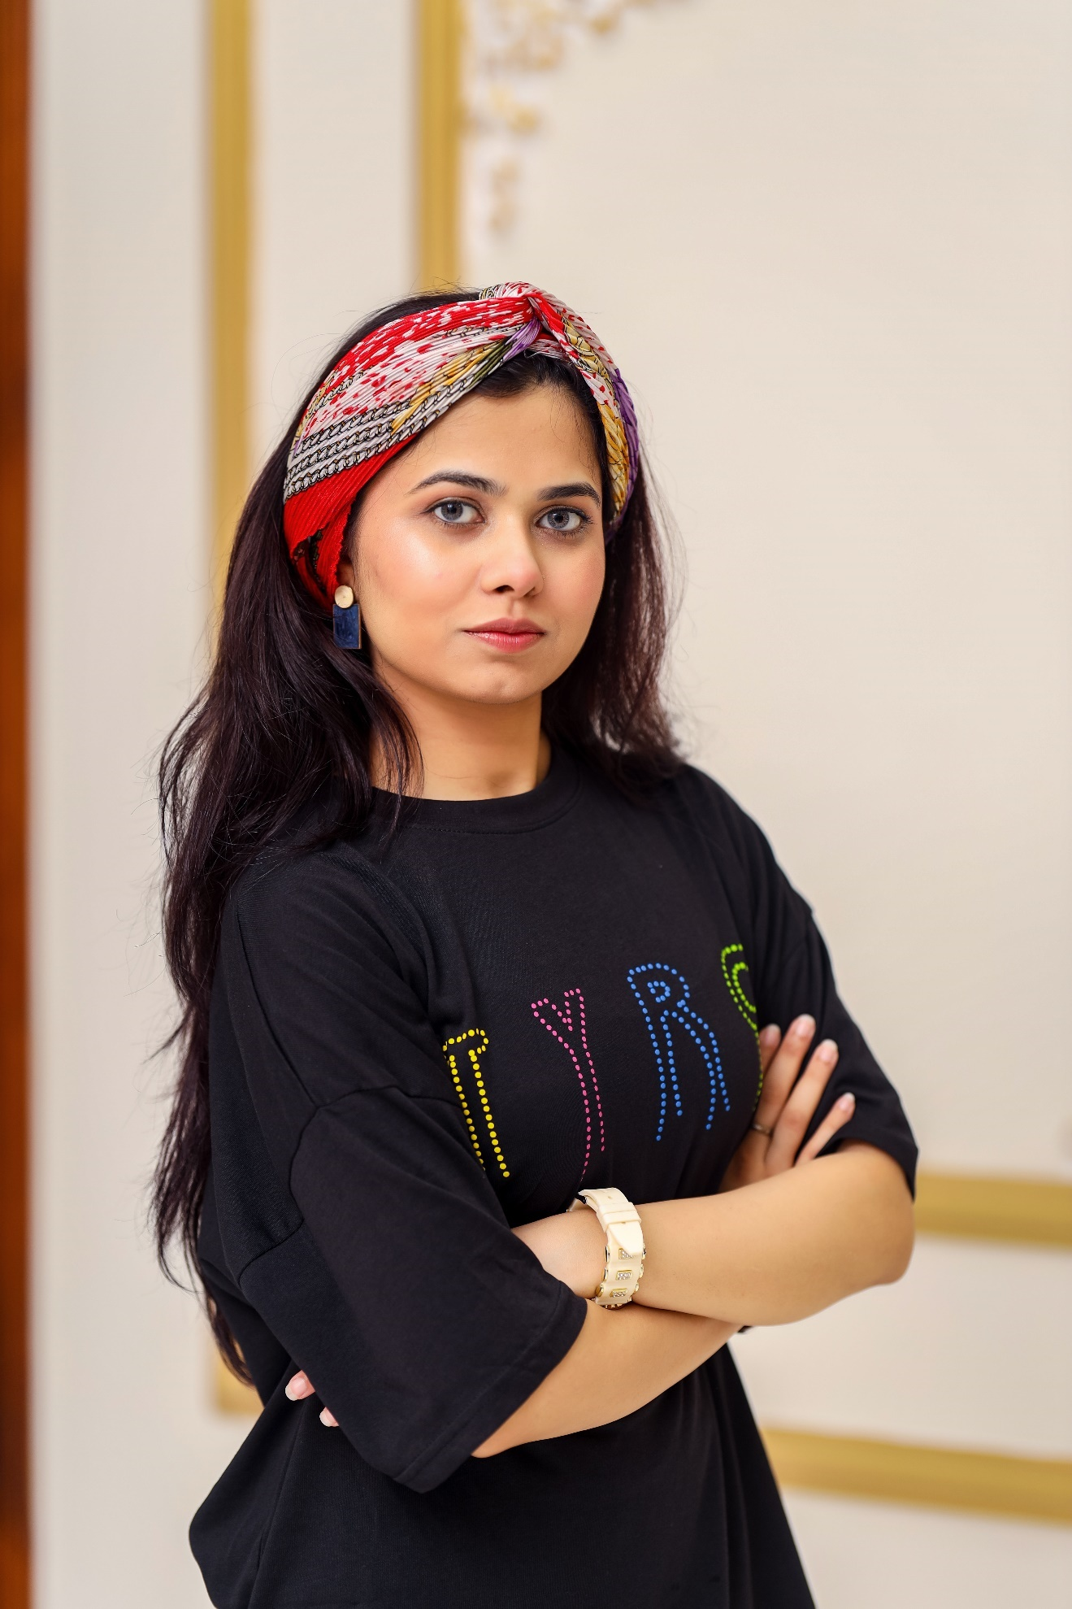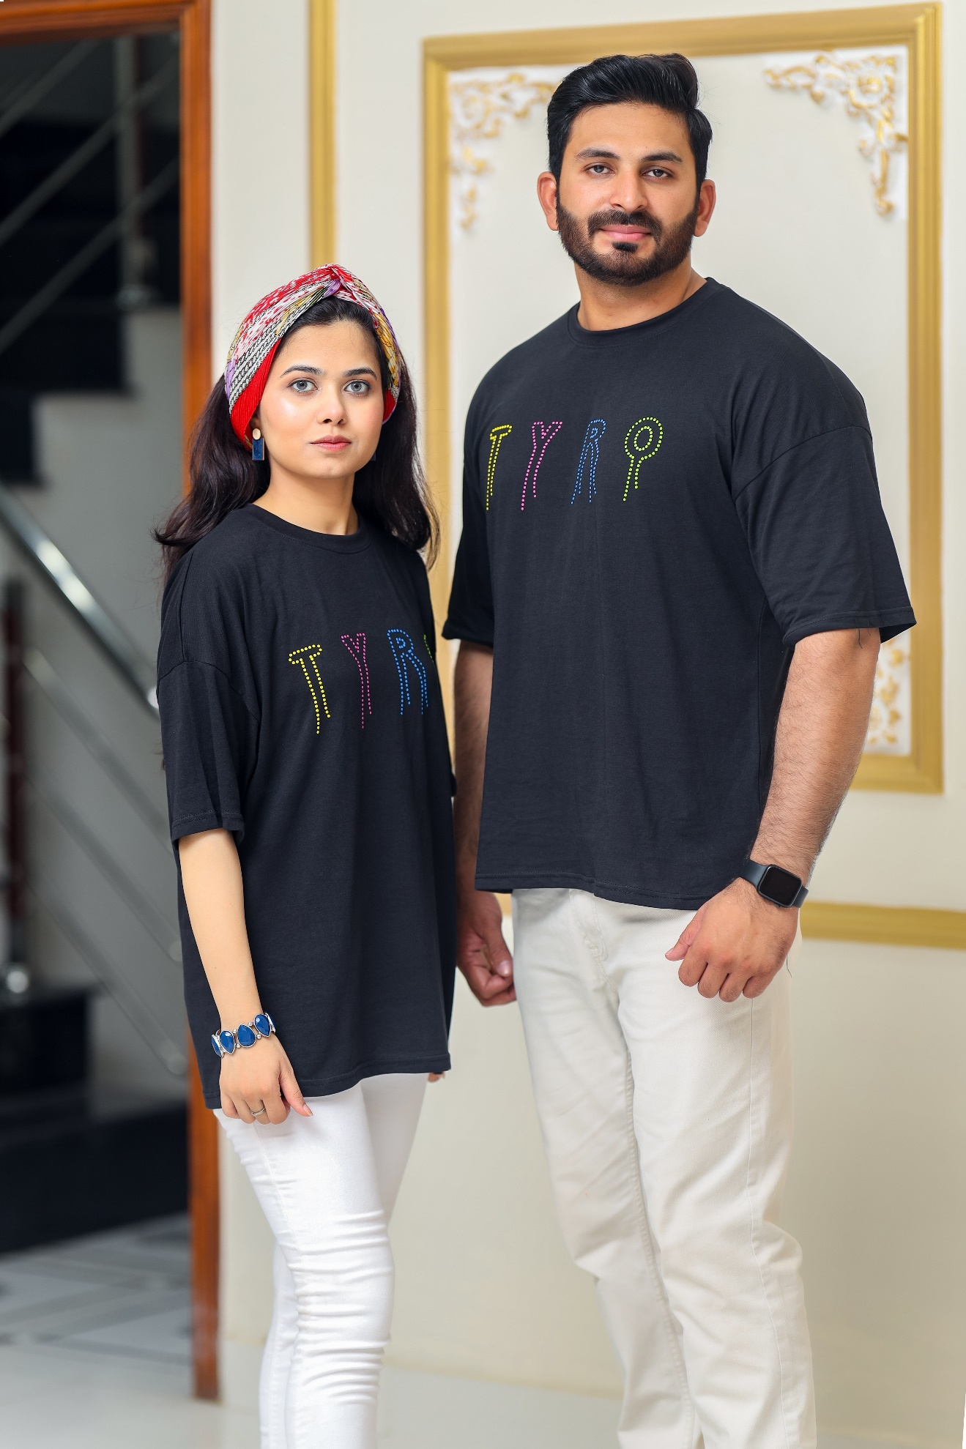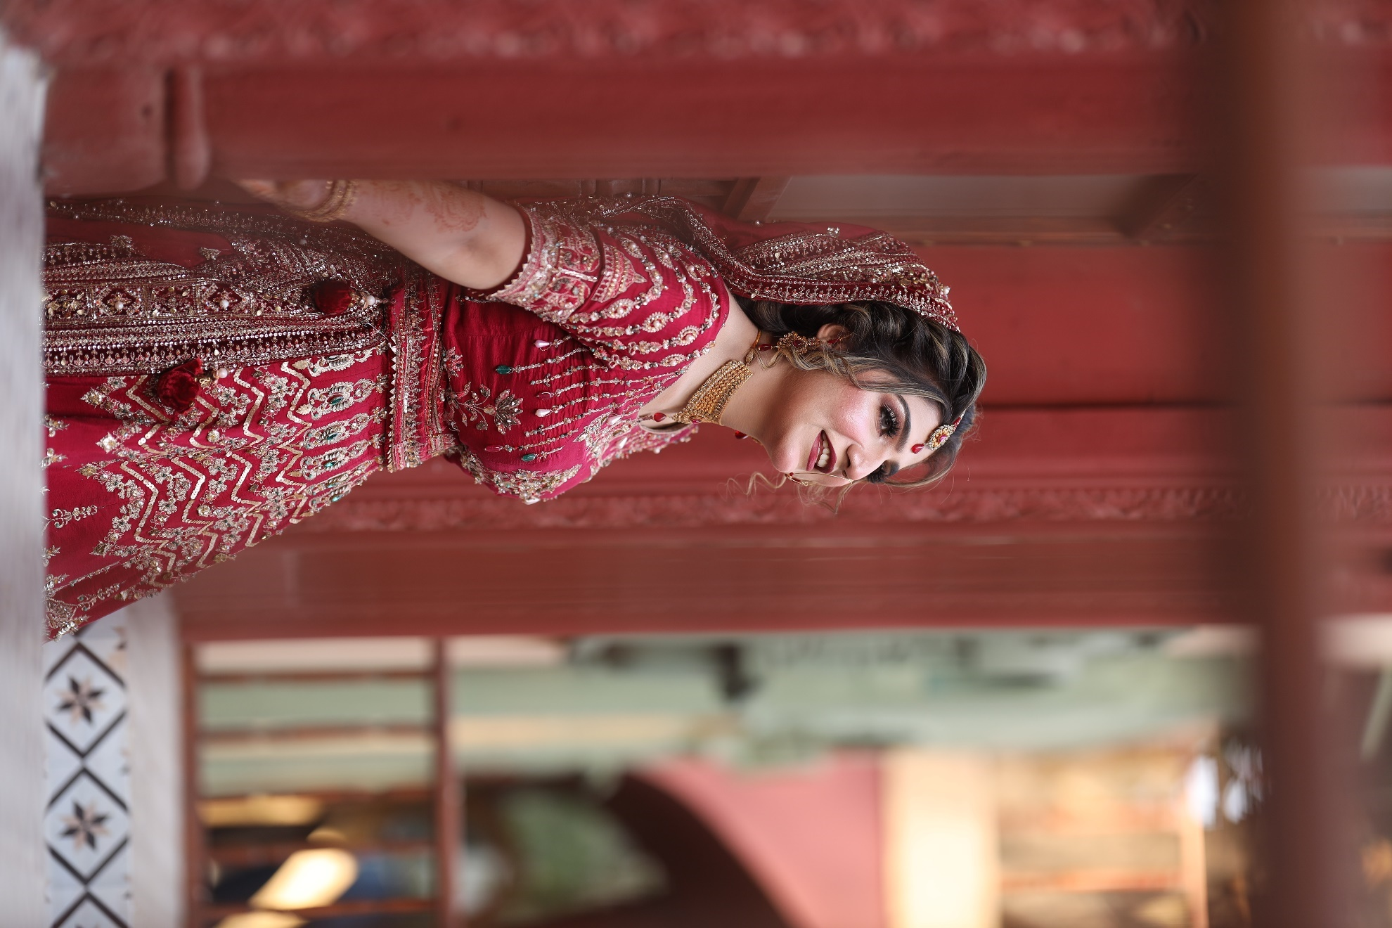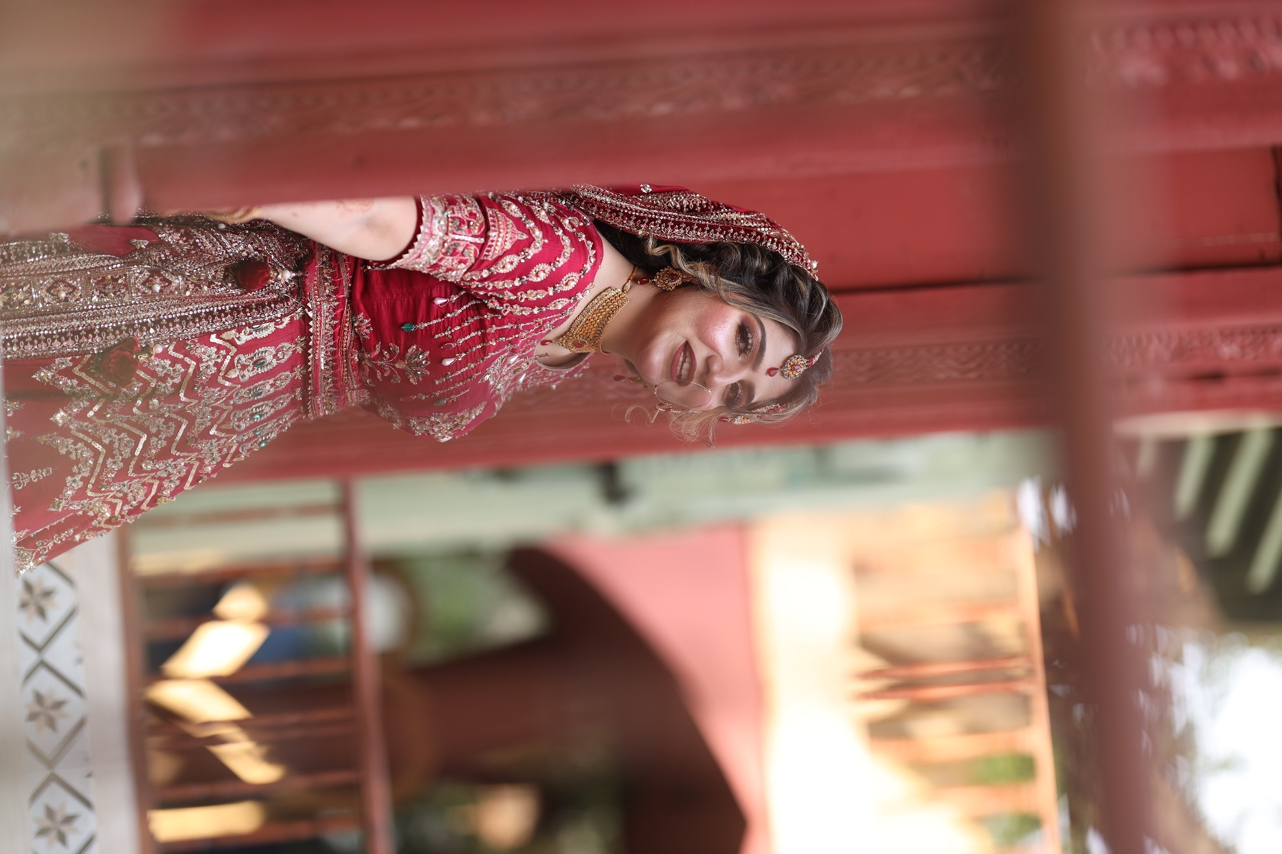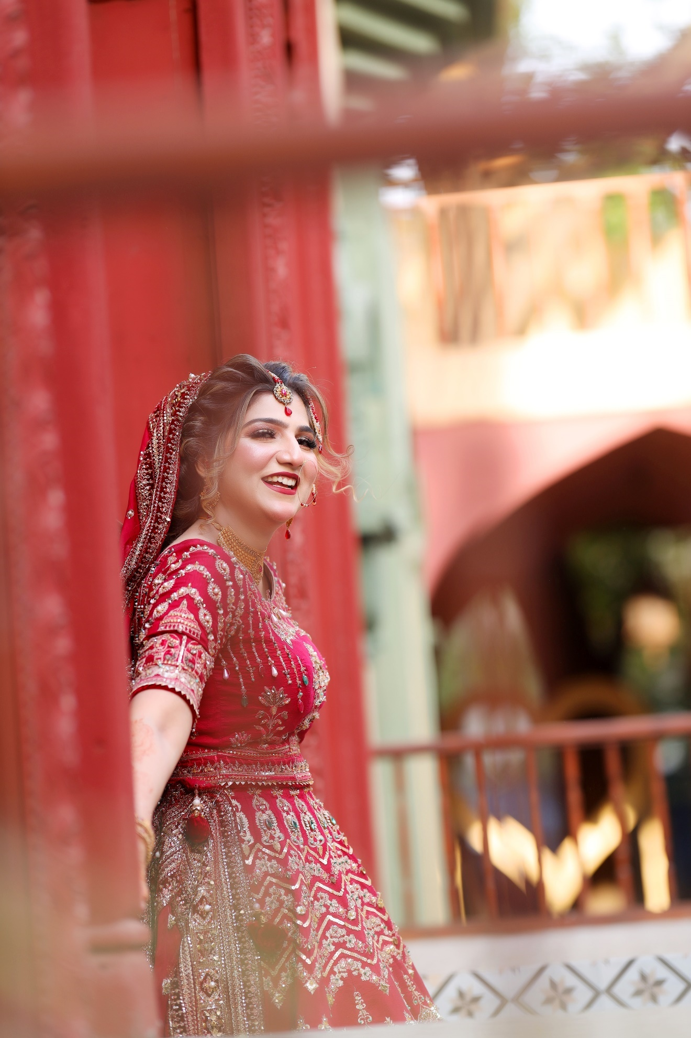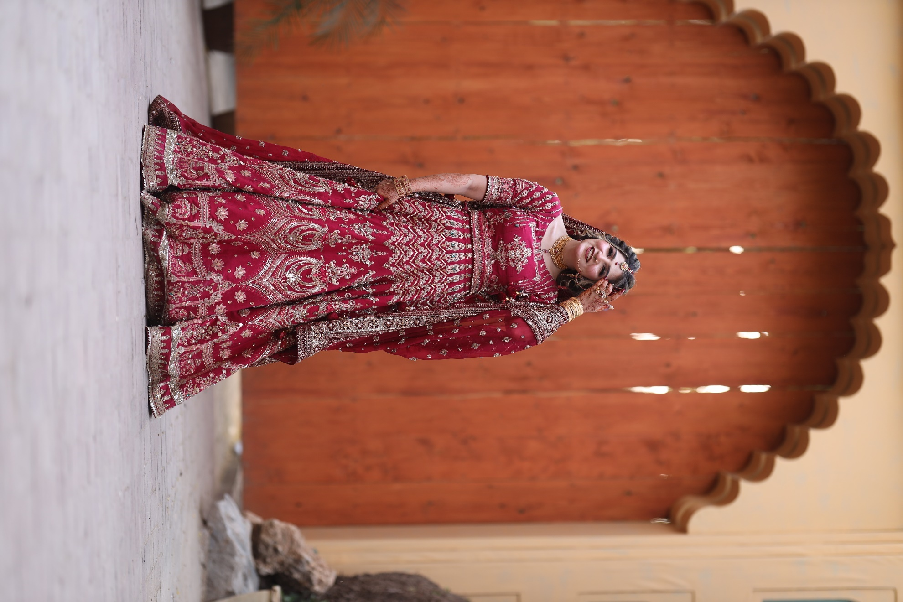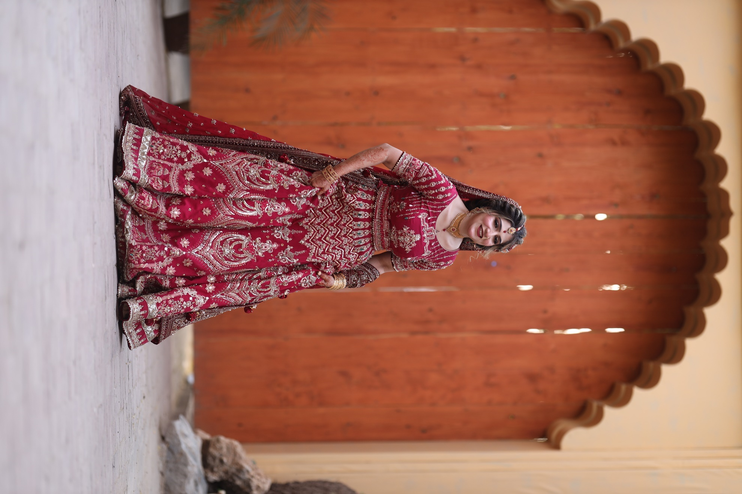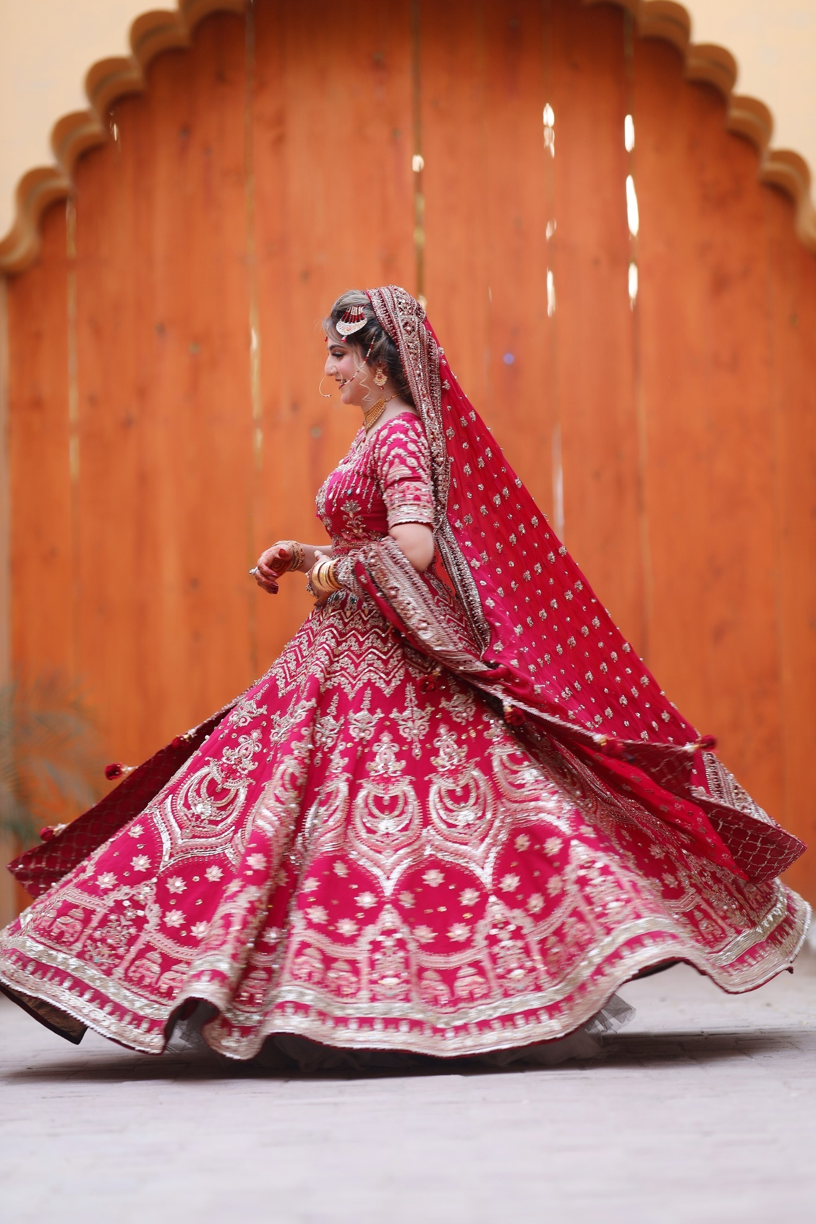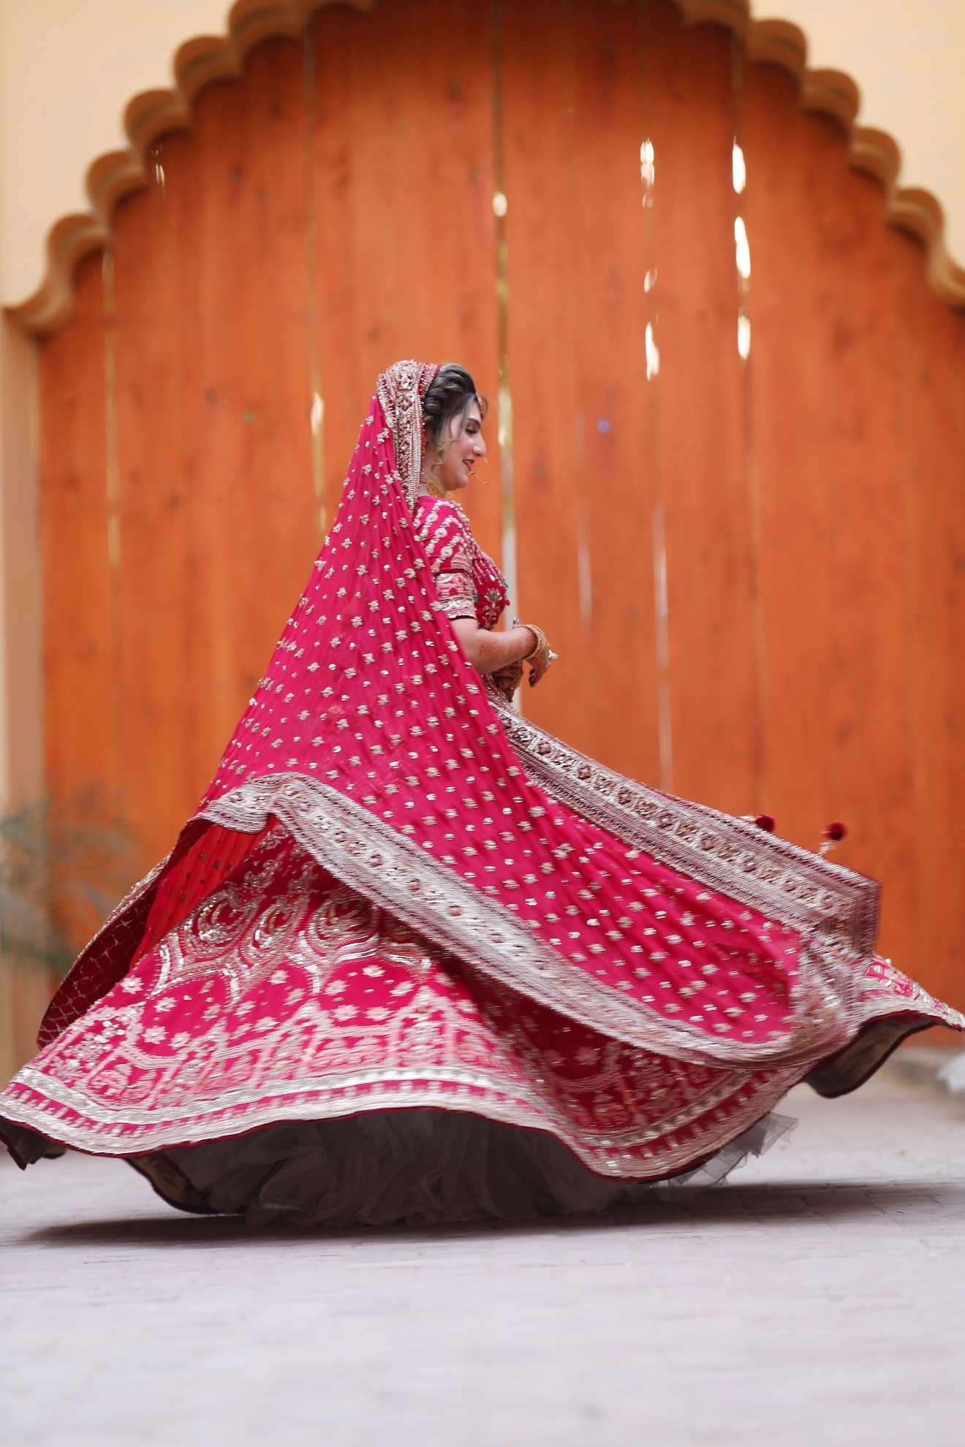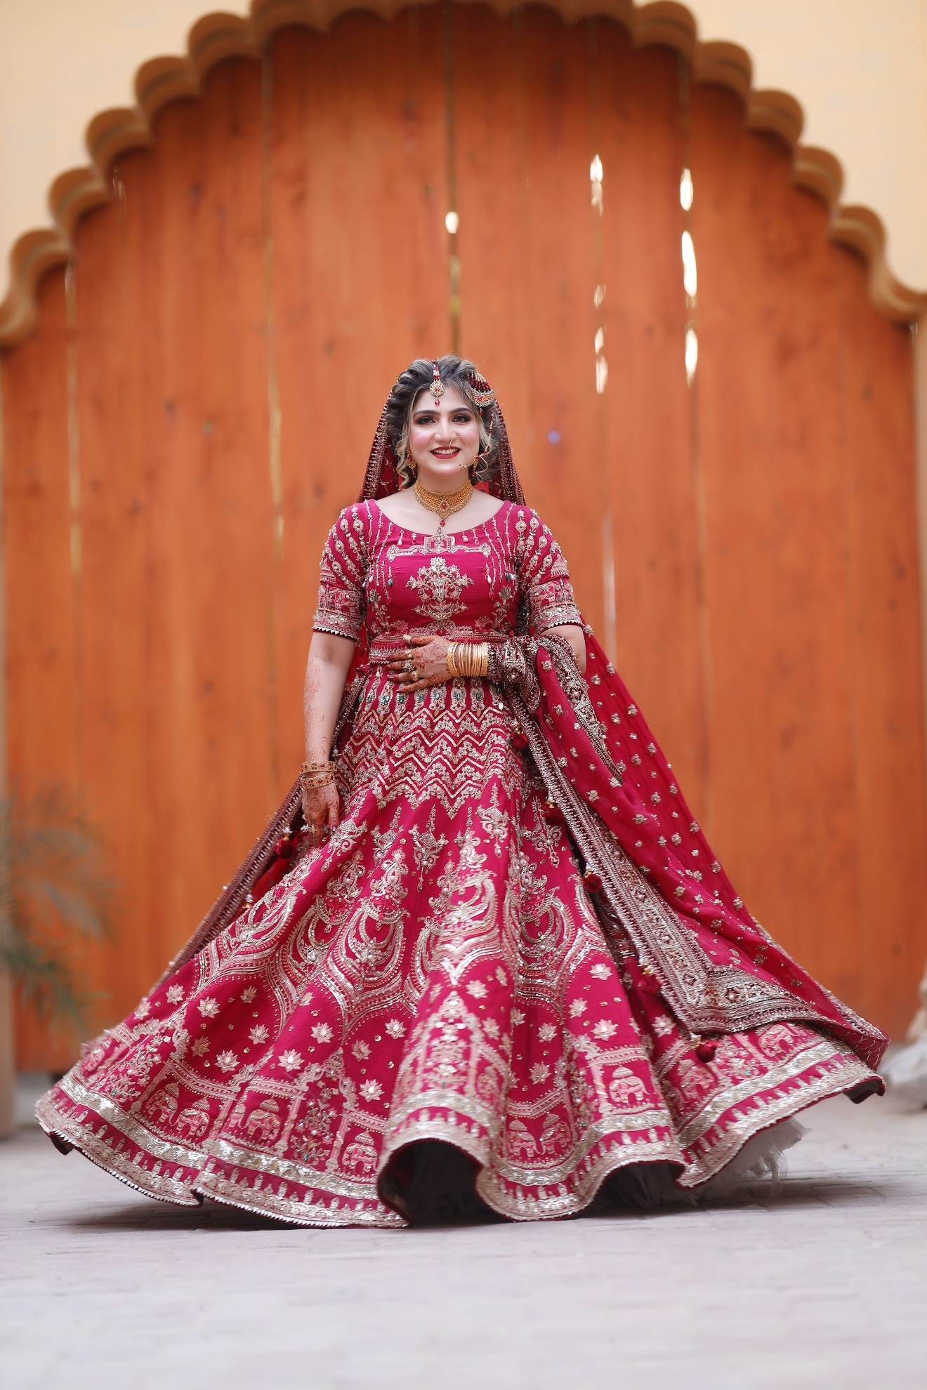

SWOT ANALYSIS

STRENGTH
In my opinion the strengths of Atif Riaz Productions involve:
- giving Salaries and pay checks on time to all the staff, the attractive infrastructure and flexible and work routine.
- Experienced people/ crew and staff and Discipline
- Among all the strengths, the most highlighted strength is that the company allows one to come forward and learn every single technical and non-technical thing whether it belongs to any department or domain.
- The Studio possesses a great reputation built over several years and the clients trust the studio with important days of their lives and also with their brands and marketing campaigns.
- The Portfolio is quite diverse and this thing puts Atif Riaz Productions ahead of their competitors.

WEAKNESSES
- The organization is weak in breaking office politics and grouping, but it is having more professional and experienced people who can make this organization get rid of this type of grouping and politics, which play negative role in the organization.
- The budget of various projects offered to this organization was low or mid-range which leads to difficulty in the execution of the plan.
- The geographic reach of the organization is limited as for now it only operates in major cities of Pakistan is headquartered in Lahore, so, it will be difficult of the organization to expand its operations internationally or nationwide.
- The organization is mainly dependent on key personnels like the CEO and things could get tricky in terms of succession and leadership
- Maintaining modern and high-end Camera and lighting Gear and Software licenses with ever-rising inflation may interfere in the path of success and could strain organizations financial resources.

OPPORTUNITIES
- With the rising popularity of digital media/ social media Atif Riaz Productions can opt for Digital content creation such as music videos and stuff like that and upload on their own social media handles and channels like YouTube and Facebook to earn more revenue.
- The company’s portfolio and area of services is quite wide but still there is more room for diversification of the portfolio like 360-degree video production and there are thousands of other avenues to work in.
- Now that the world has become a Global village and international outreach has become so easy and collaborating with brands, clients and partners beyond Pakistan could possibly open new revenue streams.

THREATS
- Nowadays, there is a lot of saturation and tough competition in media production and marketing industry and this intense competition exerts pricing pressure and erode profit margins.
- The Pakistan’s economy is facing downturn and it has impacted every small and major business in the negative way and this has caused reduced marketing budgets and cost cuttings to stay profitable.
- Rapid advancements in the field of media and Technology may cause equipment obsolescence and continuous upgradation of equipment which is quite costly and failing in do so could compromise the overall production quality.
- The organization usually works and relies on some major clients which poses a risk. If one of them is lost the entire revenue system and stability of the organization is compromised.

CONCLUSION
My internship experience as an Associate Director of Photography (DOP) and Editor at Atif Riaz Productions has been a transformative journey that has significantly contributed to my growth and development in the field of media production. Throughout the internship, I had the privilege of working on different projects, which provided me with practical knowledge and skills in various aspects of the production process, research, and visual storytelling.
During the internship, I actively participated in all stages of the production, from initial conceptualization and research to the final stages of filming, editing, and post-production. This comprehensive experience allowed me to understand the intricacies of creating a compelling content. I learned how to conduct thorough research, gather relevant information, and craft engaging storylines that effectively communicate complex ideas through visual storytelling.
One of the highlights of my internship was the opportunity to collaborate closely with a talented team of professionals, including producers, directors, cinematographers, and editors. Working in this collaborative environment emphasized the importance of effective communication, coordination, and teamwork in achieving a shared vision. I was able to witness the power of collective creativity and how different roles and perspectives contribute to the success of a media production.
Throughout the internship, I applied my technical skills in camera operation, video and photo editing software, and audio recording equipment. This hands-on experience not only enhanced my technical proficiency but also provided me with a deeper understanding of the technical requirements and challenges involved in production. As a DOP, I was responsible for capturing visually stunning footage, while as an Editor, I brought the desired mood and atmosphere to life through color grading and retouching.
The internship also fostered my critical thinking, creativity, problem-solving abilities, and decision-making skills. I was encouraged to think outside the box, propose innovative ideas, and actively contribute to the overall vision of the documentary. This experience has nurtured my passion for storytelling and equipped me with the skills necessary to tackle challenges and make informed creative choices.
In conclusion, my internship as a DOP and Editor at Atif Riaz Productions has been an enriching and fulfilling experience. It has deepened my passion for media production and storytelling while providing me with practical skills and industry knowledge. I am excited to continue my journey in the media industry, leveraging the valuable lessons and experiences gained during this internship to contribute to future endeavors.

