INTERNSHIP REPORT 2023
RB Tech and Games

Time Period: 6 weeks
(July 10th, 2023 to August 21th, 2023)

Submitted to: Ms. Ayesha Mirza
Submitted by: Abdul Rafay Faisal
Registration Number: SP20-BMC-014


MEDIA AND COMMUNICATION STUDIES, DEPARTMENT OF HUMANITIES COMSATS UNIVERSITY ISLAMABAD, LAHORE CAMPUS.

Internship Undertaking:

I, Abdulrafay Faisal, student of media and communication studies department of COMSATS University Islamabad Lahore Campus, under the student ID SP20-BMC-014 solemnly declare that I have completed my internship as a compulsory part of my BS program in my seventh (8th) semester. I completed my six-week internship from RB Tech and Games, in Social Media Marketing. I was keen to absorb new experiences and tried to learn and explore new things.
I hereby submit this report that primarily focuses on my learning from workshop with different departments, working environment of the organization and observation regarding to the organization that I look during my internship period. I’ve tried to elucidate all important aspects I’ve experienced during my internship.
I assure that my report is free from plagiarized content except of the important information that was related to the organization. The source material used in the report is mentioned in reference list at the end of this report. In case of any requirement, I will provide further details.

Abdul Rafay Faisal
ID: SP20-BMC-014
BS in Media and Communication Studies
COMSATS University Islamabad,
Lahore Campus

Turnitin Report:
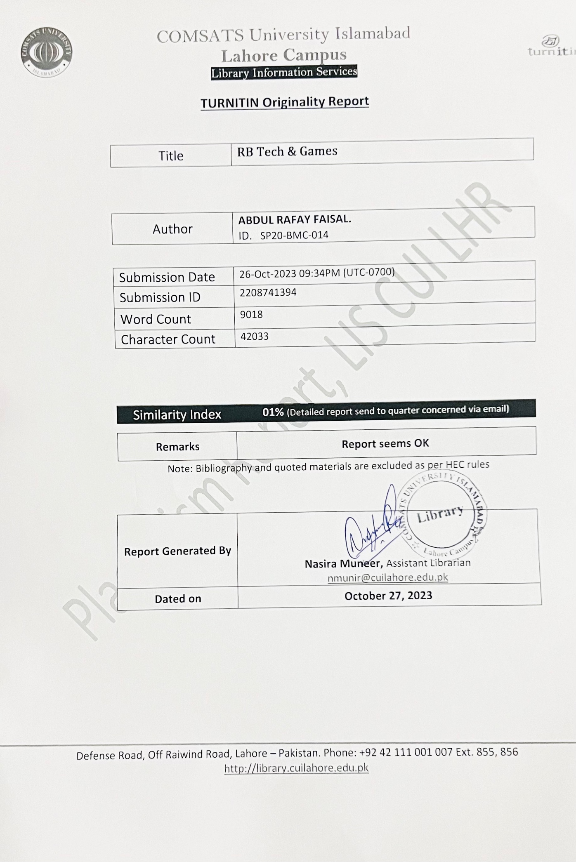

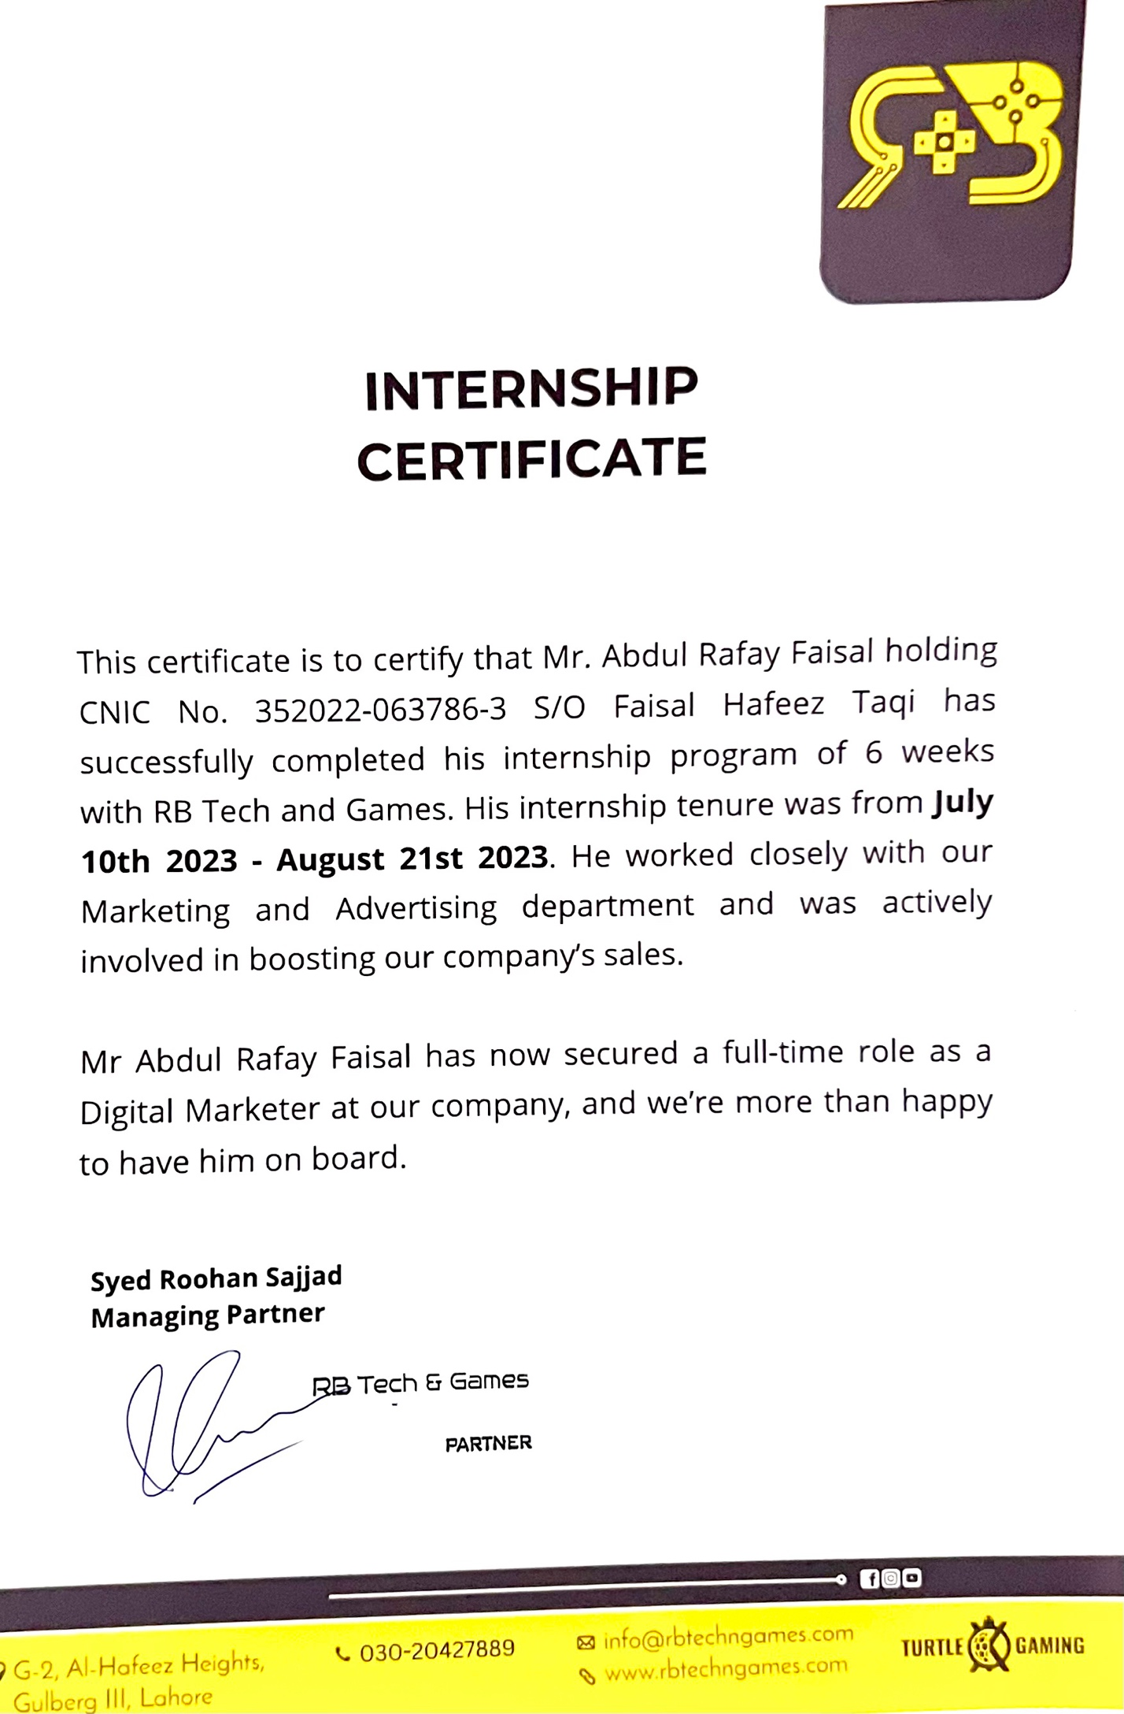
Internship Certificate:

Acknowledgment:

I’d like to take a moment and thank my Internship supervisor Mr. Syed Roohan Sajjad, who, despite being the CEO of the brand itself, took it upon himself personally to supervise my internship and make sure I gained valuable insight in the world of sales and marketing. His guidance throughout my internship tenure made me see things differently. His mentorship has truly guided me at the organization, and I can’t thank him enough for his precious time.
I would also like to thank Mr. Bilal Nasir, the head of Sales at the company who started out as a fellow team member that I was to work under, but quickly became a close friend and peer. Bilal heads the sales department and working with him helped me understand how my marketing and advertising efforts had the capacity to make a difference in the number of sales.
Lastly, I would like to thank the honorable Prof. Dr. Sohail Riaz Rajah who allowed me to pursue an internship outside the circle of our departmental connections. This truly enabled me to make a place for myself at a company where I started from scratch; ultimately being offered a full-time position under the title “Digital Marketing Executive”.
A special thanks to my internship supervisor, Ma’am Ayesha Mirza, who has always pushed me to great lengths because of her profound faith in me, and my abilities. I consider myself fortunate to have been able to work under her guidance, and I look forward to the day when I can get a chance to learn from her again.
Abdul Rafay Faisal

Executive Summary:

RB Tech & Games is a computer hardware retail store that specializes in selling high-end computer hardware used for gaming and video rendering. In addition to its physical retail store, RB Tech & Games also has a website where customers can purchase their products online.
As an intern for their social media marketing, I had an opportunity to gain valuable experience in marketing for their online Presence as well as their website. The Primary page of the company is on Facebook, and by extension, on Instagram. My task was to boost sales through social media marketing. This involved extensive graphics design work on apps like Canva, Photoshop, and Illustrator, as well as creating short-form content such as TikTok and Instagram reels.
Not only that but during my internship, I was also responsible for tasks such as SEO-based content writing for the company’s website. My main goal was to work closely with the sales team of the company to understand what their message was, and how I could best portray that message through my efforts.
This report includes everything I did during my time there, as well as all the things that I learned and understood simply by being out in the field. I’ve also included a reflective journal that demonstrates the day-to-day tasks I was given, and how I believed those tasks helped carve my abilities as a marketer. I’ve discussed my training program thoroughly in this report, and I believe it will be up to the mark when it comes to understanding what the fundamental scope of my internship was. Last but not least, I included some of my work which I had done during this internship, to give you a better idea of how my tasks contributed to the company.
It is worth noting that I included a SWOT analysis right at the end of my report to give you a deeper insight on what I believe are some of the downsides, and upsides of the company followed up with a few recommendations for the company’s betterment in the long run. I believe RB Tech and Games has the potential to become one of the leading retailers in the nation, all it needs at the moment is some nurturing and planning for the long run.
In the conclusion of the report, I’ve mentioned how far the company has to go still, to become one of the leading brands in the nation, however, at the moment, without a shadow of a doubt, the company has come a long way. I remember being a client of theirs not to long ago, and my journey from a client, to a team member has been nothing short of welcoming and fun. The way they handle people, the way they deal, and the way they carry themselves as the pioneers of the industry has truly made me see the market of Pakistan in a different light. I look forward to working with them in the future, and I thank you for taking the time out of your day to read my report.

Table Of Contents
Internship Undertaking: 1
Turnitin Report: 3
Internship Certificate: 4
Acknowledgment: 5
Executive Summary: 6
Company Overview: 8
Partnerships: 9
Organizational Structure: 10
Internship Program Plan: 12
Training Program: 13
Reflective Journal 14
Work Samples: 20
Critical Analysis: 26
SWOT Analysis: 26
Some Recommendations: 27
Conclusion: 28

Company Overview:

RB Tech & Games is a computer hardware retail store that specializes in high-end hardware used for gaming and video rendering. Founded in 2019, the company is based in Lahore, Pakistan, and has built a reputation for providing top-of-the-line computer hardware products to customers all over Pakistan.
If take a closer look at the history of the company, it was started back in 2019 by a young gamer (Syed Roohan Sajjad) who had a dream that one day, Pakistan would also be considered one of the top countries in the world where esports was important. Being the gamer that Mr. Roohan was, he started out selling accessories in his local community and quickly made a name for himself due to his honesty, charisma, knowledge, and nerdiness; something that the leaders of the market were not aware of. You see, in Pakistan, especially in the gaming sector, old uncles have the urge to sell stuff like regular shopkeepers, with a high markup and a stingy attitude. When youngsters meet someone who’s a gamer, who’s friendly, who knows his videogames, and who has a fire in his heart for selling the best, at the best possible price, it is VERY hard to ignore, and that is what RB Tech and Games focuses on.
Sure, the company has competitors just like every other company out there. But the difference is, that RB Tech and Games is a trendsetter, not a follower. With every effort, every advert, and every product, the company’s goal is to provide top-notch service to the gamers of Pakistan. An experience unlike any other. That is also part of the reason why 95% of the company’s employees are young gamers who have a fire for gaming and can relate to the needs of their clients. At RB Tech & Games, customers can find a wide range of products including graphics cards, processors, motherboards, gaming peripherals, and more. The company's goal is to provide the latest and most advanced technology in the computer hardware industry, and they strive to offer competitive prices and excellent customer service. The company's website also offers customers the convenience of shopping online and having products shipped directly to their doorstep. In addition to its products, RB Tech & Games is known for its commitment to customer satisfaction. The company's knowledgeable and friendly staff are dedicated to helping customers find the right products for their needs and are always available to answer questions and provide support. RB Tech & Games also recognizes the importance of giving back to the community. The company participates in various charitable initiatives and events to support local organizations and causes.
Overall, RB Tech & Games is a reputable and reliable source for high-end computer hardware, with a commitment to providing exceptional products and service to customers all over Pakistan. The company motto “Make Every Paisa Worth” speaks for itself. In a country like Pakistan where sellers more than often misinform or scam the buyers, RB Tech and Games promises to offer the best bang for your buck, when it comes to the latest and greatest tech in the industry.

Partnerships:

As a pioneer in the industry, RB Tech and Games has built partnerships with global partners that are considered leaders of the industry. When a company like this affiliates itself with industry-leading brands, the question of credibility is thrown right out the window. Some of these brands have been around for decades, and others can’t wait to grow with the endorsement of RB Tech and Games.
- RB Tech X Pakistani PC Gamers
The Pakistani PC Gamers community is a group on Facebook that encompasses well over 100 thousand members from all over Pakistan. This group has been around for a long time and has officially partnered with RB Tech and Games after the profound love shown to the brand by their community. The group hosts yearly contests for the best seller award in different regions of Pakistan. A handful of stores are chosen by the community, and then the community is asked to vote on who the best seller is. RB Tech and Games has been lucky enough to successfully be titled as the best seller for 3 consecutive years (2020, 2021, 2022). This is without a doubt, one of the best achievements made by the brand because it directly involves endorsements made by the community. When customers start vouching for you and the level of service you provide, that is when you begin to understand that you’ve made an impact in the market with your presence.
Furthermore, it is important to note that ever since RB Tech and Games has become a partnered store, the Pakistani PC Gamers (PPG) community has pushed flash deals and limited-time offers to their consumers on their behalf, which has ultimately boosted sales and targeted a wider audience. Not only that, but PPG has also gone ahead and given RB Tech and Games an official role on their Facebook group, which allows the brand to establish its own presence and publish its own posts and content. This is a major thing to commend, and RB Tech and Games cherishes this connection with the management over at the PPG community.
- RB Tech X Logitech
Logitech is a company that has been around for a long time, and recently RB Tech and Games became the official distributor of Logitech, and that came with a few perks. Not only does the brand get to claim exclusivity over the first releases of new items, but RB Tech and Games also gets an exclusive 1-year local warranty that they can extend over to their consumer base, granting them an edge over their competitors.
- RB Tech X Gigabyte
Another behemoth of the industry, Gigabyte is an industry leader when it comes to the production of motherboards and graphics cards. People with caught off guard by RB Tech and Games’ partnership with Gigabyte simply because Gigabyte was one of the few brands that was not easily available in Pakistan, however, after their partnership with RB Tech and Games, Gigabyte was immediately greeted with love when it hit the Pakistani market with tier A products.
- RB Tech X Silverstone Technologies
One of the most profound brands in the realm of PC power supplies, Silverstone has been around for decades in the Western market and has recently partnered up with RB Tech and Games to bring forth their latest addition to the Pakistani market. Upon their partnership, RB Tech and Games gained an exclusive extended warranty that included damage protection as well. And for a nation like Pakistan where power outages and surges are frequent, this was a major plus point for anyone buying Silverstone directly from RB Tech and Games.

- RB Tech X TCS
RB Tech and Games is a brand that relies on delivering a top-notch experience to its consumers, and who better to help deliver that experience than the household name TCS? With the official partnership of TCS with RB Tech and Games, it has been made possible to deliver products all across Pakistan in a matter of nights. Usually courier services take a few days, and more often than not damage the product in shipping, however, RB Tech and Games gained an exclusive edge, where the local TCS office ensures extra care and safety in each package that was dispatched by RB Tech and Games. This again, provides an added bonus to the end consumer who would want to shop with the company but is fearful of the product being damaged in transit.
- RB Tech X ADATA
ADATA is regarded as one of the pioneers when it comes to storage solutions and RAM modules. RB Tech and Games was lucky enough to partner up with ADATA Pakistan to bring the best of the best ADATA products to its consumers a few days after their global release. Furthermore, with ADATA’s endorsement of RB Tech and Games, they too, provided an extended warranty period over all of their products, giving their consumers a bonus 2 years-worth of limited warranty during which the consumers are entitled to a free replacement or refund, in case their product is deemed faulty or defected.
All in all, I believe RB Tech and Games partnering with so many global and local brands is the perfect example of growing a company in the right way. Some of the brands here have been around for more than a few decades, which is why affiliating with them is the perfect way of building brand loyalty and credibility. While a lot of consumers in Pakistan today fear falling for scams and fake products, I personally feel like having your company partner up with another is a way of eliminating that fear from the minds of your consumers.
Not only that, but by bringing exclusive offers to your consumer base like extended warranty, damage protection, and so on, you preserve the consumer’s will to be with you and choose you as the brand they do business with.

Organizational Structure:

The organizational structure for RB Tech & Games as a retail store includes the following:

- Board of Directors – responsible for overall governance and strategic direction of the company. These were the metaphorical captains of the ship that steered the fate of the company. From budget allocation to advertising strategies and operational improvement, the board of directors had their hands full with the strategic side of things.
- Executive Team – top-level management responsible for day-to-day operations and decision-making. This team was responsible for product acquisition. A new product just hit the market? This team’s task was to understand whether or not we should acquire it for resale.
- Sales and Marketing Department – responsible for developing and executing sales and marketing strategies to drive revenue and growth. I consider this department my own simply because of the hours I put in, however, it's safe to say that this department is one of the few departments of the company that have a direct impact on the performance of the company. The better and higher the quality of the marketing efforts, the more revenue generated by the company.
- Website Development Department – responsible for designing, developing, and maintaining the website. Another USP is RB Tech and Games’ strong online presence. With their website, clients get the chance to browse all the latest and greatest products with a few clicks away.
- Operations Department – responsible for managing logistics, inventory, and supply chain operations. It is paramount to make sure that the inventory is kept track of simply because the tiniest of things have the highest value. Apart from that, making sure day-to-day operations go smoothly is very important in ensuring client satisfaction.
- Warranty and RMA Process Department – responsible for handling product warranties and customer returns. One of the main USPs of RB Tech and Games is their aftersales service which includes a quick and smooth warranty claim procedure. Even if the company is losing money, it doesn’t matter. As the customer, your replacement will be validated and our word will be kept.
- Finance and Accounting Department – responsible for managing financial operations, including budgeting, forecasting, and accounting. These folks love their numbers, and without a doubt, serve as the pillars of the company.
- Customer Service Department – responsible for managing customer inquiries and providing support. The CX department is one of the fundamental departments that ensures the customers are taken into consideration.
- Human Resources Department – responsible for managing personnel, hiring, training, and employee relations. By far the most important department simply because it ensures synchronization between the various teams of people who work closely together to keep the metaphorical cogs in order.
Now that we’ve got a basic idea of how the company is divided, let's take a look at how many employees there are, in total. The organization has employed almost 20 people, and it is worth noting that the monthly sales with these many people are roughly around 30 million PKR. As a business that started back in 2019 with one man, and his dream to cater to the gamers of Pakistan, that is a massive feat to accomplish.
My opinion, I strongly believe that the backbone of the company is the sales and marketing team, which aims to make sure that people look no further away than RB Tech and Games for all their gaming and tech needs.

Internship Program Plan:

As a Social Media Marketing intern, I had the opportunity to work with a team of experienced marketers and gain hands-on experience in social media marketing. Over the course of the six-week internship program, I learned how to use Meta for Marketing via Facebook and Instagram. This also allowed me to dive deep into the realm of paid advertising. As the brand was solely focused on staying true to an organic approach, with my help, we were able to launch a paid advertising campaign that highlighted the mission of the company through social media posts. The aim is to spread awareness about the company and highlight the USPs that make it different than its competitors.
My internship duration was 6 weeks, which started on the 10th of July, 2023, till the 21st of August, 2023. As mentioned earlier, during this time I worked in the marketing department where I initially started off as a content writer for the company’s online presence. My English writing skills as well as prior knowledge in keyword-based content writing were taken into consideration by my supervisor, and thus, I was tasked with managing the company’s Meta presence. This involved day-to-day status updates, as well as scheduling posts that showcased the frequent PC Builds that were made for our clients. This was my initial task for the first two weeks.
After the two weeks had passed, my supervisor had taken my skills as a videographer/editor into consideration and asked me to start making Instagram reels for the brand's Instagram page, which has over 4,000 active followers. The goal with this was simple, create decent, aesthetically pleasing reels that showcase the premium products that were being offered, and to make sure we did it in style. I have to say, I was pretty good at making those, with my reels averaging well over 2-3K average views in the 1st 24 hours of publishing. This, in turn, boosted our page’s reach and helped us garner more leads. After that, I was tasked with gaining a new skill; website management. While my primary tasks were still related to my domain (social media marketing) I was asked to pick up some new, worthwhile skills like WordPress management.
Through the use of plugins like WooCommerce and Yoast, my tasks were made relatively simpler. To assist in adding products to the company’s website and utilize my SEO-based writing skills to write optimized descriptions for these products. You see before I joined, the company hadn’t made efforts to improve its online presence as the growth of the company was at a slow and gradual pace, but with a few tweaks in its website, some hashtags in its posts, and a strict day-to-day posting schedule, the online presence of the brand was at an all-time high.
Lastly, as I was beginning to understand the basics of managing a website, I was tasked with helping redesign the website as well, due to my prior knowledge and skill in graphics design. This allowed me to brush up on my Photoshop skills, while also learning how WordPress-based websites are made, and how the theme of the website can be altered based on the brand's requirements. Sure, it is a bit hectic and confusing, but with a little bit of YouTube and a lot of dedication, I managed to learn it all on my own. From designing all the banners on the official RB Tech and Games website to the content on their pages, I slowly but surely made my way when it came to establishing an online presence that was heaped above any of our competitors.

Training Program:

My time over at RB Tech and Games has been nothing short of welcoming. I still remember the very first day I met my supervisor, who was the CEO of the company and since I was a fresh new intern who had just been told he’d be mentored by the company’s CEO, I was caught off-guard. However, after my initial meeting with Mr. Roohan, it became evident that his mannerisms with me, or any of his employees, didn’t really feel like an employee-boss relationship, but rather a discussion with a friend or a brother. That’s something I caught on to and admired right from the get-go.
In today’s day and age, it is very rare to find a person or a company that treats interns with respect and actually seeks to guide them and hone their skills. But I for one, was a very lucky person. It is without a shadow of a doubt that my knowledge in gaming and tech definitely helped me make a name for myself, as I did not have to struggle like some of the other interns who managed to secure the internship but were too uneducated about the intricacies of gaming or computers to catch on. I was asked to strictly observe the sales team at the start, and learn how to interact with the clients that came in. While yes, my internship focused on Social Media Marketing, I was also to work on improving customer experience and understanding the basics of dealing with a client, whether it be an individual or a corporate client.
Mr. Roohan was not the type of supervisor to push orders, instead, he’d ask me to give him my insights and observations and recommend fixes. For instance, one of the main things I immediately caught was the non-regular posting schedule, as well as the poor grammar and poor-quality images that were regularly posted on the company’s Facebook/Instagram pages. Mr. Roohan took the immediate liberty of granting me access to the brand’s Meta platform, allowing me to make changes as I see fit.
This allowed me to take matters into my own hands and I created a regular posting schedule that used high-quality images and videos that I recorded myself, of the company’s PC builds, along with professionally written captions and top-reaching hashtags that brought all the more attention to our posts. Furthermore, I advised Mr. Roohan to start advertising the company’s efforts on Facebook pages, most notably the Pakistani PC Gamers Community page Facebook which has a massive following of well over 150K members on their socials. Once I got the go-ahead for this, I used Meta to post our daily posts on Instagram, and Facebook, as well as the Pakistani PC Gamers page to gain a massive influx of reach on our Facebook page. Not only did this boost our sales and lead generation, but since our reviews were kept positive, the community welcomed us with open arms.
Speaking of reviews, as I was responsible for making sure our online presence was top-notch, I took a moment to create a custom “Drop a Review” link for our Google Business page. After getting access to the Google Business Profile from Mr. Roohan, my goal was simple. Just get people to drop a review that’s honest. My focus wasn’t simply on the good reviews, it was on the bad ones too, and I made a habit of replying to every one of those reviews to make sure the clients felt heard, and the issues were sorted. When I started pushing for reviews, we were at around 30-40 reviews in total, however, at the moment, we’re easily sitting at 325 Google reviews with a solid 4.9 Star rating.
One of my own personal missions was to make a name for myself in the community and have my clients want to deal with me directly. And I have to say, my efforts in marketing did not go unnoticed. Our clients kept mentioning how the marketing efforts made were just spot on, and how RB Tech and Games has quickly gone from being a local brand to being a brand that offers a one-of-a-kind “western level” service. This right here is the reason why my skilled English writing helps, and that skill hasn’t gone unnoticed by Mr. Roohan.

I was quickly assigned to make a new “Blog” section on the brand's website that not only pushed the website’s SEO ranking, but also helped our clients solve their issues, or educate them on worthy topics. For instance, is the summer approaching? Perhaps you might want to look into some new methods to help keep your PC cool. Another example could be the top 5 ways to troubleshoot your PC. I wrote two types of blogs, a basic How-to type of blog, and an extensive guide. Not only that but to boost our website traffic and ensure our blogs were being read, I would design Facebook/Instagram posts that would include a link to the blog page. Doing this prompted the user to quickly hop into the blog and give it a read.

This way of persuading the end user to read our blog updates proved very beneficial, as we were able to quickly share the latest and greatest happening in the tech industry with our followers who paid close attention due to the regular updates on our blog page. The fact that I could be utilized in a number of different domains and be nicknamed that jack of all trades was an honor in and of itself. This meant that I had all the necessary skills needed to market the brand not at a small scale, but at a much larger scale than intended.

Looking at my drive and urge to gain as much knowledge as I could, Mr. Roohan decided to lend me his Udemy Account which had a premium membership, granting me access to millions of different repositories from where I could get knowledge. I took this gesture very generously as I know not everyone goes out of their way to mentor an intern like this. I completed a few SEO-related courses there and that really helped me polish some of the things I was missing in my work, ultimately allowing me to iron those mistakes out.

Reflective Journal
Date | Day | Task | Dec. | Interpretation | Plan
July 10 | Mon | Observe the sales team | TO observe how the sales team conducts their day-to-day business and how a client is looking to be treated. | This is a very decent way to understand how dealing is done. | I think sticking to a “customer is always right” mentality will go a long way.
July 11 | Tue | Analyze the company’s social media pages | To analyze the company’s online presence and make sure there are no flaws. | This is a very well-needed analysis that will give me a clear path to work with. | I’ve already changed all the flaws that I could find and fixed up the errors.
July 12 | Wed | The task was to engage with clients online and cater to their needs | The goal was to speak to clients on the company’s WhatsApp number and answer their queries. | Allows me to understand how to deal with clients on WhatsApp and serve them. | I need to be done with other tasks before I take this on, as it drains energy and time.
July 13 | Thurs | Analyze the company’s competitors | RB Tech and Games has a handful of competitors that are present in the area. The task was to analyze them, and their weaknesses. | By far, one of the best ways to spice up our online presence is to understand our competitors. | Seems to me like this will work well and give my supervisor an edge in understanding what we’re dealing with.
July 14 | Fri | Create a content plan | A well-needed content plan is required in order to push sales at a constant pace. | Creating a plan and a schedule will help us stick to a track and not stray. | Sticking to a cloud-based online planner would be the best possible way of adhering to a strict timeline.
July 15 | Sat | Do some research on Hashtags | Through the use of Hootsuite, I was able to do some research on the top hashtags to use. | Through the use of external software, we’d be able to better achieve our goals. | Using Hootsuite I’d be able to understand what hashtags are training and use those accordingly.
July 16 | Sun | - | - | -
July 17 | Mon | Create some eye-catching designs via Canva and Photoshop | Both Canva and Photoshop were bought and paid for by the company, and using these tools has been a blast. | With my experience in design, creating eye-catching ads is going to be beneficial | Canva is fairly simple to use and is probably the fastest way of designing efficiently.
July 18 | Tue | Schedule some posts on Meta in advance | In order to keep the log clear of previous, I was asked to schedule posts in advance on our FB/Instagram page as well as the Paki Gamer community | Scheduling posts in advance on Meta will allow us to be ahead of time in terms of our posting schedule. | Posting in advance is a time saver!
July 19 | Wed | Meta engagement | Due to the prior posting on meta, there were countless quires that were looking to be answered, | Since Facebook is our primary page there are a lot of queries that were catered to.
July 20 | Thurs | Review the page’s analytics and understand the errors | I was asked to do my own fair bit of research into WordPress analytics. | There were some SEO-based website errors that were overlooked. | Opting for Google to crawl through the website and find the issues is perfect.
July 21 | Fri | Reach out to some potential influencers for marketing | Reaching out to celebrity influencers is a bit of an issue at first, but once I that line, I was able to reach out to Arsalan Ash, the Tekken champion of Pakistan. | As Arsalan was globally known for being a Tekken champion, he’d be a great fit. | By far the best way of getting endorsed.
July 22 | Sat | Create some new content with the help of an influencer | To come up with a few content video ideas that could be worked on with the help of Arsalan. | Collaborating with Arsalan on a video would be a great way of getting our content creation kick-started as well.
July 23 | Sun | - | - | -
July 24 | Mon | Create some short video content like an Instagram reel | Create an aesthetically pleasing shot of the products and provide a decent cover picture | Instagram reels are the future and definitely help in creating reach.
July 25 | Tue | Create some polls on Meta stories to boost engagement | Polls are an excellent way of gathering reach and click on your Instagram post. | Creating such an engagement between audiences is a great way of getting people to communicate.
July 26 | Wed | Social Media Advertising via status updates and designs | I would need to take photos and record videos and have them posted on our official Instagram. | Taking day-to-day videos and photos is a great way of letting people what the new items in stock are.
July 27 | Thurs | Creating a unique, silent aesthetic reel | Another silent yet unique reel is to be created | More focus is built up around a new product.
July 28 | Fri | Muharram Holiday | - | -
July 29 | Sat | Muharram Holiday | - | -
July 30 | Sun | - | - | -
July 31 | Mon | Host a social media giveaway for reach | The most effective way of garnering an audience is by offering a product. | Giveaways can be a great way of getting back to the community
Aug 1 | Tue | Hop on Instagram Live and answer some questions | This was an interactive session with myself as well as my colleague who answered our client’s random queries. | Let the people know that there are like-minded, relatable people on the other end ready to assist.
Aug 2 | Wed | Content refresh | Dig out all the previous content created and check to see what can be salvaged. | Helps us make sure nothing is wasted, and everything is repurposed.
Aug 3 | Thurs | Creating a story Highlight | Shines a light on the brand-new products available | Doing a highlight story pushes a product to the limelight, ultimately boosting sales.
Aug 4 | Fri | Creating a user survey | This sort of survey allows us to understand what our clients look for, and how they may be unsatisfied. | No business is successful and every business has room for improvement. The goal is to hear out what the issues are and work towards a fix.
Aug 5 | Sat | Posting a customer review | Posting a customer’s endorsement is a great way to boost morale internally and externally. | Allows people to see others and their experiences with the brand.
Aug 6 | Sun | - | - | -
Aug 7 | Mon | Client Setup Reviews | Here, we can take people's setups at home and highlight those in our stories. | Motivates others to improve their systems and their setups with our help.
Aug 8 | Tue | Meta query management
Aug 9 | Wed | Designing some new stories
Aug 10 | Thurs | Creating a post for 14 August in advance | Creating an awareness post to reach | I was assigned to create an awareness post for 14 August as part of the national day.
Aug 11 | Fri | Making a new Instagram reel
Aug 12 | Sat | Making some website Banners | Since I was tasked with website assistance, I made some new banners. | Eye-catching banners play a huge role when it comes to where the client clicks.
Aug 13 | Sun | - | - | -
Aug 14 | Mon | Launching some 14 August deals via community posts | Creating 14 August deals is a great way to entice the clients with some new deals.
Aug 15 | Tue | Utilizing meta to create scheduled posts
Aug 16 | Wed | Creating Gaming Polls on social media stories | Polls have proven to be helpful, which is why they’re used yet again
Aug 17 | Thurs | Creating a storytelling reel
Aug 18 | Fri | Launching a new flash deal | In order to liquidate some inventory, a flash deal is launched with staggering prices.
Aug 19 | Sat | Announcing a collaboration with a content creator | Collaborating with yet another content creator Brownlad Hussnain
Aug 20 | Sun | - | - | -
Aug 21 | Mon

Work Samples:

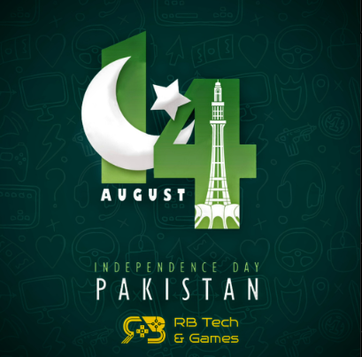

Added above is a design post I made for 14 August. The goal with this was simple; to promote RB Tech and Games celebrate the national day and launch some Azaadi deals on our best-selling items.

My key contribution here was the addition of Azaadi Deals. The thing to understand with sales is that people can’t help themselves when they are told that there are savings to be made. They splurge on getting the best of the best, and launching deals on such events is more than often the best idea.

Eid Al Adha Post:

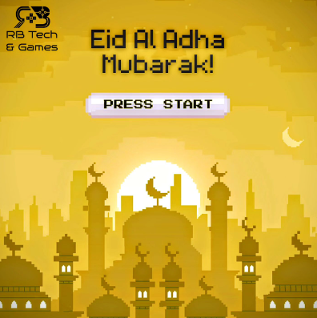

Here is yet another post I designed for Eid al Adha. The pixel-popping theme is in line with classic retro videogames, and therefore it was received quite well by the audience. As I’ve always fixated, on the company’s designer, my goal was to always make sure I focused on creating designs that could speak to the people who see them. When a gamer sees this image, they’re quickly reminded that yes, this is RB Tech and Games, this is what they’re all about. As soon as they see that yellow and black theme, they should know that RB Tech and Games is there to play.

Digital Campaign:

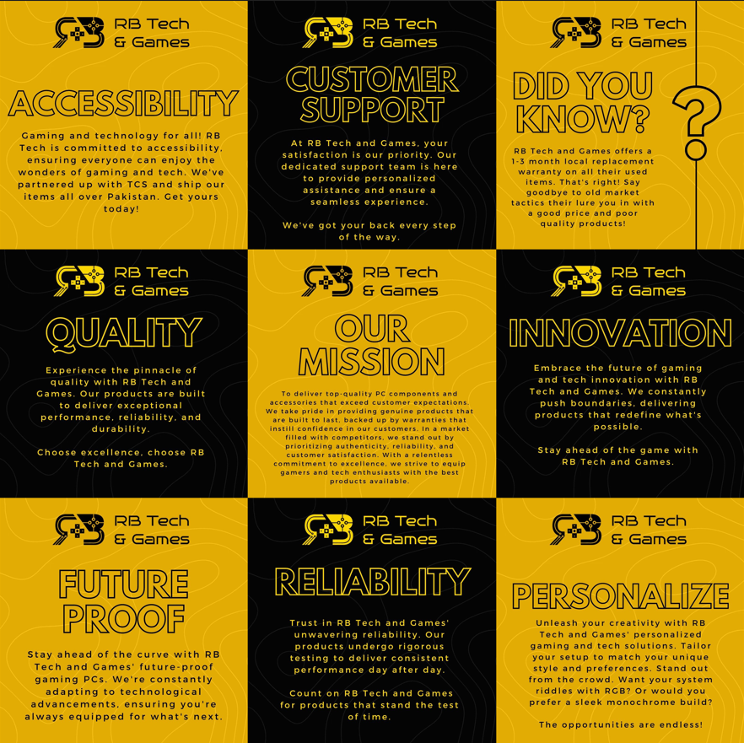

The images above were a series of 9 separate Instagram posts that were strategically created to form a grid of missions that the company set out to achieve. The goal here was to create a positive association of the company, with each of the words in the post. This campaign was successful and gained a lot of traffic on the company’s various social channels.

This was by far one of the most fun and anticipated endeavors I worked on, during my internship tenure at RB Tech and Games, This was simply due to the fact that our competitors always focused on selling, selling, and selling. I quickly understood that while they were focused on selling, we were focused on building a company, a brand, and that we needed to let everyone know that when it comes to the best, there’s no one else that would rather be at the top. This is why I created this campaign to push the company’s goals. These goals, as simple as they may seem, are the pillars that keep RB Tech and Games from becoming just another retail store that offers gaming items.

Website Banners:
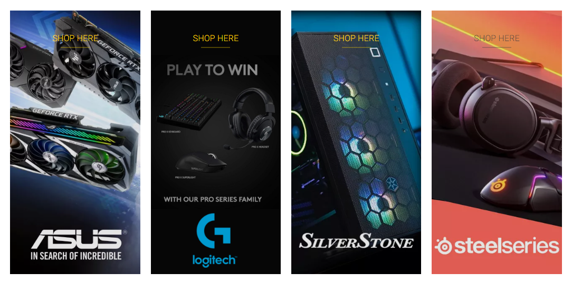


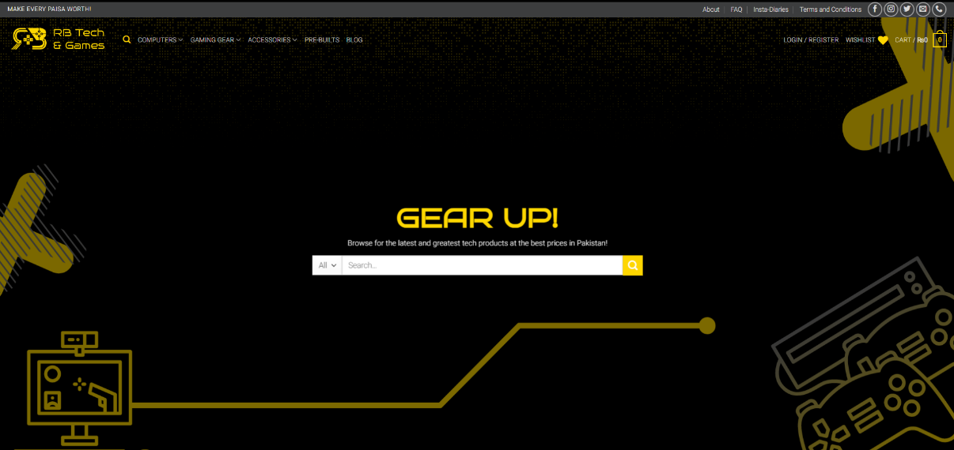
Added above are some of my website banners that I made to improve the overall look and feel of the website. The banners I made in specific were meant to be simple, yet elegant and provide a modern look and feel to the brand’s website. My goal wasn’t to be flashy or to be over the top, but I believe I managed to capture just the right amount of sleekness and elegance.
With the website banner, I was allowed to go crazy and use different styles and methods. I created a live motion banner as well, however, that proved a bit too heavy for our website’s server to manage, which is why I went back to using standard static banners. These banners change frequently from time to time and showcase some of our finest products and collaborations.
Blog Posts:
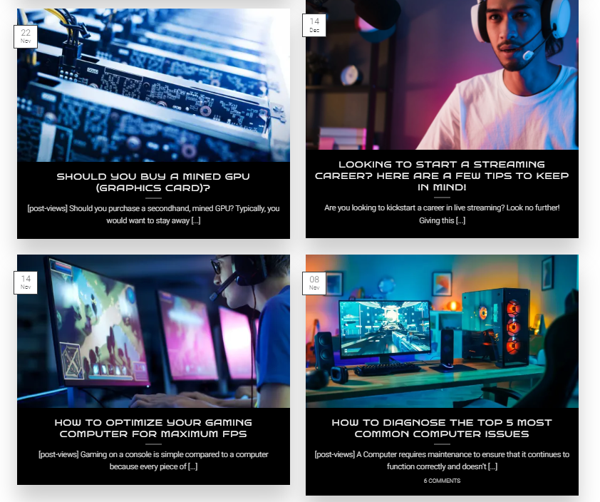
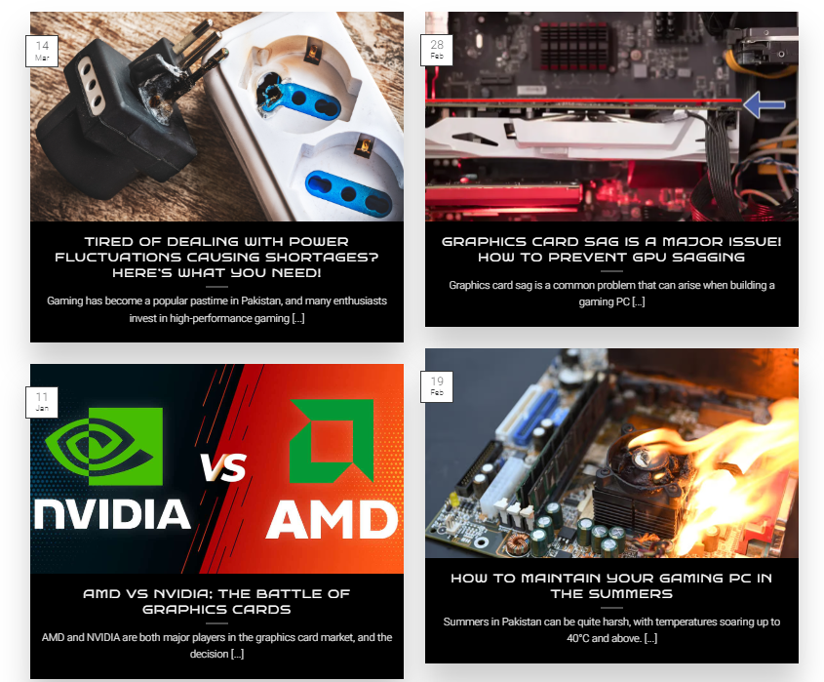

Above is my contribution to establishing the “blog” section on RB Tech and Games’ official Website. As you can see, the goal of creating a “blog” was fairly simple, and it was to educate our audience and have them understand the fundamentals when it came to gaming computers. You see, a lot of our competitors take advantage of people, and play on their lack of knowledge when it comes to the tech world, that was our sole purpose behind starting this blog. You wouldn’t need to visit random people to do the most basic of things if you would pay a visit to our blog.

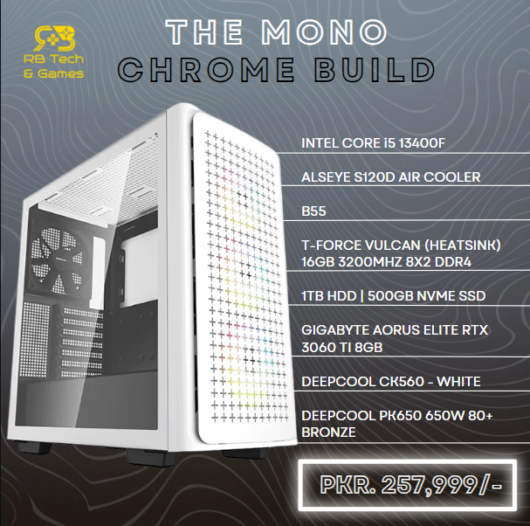
Build Posts:
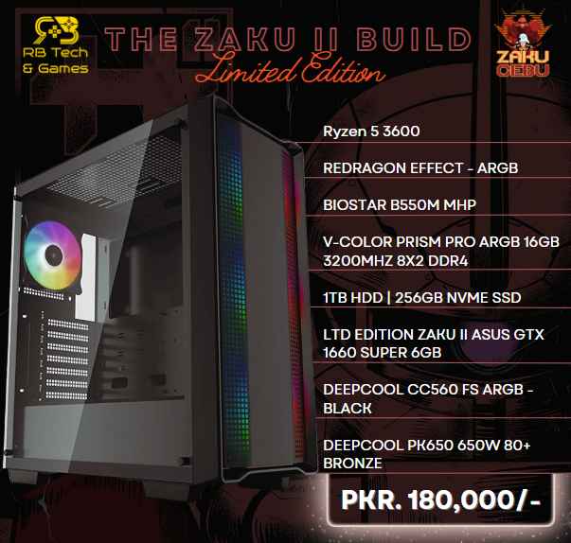

This is another one of my efforts. When I first started my internship, it came to my attention that since Rb Tech and Games was a dedicated custom computer store, the brand was basically targeting enthusiasts who knew what component went where, and what the end result and cost would be. So, my idea was to target the ones that had no idea what the gaming computer scene was about. This involved a lot of research and planning, but I was able to come up with two custom-made pre-built computers that we would be able to offer our clients. These were all set up from scratch and were strictly targeted at the lower portion of the demographic that didn’t know what to choose or where to begin. Furthermore, I ended up targeting the best price points as well, for these two systems. At the prices I used above, a new person would easily be able to understand what they’d be getting, at that price point. Not only that but upon a closed inspection of previous newcomer builds, I was enlightened that newcomers to the custom PC world often have a budget that starts around 175-180K and goes all the way up to 250-260K. That is part of the reason why I opted for two specific options aimed at different people with different needs.
One of the key points to take into consideration during this time is the fact that my supervisor pushed me to try new things. He didn’t ask me to stick to a pre-defined set of tasks, and that is something that allowed me to experiment with things, and understand what our community looks for when shopping. It’s the little things that slowly yet surely create an impact, and as a marketer, it was one of my top priorities to ensure those little things didn’t go unnoticed.

Product Catalogue Stories:


Since my focus was social media marketing, I aimed at pushing sales through social media. And to execute that, I came up with the above-included ways. Creating a catalog-styled story, and pushing it on Facebook and Instagram with the website link included as well, boosted our sales greatly, and even if we didn’t end up selling the products, I generated a lot of leads this way.
Again, as mentioned earlier since RB Tech and Games is regarded as the pioneer in the industry, other competitors quickly took this into consideration and began using the same styled methods as ours, on their own pages to promote their products, but truth be told, I’m proud of my work already since it was adopted by others. It’s only a matter of time before we bring out something else and cause panic among our competitors.

Critical Analysis:

I believe that a company like RB Tech and Games was something that was long overdue for the gaming community of Pakistan. We deserve way better representation in the gaming sector, however, sadly our government and economy fall short when it comes to their support. As far as my experience goes, I can safely say this for sure, I’ve learned a lot from RB Tech and Games, and thus, I’m able to apply this knowledge and various aspects of my day-to-day life.
As I’ve mentioned before, RB Tech and Games is the trendsetter within the industry, not only does it elevate the experience of its consumers, but it makes sure to go the extra mile and ensure customer satisfaction. That’s a level of management that is not common here in Pakistan, but RB Tech and Games makes sure of it. The environment is friendly, the people are amazing, and the management is nothing short of familial when it comes to guidance and support.
Not only that, but being with them, I was able to contact some of the leading influencers in the gaming niche like Arsalan Ash, who’s a world champion Tekken player, as well as Brownlad Hussnain, a YouTube with a massive following. As far as my personal development goes, I’ve learned how to manage my time far more effectively, I’ve learned how to conduct myself professionally, I’ve learned how to cater to the clients, and most importantly, I’ve caught on to new skills that allow me to excel in my field of marketing and advertising.
This opportunity is not one that comes by every day, and I’m thankful to the management for their hospitality and nurturing behavior. I look forward to crossing paths with the team soon again and am more than excited about what the future holds.

SWOT Analysis:

Strengths:
RB Tech and Games is one of the very few stores that is built for gamers, by gamers. This means that the typical buyer-seller dynamic is thrown out the window. As a gamer, one can make suggestions that differ greatly from those of your average seller who is just looking to sell their product at a margin. But one thing to keep in mind is that the aftersales services are what make RB Tech and Games stand out from the rest of the competition. No one goes out of their way to replace a product even if it is out of warranty, however, if the terms of your warranty apply, the management will give you a replacement no questions asked, and that is one hell of a bargain.
Furthermore, it is worth noting that the target demographic varies heavily, and is focused more towards people residing in DHA/Bahria, rather than your average consumer, which again, is not a bad thing. It just goes to show that the target demographic is a type that is relatable to the employees of the store.
Weaknesses:
Since the company is still in the beginning stage of growth, there is a lot of room for improvement, but there is room for failure as well, and it is important to note that without constant and consistent efforts from the management to improve the functions, there is a high chance that the growth will remain stagnant.

Opportunities:
Since RB Tech and Games is regarded as the trendsetter, there are a lot of ways in which the company could excel and leave the competition in awe. For instance, using their USPs is a decent way of offering a new service. An example of this could be the recent expansion of the company in the Laptop sector, which has drastically boosted sales and revenue.
As I’ve mentioned before, the company is one of the few in the space of gaming to be considered an actual trendsetter. The competition is eager to quickly adopt many of the proposed and implemented ideas that RB Tech and Games has had and as far as that may be considered great, the fact of the matter is, the company needs to play to this strength and implement well thought out strategies that introduce next level communication with the clients.
For example, one of the gaps I bridged, while I was there was the communication between the brand and the consumers. I used social media stories to host Q&A sessions and then post responses to the queries on the brand's official Facebook/Instagram page. What this achieves, is not only a channel of communication between a company and a consumer, but rather, establishes a reliable network of different people reaching out, and knowing the company will respond to their questions. It is not very often that a company takes time out to answer their community’s questions, and that is why I believe pushing and making strives like these is paramount to the company’s growth and survival.

Threats:
One of the biggest threats, in my opinion, has to be the stagnant growth yet again. If the company stops growing, the employees will be compensated less, and if they’re unhappy, then it is only a matter of time before things go sideways. Furthermore, without pushing into sustainable content like YouTube, I believe that as a company, RB Tech and Games is missing out on a huge chunk of the potential market. This is simply due to the fact that a lot of kids and adults surf YouTube, and are bound to come across a video every now and then. Instead of having those videos be random, the company could look into expanding and creating its own YouTube presence, with behind-the-scenes vlogs, build guides, or even podcasts discussing current events in the Pakistani gaming industry. The opportunities are endless. Furthermore, it is important to note that the brand is still focusing on maintaining an organic approach when it comes to marketing. Which in fairness, is a decent idea, however, it’s been this way since the start, and I firmly believe that in order for the brand to grow, it needs to start making consistent efforts in paid advertising to maximize the number of sales.
One reason I feel like they don’t want to pursue paid advertising is due to the sheer amount of traffic that will follow, and the teams’ distrust in their management to cater to all those people, but to that, I say it's better to risk all and learn, rather than cower away and not.

Some Recommendations:

Overall brand presence and services of RB Tech & Games are excellent. But there are some points on which they can improve their growth. Such as:
- Expand product offerings: The main thing to understand is that at the moment, RB Tech and Games is fixated on catering to its gaming niche, and that is exactly what it is, a niche. My proposition would be to target a much wider demographic and increase their potential consumer base simply by changing up their product range to encompass a larger variety of consumers. Laptops are a great example. Not everyone can afford a high-end gaming system, which is why ever since the laptop department came into play, the company’s sales have increased significantly. If we were to focus on things like premium smartphones, Tablets, and Smart watches, those would be considered “Tech” and would not ruin the company’s mission either. Doing something like that is definitely going to be for the best in the long run.
- Develop a customer loyalty program: This is one of the major things that is currently being missed out by a lot of competitors in the market, and that is a strict customer loyalty program that rewards clients based on their age as a consumer of the company, and how frequently they shop at the store. Implementing some sort of a “point” system will definitely be worth it, and RB Tech and Games would honestly be one of, if not, the only gaming brand in Lahore that was to offer that to its loyal clients.
- Expand marketing efforts: In addition to growing their online presence, I personally believe RB Tech and Games needs to take a moment and understand their potential to gain in this market if they just revamp their marketing and advertising strategy. At the moment, the company is making close to no effort, as far as paid advertising is concerned, and while having consistent organic growth is decent, I believe the company has gotten to a point where it needs that extra push to stand on its own and the best way to do that is with paid advertising.
If I were given complete control over the brand’s advertising, my goal would be to run sponsored Ads on Facebook primarily, simply because that’s where the brand’s main presence is, as well as Instagram. The goal here is not to spam ads but to create a way of elegantly getting people curious enough to question what the message is about. Through video campaigns and graphical banners, I believe RB Tech and Games has the capacity to surpass its current market value by a hefty margin. All they need is someone with a knack for content creation and marketing, to guide them in the right direction.

Conclusion:

As my internship at RB Tech & Games as a Social Media Marketer comes to a close, I reflect on the valuable experiences I have gained over the past three months. Throughout my time here at RB Tech and Games, I was reminded that regardless of the political state of the nation, we need to understand that we must continue to provide a one-of-a-kind experience to our customers. It doesn’t matter what our competitors do, as long as we are the ones pushing new things and ideas into a market that is otherwise cluttered with people with an old mentality. The company’s most prized possession at the moment is the young minds that make it up. Without them, these efforts would be meaningless. It is also important to mention that during my time there, I began to make new relationships with our clients, who to this day, ask for me to guide them by name. That may not seem like much, but for an intern who was given a chance to grow and excel, this means a lot.
While my internship primarily focused on social media marketing, one of the major skills I picked up was regarding website management and WordPress development. Since the brand’s website was built on the WordPress platform, it was quite easy to understand and quickly get a hold of. I was pursued to understand the basics as it was something new and would be useful if I learned it. And yes, I agree, learning WordPress management and picking that skill up has been an eye-opener. Before this, I had no idea how an e-commerce website was made from scratch, or how the products were managed, however, now, I consider myself a self-taught pro in this field. Simply because I’m one of the few people that need to rely on someone else. If I were to make a website, I could now be my developer, my designer, and my manager without breaking a sweat, and that is something that is considered a plus in the field.
In conclusion, I owe RB Tech and Games a lot. Ever since I moved here from Saudi Arabia, my thoughts on the work sector were mixed due to the bad experiences of my peers. Nepotism, bad company ethics, poor communication, and lack of trust were some of the few doubts I had in mind whenever I considered joining, however, my doubts were all they were; doubts. Rb Tech and Games has such an amazing atmosphere and ambiance that plays hand in hand with the team of like-minded youngsters that all share one goal; to MAKE EVERY PAISA WORTH , and that they do. From the moment a client steps in, he/she knows they’re going to get the best of the best that money can buy, and that is not a small thing.
At the end of my internship, my performance was evaluated, and I was offered a full-time job under the title of “Digital Media Executive”. I was caught in awe at first because I only thought of myself as a temporary person there, but fate had other plans in mind. I wasn’t going to let this opportunity get away, so now, I’m officially affiliated with the company as their Digital Marketing expert, and In sha Allah, I will make some well-worth changes that will boost the company in the long run.

