Source Apportionment of PM_{2.5} in Lahore: Chemical Mass Balance Modeling and Inter-Study variability Assessment



MS Thesis
by
Muhammad Nabeel Khan
CIIT/FA23-RNE-04/LHR

COMSATS University Islamabad
Pakistan
Fall 2025

Source Apportionment of PM2.5 in Lahore: Chemical Mass Balance Modeling and Inter-Study variability Assessment

A thesis submitted to
COMSATS University Islamabad, Lahore Campus

In partial fulfillment
of the requirement for the degree of

Master of Science
in
Energy and Environmental Engineering
by

Muhammad Nabeel Khan
CIIT/FA23-RNE-04/LHR
Department Of Chemical Engineering
Faculty Of Engineering

COMSATS University Islamabad, Lahore Campus
Pakistan
Fall 2025

Source Apportionment of PM2.5 in Lahore: Chemical Mass Balance Modeling and Inter-Study variability Assessment

This thesis is submitted to the department of chemical Engineering in partial fulfillment of the requirement for the award of degree of Master of Science in Energy and Environmental Engineering

Name | Registration Number
Muhammad Nabeel Khan | FA23-RNE-004

Supervisory Committee

Supervisor
Dr. Wajih Ur Rehman
Assistant Professor
Department of Chemical Engineering
COMSATS University Islamabad
CUI Lahore Campus

Co-supervisor
Dr. Faisal Ahmed
Associate Professor
Department of Chemical Engineering
COMSATS University Islamabad
CUI Lahore Campus

Member
Dr. Azeem Mushtaq
Assistant Professor
Department of Chemical Engineering
COMSATS University Islamabad
CUI Lahore Campus

Certificate of Approval

This thesis titled

Source Apportionment of PM_{2.5} in Lahore: Chemical Mass Balance Modeling and Inter-Study variability Assessment

by

Muhammad Nabeel Khan
FA23-RNE-004

has been approved for

COMSATS University Islamabad, Lahore Campus

External Examiner:
Dr. External Examiner
University Name

Supervisor:
Dr. Wajih Ur Rehman
Assistant Professor
Department of Chemical Engineering
(CUI), Lahore Campus

Head of Department:
Dr. Khaliq Majeed
Associate Professor
Department of Chemical Engineering
(CUI), Lahore Campus

Author’s Declaration
I, Muhammad Nabeel Khan, Registration No. FA23-RNE-004, hereby declare that the work presented in this thesis was carried out by me during the scheduled period of study. I further declare that no material has been used from any other source except where properly cited and referenced, and that the level of plagiarism is within the limits prescribed by the Higher Education Commission (HEC) of Pakistan. I understand that any violation of HEC plagiarism rules may result in disciplinary action.

Date: _____________

Signature of the Student

__________________
Muhammad Nabeel Khan
FA23-RNE-004

Certificate of Approval

It is certified that Muhammad Nabeel Khan, Registration No. FA23-RNE-004, has carried out the research work presented in this thesis under my supervision at the Department of Chemical Engineering, COMSATS University Islamabad, Lahore Campus. The work fulfills the requirements for the award of the degree of Master of Science in Energy and Environmental Engineering.

Date: ___________

Supervisor

________________________
Dr. Wajih Ur Rehman
Assistant Professor,
Chemical Engineering,
COMSATS University Islamabad
Lahore Campus

Dedication

To my parents and family,
for their unconditional support, patience, and prayers.

Acknowledgements
Praise to be ALLAH, the Cherisher and Lord
of the World, Most gracious and Most Merciful
First and foremost, I would like to thank ALLAH Almighty (the most beneficent and most merciful) for giving me the strength, knowledge, ability and opportunity to undertake this research study and to preserve and complete it satisfactorily. Without countless blessing of ALLAH Almighty, this achievement would not have been possible. May His peace and blessings be upon His messenger Hazrat Muhammad (PBUH), upon his family, companions and whoever follows him. My insightful gratitude to Hazrat Muhammad (PBUH) forever a track of guidance and knowledge for humanity as a whole. I express my sincerest gratitude to my supervisor Dr. Wajeeh Ur Rehman and co supervisor Dr. Faisal Ahmed for leading me through research. Their positive attitude towards research and zest for research work has prompted me for the timely completion of the work. Thank you for continually inspiring me to do my best, you help me strive for goals. I am really thankful to my father and my mother whose strive efforts, adorable behavior, financial and moral support in each and every step of my life make me strong and drive me through my thick and thin circumstances. I am especially thankful to my siblings who inspired me in my practical life, provided me extraordinary guide throughout my research work.I would also like to mention all my teachers of Chemical Engineering Department for showing me the right path in life.Above all, I thank to Almighty Allah for providing me valuable opportunities in my life, with Shukar and Sabar all these people that helped me and encouraged me.

Muhammad Nabeel Khan
FA23-RNE-004

Abstract
Source Apportionment of PM2.5 in Lahore: Chemical Mass Balance Modeling and Inter-Study variability Assessment
by
Muhammad Nabeel Khan
Elevated concentrations of fine particulate matter (PM₂.₅) pose a serious public health risk in Lahore due to their ability to penetrate deep into the respiratory system. This thesis applies the U.S. Environmental Protection Agency Chemical Mass Balance receptor model (CMB v8.2) to apportion PM₂.₅ sources using three independent, chemically speciated datasets from Lahore: a winter campaign (February 2019), a year-long monthly study (2019), and paired summer–winter measurements (2022). U.S. EPA source profiles for gasoline and diesel vehicles, biomass burning, coal combustion, road/soil dust, industrial emissions, and secondary Sulfate and Nitrate were employed. Model performance was evaluated using standard diagnostics (R², χ², percent mass explained, t-statistics, and residuals). The winter 2019 analysis showed good model performance (R² = 0.72, χ² = 3.8), with dominant contributions from petrol vehicles (101 µg·m⁻³) and biomass burning (81 µg·m⁻³), along with substantial secondary Nitrate and Sulfate. Monthly CMB runs for 2019 yielded R² values between 0.73 and 0.87, indicating stable performance across seasons. Diesel vehicle emissions peaked during late autumn and winter, while petrol vehicle contributions increased in warmer months. Coal and industrial combustion, together with secondary inorganic aerosols, contributed persistently throughout the year. Seasonal analysis of 2022 data showed PM₂.₅ increasing from approximately 130 µg·m⁻³ in summer to 303 µg·m⁻³ in winter, with acceptable mass closure and statistically significant source contributions. Across all datasets, combustion-related sources—vehicular emissions, biomass burning, and coal combustion—along with seasonally enhanced secondary inorganic aerosols were the dominant contributors to PM₂.₅ in Lahore, while dust sources were more influential during pre-monsoon periods. These results provide higher source resolution than previous PMF/PCA studies and support targeted mitigation strategies focused on vehicle emissions, combustion sources, and precursor gas control.
Table of Contents
Chapter 1 1
Introduction 1
1.1 Significance of Aerosols 1
1.3 Natural vs. Anthropogenic Aerosols 3
1.4 Lahore's Urban Air Quality 3
1.5 Source Allocation and Air Quality Management 4
1.6 Chemical Mass Balance (CMB) Modeling for Lahore 5
1.7 Aim of Study 6
1.8. Problem Statement 7
1.9 Research Objectives 7
Chapter 2 8
Literature Review 8
2.1 Theoretical Framework of Source Apportionment 8
2.2 Top-Down Approach 10
2.2.1: Source Apportionment Framework 13
2.3 Receptor Modeling Methodologies (CMB and PMF) 14
2.4 Fundamental Assumptions and Limitations of the CMB Model 15
2.5 Uncertainty in CMB-Based Source Apportionment 16
2.6 Source Characterization and Profile Development 16
2.7 Global and Regional Perspectives on Source Apportionment 19
2.8 Source Apportionment Studies in IGP Region, specially Lahore 20
2.9 Impact of Meteorology and Seasonality on Particulate Matter 24
2.10 Health Relevance 24
2.11 Air Quality Management (AQM) theory and policy/mitigation 25
2.11.1Role of source apportionment in AQM 25
2.12 Major Identification of Emission Sources in Lahore 26
2.13 Research Gap and Rationale for Current Study 27
Chapter 3 28
Methodology 28
3.1 CMB theory 28
3.2 Ambient Chemical Data (Receptor Inputs) 29
3.3 Data Harmonization and CMB Input Preparation 30
3.4 Source Profile Selection and Compatibility 31
3.5 Statistical Measures 31
3.5 Interstudy variability assessment 32
Chapter 4 34
Result and Discussion 34
4.1 CMB analysis of Winter 2019 Study 34
4.1.1 Source Contribution Interpretation 34
4.1.2 Seasonal Context 35
4.1.3 Combustion vs. Non-combustion Dynamics 36
4.1.4 Regional literature comparison. 36
4.2 Monthly CMB analysis of Annual Data of 2022 37
4.2.1 Vehicular Emissions (Diesel + Petrol) 39
4.2.2 Coal Combustion 40
4.2.3 Secondary Sulfate and Nitrate 41
4.2.4 Road dust 41
4.2.5 Industry 41
4.2.6 Biomass Burning 41
4.3 Summer and Winter Results of 2022 study: 42
4.3.1 CMB Model Performance 42
4.3.2 Vehicular Source (Petrol and Diesel) 43
4.3.3 Biomass Burning 43
4.3.4 Secondary Inorganic Aerosols (Sulfate and Nitrate) 43
4.3.5 Coal Combustion 43
4.3.6 Industry 44
4.3.7 Residual oil 44
4.3.8 Refined apportionment of dust: CMB vs. PMF 45
4.3.9 Evaluation of Residuals(σ)/Limitations 46
4.3.10 Policy Implications Based on CMB Source Contributions 47
Chapter 5 49
Conclusion 49
References 51
Appendix 64
Theory of the Chemical Mass Balance (CMB) Receptor Model 68
A.1 Introduction 68
A.2 CMB mass-balance formulation 68
A.3 Effective-variance weighted least squares solution 69
A.4 Iterative solution procedure 69
A.5 Model performance evaluation criteria 70
A.5.1 Reduced chi-square (χ²) 70
A.5.2 Percent mass explained 71
A.5.3 Coefficient of determination (R²) 71

List of Tables
Table 2.1: Marker Elements Associated with Various Emission Sources……………,,,,..17
Table 1.2: PM₂.₅ and PM_{2.}₁₀ Source Apportionment Studies in Lahore….………………21
Table 3.1: Important statistical measures for assessing CMB results……….……….…..30
Table 4.1: CMB(Current study) vs. PCA/MLR in Source Identification for Lahore…....35
Table 4.2: Statistical Fit Measures of CMB runs ............................................................. 37
Table 4.3: Interstudy Comparison of Current CMB analysis and 2022 study..…............ 38
Table 4.4: Monthly PM₂.₅ Source Apportionment Results (µg·m⁻³) of 2022……………40
Table 4.5: CMB output in SCE (µg/m³) ……………………….……………….……….42
Table 4.6: Interstudy Comparison of PMF source apportionment and CMB……………46

List of Figures
Figure 1.1: Effects of Particulate Matter and Particle Size on Human Health ........ 1
Figure 1.2: Particle Size Distribution .......................................................................2
Figure 1.3: Aerosols Influence on environment……………………………………3
Figure 2.1: Receptor Modelling vs. Emission Inventory .........................................9
Figure 2.2: Source Apportionment Results for Xi’an, China [2]………………….12
Figure 2.1: US-EPA source profiles of different categories[3])………………...…18
Figure 2.2: Steps to Conduct a Top-Down Source Apportionment Investigation [1]……………………………………………………………………………...…..19
Figure 2.2: PMF identified PM_{2.5} sources contribution Lahore. [5]…………...…20
Figure 3.1: Schematic Representation of the CMB Receptor Modeling Process ...28
Figure 4.1: Winter Source Apportionment 2022: % Contribution of Sources…….32
Figure 4.2: Monthly Source contribution of 2022 as per CMB Results……..……36
Figure 4.3: CMB runs of Summer and Winter of 2022 study………..…...……....42

Chapter 1

Introduction
One of the biggest environmental problems faced by emerging nations worldwide is urban air pollution. According to World Health Organization (WHO) estimates, air pollution in Asia results in over 6.5 million deaths annually [6, 7]. Heavy metals, SOx, NOx, CO, and PM are among the pollutants released during urban transportation and industrial operations, which are the main causes of this problem [8]. As verified by many toxicological studies, long or short-term exposure to these particulate matter results in diseases of lungs, hearts and other body organs, also causing many deaths across the globe. Since 2007, source apportionment studies of fine particles have particularly surfaced as a result of the later identification of the detrimental health impacts of PM₂.₅ and its connection to climate change [9].
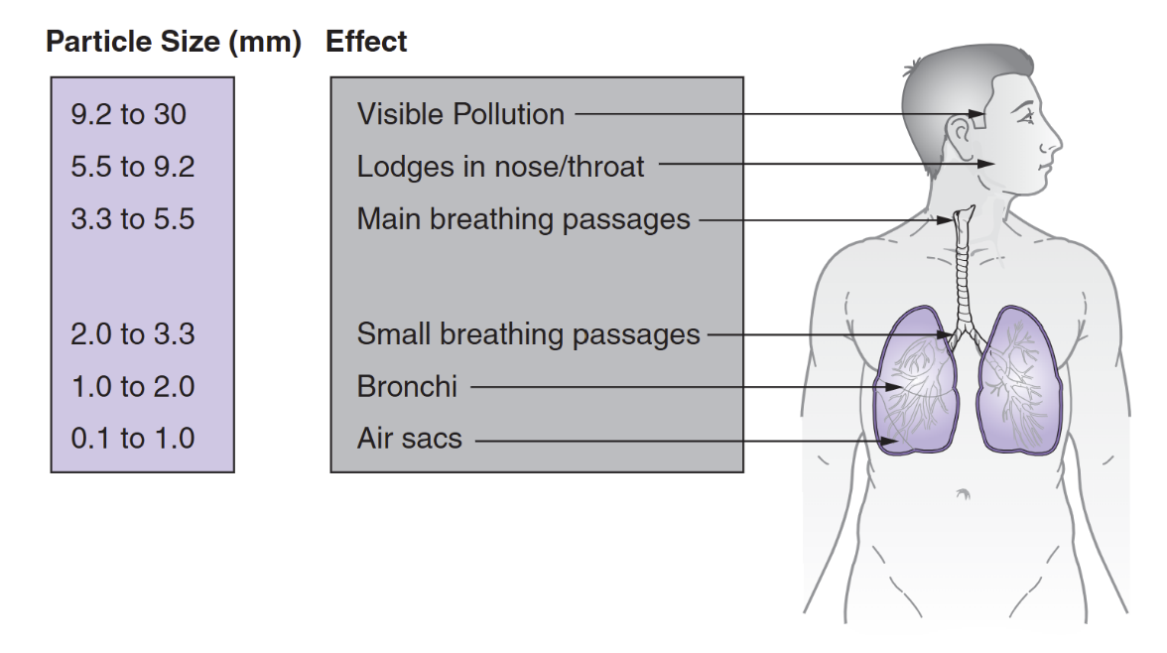
Figure 1.1: Effects of Particulate and Their Size on Human Health [1]

1.1 Significance of Aerosols
Aerosols are microscopic airborne particles that range in size from a few nanometers to many micrometers. These tiny particles, the majority of which are invisible to the human eye, have an impact on our climate through radiative forcing, cloud formation, and sight degradation. They can also cause serious health problems. They are often categorized according to their sizes, such as PM₁₀ (particles smaller than 10 micrometers) and PM₂.₅ (particles smaller than 2.5 micrometers), in order to comprehend their effects[10]. To comprehend their activities, however, other physical characteristics like quantity, mass, form, or morphology as well as chemical characteristics like composition are also crucial. The effects of PM₂.₅ on human health and various other environmental issues, such as longer atmospheric residence times, have made them more significant in recent years.
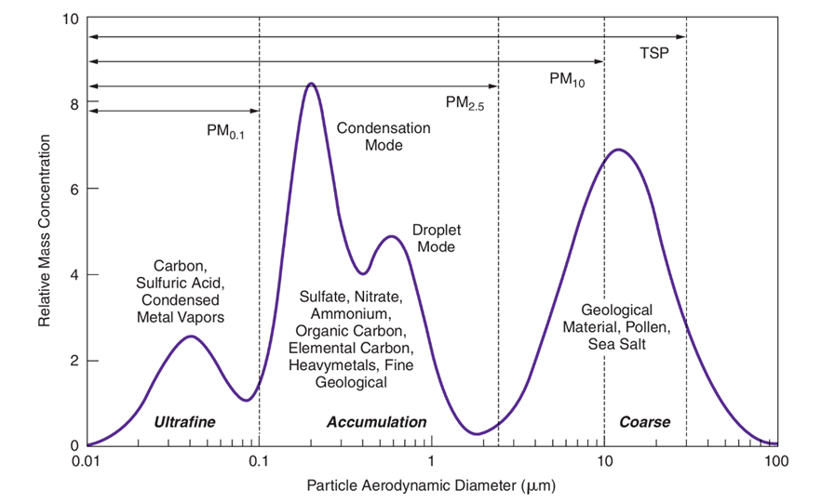
1.2 PM₂.₅ and Smaller Particles' Effects on Health
Figure 1.2:Particle size distribution [4]
Because of their smaller size and potential to enter the gas exchange region, PM₂.₅ is thought to be more dangerous than PM₁₀. It is produced by combustion processes (such as the burning of coal, wood, fossil fuels, or biomass) as well as by industries, waste incineration, mining operations, etc. Even smaller particles, such as sub micrometer particles or PM₁ (particulate matter size less than 1), may find their way into the bloodstream. They can therefore lead to cardiovascular and pulmonary disorders. These particles have been shown to be responsible for more than two million fatalities every year globally [11, 12].

1.3 Natural vs. Anthropogenic Aerosols
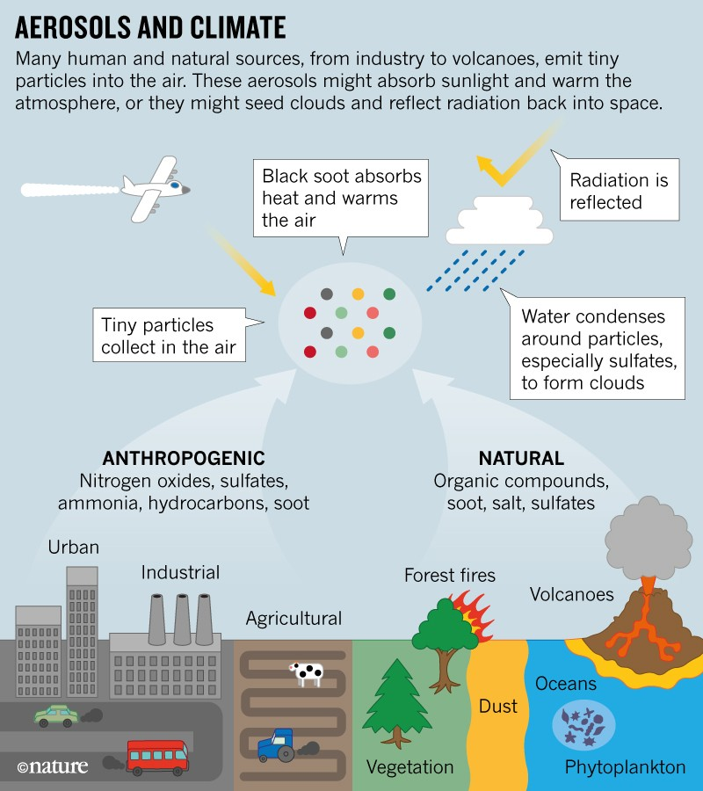
PM₂.₅ particles can come from natural or man-made sources. Anthropogenic particles are those that are left in the atmosphere as a result of human activity, such as the burning of coal, oil, natural gas, fossil fuels, and other industrial operations. The majority of naturally produced aerosols are made up of dust, clouds, or emissions from volcanoes or forest fires. Larger particles are readily deposited in the human nasal tract and do not go farther because they have a shorter residence period in the atmosphere. Smaller particles, however, will enter the pulmonary system more thoroughly[13]. Thus, research on PM₂.₅ is crucial to comprehending its impact on climate and human health.
Figure 1.3: Aerosols Influence on environment[14]

1.4 Lahore's Urban Air Quality
Once known as the "city of gardens," Lahore has been in the headlines all over the world for its declining air quality [15]. The majority of industrial regions, educational institutions, textile mills, and other small-scale companies are located in this second-largest city in Pakistan, where massive pollutants are released without following the correct environmental regulations. Immigrants from all around the province's less developed districts are constantly flooding the city in search of better possibilities. In this situation, there is no adequate mass transit system and a large number of automobiles are added to the traffic each year. Even while initiatives like the Orange Line Metro Train and Metro Bus have been made available to the public in recent years, they have not been able to reduce traffic pollution[8, 15]. Due to a lack of environmental priorities, knowledge, and technical innovation, improving air quality in poor nations is a difficult endeavor that demands unachievable remedial actions [16].
Poor air quality has been caused by a number of factors, including fast urbanization and population growth, industrial pollution, increased automobile traffic, coal combustion, burning of biomass, and burning of agricultural leftovers [15]. Since 2016, Pakistan's most industrialized cities, such as Lahore and Faisalabad, have experienced a new smog season characterized by limited vision, excessive pollution loading, and an air quality index that is significantly below WHO recommended levels. Lahore was ranked as the world's most polluted city in the Swiss air quality technology company's annual 2023 study [17].
A simple description of air pollution would be air that contains a combination of various contaminants [11]. Volatile organic compounds (VOCs), ozone (O₃), carbon monoxide (CO), and nitrogen oxides (NO₂) are examples of pollutants that may exist in gaseous form. Because of its negative effects on the health of people, economic growth, and climate change, PM₂.₅ is the most unmanageable of all of these [18]. The effects on the immune system, neurological conditions, cardiovascular ailments, and respiratory issues were among the health consequences [19].

1.5 Source Allocation and Air Quality Management
An emission inventory is necessary for Lahore's air quality in order to provide policymakers with information on pollutants, their sources, and their contributions to pollution. The inventory encourages resource allocation, focused interventions, and evidence-based decision-making. To address any problem, a city's air pollution strategy must take into account all pertinent information. Understanding pollutant kinds, concentrations, chemical composition, temporal and spatial dispersion, and health and environmental concerns are all part of this[1].
An effective method for detecting and measuring air pollutants is source apportionment. Vehicle emissions, industrial discharges, burning biomass, construction dust, soil dust, and sea spray are some of the sources of pollution. Their contributions are evaluated using source apportionment. Source apportionment is necessary for developing an air quality control strategy. They help policymakers prioritize actions, restrict large polluters' emission limitations, enhance urban design that reduces pollution, and promote cleaner technology. Monitoring and updating the pollutant inventory guarantees that policies adapt to shifting environmental conditions. In Lahore, where growing industrialization and urbanization have reduced air quality, data-driven initiatives are crucial for public health and sustainable urban development. In order to identify potential sources and contributions, it integrates samples from the receptor, or site of interest[1].
The process of source apportionment establishes which emission sources such as automobiles, brick kilns, industry, open burning, and crustal/dust are accountable for the observed levels of ambient particulate matter. Receptor modeling is a useful family of source-apportionment techniques that deduces sources from chemical measurements taken at a monitoring site (the "receptor"). This can be done by either using known source fingerprints to solve mass-balance equations and estimate each source's mass contribution, or by finding statistical compositional patterns among the measured species (factor-analytic approaches) [20, 21].
Most source apportionment studies in Lahore have applied Principal Component Analysis (PCA) and Positive Matrix Factorization (PMF), two factor-analytic techniques applied to speciated PM₂.₅ datasets to uncover statistically derived source factors (e.g., soil/road dust, vehicular emissions, industry/brick kilns, and secondary inorganic aerosol) and their seasonal [5, 22]. Factor-analytic techniques do not require prior knowledge of source fingerprints, making them effective exploratory tools, though factor solutions are statistical constructs requiring interpretation when mapped to physical causes [23].

1.6 Chemical Mass Balance (CMB) Modeling for Lahore
CMB modeling provides a complementary, profile-driven approach to source apportionment. By taking representative source emission profiles (source "fingerprints") and ambient data at receptor sites as inputs, CMB solves mass-balance equations to estimate the mass contribution of each specified source to measured ambient concentrations [24]. When source profiles are appropriate for the study area and the ambient dataset contains a sufficiently discriminating set of species (e.g., elemental carbon/organic carbon EC/OC, major inorganic ions, crustal elements, trace metals, and, where possible, organic molecular markers), CMB generates quantitative, directly interpretable mass apportionments that are well suited to regulatory planning[25].
According to reviews and intercomparison studies, PMF/PCA and CMB have complementary strengths: PMF is useful for exploratory factor identification for mixed or evolving sources, whereas CMB produces mass-based contributions but is critically dependent on profile representativeness and species coverage [26, 27]. Combining factor-analytic diagnostics with profile-driven quantification and systematic sensitivity testing is commonly regarded as the ideal technique for reliable source attribution. PMF can get source profiles as an output result, but CMB cannot [28]. PMF or Unmix, lack the ability to allocate source contributions based on short-term data [29, 30], but CMB can operate on even daily readings.
For Lahore, this complementing approach is appealing. The city's source mix includes road traffic (diesel and gasoline fleets), coal and biomass-fired brick kilns, small industries, open waste burning, and crustal dust, suggesting that typical profiles are either available in the literature or can be derived from regionally relevant observations [22, 31]. Using CMB on these chemical species will convert factor fingerprints from previous PMF/PCA studies into quantitative, mass-based source contributions, Test and refine earlier factor interpretations.

1.7 Aim of Study
This project aims to identify the primary PM₂.₅ pollution sources affecting Lahore, quantify each source's contribution, and offer evidence-based mitigation suggestions. All CMB runs will include strict uncertainty specification, diagnostic evaluation (residuals, chi-square, percent mass explained), and sensitivity testing. Results will be evaluated using temporal patterns and literature-reported evidence as needed, producing mass-based contributions with uncertainties and a prioritized set of mitigation actions tied to source magnitude, seasonality, and likely health relevance. Obtained CMB runs will be compared with the source apportionment findings of studies from which ambient data was taken. Practical recommendations for additional tracers or sampling to reduce apportionment uncertainty in future studies will also be provided.

1.8. Problem Statement
Lahore suffers extreme, seasonally driven PM₂.₅ pollution (annual means 100–216 µg·m⁻³; winter peaks 190–303.2 µg·m⁻³), imposing a large public-health burden. Proper allocation of how much each source, vehicles, industries and biomass burning are contributing to the PM₂.₅ environmental pollution, that is the requirements for policy making. Although several local studies have chemically characterized PM₂.₅ and a few have applied statistical receptor methods (e.g., PMF, PCA) for exploratory source identification, these approaches and short monitoring campaigns can under- or over-aggregate emitters and do not provide mass-closed, profile-based source quantification. Consequently, few to no peer-reviewed study has produced policy-grade, CMB-based source apportionments from annually resolved, chemically-speciated ambient datasets for Lahore. This study fills this gap by applying CMB with representative source profiles to year-round speciated data to convert compositional knowledge into quantitative, source-resolved contributions that support sector-specific mitigation and evidence-based air-quality policy.

1.9 Research Objectives
- Identify and quantify contributions from major emission sources of Lahore, using CMB model.
- Evaluate the suitability and reliability of source profiles and results of CMB using statistical measures.
- Recommend evidence based and source specific pollution mitigation strategies for Lahore.

Chapter 2

Literature Review

2.1 Theoretical Framework of Source Apportionment
Source Apportionment studies are environmental forensic investigations that identify the existence of contaminants or their sources in a certain region. In order for policymakers to develop a plan for pollution reduction measures and risks to human health, these studies are crucial in determining the sources or elements in a particular place that impact its atmosphere. These approaches are used in water and soil quality evaluations, however they are mostly used for atmospheric particle matter (PM) [23]. SA's main goal is to give policymakers a solid scientific foundation on which to build focused emission reduction plans [32].
A thorough grasp of the source and measurement of ambient pollutants is essential for the development of a science-based Air Quality Management System. Two different methodological frameworks have historically been used by researchers: top-down (receptor-based) modeling and bottom-up (source-based) emission inventories. Although both methods seek to ascertain the proportional contributions of different sectors to local air quality, they are based on essentially distinct analytical premises[1].
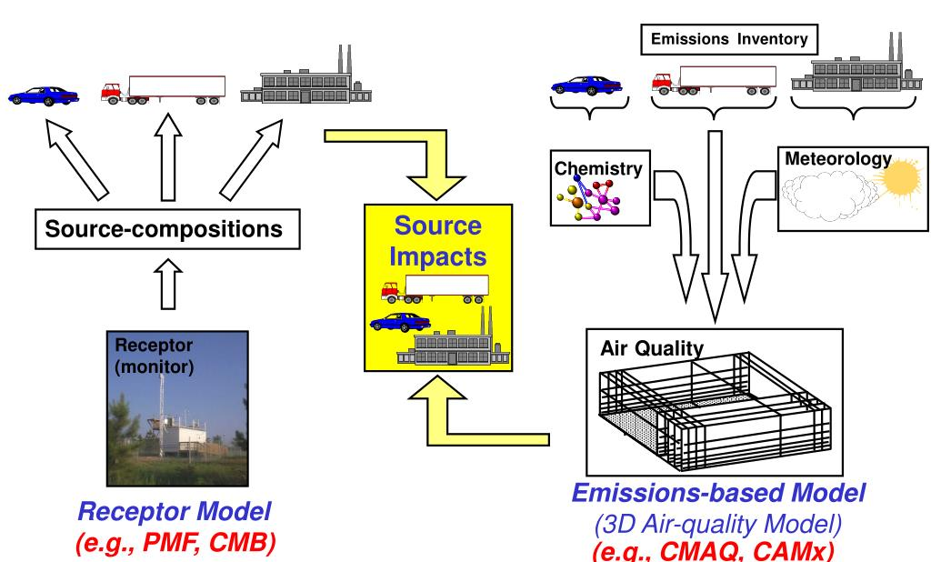
Figure 2.1: Receptor Modelling vs Emission Inventory
- The source model (bottom-up) uses source emissions as input to calculate concentrations in the ambient environment. Because of atmospheric processes as gas-to-particle conversion and particle deposition, source models (top-bottom) are only able to estimate the concentration in the atmosphere [33]
- Conversely, a receptor model (top-down) uses ambient species concentrations as input to calculate source emissions, which are typically expressed in µg/m³.
Bottom-up models are useful, but they are often plagued by practical errors. The preciseness of emission inventories, which are frequently clouded by "hidden" or unofficial sources including illicit waste burning, home biomass combustion, and the long-distance transportation of pollutants from nearby jurisdictions, is crucial to these models. For instance, regardless of its practical significance, a source that was not first included in the bottom-up register will never appear in the final results. Top-down source apportionment provides an especially economical and adaptable initial stage in emerging countries, where data may be limited and urbanization is accelerating. These approaches can start with comparatively basic analytical tools and advance in complexity as institutional capability increases [1].
Due to national air quality regulations in many nations worldwide it was made necessary to identify the origins of the particles, in order to develop and implement efficient management methods. Dispersion models of point sources were the main focus of the early attempts to identify particle sources, and this method typically led to a significant decrease in APM levels. Therefore, more techniques were needed to determine and quantitatively allocate the particle mass to sources with higher resolution. These techniques are referred to as receptor models. These models employ measured characteristics of gathered ambient samples to deduce the sources' contributions to the pollutant concentrations.
The conceptual foundation of receptor modeling is the mass conservation principle, which assumes that the chemical makeup of ambient airborne particles at the receptor location is a linear mixture of emissions from various sources following air travel and transformation. Receptor models, in contrast to emission-based methods, use variations in chemical fingerprints across sources observed at the receptor to infer source contributions without requiring prior understanding of the rate of emission or dispersion patterns. Because of this conceptual framework, receptor modeling is especially appropriate for complicated metropolitan contexts where it is challenging to explicitly describe atmospheric processes and emission inventories are inadequate[23, 25].

2.2 Top-Down Approach
The basis for source apportionment techniques is the fact that various emission sources have distinct chemical profiles or patterns of air pollution. For instance, diesel exhaust mostly comprises carbonaceous PM, cement facilities produce PM that contains calcium, and iron and steel mills release PM that is rich in iron.
Certain components, such metals, may generally be used as indicators of pollution from various industrial operations. By combining contributions from several sources, source apportionment seeks to explain the chemical makeup of ambient PM samples.
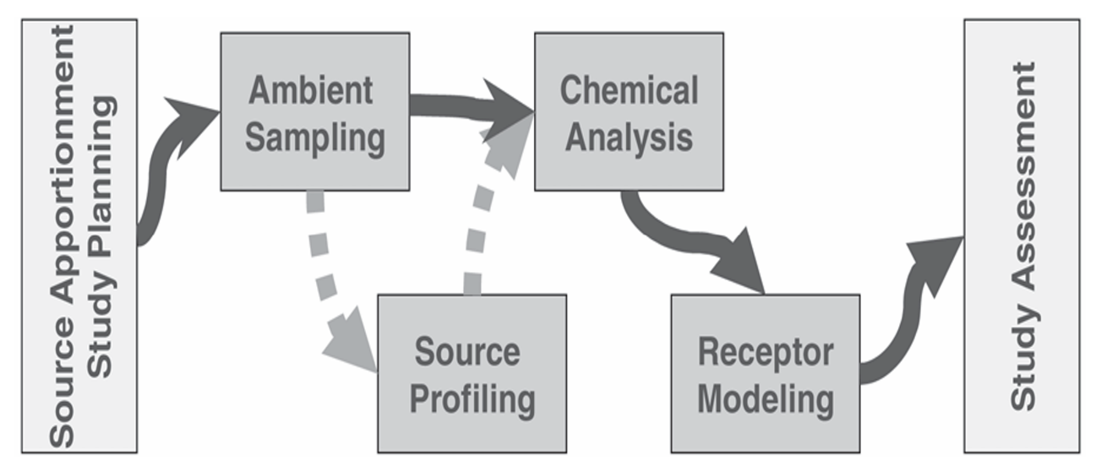
A city's air pollution issue can be better understood scientifically by using top-down source apportionment techniques. Specifically, top-down approaches may measure the relative contributions of various sources to the PM issue as a whole. These techniques are especially pertinent for usage in developing nation cities as they may be implemented somewhat rapidly and affordably.
Figure 2.2: Steps to Conduct a Top-Down Source Apportionment Investigation [1]
A receptor-oriented source apportionment research offers: data on the kinds of sources accountable for the pollutants observed, estimates of the sources' percentage contribution for various locations over a specified time period, and a foundation for assessing practical and affordable PM pollution reduction strategies.
The selection of acceptable sampling locations, an appropriate sampler and particle size range, and filter media suitable with the planned physical and chemical tests are the initial stages in a successful PM sampling program. To accurately measure population exposure, sampling sites should reflect the primary functional zones of an urban region, including residential, commercial, industrial, traffic-influenced, green spaces, source-dominated places, and background areas.
The quantity of samples taken must be adequate to record changes in emission patterns and weather over time. By directing the choice of monitoring sites, particle size fractions, chemical species suitable for analysis, and the overall quantity of samples needed, a clearly defined conceptual model helps cut down on the time and expense of source apportionment investigations. This kind of preparation guarantees that the information gathered is suitable for receptor modeling techniques and produces accurate estimations of source contribution.
A set of source profiles that represent the emission sources affecting the metropolitan region under study is a crucial element required to do a top-down analysis. The amounts of particular air pollutants (elements and ions) released from different sources are identified by a source profile. When evaluating the contribution of different pollution sources to ambient concentrations, these professionals are essential. The likelihood of producing high-quality outcomes increases with the accuracy of a source. Although source profiles can be found locally, the majority of source profiles that are currently accessible are from industrialized nations, where the fuel mix and combustion techniques may differ from those used in poor nations.
The usual outcomes of a Source Apportionment study are depicted in the picture below.
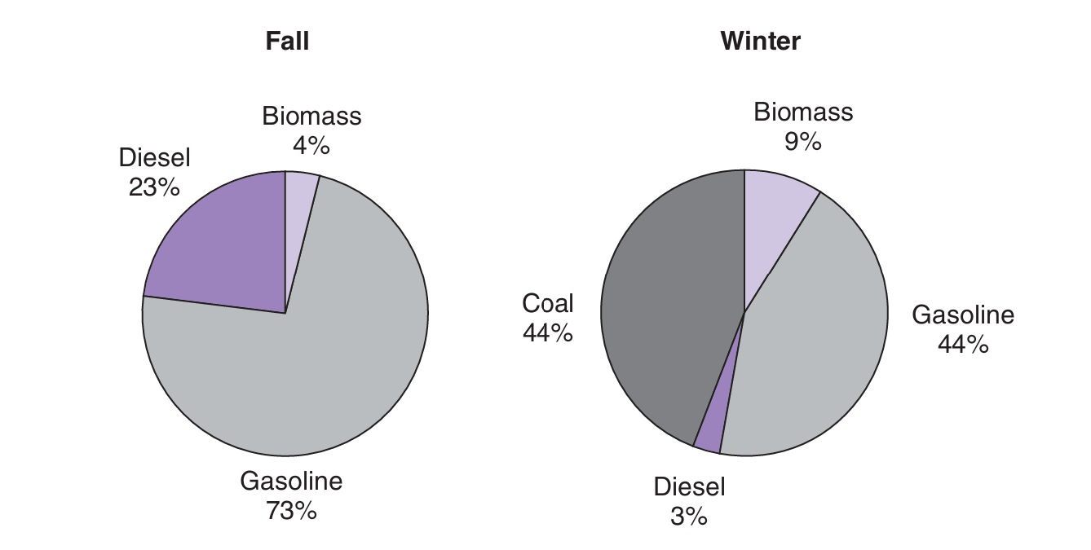
Figure 2.3: Source Apportionment Results for Xi’an, China [2]
It is clear from the Xi'an, China, figure that the results of source apportionment differ greatly by season because of variations in weather and human activities[2]. Coal combustion, which is insignificant in the fall, becomes an important factor at 44% of the Total Carbon (TC) during the winter, which is characterized by a significant shift toward emissions associated to heating. In a comparable manner, the burning of biomass exceeds a double (from 4% to 9%), indicating a rise in the use of coal and wood for domestic heating.In the end, these results demonstrate that a "one-size-fits-all" pollution solution is useless because source apportionment is extremely sensitive to temporal fluctuations[2, 7]. Air quality control must be seasonally adaptable since the primary sources change from automobile exhaust in fall to coal and biomass in the winter. Emissions Inventory (EI) and Receptor Modeling (RM) are the two primary branches of Source Apportionment, as was previously indicated. We also discussed the benefits of RM over EI, and as Receptor Modeling is the main focus of our work, we will highlight this approach more frequently[7].
The types of "Sources" that are present in a given location, such as biomass burning aerosol, traffic sources, Secondary Sulfate and secondary Nitrate, marine aerosol, coal combustion, etc., are identified using Source Apportionment approaches. While some of these sources may have little to no impact on health, others may be exceedingly detrimental. The chemical and physical properties of gases and particles measured at the source and the receptor are used by receptor models to both detect the existence of and quantify source contributions to receptor concentrations, which is how source apportionment is primarily accomplished. Dispersion models conversely, use pollutant emissions rate estimates, meteorological transport, and chemical transformation mechanisms to estimate the contribution of each source to receptor concentrations. The two types of models are complementary, with each type having strengths that compensate for the weaknesses of the other[1].
Source apportionment, which explicitly links ambient PM_{2.5} concentrations to emission source types, offers useful information from a regulatory standpoint. Source apportionment identifies responsibility, as opposed to concentration-only assessment, which identifies pollution severity. This distinction is crucial for policymaking based on because mitigation measures can be prioritized based on the toxicity and magnitude of individual source contributions. As a result, regulatory agencies and guideline organizations now use source apportionment as a crucial part of their air quality strategy and execution frameworks[21, 32, 34].

2.2.1: Source Apportionment Framework
Chemically speciated ambient observations obtained at a receptor location are fundamental to receptor modeling. Carbonaceous fractions like organic carbon (OC) and elemental carbon (EC), significant inorganic ions (including sulfate, nitrate, and ammonium), trace elements, and, if available, organic molecular markers like polycyclic aromatic hydrocarbons (PAHs) are usually included in these assessments. These species are chosen because they can serve as tracers for various emission categories due to their source-specific fingerprints [35, 36]
These chemical datasets are used by multivariate receptor modeling approaches like Principal Component Analysis (PCA), Chemical Mass Balance (CMB), and Positive Matrix Factorization (PMF) to mathematically deconvolve the measured ambient concentrations into contributions from specific sources. More sophisticated receptor models like CMB and PMF offer quantitative estimates of source contributions by directly connecting measured species concentrations to source profiles or factor loadings, whereas exploratory methods like PCA find statistical patterns in the data [23, 37]
Emission inventories, source-oriented dispersion models, and established activity patterns are examples of independent data that are frequently used to assess the validity of receptor model findings. Such cross-validation helps find any omissions or misrepresentations in the modeling framework and increases confidence in the inferred source contributions [32, 36].

2.3 Receptor Modeling Methodologies (CMB and PMF)
Receptor models estimate and detect the existence of source contributions to the receptor using the chemical and physical properties of gases and particles observed at the source and receptor. The properties of the particles must be such that: 1) they are present in various ratios in various source emissions; 2) these ratios stay reasonably consistent for each kind of source; and 3) variations in these ratios between source and receptor are insignificant or can be estimated. Chemical mass balance (CMB), principle component analysis (PCA, sometimes called factor analysis), and multiple linear regression (MLR) are common receptor model types[20].
The foundational receptor model is CMB , which serves as the fundamental basis for all other methods (such as PCA and MLR). Each receptor concentration of a chemical species is expressed as a linear sum of products of source profile species and source contributions in the chemical mass balance, which is a least squares solution to a set of linear equations. The CMB model uses the source profile species abundances (i.e., the fractional quantity of the species in the emissions from each source-type) and the receptor concentrations with suitable uncertainty estimates as input data. The quantity that each source type contributes to each chemical species makes up the output. Each source's contribution and its uncertainty are computed using the model. Input data uncertainties are utilized to compute the uncertainties of the source contributions as well as to weight the significance of input data values in the solution[25].
These days, receptor modeling methods like Chemical Mass Balance (CMB) and Positive Matrix Factorization (PMF) are given the most attention. CMB modeling provides a complementary, profile-driven approach to source apportionment: by taking representative source emission profiles (source "fingerprints") and ambient data at receptor sites as inputs, CMB solves mass-balance equations to estimate the mass contribution of each specified source to measured ambient concentrations [3]. When source profiles are appropriate for the study area and the ambient dataset contains a sufficiently discriminating set of species (e.g., EC/OC, major inorganic ions, crustal elements, trace metals, and, where possible, organic molecular markers), CMB generates quantitative, directly interpretable mass apportionments that are well suited to regulatory planning[38].
Particulate matter source allocation frequently uses both factor analysis and receptor models, each of which has unique advantages. By finding patterns in the data, Principal Component Analysis (PCA) and Positive Matrix Factorization (PMF) are especially useful for investigating unidentified or changing sources. The Chemical Mass Balance (CMB) model, on the other hand, uses predetermined chemical profiles to quantify source contributions. It provides direct mass-based estimations but necessitates precise and representative source data [39, 40]. Despite their drawbacks, both methods are nonetheless frequently used in studies on air quality.

2.4 Fundamental Assumptions and Limitations of the CMB Model
These models are predicated on specific assumptions and have limits. According to "Protocol for Applying and Validating the CMB Model for PM₂.₅ and VOC" [24], the following are the CMB model assumptions:
- All sources that could contribute to the receptor have been identified and their emissions have been characterized;
- chemical species do not react with one another (i.e., they add linearly);
- the compositions of source emissions remain constant throughout the ambient and source sampling period;
- the source profiles are linearly independent of one another;
- measurement errors are random, uncorrelated, and normally distributed; and
- the number of sources or source categories is fewer than or equal to the number of species.
The particle and gas parameters measured at the source and receptor have a significant impact on how well these assumptions are satisfied in applications. The six presumptions are quite strict and will never be fully agreed to in real-world situations.

2.5 Uncertainty in CMB-Based Source Apportionment
The modeling framework's simplifying assumptions, insufficient source lists, within-source and temporal variation in source profiles, analytical measurement error, and other factors all contribute to the inherent uncertainty of source apportionment. Formal estimation of uncertainty and sensitivity testing are typical procedures because uncertainties in ambient concentrations and source profiles, in particular, propagate directly into the confidence ranges of predicted source contributions in CMB applications. Chi-square and residual analysis, comparing modeled and observed species, profile replacement or resampling methods to evaluate the resilience of solutions are common diagnostic techniques. For accurate results interpretation and the application of apportionment results in policy and regulatory decisions, honest disclosure of these uncertainty evaluations is crucial.

2.6 Source Characterization and Profile Development
The input data for CMB are the receptor concentrations, together with suitable uncertainty estimates, and the source profile abundances. The CMB model determines the values and uncertainty of each source's contribution. Source profiles are the fractional mass abundances of chemical species emitted by a given source category (e.g., vehicle exhaust, brick-kilns). Instead of describing a specific emitter, they explain the general chemical "fingerprint" of that group. The purpose of profiles is to depict collections of related emitters (a source category). The category in CMB input files is represented by profiles, which are constructed as composites from several observations since individual emitters differ[1].
The CMB mass-balance method is unable to separate the contributions of two source profiles that are chemically extremely similar (collinear). Collinearity reduces confidence in apportionment conclusions, increases uncertainty, and might result in unreasonably large or negative source estimations. A key component of CMB validation is evaluating and reducing collinearity[24].
Table 2.4: Marker Elements Associated with Various Emission Sources (Chow, 2005)
Emission Source | Marker Elements*
Soil | Al, Si, Sc, Ti, Fe, Sm, Ca
Road dust | Ca, Al, Sc, Si, Ti, Fe, Sm
Sea salt | Na, Cl, Na⁺, Cl⁻, Br, I, Mg, Mg²⁺
Oil burning | V, Ni, Mn, Fe, Cr, As, S, SO₄²⁻
Coal burning | Al, Sc, Se, Co, As, Ti, Th, S
Iron and steel industries | Mn, Cr, Fe, Zn, W, Rb
Non-ferrous metal industries | Zn, Cu, As, Sb, Pb, Al
Glass industry | Sb, As, Pb
Cement industry | Ca
Refuse incineration | K, Zn, Pb, Sb
Biomass burning | K, Cl, EC, OC, Br, Zn
Automobile gasoline | EC, Br, Ce, La, Pt, SO₄²⁻, NO₃⁻
Automobile diesel | OC, EC, S, SO₄²⁻, NO₃⁻
Secondary aerosols | SO₄²⁻, NO₃⁻, NH₄⁺

Numerous particular polluters are included in emissions inventories. These must be combined into generalized categories/sources with identifiable profiles for receptor modeling (e.g., combine power, industrial, and institutional coal burning into a single "coal combustion" category). Coal combustion, vehicle exhaust (diesel and gasoline), fugitive/crustal dust, biomass/vegetative burning, industrial point sources, and waste/open burning are typical broad categories used in PM₂.₅ CMB. Organic carbon (OC) and elemental carbon (EC), main inorganic ions (SO₄²⁻, NO₃⁻, NH₄⁺), crustal elements (Al, Si, Ca, Fe), and particular tracers like K⁺ (biomass burning) and Na⁺/Cl⁻ (sea salt) are useful particle-phase tracers for CMB. The species measured in the ambient dataset and the regional source mix should be matched when selecting tracers.
Figure 2.4: PM₂.₅ source profiles of different categories (from US-EPA SPECIATE database[3])

2.7 Global and Regional Perspectives on Source Apportionment
Receptor modeling studies are mostly focused on Asian nations due to their generally greater concentrations of PM₂.₅ or PM₁₀ than the rest of the globe. China in particular contributes significantly to PM₂.₅ concentrations; several studies have been carried out throughout China, describing the sources and their contributions [12, 41-43]. Similar receptor modeling experiments have been carried out in South Asia. For example, secondary aerosols, soil dust, vehicle emissions, biomass burning, and fossil fuel combustion were shown to be significant contributors in Delhi, India, according to PM₂.₅ source apportionment using Positive Matrix Factorization (PMF) [44, 45]. These sources were validated and long-range transport from northwest India and Pakistan was emphasized by a more thorough study utilizing different receptor models (PCA, UNMIX, and PMF) [45]. Seasonal studies conducted in Delhi and other Indo-Gangetic Plain cities highlighted secondary aerosols, soil dust, biomass burning, and vehicle emissions as the main sources of PM₂.₅ [46, 47].
Another study on Qatar city's particulate matter (PM₁₀ and PM₂.₅ ) in 2007–2008 used CMB modeling to identify pollution sources. Organic matter and carbonaceous components, or OC, made up the majority of PM₂.₅ , accounting for 31% and 56%, respectively. To determine the most precise OC sources among all combustion/burning processes that may be the potential emission component, various biomarkers were examined. In this particular investigation, the bulk of OC emissions were from non-catalyzed motor vehicles, with an average yearly concentration of 29±10 µg/m3. Diesel engines, burning biomass, and residual fuel oil combustion were the other major contributory factors. During the winter, SOA was higher, and during the fog season, it was much higher. On the other hand, PM₁₀, the course component of particulate matter, was linked to crustal matter that came from urban dust pollution[48].

2.8 Source Apportionment Studies in IGP Region, specially Lahore
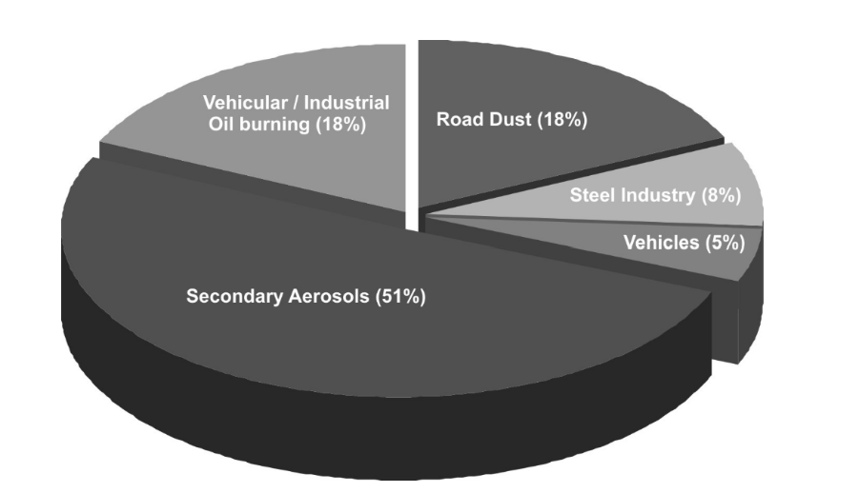
A 2009 study reported PM₂.₅ and sources of it, spanning 2005-2007. PM₂.₅ levels were higher than standards with maximum in winter seasons. In other seasons they were 4 times less. PMF model was utilized to identify industrial emissions, dust, secondary aerosols and automobile emissions as main contributors to PM₂.₅ levels [5]. Also, the study noted that neighboring areas had contribution in polluting Lahore`s air too, termed as transboundary pollutants for example Sulfate ions in cold season, that increased formation of haze [5]. With a coefficient of determination (R²) of 0.666 between the observed and model-calculated PM₂.₅ mass, the reconstructed PM₂.₅ mass demonstrated close match with gravimetrically measured concentrations. This suggests that the PMF solution accounted for around 66% of the observed PM₂.₅ fluctuation. The omission of carbonaceous aerosol components, specifically elemental carbon (EC) and organic carbon (OC), which were left out in the chemical input matrix, was the major reason given by the authors for the remaining unexplained proportion (~34%). This restriction emphasizes how crucial it is to incorporate carbonaceous species in receptor modeling studies of urban PM₂.₅, especially in areas like Lahore where combustion is predominant.
Figure 2.5: PMF identified PM_{2.5} sources contribution Lahore. [5]
PMF model was used in another research in Lahore from November 2005 to January 2006 [49]. Secondary aerosols, diesel emissions, biomass fuel burning, coal combustion, two-stroke engine exhaust, and industrial operations were identified as the main sources of particulate matter in atmosphere[49]. The method comprised of acquiring ambient samples, chemical analysis to characterize ions, metals, and carbon, then run the PMF model for source apportionment[49].
In order to source allocate the high pollution spring event of 2006 of Lahore, a study employed receptor modeling (CMB). The levels of PM₁₀, OC, and EC as well as the relevant variables were investigated in this research of Lahore. More than a hundred organic substances were examined, including the tracer species for the city's many sources of pollution. The tracers for burning biomass (levoglucosan), gasoline emissions (coronene), coal combustion (picene), and fossil fuels (steranes and hopanes). Six sources in all were found: 1. Vegetative detritus 2. Wood smoke 3. The burning of natural gas 4. Exhaust from diesel 5. Exhaust from gasoline and 6. Burning coal. With 47.5% OC, 88.3% EC, and 15.4% PM mass, mobility sources which include both gasoline and diesel exhaust were found to be the biggest source of pollution [46]. The study highlighted the serious motor vehicle pollution in Lahore by attributing gasoline and diesel emissions to 47.5% of OC, 88.3% of EC, and 15.4% of PM₁₀ mass. Another important, if unmeasured, component was dust. The report highlights transportation emissions as the main cause of the city's air quality problem[50].
Table 2.2 : PM₂.₅ and PM2.₁₀ Source Apportionment Studies in Lahore
Reference | Study Period | PM Fraction | Receptor Model | Key Findings & Source Contributions
[5] | Nov 2005 – Mar 2006 | PM₂.₅ | PMF | Secondary aerosols, vehicle exhaust, industrial pollutants, and soil/road dust are the main causes of winter smog.
[51] | Jan 2007 – Jan 2008 | PM₂.₅ & PM₁₀ | CMB | Carbonaceous aerosols account for 61% of PM_{2.5}, followed by non-catalyzed vehicles (53%), biomass (10%), diesel/oil (6%), and coal (2%).
[49] | Nov 2005 – Jan 2006 | PM₂.₅ | PMF | Coal (13%), biomass (15%), diesel/2-stroke vehicles (36%), and secondary PM (30%).
[52] | Mar 2010 | PM₁₀ | PMF | Resuspended dust (4.6%), industrial dust (18.2%), biomass (24.3%), and vehicle emissions (26.5%).
[53] | Winter & Summer 2021 | PM₂.₅ | PCA | Winter: biomass and car emissions; summer: increased SOA formation.
[54] | June & Dec 2022 | PM₂.₅ | PMF | Winter: biomass and industrial emissions; summer: secondary aerosols and coal combustion.
[55] | 2022 – 2023 | PM₂.₅ | Compositional Analysis | 26% of PM_{2.5} mass is made up of sulfate and nitrate, mostly from home and transportation activities.

Both fine (PM₂.₅) and coarse (PM₁₀) particles had high yearly average concentrations in Lahore [51]. The majority of tiny particles were carbonaceous, whereas most coarse particles came from crustal origins like dust. The largest contributor of primary organic carbon in PM₂.₅ , accounting for more than half of the total (53%), was found to be non-catalyzed motor vehicles[51]. CMB modeling for source apportionment and a thorough chemical analysis of PM₂.₅ and PM₁₀ samples were part of the technique[51].
As per studies chemical transformation of primary aerosols and man-made pollution resulted in Lahore’s high average PM₁₀ concentration in 2014 [56]. The studies used PMF technique to identify major sources of PM₁₀ that were dust (4.6%), automobile emissions (26.5%), biomass fuel combustion (24.3%), and pollution from industries (18.2%)[52]. Another research in 2019 identified high PM₂.₅ levels during extreme haze periods between October to December, that were much higher than WHO recommendations. A major portion of it was contributed by anthropogenic activities [56].
Lahore’s PM₂.₅ levels surpass WHO recommendations [31]. According to the study carbonaceous chemicals were the most prevalent species, next to ionic species. According to source apportionment techniques main sources of PM₂.₅ pollution were local emissions from industrial operations such as power plants, transportation, and brick kilns [31].
Another study investigated ambient pollution in Lahore using data gathered in 2019 and found PM₂.₅ concentration 522 ± 222 μg/m³, that was higher than international air quality standards[31]. Three sources: direct traffic emissions, biomass burning and mixed urban emissions were identified using PCA along with Multiple Linear Regression (MLA) [31].
Two historic Pakistani cities, Lahore and Peshawar, were studied in 2019 [57] for PM₂.₅ concentration and related health hazards. The February average readings for Lahore and Peshawar were 522 ± 222 and 370 ± 176 6 μg/m3, respectively, indicating higher levels of PM₂.₅ than in prior years. The majority of PM₂.₅ mass was found to be covered by carbonaceous species, and in both cities, there was a high link between OC and EC, indicating primary sources of pollution. Primary sources of pollution include burning biomass, burning coal, and industrial emissions. The findings also showed that there were carcinogenic and non-carcinogenic hazards associated with certain heavy metals in both cities. For residents of Lahore and Peshawar, Cr posed a carcinogenic danger, but Cd and Mn posed a non-carcinogenic risk.
There is a noticeable lack of recent thorough research on source allocation and the assessment of the efficacy of pollution control measures in place. Studies that annually source PM₂.₅ , reflecting and comparing all four seasons, are extremely rare, if they exist at all, and the current source apportionment researches are outdated or not so efficient. Comprising of either PMF or PCA or the chemical analysis which provide good exploration but no policy grade quantitative analysis. Therefore, we will employ CMB to provide policy grade identification and quantitative contribution of PM₂.₅ pollution sources in Lahore.

2.9 Impact of Meteorology and Seasonality on Particulate Matter
According to research conducted in Constantine, the city's many sources of pollution were identified and correlated with the seasons and meteorological factors such as temperature, relative humidity, wind direction, wind speed, and precipitation. All four seasons are included in the analysis, and the city's mean annual PM₂.₅ concentration is 54 μg/m3. Preferable findings were identified using a five-factor approach, with human sources such as industrial activities and total traffic (exhaust and non-exhaust) aggregate contributing 58.9% and natural sources such as sea salt and mineral dust contributing 41% [58]. Due to heavy traffic and the stability of the lower air boundary layer, the concentration of exhaust emissions seemed to be maximum during the winter. However, high relative humidity (>60%) and cold temperatures (<10 OC) are suitable circumstances for high PM₂.₅ concentrations during this season[58].
Seasonally speaking, non-exhaust emissions are highest in the spring and lowest in the summer, whereas high temperatures and low relative humidity which have no bearing on wind speed prove to be contributing factors to the elevation of PM₂.₅ concentrations. Although there is no correlation between the industrial source and climatic factors, spring and summer have higher levels of PM₂.₅ because of the strength of the wind. The sea salt impact is particularly noticeable in the warm summer and spring months when there is little rainfall, which encourages low atmospheric leaching and causes particles to linger longer and further. Due to poor precipitation, careless soil particle adhesion, and particle resuspension, respectively, mineral dust showed a significant contribution in hot weather, low relative humidity, and high wind speeds [59].

2.10 Health Relevance
Particles from combustion operations typically present higher health hazards per unit mass than crustal dust; the toxicological consequences of emission sources varies significantly above their contribution to total PM₂.₅ mass. Significant portions of elemental carbon (EC), organic carbon (OC), and redox-active transition metals (such as V, Ni, and Cr) are found in fine particles from residential fuel combustion and vehicle exhaust. These particles have been demonstrated to cause oxidative stress, inflammation, and cytotoxicity in vitro more potently than crustal or soil-derived particles. The order of automotive exhaust > coal combustion > biomass burning > ambient urban air was followed by mass-normalized cytotoxicity of PM₂.₅ in controlled comparison tests, demonstrating a substantially greater toxicity of combustion-related particles [60].
Additionally, epidemiological evidence indicates that carbonaceous aerosols derived from combustion contribute disproportionately to excess mortality. For instance, anthropogenic carbonaceous PM₂.₅ from residential combustion has been linked to an estimated ~72,000 excess deaths annually in Europe, with automobiles contributing ~35,000 deaths, considering a toxic potency about two times the amount of inorganic particles [61]. On the other hand, components produced from soil and crustal dust frequently show reduced oxidative potential and related health hazards per unit mass. Therefore, by taking into consideration the varying toxicity of different source types, source apportionment not only measures mass contributions but also enables health-oriented prioritizing of emission control efforts.

2.11 Air Quality Management (AQM) theory and policy/mitigation
According to the Air Quality Management (AQM) theory, AQM is a continuous, science-driven cycle that involves monitoring air quality, carrying out scientific research and modeling, creating emission inventories, establishing objectives and standards, creating and implementing mitigation programs, enforcing measures, and then monitoring and assessing outcomes[62]. This cycle is adaptive: standards, inventories, and control measures should be updated in response to new scientific discoveries or better monitoring and source-apportionment technologies (like CMB or PMF). Effective management necessitates successive steps of measurement, source apportionment, policy implementation, and assessment so the system may improve iteratively since AQM is inherently risk-based because urban sources vary over time[1, 7, 62].

2.11.1Role of source apportionment in AQM
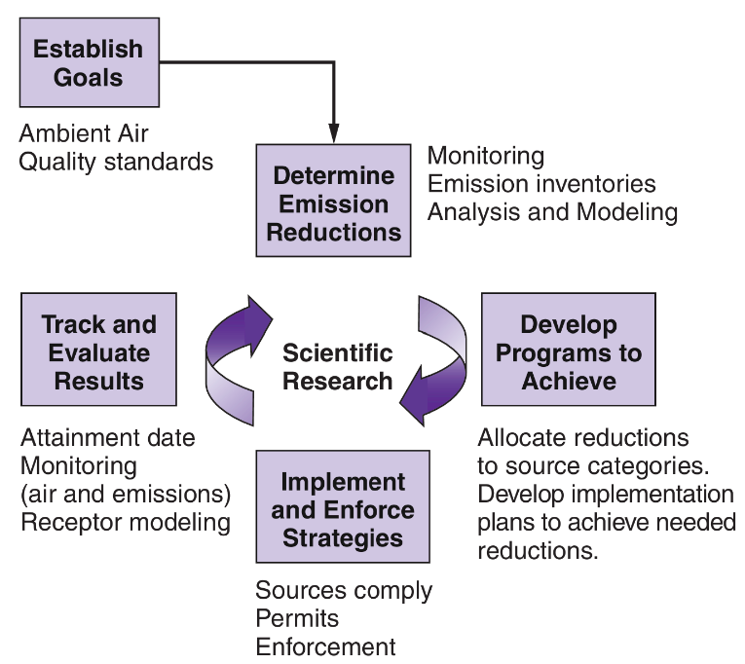
Quantitative, area-specific measurements of the mass contributions of various sources to ambient PM₂ are provided using top-down receptor techniques like CMB[7]. The AQM cycle is directly impacted by these quantitative apportionments, which assist prioritize control measures, identify flaws in bottom-up emission inventories, assign emission reduction objectives to the most significant sources, and offer a baseline for assessing the efficacy of interventions. CMB is especially helpful for guiding targeted mitigation and regulation since it produces mass-based, policy-relevant outcomes when source profiles are representative[1, 7].
Figure 2.6: Theory of Air Quality Management AQM

2.12 Major Identification of Emission Sources in Lahore
Major sources of pollution in Lahore as per source apportionment studies:
- Ambient pollution from vehicular exhausts (gasoline, diesel, CNG, motorcycles) [51]
- Emissions from industry (Energy production, cement manufacturing, masonry kilns) [30]
- Biomass combustion (agricultural waste, combustion of wood) [51]
- Dust (soil dust, road dust, construction dust) [5, 51]
- Secondary Pollutants (Sulfate, Nitrate, ammonium) [63]

2.13 Research Gap and Rationale for Current Study
There is a noticeable lack of recent thorough research on source allocation and the assessment of the efficacy of pollution control measures in place. Studies that annually source PM₂.₅ , reflecting and comparing all four seasons, are extremely rare, if they exist at all, and the current source apportionment researches are outdated or not so efficient. Comprising of either PMF or PCA or the chemical analysis which provide good exploration but no policy grade quantitative analysis. Therefore, we will employ CMB to provide policy grade identification and quantitative contribution of PM₂.₅ pollution sources in Lahore.

Chapter 3

Methodology

3.1 CMB theory
In this work, the U.S. Environmental Protection Agency Chemical Mass Balance model (EPA CMB v8.2) was used to execute a receptor-oriented least-squares technique for source apportionment of PM₂.₅. The CMB model solves the following linear system to estimate the contribution of a set of predefined source profiles to the measured ambient concentrations:

$$C_{i}=\sum_{j=1}^{p}{S_{ij}}f_{j}+ε_{i}(i=1,…,n)$$
Ci is the measured ambient concentration of species i, Sij is the mass fraction of species i in source j (source profile), fj is the contribution (mass concentration) of source j to the ambient PM₂.₅, p is is the number of candidate sources, n is the number of chemical species used, and $ε_{i}$is the residual for species i. Using weights generated from the predicted uncertainty of each ambient species concentration, weighted least squares is used to find the answer.
The CMB modeling procedure involves identifying contributing source types, selecting chemical species or properties to include in the calculation, estimating uncertainty in ambient concentrations and source profiles, and solving the chemical mass balance equations. CMB requires species with different abundances in different source types. The consistency of a species abundance is more important than the uniqueness for source quantification. CMB performs tests on ambient data and source profiles that tell how well source-type contributions can be resolved from each other for different combinations of source profiles and chemical measurements
Using comprehensive, peer-reviewed chemical speciation data from studies and US EPA source profiles, a CMB model (EPA CMB 8.2) was utilized to allocate the sources of PM₂.₅ mass. Based on annual, seasonal, and even daily mean chemical speciation data, the CMB model can be used to allocate sources. In order to determine the temporal and geographical variance of CMB source apportionment results, we made use of this benefit of CMB receptor modeling.

3.2 Ambient Chemical Data (Receptor Inputs)
All of the ambient PM₂.₅ chemical concentration data utilized in this analysis came from previously published peer-reviewed journal papers. For this thesis, no unique field sampling was done. Each dataset was utilized independently in the Chemical Mass Balance (CMB) model and handled as an independent receptor input. This approach preserves seasonal and methodological variation while avoiding combining data obtained using various sampling procedures, analytical techniques, and time periods.
The three receptor inputs, February (Winter) 2019 study[64], Annual data of 2022 [64] and Summer/Winter of 2022 [54], were chosen because they included the main particle components (carbonaceous species, ions, and trace metals), were relevant to different seasonal pollution situations, and provided chemically speciated PM₂.₅ data for Lahore. CMB modeling was performed using just samples that were gathered in Lahore. Other than Lahore, data from other cities included in these researches was not included.
A study of year 2021 provided the chemically speciated data, which focused on PM₂.₅ pollution during the winter [57]. Sampling took place in February 2019 during a winter with high pollution levels. Samples illustrating an urban backdrop environment were taken in Lahore on the roof of the fourth floor of a building at a height of around 10 to 12 meters above the ground. A total of 19 chemical species detected in PM₂.₅ are included in this dataset. With comprehensive carbonaceous and ionic coverage (OC, EC, NO₃⁻, SO₄²⁻, NH₄⁺), this winter dataset focuses on Lahore's worst-season conditions and aids in isolating secondary Nitrate production and combustion signals over the winter. Annual data was selected from a surveillance study that lasted a full year of 2022[64]. Samples of PM₂.₅ were taken from the roof of the Pak Green Enviro-Engineering Laboratory in Gulberg III, Lahore [55]. The entire calendar year, from January to December, was sampled, making it. This study provides year-round temporal coverage, allowing for clear recognition of 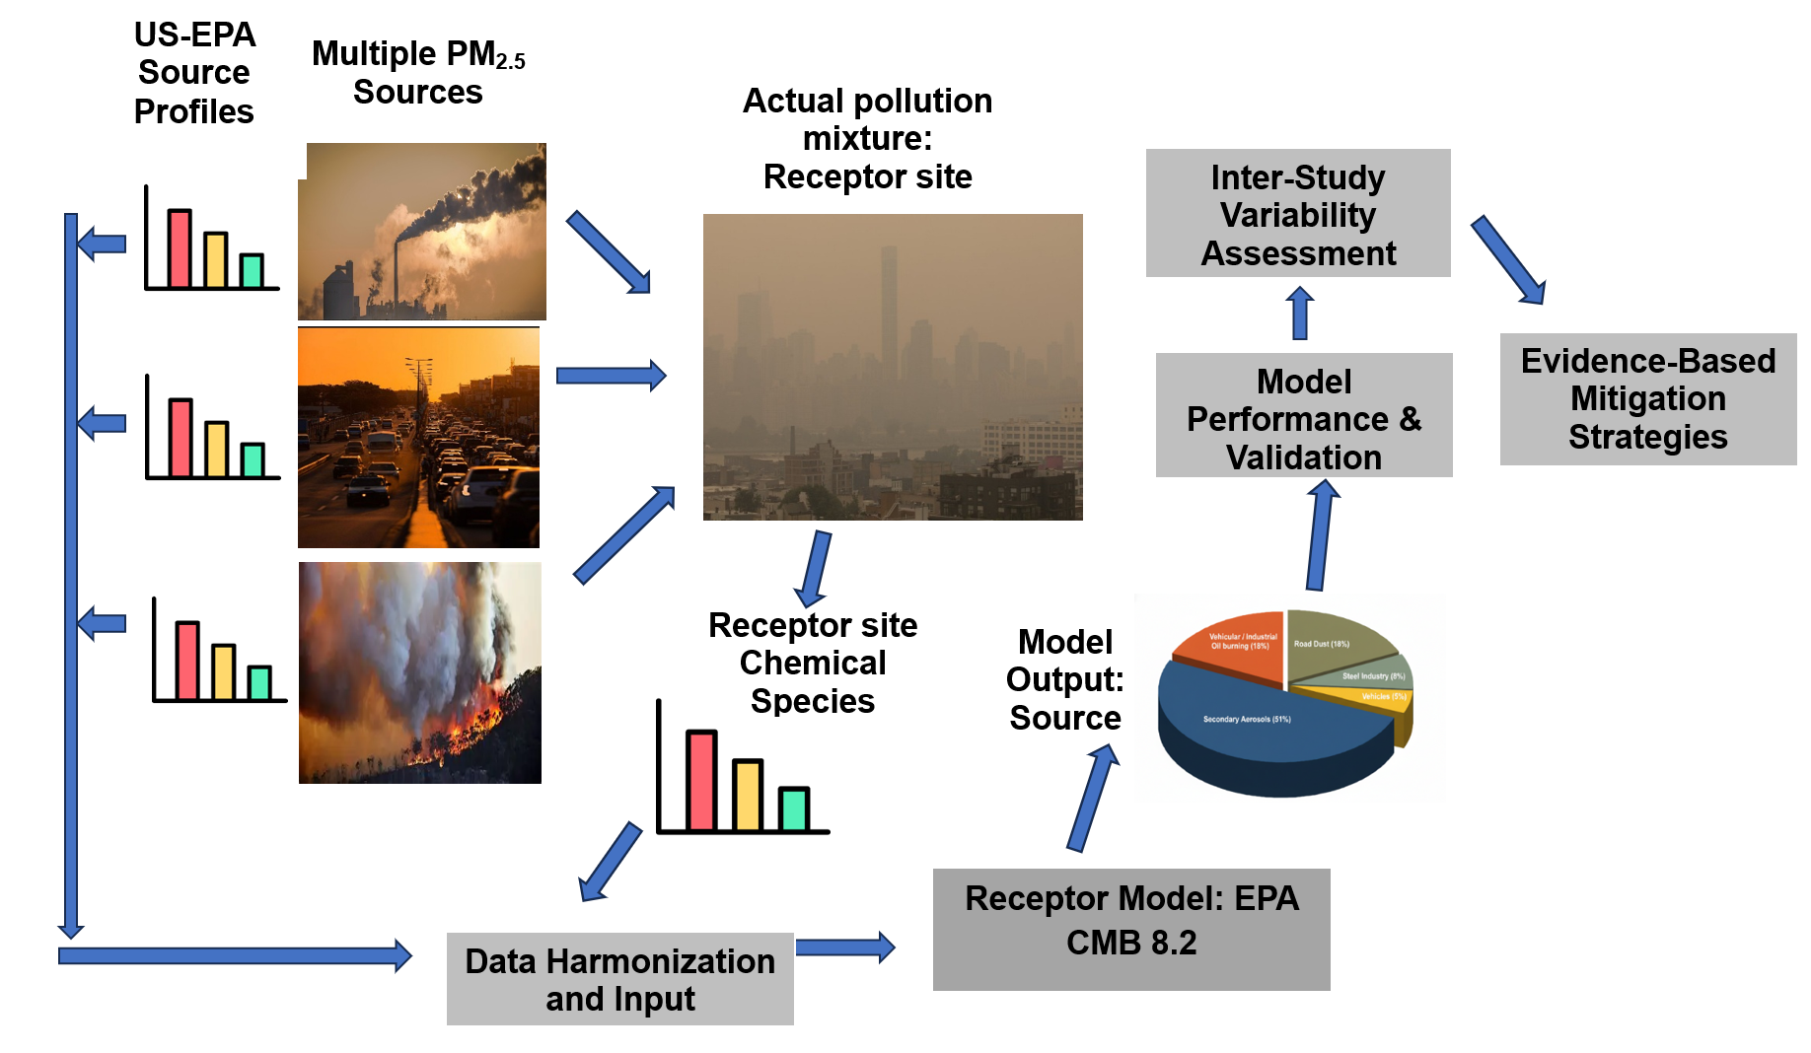recurring source-season couples (e.g., winter Nitrate, spring dust maxima) and monthly and seasonal trend analysis. For summer and winter results analysis a study conducted in 2022 was chosen[54]. This study included 21 different chemical species. Summer (June 1–28, 2022) and winter (December 1–29, 2022) were the two seasons in which sampling was conducted[54]. In order to address seasonal variations in industrial/metal signatures and biomass-related tracers, this includes paired-season sampling at the same site (summer and winter) [54]. It is especially useful for comparing combustion vs. non-combustion contributions and for verifying seasonal divides as it covers both seasons.
Figure 3.1: Schematic representation of the Chemical Mass Balance (CMB) receptor modeling process

3.3 Data Harmonization and CMB Input Preparation
All chemical species concentrations from the three studies were used in their original units (µg m⁻³). Only species that overlapped with available EPA source profiles were selected for each CMB model run. Species present in the EPA profiles but absent in a given receptor dataset were excluded from that specific run. No artificial estimation or interpolation of missing species was performed. When available, uncertainty estimates for ambient species were derived from the original research. Uncertainties were assigned in accordance with standard CMB practice where they were not reported [25, 26, 28].

3.4 Source Profile Selection and Compatibility
The U.S. Environmental Protection Agency (US-EPA) database provided the source profiles used in this investigation. Based on earlier research, potential significant source profiles for the CMB model, US-EPA source profiles (biomass burning, diesel vehicle exhaust, gasoline vehicle exhaust, road dust, and emissions from coal-fired thermal power plants) were used. Additionally, the CMB used Ammonium Sulfate and ammonium Nitrate source profiles (secondary sources), which include pure ammonium Sulfate (22.0% NH₄⁺, 58.6% SO₄²⁻, and 24.2% sulfur element) and pure ammonium Nitrate (21.3% NH₄⁺ and 73.5% NO₃⁻), respectively [10, 36]. Assuming that the sources affecting all sites were identical, the same source profiles were applied at each site [10, 40]. The US EPA source profiles were also utilized in earlier source apportionment studies that included the CMB [3, 27, 51].
EPA profiles offer a justifiable baseline for CMB mass-closure runs due to the absence of an extensive, locally measured profile library covering the same species collection; Major ions, carbonaceous fractions, and trace metals are among the 34 chemical species found in the chosen source profiles. In order to assess representativeness, we (1) verified core overlap for major tracers (OC, EC, NH₄⁺, NO₃⁻, SO₄²⁻, Fe, Zn, Pb, and Ca) by comparing the species and relative abundances in each receptor dataset to the EPA profiles, and (2) examined model diagnostics (R², reduced χ², t-statistics, % mass explained) for systematic misfits. Particularly for iron (Fe), zinc (Zn), lead (Pb), manganese (Mn), potassium (K), Sulfate, Nitrate, ammonium, OC, and EC, there is significant overlap between the species detected in the three ambient chemical concentrations of species and those found in the EPA profiles. This overlap guarantees that source profiles and receptor data are compatible, which is necessary for accurate CMB modeling [23, 65].

3.5 Statistical Measures
Several statistical measures are used to evaluate the quality and reliability of the CMB results. The percentage mass (%Mass) explained values and statistical metrics (R² and Chi-square) were used to assess the CMB results.
 | Measure | Ideal Range | Meaning
 | R² (R-Square) | 0.8 – 1.0 | Indicates how well the model explains the data. 1.0 is a perfect match.
 | Chi-Square (χ²) | 0 – 4.0 | Measures the difference between calculated and measured values uncertainities; lower is better.
 | Percent Mass | 80% – 120% | Ratio of predicted total mass to actual measured mass.
 | T-Statistic | > 2.0 | Ensures the source contribution is significant and not just noise.
 | Degrees of Freedom | > 5 | Extra information available to solve the model equations.
Table 3.1: Important statistical measures and optimum ranges, for assessing CMB results.
The variability in the ambient species concentrations that may be accounted for by the computed species concentrations is known as R². High values (between 0.8 and 1.0) are therefore preferred. With the exception of taking into account the uncertainty of the computed species concentrations, chi-square (χ²) is comparable to R². In general, low χ² scores (< 4.0) are trustworthy. The total mass concentration divided by the sum of the source contribution estimates (SCE) yields the %Mass explained values. In general, a result of 100% ± 20% is considered acceptable [25]. Table 2 summarizes the key metrics, their ideal ranges, and their practical interpretations.

3.5 Interstudy variability assessment
CMB is meant to enhance, not replace, existing data analysis and modeling methodologies. CMB explains data but does not anticipate ambient affects like dispersion models. To check the robustness of our CMB runs, each of the CMB result was compared with the source apportionment done in that specific study. As PMF and PCA are factor analytic and tend to group similar sources together often, CMB was aimed to provide better resolution of the sources identified and provide exact contribution in µg/m3.

Chapter 4

Result and Discussion

4.1 CMB analysis of Winter 2019 Study
For the February (Winter) 2019 study [64], the CMB model achieved R² = 0.72, a Fit Measure of 0.71, and reduced χ² = 3.8. The model reconstructed 287 µg·m⁻³, accounting for 85% of the observed PM₂.₅ mass (338 ± 67.7 µg·m⁻³) [57]. Statistical measures indicate well-separated sources without significant collinearity. T-statistics for major sources (Vehicular: 3.21, Nitrate: 4.26, Sulfate: 3.22, Soil: 3.69, Industry: 3.11) exceeded the
Figure 4.1: Winter-time Source Apportionment 2022: % Contribution of Sources

reliability threshold of 2 [37].

4.1.1 Source Contribution Interpretation
As per CMB analysis there was a combination of secondary aerosol generation and primary combustion sources. The biggest contributors were:
- Biomass Burning 81.18 µg/m³
- Petrol Vehicle 101.15 µg/m³
- Coal Combustion 23.19 µg/m³
- Industry 19.89 µg/m³
- Soil Dust 16.88 µg/m³
- Secondary Sulfate 21.04 µg/m³
- Secondary Nitrate23.92 µg/m³
The dominance of vehicle exhaust is in line with previous research done in Lahore, which shows that transport emissions primarily from older vehicles and high diesel NOₓ emissions are the largest year-round source of PM₂_{.5} [66, 67].
Table 4.1: CMB(Current study) vs. PCA/MLR in Source Identification for Lahore.
Source | CMB Contribution (µg/m³) | PCA/MLR Results[57]
Petrol Vehicle | 101.15 | Identified as a major contributor, but grouped with other sources.
Biomass Burning | 81.18 | Combined with secondary aerosol ; exact partition not possible
coal combustion | 23.19 | Part of “Mixed Sources”
Industry | 19.89 | Not distinguished as a separate source
Soil Dust | 16.88 | Mixed with traffic/coal dust
Secondary Sulfate | 21.04 | Included in secondary aerosol factor
Secondary Nitrate | 23.92 | Included in secondary aerosol factor

4.1.2 Seasonal Context
Secondary inorganic aerosol is substantial in this run, with Secondary Nitrate= 23.92 µg m⁻³ and Secondary Sulfate= 21.04 µg m⁻³. Wintertime ammonium–Nitrate and ammonium–Sulfate accumulation is supported by the combination of abundant gaseous precursors (NOₓ from vehicles and diesel generators; SO₂ from coal and industrial sources), available ammonia from agricultural and peri-urban sources, and stagnant meteorology that favors partitioning and accumulation under shallow boundary layers[57]. These causal factors have been well documented in winter studies across the Indo-Gangetic Plain, including Delhi, Kanpur, and Lahore [34, 51, 52, 57, 68, 69].

4.1.3 Combustion vs. Non-combustion Dynamics
The apportioned PM₂.₅ mass in this wintertime run shows a strong signal from combustion-related sources. Biomass contributes 81.18 µg m⁻³, Petrol Vehicle exhaust contributes 101.15 µg m⁻³, and Coal Combustion contributes 23.19 µg m⁻³. Together, these three sources account for 205.5 µg m⁻³ of the 287.25 µg m⁻³ apportioned mass (71.5% of apportioned mass; 60.8% of measured mass), consistent with regional winter studies that find combustion-derived sources dominate PM₂.₅ in northern South Asian cities [57, 68]. Soil dust contributes 16.88 µg m⁻³, a moderate share; seasonal studies in the Indo-Gangetic Plain indicate that crustal/dust contributions are typically larger during the pre-monsoon dry-wind period and smaller in stagnant winter episodes, so a lower soil-dust fraction in February aligns with expected seasonal patterns [29, 68].
Industry contributes 19.89 µg m⁻³, adding to combustion-related and anthropogenic emissions in the city. Overall, this wintertime source apportionment shows that combustion sources (Biomass, Petrol Vehicle, Coal Combustion) dominate the PM₂.₅ mass in Lahore, while secondary inorganic aerosols (secondary Nitrate, Secondary Sulfate) and Industry make a significant but smaller contribution, and Soil dust contributes a minor fraction, consistent with regional winter patterns.

4.1.4 Regional literature comparison.
The large Secondary Nitrate and Secondary Sulfate contributions in this winter run match prior Lahore and IGP winter studies that report strong wintertime secondary ammonium–Nitrate and ammonium–Sulfate fractions under stagnant meteorology [51, 57]. The run also shows dominant combustion sources Petrol Vehicle, Biomass, Coal Combustion, and Industry which is consistent with local source-apportionment work for Lahore and with receptor studies in Delhi and other IGP cities where combustion sources drive winter PM₂.₅ peaks [52, 68]. Soil dust is a smaller share in this run, aligning with regional seasonality where crustal contributions are typically larger in pre-monsoon/dry months than during stagnant winter episodes [5]. Overall, the pattern of strong secondary aerosol plus combustion dominance in winter is consistent with the regional literature cited above.

4.2 Monthly CMB analysis of Annual Data of 2022
This section presents the results of CMB source apportionment applied to speciated PM_{2.5} samples collected in Lahore during January–December 2022(Excluding July and August as they are monsoon peak(Washout seasons), with fairly normal AQI.
Table 4.2: Statistical Fit Measures of current CMB analysis of 2022 months
Metric | Jan | Feb | Mar | Apr | May | Jun | Sep | Oct | Nov | Dec
R² | 0.79 | 0.82 | 0.87 | 0.8 | 0.75 | 0.78 | 0.73 | 0.73 | 0.78 | 0.76
X² | 20.5 | 13.18 | 8.81 | 14.87 | 18.86 | 16.97 | 20.56 | 20.56 | 17.15 | 19.33
Mass (%) | 75.2 | 98.3 | 102.4 | 90.9 | 103.6 | 105.8 | 99 | 99 | 88.2 | 85.9

Figure 4.2: Monthly Source contribution as per CMB runs of 2022 study Months.
The model performed well, with R² values ranging from 0.73 to 0.87, averaging 0.78, indicating that the selected source profiles captured most of the variation in PM₂.₅ species. The total mass explained ranged from 75.2% to 105.8%, within the recommended 80–120% range for a valid mass balance. X² values were higher than the ideal limit, ranging from 8.8 to 20.6, which is common when generic EPA profiles are applied to local datasets. These higher values reflect differences between standard chemical signatures and local emissions or possible underestimation of measurement uncertainties[3]. Overall, the model provides a reasonable representation of PM₂.₅ sources despite these limitations.
Table 4.3: Interstudy Comparison of Current CMB analysis and 2022 study
Sources Identified | Annual study of 2022 [55] | Current CMB Findings
Secondary Nitrate | Part of the 26% ions | Distinguished source averaging 20% mass year-round.
Secondary Sulfate | Distinguished major component from fossil fuel burning but combined with Nitrate. | Distinguished source peaking in February (19.91%)
Coal Combustion | Mentioned of coal as precursor sources for Sulfate. | Identified as a major year-round source, peaking at 33.3% in Sep/Oct.
Diesel Vehicles | Grouped in all vehicles as a general "major contributor." | A distinguished source with major contributions in November (35.39%) and January (22.89%).
Petrol Vehicles | Grouped in all vehicles. | A distinguished source prevalent in December (41.89%) and April (25.26%).
Road Dust | Linked Si, Ca, and Fe as indicators of natural dust. | A major source identified with pattern: Highest in March (25.88%) and dropping in December due to "washout(rain)."
Industry | Generic link to poor industrial policies and emissions. | Distinguished source with highest 15.19% contribution in January, and prevalent in other months
Biomass Burning | Biomass burning and household wood use linked to smog season | Distinguished and quantified as highest4.29% during the harvest/transitioning months (Sep/Oct).

4.2.1 Vehicular Emissions (Diesel + Petrol)
There was a noticeable seasonal change in vehicle emissions. Winter was the most significant season for diesel emissions, with maximum in November at 69.3 µg/m³ (35.4%) and December at 60.0 µg/m³ (37.5%). With a high of 24.2 µg/m³ (25.3%) in April and little contribution (15–20%) in warmer months, petrol (gasoline) emissions were greater in the spring and summer. Reduced vertical mixing and air constriction, which retain transportation pollutants close to the ground, are the causes of winter increases. This effect is made worse by Lahore's heavy traffic, extensive use of diesel, and aging automobile fleet. These findings are consistent with other research showing that transportation is the main source of PM₂.₅ in Lahore [51, 70]. With data showing that particle formation is improved by greater sulfur in local diesel fuels [58, 71].
Table 4.4: Monthly PM₂.₅ Source Apportionment Results (µg·m⁻³) of 2022
Source Category | Jan | Feb | Mar | Apr | May | Jun | Sep | Oct | Nov | Dec
Biomass | 2.9 | 2.43 | 1 | 2.58 | 2.43 | 3.17 | 4.52 | 4.52 | 7.08 | 6.04
Coal Combustion | 32.51 | 20.41 | 19.03 | 20.65 | 24.46 | 26.04 | 35.13 | 35.13 | 43.68 | 38.04
Diesel vehicle | 30.61 | 0 | 0 | 0 | 0 | 0 | 0 | 0 | 69.31 | 60.02
Industry | 20.31 | 0 | 0 | 0 | 0 | 0 | 0 | 0 | 0 | 0
Petrol vehicle | 0 | 18.22 | 16.05 | 24.16 | 16.03 | 7.15 | 16.05 | 16.05 | 0 | 0
Road Dust | 6.07 | 22.69 | 28.69 | 16.06 | 11.15 | 19.27 | 5.07 | 5.07 | 14.03 | 11.89
Secondary sulfate | 15.38 | 21.83 | 19.83 | 13.19 | 11.33 | 12.15 | 18.21 | 18.21 | 21.28 | 16.04
Secondary nitrate | 25.95 | 24.09 | 26.27 | 19.02 | 11.62 | 11.33 | 26.5 | 26.5 | 40.45 | 27.86
Total | 133.73 | 109.67 | 110.87 | 95.66 | 77.02 | 79.11 | 105.48 | 105.48 | 195.83 | 159.89

4.2.2 Coal Combustion
The yearly mean impact of coal combustion to PM₂.₅ levels was about 29.5 ug/m3 (26%). The lowest was 19.0 µg/m³ (17.2%) in March, while the highest was 43.7 ug/m³ (22.3%) in November. Higher demand for heating and atmospheric conditions mentioned earlier are reason. Brick kilns and small industrial boilers, which frequently burn garbage, tires, and low-quality coal, serve as key contributors. These results are consistent with earlier research that found these sources to be significant causes of Lahore's smog and high amounts of Sulfate and carbonaceous particles [31, 51, 72]

4.2.3 Secondary Sulfate and Nitrate
Strong seasonal dependency was seen in secondary inorganic aerosols. Due to increased Ammonium Nitrate production at low temperatures, Secondary Nitrate peaked in November (40.5 µg/m³, 20.7%) and December (27.9 µg/m³, 17.4%). Sulfate remained mild during the warmer months (12–18 µg/m³, 10–17%) and peaked in February (21.8 µg/m³, 19.9%). These secondary aerosols had annual mean contribution of around 40 µg/m³ (34%). While SO₂ oxidation from coal, automobiles, and industry drives Sulfate creation, cooler temperatures, greater humidity, and stagnant circumstances enhance NOₓ conversion to ammonium Nitrate. Regional observations in Lahore are consistent with these seasonal tendencies [31, 70].

4.2.4 Road dust
Dust concentrations rose in March (28.7 µg/m³, 25.9%) and showed another peak in June (19.3 µg/m³, 24.4%) during the dry months. The yearly average was around 14.0 µg/m³ (14%). Because of the abundance of combustion sources and wet conditions, winter contributions were the lowest. This pattern can be explained by dust resuspension caused by wind, unpaved surfaces, traffic, and construction sources, enhance especially during the pre-monsoon dry months. Similar seasonal dust maximums with enhanced crustal elements (Si, Ca, and Fe) are reported by elemental and receptor investigations in Lahore [5, 51, 73].

4.2.5 Industry
In one-month, industrial emissions were significant, accounting for around 20.3 µg/m³ (15%). These most commonly come from low quality or non-conventional fuel combustion, metal processing, or local manufacturing. Depending on operations schedules and atmospheric dispersion, industrial contributions are frequently episodic [51, 70].

4.2.6 Biomass Burning
Biomass burning varied from 1.0 µg/m³ (0.9%) in March to 7.1 µg/m³ (3.6%) in November, with an annual mean of around 3.7 µg/m³ (3.3%) in current CMB analysis. The burning of local agricultural waste and home heating are reflected in the wintertime peaks. Despite being relatively small, biomass is a persistent secondary PM₂.₅ source in Lahore, according to earlier studies which employed more ambient species compared to the current one [72, 74].

4.3 Summer and Winter Results of 2022 study:

4.3.1 CMB Model Performance
The CMB modeling results show statistically meaningful agreement with the measured PM₂.₅ mass for both winter and summer of 2022 study[54]. In winter, the model achieved an R² of 0.60 and explained 75.5% of the measured mass, with a χ² value of 7.81 and a fit measure of 0.62. These statistics indicate a moderate but acceptable fit, which is common for receptor models applied in complex urban environments where local source profiles are limited [29, 30]. In summer, the model performance improved, with an R² of 0.71, a mass explained of 128.1%, and a χ² value of 8.93. The higher R² and moderate χ² suggest reasonably strong model performance despite uncertainties related to source profiles and atmospheric processes [75]. Overall, these results are consistent with PM₂.₅ CMB studies in other urban areas, where R² values typically range from 0.5 to 0.8 and χ² values below about 10 are considered acceptable under real-world conditions [30]. The T-statistics for most major sources are ≥2 in both seasons, indicating that the estimated source contributions are statistically significant. table
Table 4.5: CMB output in SCE (µg/m³)
Source Name | Summer SCE (µg/m³) | Winter SCE (µg/m³)
Biomass Burning | 62.13 | 13.60
Coal Combustion | 37.55 | 23.14
Secondary Nitrate | 17.96 | 39.71
Soil Dust | 17.87 | 0.00
Secondary Sulfate | 15.77 | 21.84
Industry | 13.80 | 0.00
Residual Oil | 2.13 | 0.00
Petrol Vehicle | 0.00 | 68.72
Diesel Vehicle | 0.00 | 61.92
Total Predicted Mass | 167.22 | 228.94

4.3.2 Vehicular Source (Petrol and Diesel)
Vehicle emissions are the main source group throughout the winter. The CMB assigned 61.92 µg·m⁻³ to diesel vehicle and 68.72 µg·m⁻³ to petrol vehicle. These two groups add up to 130.65 µg·m⁻³, which is equivalent to 43.1% of the observed winter PM₂.₅ (130.65 / 303.2). The significant winter contribution from automobiles suggests high local primary emissions, which get worse by wintertime weather patterns that restrict mixing and encourage the buildup of primary combustion aerosol[5, 30].

4.3.3 Biomass Burning
In the summer solution, burning biomass is the main source. 62.13 µg·m⁻³, 47.6% of the observed summer PM₂.₅ (62.13 / 130.4), are contributed by the biomass burning. Winter biomass burning, on the other hand, is lower at 13.60 µg·m⁻³ (5.9% of modeled winter mass 4.5% of observed winter PM₂.₅ ). The seasonal shift shows that while biomass is a secondary main source in winter, open burning, agricultural residue combustion, and regional transportation have a greater proportional contribution in the tested summer period [76].

4.3.4 Secondary Inorganic Aerosols (Sulfate and Nitrate)
Although they exhibit distinct seasonal splitting, Secondary Sulfate and secondary Nitrate combined make up a significant portion of PM₂.₅ in both seasons. Secondary Sulfate = 21.84 µg·m⁻³ and Secondary Nitrate = 39.71 µg·m⁻³ in the winter, with a combined SIA 61.55 µg·m⁻³ (26.9% of the modelled winter mass). Secondary Sulfate = 15.77 µg·m⁻³ and Secondary Nitrate = 17.96 µg·m⁻³ in the summer, with a combined SIA 33.74 µg·m⁻³ (20.2% of the modeled summer mass). Temperature and boundary layer-dependent Nitrate partitioning and buildup during the colder months is reflected in the much higher particle Nitrate in the winter[47].

4.3.5 Coal Combustion
A consistent contribution in all seasons, coal combustion is greater in the summer solution (23.14 µg·m⁻³ in winter, or about 10.1% of the simulated winter mass, and 37.55 µg·m⁻³ in summer, or approximately 22.5% of the modelled summer mass). This pattern suggests a year-round impact from industrial boilers and/or coal-fired sources the sharp rise in summer can be attributed to summer time electrical demand spike of local users.[72, 77].

4.3.6 Industry
With a summer contribution of 13.80 µg·m⁻³ (8.3% of the simulated summer mass), industrial emissions seem to be a modest, consistent source. The industrial signal is consistent with ongoing manufacturing and process emissions that don't vary as much by season, although it is less than the main vehicular or biomass signals in the corresponding dominating seasons[47, 51].

4.3.7 Residual oil
One small component of the solutions is residual oil. The residual oil estimate in the summer is 2.13 µg·m⁻³ (about 1.3% of the modeled summer mass), whereas in the winter solution, it has negligible statistical weight. The residual-oil contribution's low volume and restricted relevance suggest that heavy-fuel combustion is not a significant source in the ambient mix examined.
Figure 3.3: CMB runs of Summer and Winter of 2022 study
Overall, the integrated results show that the use of biomass, coal combustion, soil dust, and photochemically formed secondary aerosols are the main causes of summer PM₂.₅ in Lahore, while vehicular emissions and secondary Nitrate formation are the main causes of winter PM₂.₅ , with coal use and Sulfate providing a persistent overall contribution.

4.3.8 Refined apportionment of dust: CMB vs. PMF
Unlike factorization methods (PMF), which group elements that co-vary into factors such as “crustal” or “industrial” based on temporal covariance, CMB explicitly fits ambient species to predefined source profiles. When suitable and distinct profiles are available, CMB can separate natural soil/road dust from industrial dust (anthropogenic crustal matter). In our summer CMB run Soil Dust contributed 18.2 ± 4.0 µg·m⁻³ (13.9% of total) and Industrial Dust 14.0 ± 4.3 µg·m⁻³ (10.7% of total), giving cumulative dust 24.6%, higher than the single “Crustal Matter” factor (11%) reported by PMF model. This difference can occur when PMF merges temporally correlated sources while CMB splits them using profile chemistry. The differences in source contribution estimates (SCE) between the two models are shown in the following table, which also underlines the originality of the CMB technique in resolving certain fuel types and secondary components.
Table 4.6: Comparison of 2022 PMF source apportionment and current CMB Analysis
Season | PMF analysis | Current CMB Analysis | (SCE μg/m3) | Novelty of CMB results
Summer | Coal Combustion & Secondary Aerosol (31%) | Coal Combustion | 37.55 | CMB distinguished the primary coal power plant fraction from secondary Nitrate and Sulfate.
Summer | Crustal Matter (11%) | Soil dust | 17.87 | CMB differentiates natural soil dust from industrial-derived dust.
Winter | Total Traffic (20%) | Diesel & Petrol vehicle | 130.65 | CMB provides a high-resolution split between diesel 61.92 µg·m⁻³ and petrol 68.7 µg·m⁻³.
Winter | Industrial & Secondary Aerosol (28%) | Secondary Nitrate and Secondary Sulfate | 39.71 | CMB quantifies the specific mass of secondary ammonium Nitrate as a discrete source.

4.3.9 Evaluation of Residuals(σ)/Limitations
The residuals from these CMB runs reflect typical patterns for wintertime PM₂.₅ in Lahore [54, 57, 64].
  - Organic Carbon (OC): Overestimation of OC (+2σ) occurs when using standard Biomass profiles for mixed-fuel combustion, due to higher char fractions and moisture content in local fuels [51, 52].
  - Chloride: Slight underprediction (-2σ) may reflect unaccounted local sources such as household combustion and small-scale urban waste burning.
  - Heavy Metals (Zn, Pb, Fe): Underprediction (-3 to -5σ) suggests that standard Industry and coal combustion profiles do not fully capture local industrial or metallurgical contributions.
Although suggesting localized profile adoption, these residuals are consistent with wintertime trends across the Indo-Gangetic Plain, where mismatches in chloride and metals often arise from diverse home fuels and localized industrial emissions [78].

4.4 Policy Implications Based on CMB Source Contributions
According to the CMB data, the main sources of PM₂.₅ during the winter in Lahore are secondary inorganic aerosols, biomass combustion, coal-fired sources, and vehicle emissions. Policies should emphasize transport-sector emission management, including stricter in-use vehicle emission requirements, a quicker phase-out of older cars, and better fuel quality, given the significant contribution of gasoline and diesel vehicles. Similar actions have been successful in lowering urban PM₂.₅ levels in cities throughout Europe and East Asia, especially when paired with improved maintenance and inspection programs and traffic control during periods of winter stagnation[79, 80]. Studies in developed countries have shown that sector specific and coordinated mitigation measures have decreased PM₂.₅ by 30–50% if effectively implemented and maintained [81].
Persistent, Statistically Robust Sources:
- Secondary nitrate (23–40 µg·m⁻³)
- Secondary sulfate (15–22 µg·m⁻³)
- Coal combustion (20–44 µg·m⁻³)
- Vehicular emissions (60–170 µg·m⁻³ in winter)
Strong Seasonal Occurrence, Impactful Sources:
- Biomass burning (60–80 µg·m⁻³ during episodes)
- Soil / road dust (17–29 µg·m⁻³ in spring–summer)
- Industrial dust (13–20 µg·m⁻³ mainly in summer)
Secondary Nitrate (Highest Priority): Secondary nitrate is among largest and persistent contributor of PM₂.₅. Both of its precursor NOx and NH₃, must be handled as targeting just NOx , has proven non-satisfactory [82, 83]. To reduce NH₃, sewage, manures and organic wastes must be stored or treated properly to reduce NH₃. A large reduction in NO_{x} PM: 40% has been proven by applying diesel particulate filters (DPF) and selective catalytic reduction (SCR) systems to heavy duty vehicles [84, 85].
Secondary Sulfate: For reducing secondary sulfate, SO₂ must be controlled efficiently. low sulfur fuel use only, for all kind of industries and brick kilns that burns poor quality fuels that is high in SO₂. Control programs in China such as flue gas desulfurization (FGD) setups alongside boilers, demonstrated considerable reduction in SO₂ [81].
Coal Combustion: Gradually switching from coal-based combustion sources to cleaner energy alternatives are all in line with well-established air-quality management techniques used in cities in South and East Asia that experience comparable winter smog conditions [86, 87]. Modifications such as baghouses or electrostatic precipitators (ESPs) decreased PM₂.₅ emissions by roughly 0.45 tons per kiln annually along with 10.5% energy savings [88].
Vehicular Emissions: The modification of public transportation vehicles, particularly buses and trucks, with modern pollution control technology is direly needed in order to minimize vehicular emissions. In addition, automobile renovation is needed to meet Euro-VI/BS-VI emission regulations and gradually switch to electric buses. Developed regions with fleet meeting these standards have reported significant reduction in BC emissions (from 0.28 g·kg⁻¹ to 0.04–0.05 g·kg⁻¹) [84, 85].

Chapter 5

Conclusion
In order to generate mass-based, policy-relevant source apportionments and evaluate inter-study and seasonal variability, this thesis applied the EPA Chemical Mass Balance (CMB v8.2) receptor model to three separate, chemically-speciated PM₂.₅ studies for Lahore (a winter campaign, an annual 2022 study, and paired-season 2022 research). Combustion sources provide for the majority of ambient PM₂.₅ in Lahore across all datasets: biomass combustion and vehicle emissions (diesel and gasoline) are typically the biggest contributors, but coal and industrial combustion also contribute significantly throughout the year. Ammonium-Nitrate and ammonium-Sulfate secondary inorganic aerosols are significant seasonal components that significantly increase winter PM₂.₅ mass in stagnant weather.
The CMB solutions are generally robust, as shown by model diagnostics: winter runs captured about 85% of observed mass (e.g., February 2019 run reconstructed 287 µg·m⁻³ of 338 µg·m⁻³ measured mass with R² 0.72), and annual/monthly runs typically achieved R² values in the 0.73–0.87 range (average 0.78). Elevated χ² values in some runs indicate discrepancies that probably result from applying generic (US-EPA) source profiles to local emission mixes. Consistent seasonal trends and concordance with local literature boost confidence in the main conclusions despite these limitations.
From a policy perspective, the findings suggest that improving Lahore's air quality will necessitate prioritized control of combustion emissions: (1) transport sector measures, such as stricter vehicle emissions standards, improved fuel quality, switching to euro 5 or euro 6 engine standards and improved inspection and public transportation options; (2) reduction of residential and small-scale biomass burning through the deployment of cleaner fuel and technology and the enforcement of open-burning bans; and (3) stricter controls and cleaner technologies for coal-using industries and brick kilns. Precursor reductions (NOₓ, SO₂, NH₃) should be included into emission control measures since secondary PM generation is a significant wintertime contribution.
Finally, the study emphasizes the need of locally measured source profiles, extended multi-site sampling, and the combined use of profile-driven (CMB) and factor-analytic (PMF/PCA) methodologies to minimize uncertainty and improve policy relevance of apportionments. While the use of secondary datasets and EPA profiles has obvious limits, our approach turns compositional information into practical, mass-based source contributions, providing a solid framework for targeted mitigation in Lahore.

References
[1] T. M. Johnson et al., "Tools for improving air quality management: A review of top-down source apportionment techniques and their application in developing countries," 2011.
[2] Y. Wang, X. Zhang, and R. Arimoto, "The contribution from distant dust sources to the atmospheric particulate matter loadings at XiAn, China during spring," Science of the Total Environment, vol. 368, no. 2-3, pp. 875-883, 2006.
[3] L. Veal, "United States environmental protection agency," US Environmental Protection Agency (EPA)(2005) National Management Measures to Control Non-Point Source Pollution for Urban Areas, 2021.
[4] M.-C. O. Chang, J. C. Chow, J. G. Watson, P. K. Hopke, S.-M. Yi, and G. C. England, "Measurement of ultrafine particle size distributions from coal-, oil-, and gas-fired stationary combustion sources," Journal of the Air & Waste Management Association, vol. 54, no. 12, pp. 1494-1505, 2004.
[5] A. Lodhi, B. Ghauri, M. R. Khan, S. Rahman, and S. Shafique, "Particulate matter (PM2.5) concentration and source apportionment in lahore," Journal of the Brazilian Chemical Society, vol. 20, no. 10, pp. 1811-1820, 2009, doi: 10.1590/s0103-50532009001000007.
[6] "Review of Pai et al. (2019)," ed: Copernicus GmbH, 2019.
[7] D. Schwela, "Review of Urban Air Quality in Sub-Saharan Africa Region," ed: World Bank, Washington, DC, 2012.
[8] R. Nawaz et al., "Air Pollution Tolerance Index and Heavy Metals Accumulation of Tree Species for Sustainable Environmental Management in Megacity of Lahore," Air, vol. 1, no. 1, pp. 55-68, 2022/12/07 2022, doi: 10.3390/air1010004.
[9] M. Zheng et al., "Seasonal trends in PM2.5 source contributions in Beijing, China," Atmospheric Environment, vol. 39, no. 22, pp. 3967-3976, 2005/07 2005, doi: 10.1016/j.atmosenv.2005.03.036.
[10] R. Hu et al., "Mixing state of ambient aerosols during different fog-haze pollution episodes in the Yangtze River Delta, China," Atmospheric Environment, vol. 178, pp. 1-10, 2018/04 2018, doi: 10.1016/j.atmosenv.2018.01.032.
[11] J. I. Steinfeld, "Atmospheric Chemistry and Physics: From Air Pollution to Climate Change," Environment: Science and Policy for Sustainable Development, vol. 40, no. 7, pp. 26-26, 1998/09 1998, doi: 10.1080/00139157.1999.10544295.
[12] H. Guo et al., "Source contributions and potential reductions to health effects of particulate matter in India," Atmospheric Chemistry and Physics, vol. 18, no. 20, pp. 15219-15229, 2018/10/23 2018, doi: 10.5194/acp-18-15219-2018.
[13] Q. Zhang, X. Meng, S. Shi, L. Kan, R. Chen, and H. Kan, "Overview of particulate air pollution and human health in China: Evidence, challenges, and opportunities," The Innovation, vol. 3, no. 6, 2022.
[14] K. Chand et al., "Aerosol characteristics and their impact on the himalayan energy budget," Sustainability, vol. 14, no. 1, p. 179, 2021.
[15] A. Malik et al., "SMOG CRISIS IN LAHORE: EVALUATING AIR QUALITY TRENDS AND PUBLIC HEALTH IMPLICATIONS," Bulletin of Biological and Allied Sciences Research, vol. 2024, no. 1, p. 87, 2024/11/13 2024, doi: 10.54112/bbasr.v2024i1.87.
[16] B. Chen and H. Kan, "Air pollution and population health: a global challenge," Environmental health and preventive medicine, vol. 13, no. 2, pp. 94-101, 2008.
[17] D. D. Sin et al., "Air pollution and COPD: GOLD 2023 committee report," European Respiratory Journal, vol. 61, no. 5, 2023.
[18] R. S. A. Usmani, A. Saeed, A. M. Abdullahi, T. R. Pillai, N. Z. Jhanjhi, and I. A. T. Hashem, "Air pollution and its health impacts in Malaysia: a review," Air Quality, Atmosphere &amp; Health, vol. 13, no. 9, pp. 1093-1118, 2020/07/22 2020, doi: 10.1007/s11869-020-00867-x.
[19] D. A. Glencross, T.-R. Ho, N. Camiña, C. M. Hawrylowicz, and P. E. Pfeffer, "Air pollution and its effects on the immune system," Free Radical Biology and Medicine, vol. 151, pp. 56-68, 2020/05 2020, doi: 10.1016/j.freeradbiomed.2020.01.179.
[20] P. K. Hopke, Y. Feng, and Q. Dai, "Source apportionment of particle number concentrations: A global review," Science of The Total Environment, vol. 819, p. 153104, 2022/05 2022, doi: 10.1016/j.scitotenv.2022.153104.
[21] M. Viana et al., "Source apportionment of particulate matter in Europe: a review of methods and results," Journal of aerosol science, vol. 39, no. 10, pp. 827-849, 2008.
[22] M. Ahmad et al., "Fine particulate matter from brick kilns site and roadside in Lahore, Pakistan: Insight into chemical composition, oxidative potential, and health risk assessment," Heliyon, vol. 10, no. 4, p. e25884, 2024/02 2024, doi: 10.1016/j.heliyon.2024.e25884.
[23] P. K. Hopke, "Review of receptor modeling methods for source apportionment," Journal of the Air &amp; Waste Management Association, vol. 66, no. 3, pp. 237-259, 2016/01/12 2016, doi: 10.1080/10962247.2016.1140693.
[24] E. Us, Manual of Small Public Water Supply Systems. CRC Press, 2020.
[25] V. A. Hanzel and N. Durham, "PEER REVIEW OF THE CHEMICAL MASS BALANCE MODEL (EPA-CMB8. 2) AND DOCUMENTATION US ENVIRONMENTAL PROTECTION AGENCY," 2005.
[26] P. K. Hopke, Q. Dai, L. Li, and Y. Feng, "Global review of recent source apportionments for airborne particulate matter," Science of The Total Environment, vol. 740, p. 140091, 2020.
[27] S. Lee, W. Liu, Y. Wang, A. G. Russell, and E. S. Edgerton, "Source apportionment of PM2. 5: Comparing PMF and CMB results for four ambient monitoring sites in the southeastern United States," Atmospheric Environment, vol. 42, no. 18, pp. 4126-4137, 2008.
[28] J. G. Watson, J. C. Chow, and L. W. A. Chen, "Summary of Organic and Elemental Carbon/Black Carbon Analysis Methods and Intercomparisons," Aerosol and Air Quality Research, vol. 5, no. 1, pp. 65-102, 2005, doi: 10.4209/aaqr.2005.06.0006.
[29] A. S. Pipal, R. Jan, P. G. Satsangi, S. Tiwari, and A. Taneja, "Study of Surface Morphology, Elemental Composition and Origin of Atmospheric Aerosols (PM2.5 and PM10) over Agra, India," Aerosol and Air Quality Research, vol. 14, no. 6, pp. 1685-1700, 2014, doi: 10.4209/aaqr.2014.01.0017.
[30] B. A. Begum, S. K. Biswas, and P. K. Hopke, "Source Apportionment of Air Particulate Matter by Chemical Mass Balance (CMB) and Comparison with Positive Matrix Factorization (PMF) Model," Aerosol and Air Quality Research, vol. 7, no. 4, pp. 446-468, 2007, doi: 10.4209/aaqr.2006.10.0021.
[31] M. Ahmad, S. Cheng, Q. Yu, W. Qin, Y. Zhang, and J. Chen, "Chemical and source characterization of PM2.5 in summertime in severely polluted Lahore, Pakistan," Atmospheric Research, vol. 234, p. 104715, 2020/04 2020, doi: 10.1016/j.atmosres.2019.104715.
[32] C. A. Belis, F. Karagulian, B. R. Larsen, and P. K. Hopke, "Critical review and meta-analysis of ambient particulate matter source apportionment using receptor models in Europe," Atmospheric Environment, vol. 69, pp. 94-108, 2013/04 2013, doi: 10.1016/j.atmosenv.2012.11.009.
[33] J. A. Cooper and J. G. Watson, "Receptor Oriented Methods of Air Particulate Source Apportionment," Journal of the Air Pollution Control Association, vol. 30, no. 10, pp. 1116-1125, 1980/10 1980, doi: 10.1080/00022470.1980.10465157.
[34] P. Acharja et al., "Enhanced secondary aerosol formation driven by excess ammonia during fog episodes in Delhi, India," Chemosphere, vol. 289, p. 133155, 2022/02 2022, doi: 10.1016/j.chemosphere.2021.133155.
[35] J. C. Chow and J. G. Watson, "Review of PM2. 5 and PM10 apportionment for fossil fuel combustion and other sources by the chemical mass balance receptor model," Energy & Fuels, vol. 16, no. 2, pp. 222-260, 2002.
[36] J. G. Watson, T. Zhu, J. C. Chow, J. Engelbrecht, E. M. Fujita, and W. E. Wilson, "Receptor modeling application framework for particle source apportionment," Chemosphere, vol. 49, no. 9, pp. 1093-1136, 2002.
[37] J. G. Watson, J. C. Chow, and J. E. Houck, "PM2.5 chemical source profiles for vehicle exhaust, vegetative burning, geological material, and coal burning in Northwestern Colorado during 1995," Chemosphere, vol. 43, no. 8, pp. 1141-1151, 2001/06 2001, doi: 10.1016/s0045-6535(00)00171-5.
[38] W. U. Rehman, M. Park, J. Chong, K. Lee, J. Jang, and K. Park, "Determination of sources of fine particles in different ambient atmospheres in South Korea using a chemical mass balance model," Environmental Forensics, vol. 21, no. 1, pp. 48-58, 2020.
[39] J. G. Watson, J. C. Chow, and E. M. Fujita, "Review of volatile organic compound source apportionment by chemical mass balance," Atmospheric Environment, vol. 35, no. 9, pp. 1567-1584, 2001/03 2001, doi: 10.1016/s1352-2310(00)00461-1.
[40] W. U. Rehman, M. Park, J. Chong, K. Lee, J. Jang, and K. Park, "Determination of sources of fine particles in different ambient atmospheres in South Korea using a chemical mass balance model," Environmental Forensics, vol. 21, no. 1, pp. 48-58, 2019/12/01 2019, doi: 10.1080/15275922.2019.1694099.
[41] M. Dan, "The characteristics of carbonaceous species and their sources in PM2.5 in Beijing," Atmospheric Environment, vol. 38, no. 21, pp. 3443-3452, 2004/07 2004, doi: 10.1016/j.atmosenv.2004.02.052.
[42] Y. Song et al., "Source apportionment of PM2.5 in Beijing by positive matrix factorization," Atmospheric Environment, vol. 40, no. 8, pp. 1526-1537, 2006/03 2006, doi: 10.1016/j.atmosenv.2005.10.039.
[43] W. Zhang et al., "A refined source apportionment study of atmospheric PM2.5 during winter heating period in Shijiazhuang, China, using a receptor model coupled with a source-oriented model," Atmospheric Environment, vol. 222, p. 117157, 2020/02 2020, doi: 10.1016/j.atmosenv.2019.117157.
[44] S. Jain, S. K. Sharma, N. Vijayan, and T. K. Mandal, "Seasonal characteristics of aerosols (PM2.5 and PM10) and their source apportionment using PMF: A four year study over Delhi, India," Environmental Pollution, vol. 262, p. 114337, 2020/07 2020, doi: 10.1016/j.envpol.2020.114337.
[45] M. Saxena et al., "Water soluble inorganic species of PM10 and PM2.5 at an urban site of Delhi, India: Seasonal variability and sources," Atmospheric Research, vol. 184, pp. 112-125, 2017/02 2017, doi: 10.1016/j.atmosres.2016.10.005.
[46] R. Jat and B. R. Gurjar, "Contribution of different source sectors and source regions of Indo-Gangetic Plain in India to PM2.5 pollution and its short-term health impacts during peak polluted winter," Atmospheric Pollution Research, vol. 12, no. 4, pp. 89-100, 2021/04 2021, doi: 10.1016/j.apr.2021.02.016.
[47] J. Kar et al., "Wintertime pollution over the Eastern Indo-Gangetic Plains as observed from MOPITT, CALIPSO and tropospheric ozone residual data," Atmospheric Chemistry and Physics, vol. 10, no. 24, pp. 12273-12283, 2010/12/23 2010, doi: 10.5194/acp-10-12273-2010.
[48] W. Javed and B. Guo, "Chemical characterization and source apportionment of fine and coarse atmospheric particulate matter in Doha, Qatar," Atmospheric Pollution Research, vol. 12, no. 2, pp. 122-136, 2021/02 2021, doi: 10.1016/j.apr.2020.10.015.
[49] S. Raja, K. F. Biswas, L. Husain, and P. K. Hopke, "Source Apportionment of the Atmospheric Aerosol in Lahore, Pakistan," Water, Air, and Soil Pollution, vol. 208, no. 1-4, pp. 43-57, 2009/08/05 2009, doi: 10.1007/s11270-009-0148-z.
[50] Y. Zhang, T. Quraishi, and J. J. Schauer, "Daily Variations in Sources of Carbonaceous Aerosol in Lahore, Pakistan during a High Pollution Spring Episode," Aerosol and Air Quality Research, vol. 8, no. 2, pp. 130-146, 2008, doi: 10.4209/aaqr.2007.09.0042.
[51] E. Stone, J. Schauer, T. A. Quraishi, and A. Mahmood, "Chemical characterization and source apportionment of fine and coarse particulate matter in Lahore, Pakistan," Atmospheric Environment, vol. 44, no. 8, pp. 1062-1070, 2010/03 2010, doi: 10.1016/j.atmosenv.2009.12.015.
[52] K. Alam et al., "Source Apportionment and Characterization of Particulate Matter (PM10) in Urban Environment of Lahore," Aerosol and Air Quality Research, vol. 14, no. 7, pp. 1851-1861, 2014, doi: 10.4209/aaqr.2014.01.0005.
[53] M. Ahmad et al., "Characteristics, sources, and exposure risk of the carbonaceous species of PM2.5 in Lahore, Pakistan," ed: Springer Science and Business Media LLC, 2022.
[54] S. Ashraf and A. A. Din, "SOURCE APPORTIONMENT OF PM2. 5 IN LAHORE USING POSITIVE MATRIX FACTORIZATION (PMF)."
[55] J. Iqbal, I. Ahmad, R. Haider, H. Khokhar, and A. Farooq, "MONITORING AND ANALYSIS OF THE COMPOSITION OF PM2. 5 IN LAHORE, PAKISTAN," Pakistan Journal of Science, vol. 75, no. 3, 2023.
[56] S. Mohyuddin et al., "Characterization and source identification of PM2.5 during intense haze episodes in an urban environment of Lahore," Atmospheric Environment: X, vol. 23, p. 100276, 2024/08 2024, doi: 10.1016/j.aeaoa.2024.100276.
[57] M. Ahmad, Q. Yu, J. Chen, S. Cheng, W. Qin, and Y. Zhang, "Chemical characteristics, oxidative potential, and sources of PM2.5 in wintertime in Lahore and Peshawar, Pakistan," Journal of Environmental Sciences, vol. 102, pp. 148-158, 2021/04 2021, doi: 10.1016/j.jes.2020.09.014.
[58] L. Naidja et al., "Source apportionment of PM2.5 and their associated metallic elements by positive matrix factorization at a traffic site in Constantine, Algeria," Air Quality, Atmosphere &amp; Health, vol. 15, no. 12, pp. 2137-2155, 2022/09/15 2022, doi: 10.1007/s11869-022-01241-9.
[59] B. Xu et al., "Source apportionment of fine particulate matter at a megacity in China, using an improved regularization supervised PMF model," Science of The Total Environment, vol. 879, p. 163198, 2023/06 2023, doi: 10.1016/j.scitotenv.2023.163198.
[60] X.-S. Luo et al., "Source differences in the components and cytotoxicity of PM 2.5 from automobile exhaust, coal combustion, and biomass burning contributing to urban aerosol toxicity," Atmospheric Chemistry and Physics, vol. 24, no. 2, pp. 1345-1360, 2024.
[61] N. Paisi, J. Kushta, A. Pozzer, A. Violaris, and J. Lelieveld, "Health effects of carbonaceous PM2. 5 compounds from residential fuel combustion and road transport in Europe," Scientific Reports, vol. 14, no. 1, p. 1530, 2024.
[62] J. Bachmann, "Will the circle be unbroken: a history of the US National Ambient Air Quality Standards," Journal of the Air & Waste Management Association, vol. 57, no. 6, pp. 652-697, 2007.
[63] R. Majeed et al., "Solving the mysteries of Lahore smog: the fifth season in the country," Frontiers in Sustainable Cities, vol. 5, 2024/01/05 2024, doi: 10.3389/frsc.2023.1314426.
[64] J. Iqbal, I. Ahmad, R. Haider, H.Khokhar, and A.Farooq, "MONITORING AND ANALYSIS OF THE COMPOSITION OF PM2.5 IN LAHORE, PAKISTAN," Pakistan Journal of Science, vol. 75, no. 03, pp. 480-487, 2023/09/30 2023, doi: 10.57041/pjs.v75i03.1016.
[65] "Environmental Protection Agency (EPA)," in SpringerReference: Springer-Verlag.
[66] A. U. Bajwa and H. A. Sheikh, "Contribution of Road Transport to Pakistan’s Air Pollution in the Urban Environment," Air, vol. 1, no. 4, pp. 237-257, 2023/11/02 2023, doi: 10.3390/air1040018.
[67] M. Ali and M. Athar, "Impact of transport and industrial emissions on the ambient air quality of Lahore City, Pakistan," Environmental Monitoring and Assessment, vol. 171, no. 1-4, pp. 353-363, 2010/01/06 2010, doi: 10.1007/s10661-009-1283-0.
[68] P. Pant, A. Shukla, S. D. Kohl, J. C. Chow, J. G. Watson, and R. M. Harrison, "Characterization of ambient PM2.5 at a pollution hotspot in New Delhi, India and inference of sources," Atmospheric Environment, vol. 109, pp. 178-189, 2015/05 2015, doi: 10.1016/j.atmosenv.2015.02.074.
[69] A. Franchin et al., "Airborne and ground-based observations of ammonium-nitrate-dominated aerosols in a shallow boundary layer during intense winter pollution episodes in northern Utah," Atmospheric Chemistry and Physics, vol. 18, no. 23, pp. 17259-17276, 2018/12/06 2018, doi: 10.5194/acp-18-17259-2018.
[70] A. Rasheed, V. P. Aneja, A. Aiyyer, and U. Rafique, "Measurement and Analysis of Fine Particulate Matter (PM2.5) in Urban Areas of Pakistan," Aerosol and Air Quality Research, vol. 15, no. 2, pp. 426-439, 2015, doi: 10.4209/aaqr.2014.10.0269.
[71] A. Rasheed, V. P. Aneja, A. Aiyyer, and U. Rafique, "Measurement and analysis of fine particulate matter (PM2. 5) in urban areas of Pakistan," Aerosol and Air Quality Research, vol. 15, no. 2, pp. 426-439, 2015.
[72] M. Ahmad et al., "Fine particulate matter from brick kilns site and roadside in Lahore, Pakistan: Insight into chemical composition, oxidative potential, and health risk assessment," Heliyon, vol. 10, no. 4, 2024.
[73] S. Iqbal, M. Wasim, M. Tufail, M. Arif, and M. M. Chaudhry, "Elemental contamination in urban parks of Rawalpindi/Islamabad—a source identification and pollution level assessment study," Environmental Monitoring and Assessment, vol. 184, no. 9, pp. 5497-5510, 2011/09/14 2011, doi: 10.1007/s10661-011-2356-4.
[74] S. Sidra, Z. Ali, Z. Ahmad Nasir, and I. Colbeck, "Seasonal variation of fine particulate matter in residential micro–environments of Lahore, Pakistan," Atmospheric Pollution Research, vol. 6, no. 5, pp. 797-804, 2015/09 2015, doi: 10.5094/apr.2015.088.
[75] P. Pipalatkar, V. V. Khaparde, D. G. Gajghate, and M. A. Bawase, "Source Apportionment of PM2.5 Using a CMB Model for a Centrally Located Indian City," Aerosol and Air Quality Research, vol. 14, no. 3, pp. 1089-1099, 2014, doi: 10.4209/aaqr.2013.04.0130.
[76] R. Azhar, M. Zeeshan, and K. Fatima, "Crop residue open field burning in Pakistan; multi-year high spatial resolution emission inventory for 2000–2014," Atmospheric Environment, vol. 208, pp. 20-33, 2019/07 2019, doi: 10.1016/j.atmosenv.2019.03.031.
[77] A. Anthony, "Climate Change and Peak Demand for Electricity: Evaluating Policies for Reducing Peak Demand Under Different Climate Change Scenarios," University of Rhode Island. [Online]. Available: http://dx.doi.org/10.23860/diss-anthony-abigail-2009
[78] S. Tiwari et al., "Study of the carbonaceous aerosol and morphological analysis of fine particles along with their mixing state in Delhi, India: a case study," Environmental Science and Pollution Research, vol. 22, no. 14, pp. 10744-10757, 2015/03/11 2015, doi: 10.1007/s11356-015-4272-6.
[79] "Review for "Health effects of exposure to sulfur dioxide, nitrogen dioxide, ozone, and carbon monoxide between 1980 and 2019: A systematic review and meta‐analysis"," ed: Hindawi Limited, 2022.
[80] R. Zellner, "John H. Seinfeld and Spyros N. Pandis: Atmospheric Chemistry and Physics, from Air Pollution to Climate Change," Journal of Atmospheric Chemistry, vol. 37, no. 2, pp. 212-214, 2000/10 2000, doi: 10.1023/a:1006483708571.
[81] Q. Zhang et al., "Drivers of improved PM <sub>2.5</sub> air quality in China from 2013 to 2017," Proceedings of the National Academy of Sciences, vol. 116, no. 49, pp. 24463-24469, 2019/11/18 2019, doi: 10.1073/pnas.1907956116.
[82] M. Li et al., "Nonlinear responses of particulate nitrate to NO <sub>x</sub> emission controls in the megalopolises of China," Atmospheric Chemistry and Physics, vol. 21, no. 19, pp. 15135-15152, 2021/10/12 2021, doi: 10.5194/acp-21-15135-2021.
[83] A. Clappier, P. Thunis, M. Beekmann, J. P. Putaud, and A. de Meij, "Impact of SOx, NOx and NH3 emission reductions on PM2.5 concentrations across Europe: Hints for future measure development," Environment International, vol. 156, p. 106699, 2021/11 2021, doi: 10.1016/j.envint.2021.106699.
[84] T. R. Dallmann, R. A. Harley, and T. W. Kirchstetter, "Effects of Diesel Particle Filter Retrofits and Accelerated Fleet Turnover on Drayage Truck Emissions at the Port of Oakland," Environmental Science &amp; Technology, vol. 45, no. 24, pp. 10773-10779, 2011/11/14 2011, doi: 10.1021/es202609q.
[85] J. Kubsh, "Diesel retrofit technologies and experience for on-road and off-road vehicles," Int. Council of Clean Transportation (ICCT), 2017.
[86] S. K. Akagi et al., "Emission factors for open and domestic biomass burning for use in atmospheric models," Atmospheric Chemistry and Physics, vol. 11, no. 9, pp. 4039-4072, 2011/05/03 2011, doi: 10.5194/acp-11-4039-2011.
[87] D. G. Streets et al., "An inventory of gaseous and primary aerosol emissions in Asia in the year 2000," Journal of Geophysical Research: Atmospheres, vol. 108, no. D21, 2003/11/11 2003, doi: 10.1029/2002jd003093.
[88] N. Brooks et al., "Reducing emissions and air pollution from informal brick kilns: Evidence from Bangladesh," Science, vol. 388, no. 6747, 2025/05/08 2025, doi: 10.1126/science.adr7394.

Appendix

Table 3: Concentrations of Measured Species of PM₂.₅ in 2019 February (winter) [57]
Species Class | Chemical Species | Mean ± SD
Total Mass & Carbon | PM₂.₅ (μg/m³) | 522 ± 222
 | Organic Carbon (OC) (μg/m³) | 50.7 ± 30.5
 | Elemental Carbon (EC) (μg/m³) | 26.5 ± 18.0
 | Water-Soluble Organic Carbon (WSOC) | 35.2 ± 14.9
 | Secondary Organic Carbon (SOC) | 15.7 ± 11.3
Water-Soluble Ions | Nitrate (NO₃⁻) (μg/m³) | 20.6 ± 11.7
 | Sulfate (SO₄²⁻) (μg/m³) | 24.2 ± 12.3
 | Chloride (Cl⁻) (μg/m³) | 27.3 ± 18.8
 | Sodium (Na⁺) (μg/m³) | 1.3 ± 0.6
 | Ammonium (NH₄⁺) (μg/m³) | 14.7 ± 8.2
 | Potassium (K⁺) (μg/m³) | 4.9 ± 2.5
 | Magnesium (Mg²⁺) (μg/m³) | 0.6 ± 0.2
 | Calcium (Ca²⁺) (μg/m³) | 3.2 ± 1.7
Trace Metals | Lithium (Li) (ng/m³) | 2.4 ± 2.9
 | Magnesium (Mg) (ng/m³) | 1170 ± 853
 | Aluminum (Al) (ng/m³) | 2280 ± 2130
 | Titanium (Ti) (ng/m³) | 94.6 ± 88.4
 | Vanadium (V) (ng/m³) | 5.5 ± 7.6
 | Chromium (Cr) (ng/m³) | 66.5 ± 55.3
 | Manganese (Mn) (ng/m³) | 170 ± 116
 | Iron (Fe) (ng/m³) | 4490 ± 4710
 | Nickel (Ni) (ng/m³) | 28.7 ± 26.5
 | Copper (Cu) (ng/m³) | 174 ± 129
 | Zinc (Zn) (ng/m³) | 7290 ± 6050
 | Arsenic (As) (ng/m³) | 17.6 ± 19.1
 | Strontium (Sr) (ng/m³) | 37.7 ± 23.2
 | Cadmium (Cd) (ng/m³) | 64.0 ± 77.0
 | Tin (Sn) (ng/m³) | 92.8 ± 74.3
 | Barium (Ba) (ng/m³) | 69.7 ± 42.0
 | Lead (Pb) (ng/m³) | 3810 ± 5610
 | Bismuth (Bi) (ng/m³) | 11.8 ± 11.6

Table 4: Concentrations of Measured Species in 2022 study [64]
Species | Concentration (μg/m³)
PM₂.₅ Mass | 194.2 ± 95.8
Organic Carbon (OC) | 48.0 ± 22.1
Elemental Carbon (EC) | 15.3 ± 8.7
Water-Soluble Ions
- Sulfate (SO₄²⁻) | 14.5 ± 7.9
- Nitrate (NO₃⁻) | 26.5 ± 15.0
- Ammonium (NH₄⁺) | 11.2 ± 5.9
- Chloride (Cl⁻) | 10.9 ± 9.0
Trace Elements
- Iron (Fe) | 2.50 ± 1.23
- Calcium (Ca) | 1.93 ± 1.10
- Aluminum (Al) | 1.14 ± 0.65
- Potassium (K) | 2.11 ± 1.05
- Magnesium (Mg) | 0.44 ± 0.20

Table 5: Concentrations of Measured Species in 2022 study [54]
Species | Summer Mean ± SD | Winter Mean ± SD
PM₂.₅ | 130.16 ± 35.7 | 303.2 ± 95.6
OC | 24.51 ± 5.7 | 114.5 ± 35.1
EC | 8.20 ± 5.9 | 70.6 ± 32.6
Na⁺ | 1.70 ± 0.7 | 1.8 ± 1.5
SO₄²⁻ | 23.73 ± 14.0 | 19.1 ± 12.2
NH₄⁺ | 7.68 ± 3.1 | 20.0 ± 7.9
NO₃⁻ | 17.04 ± 9.6 | 30.1 ± 19.5
K⁺ | 0.95 ± 0.7 | 5.6 ± 13.3
Ca²⁺ | 3.51 ± 4.3 | 2.1 ± 1.5
Cl⁻ | 26.91 ± 14.0 | 2.2 ± 2.3
Cr | 0.066 ± 0.04 | 17.6 ± 24.8
As | 0.020 ± 0.01 | 0.1 ± 0.09
Ba | 0.060 ± 0.05 | 0.0 ± 0.02
Fe | 3.894 ± 2.3 | 0.0 ± 0.03
Pb | 2.272 ± 3.2 | 5.5 ± 4.01
Mn | 0.164 ± 0.1 | 3.203 ± 3.1
Ni | 0.42 ± 0.02 | 0.1 ± 0.1
Al | 2.121 ± 2.1 | 0.0 ± 0.03
Mg²⁺ | 1.724 ± 1.2 | 1.3 ± 0.6
Ti | 0.126 ± 0.08 | 0.1 ± 0.1
V | 0.008 ± 0.007 | 0.0 ± 0.003
Zn | 5.311 ± 6.5 | 8.2 ± 4

Theory of the Chemical Mass Balance Receptor Model

A.1 Introduction
The Chemical Mass Balance (CMB) receptor model attributes measured ambient particulate concentrations to predefined emission sources using mass-balance principles. The model assumes that:
(1) chemical species are present in different proportions in different source emissions;
(2) these proportions remain relatively constant for each source type during the sampling period; and
(3) changes in species composition between source and receptor are negligible for the selected tracers or are accounted for through uncertainty treatment.
CMB is a profile-driven, mass-closed receptor model widely used for quantitative source apportionment when representative source profiles and chemically speciated ambient datasets are available.

A.2 CMB mass-balance formulation
For I chemical species and J emission sources, the CMB model expresses the concentration of species i at the receptor as:
$$C_{i}=\sum_{j=1}^{J}{F_{ij}}S_{j}+e_{i}(i=1,2,…,I)$$
or in matrix notation:
$$C=FS+e$$
where:
- $C_{i}$is the measured concentration of species i at the receptor,
- $F_{ij}$is the fractional abundance of species i in source j,
- $S_{j}$is the mass contribution of source j (µg·m⁻³),
- $e_{i}$is the residual error for species i.
A unique solution requires the number of independent species (I) to be greater than or equal to the number of sources (J), and that source profiles are linearly independent.

A.3 Effective-variance weighted least squares solution
CMB is typically solved using an effective-variance (EV) weighted least-squares approach, which incorporates uncertainties in both receptor concentrations and source profile compositions. This approach assigns greater weight to species with lower combined uncertainty and provides uncertainty estimates for the calculated source contributions.
The solution minimizes:
$$\left(C-FS)^{T}V_{e}^{-1}(C-FS\right)$$
where $V_{e}$is a diagonal matrix of effective variances for each species. Because the effective variance depends on the unknown source contributions, the solution is obtained iteratively.

A.4 Iterative solution procedure
The effective-variance solution is obtained using the following steps:
- Initialize source contributions $S_{j}^{\left(0\right)}=0$.
- Calculate effective variances using current estimates of $S_{j}^{\left(k\right)}$.
- Solve the weighted normal equations:
$$S^{\left(k + 1\right)}={\left(F^{T}V_{e}^{-1}F\right)}^{-1}F^{T}V_{e}^{-1}C$$
- Test convergence; if relative changes in $S_{j}$are less than 1%, the solution is accepted.
- Estimate uncertainties of $S_{j}$from the covariance matrix:
$$\text{Cov}(S)={\left(F^{T}V_{e}^{-1}F\right)}^{-1}$$
Matrix inversion may be stabilized using singular value decomposition (SVD) or ridge regression where necessary.

A.5 Model performance evaluation criteria
To assess model reliability and goodness of fit, standard performance indicators were calculated as follows.

A.5.1 Reduced chi-square (χ²)
$$\begin{matrix} & χ^{2}=\frac{1}{I-J}\sum_{i=1}^{I}{\frac{{\left(C_{i} − \sum_{j=1}^{J}{F_{ij}}S_{j}\right)}^{2}}{V_{e,ii}}} & & \text{(A-10)}\end{matrix}$$
where $V_{e,ii}$is the effective variance of species i.
A reduced χ² value close to unity indicates an acceptable model fit given the assigned uncertainties.

A.5.2 Percent mass explained
$$\begin{matrix} & \text{Percent Mass Explained}=\left(\frac{\sum_{j=1}^{J}{S_{j}}}{C_{t}}\right)×100 & & \text{(A-11)}\end{matrix}$$
where $C_{t}$is the total measured particulate mass concentration.
Values near 100% indicate good mass closure.

A.5.3 Coefficient of determination (R²)
$$\begin{matrix} & R^{2}=1-\frac{\sum_{i=1}^{I}{{\left(C_{i} − \sum_{j=1}^{J}{F_{ij}}S_{j}\right)}^{2}}}{\sum_{i=1}^{I}{{\left(C_{i} − \overset{ˉ}{C}\right)}^{2}}} & & \text{(A-12)}\end{matrix}$$
where $\overset{ˉ}{C}$is the mean measured concentration.
Higher values of $R^{2}$indicate better agreement between measured and modeled concentrations.

