INTERNSHIP REPORT 2023
DISCOVER PAKISTAN UHD TV
6 Weeks
(17th July, 2023 to 31th August, 2023)
Submitted to: Ma’am Ayesha Mirza
Submitted by: Muhammad Waqar Akram
Registration Number: FA20-BMC-045
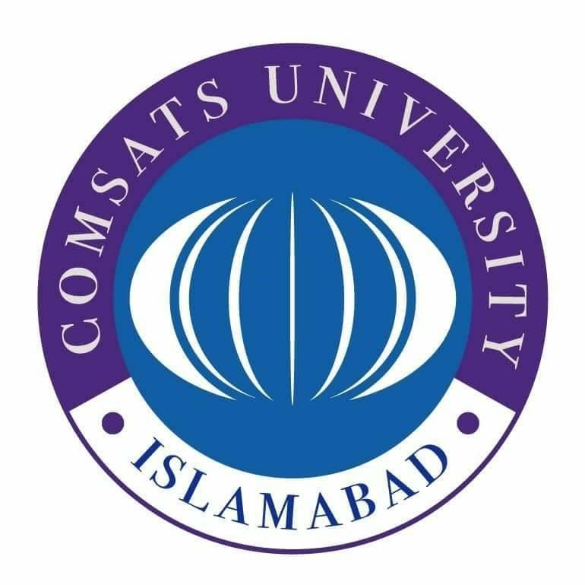
MEDIA AND COMMUNICATION STUDIES
DEPARTMENT OF HUMANTIES
COMSATS UNIVERSITY ISLAMABAD, LAHORE CAMPUS.

Letter of undertaking

My name is Muhammad Waqar Akram and I am a student of Bs media and communication studies at COMSATS University Islamabad, Lahore campus. My roll number is FA20-BMC-045. I have completed my internship as a compulsory part of the BS program in my seventh (7Th) semester. I completed my six-week internship at Discover Pakistan HD TV in the News department and have tried my best to achieve my objectives from it.
I have completed my internship and am submitting this report, which centers mostly about my learning from working with various departments, the working atmosphere of the company, and the observations I've made about the business throughout my time there as an intern. I gave it my best effort to write this report in a way that is both honest and focused and to address all of the relevant issues that are significant about this topic.
You have my word that I have not plagiarized any of the material that makes up my report in any way, shape, or form. I am eagerly awaiting the conclusion that this report will be accepted. If you have any questions or need further information, please let me know, and I would be glad to assist you.

Muhammad Waqar Akram
FA20-BMC-045
BS Media and Communication Studies

Internship certificate
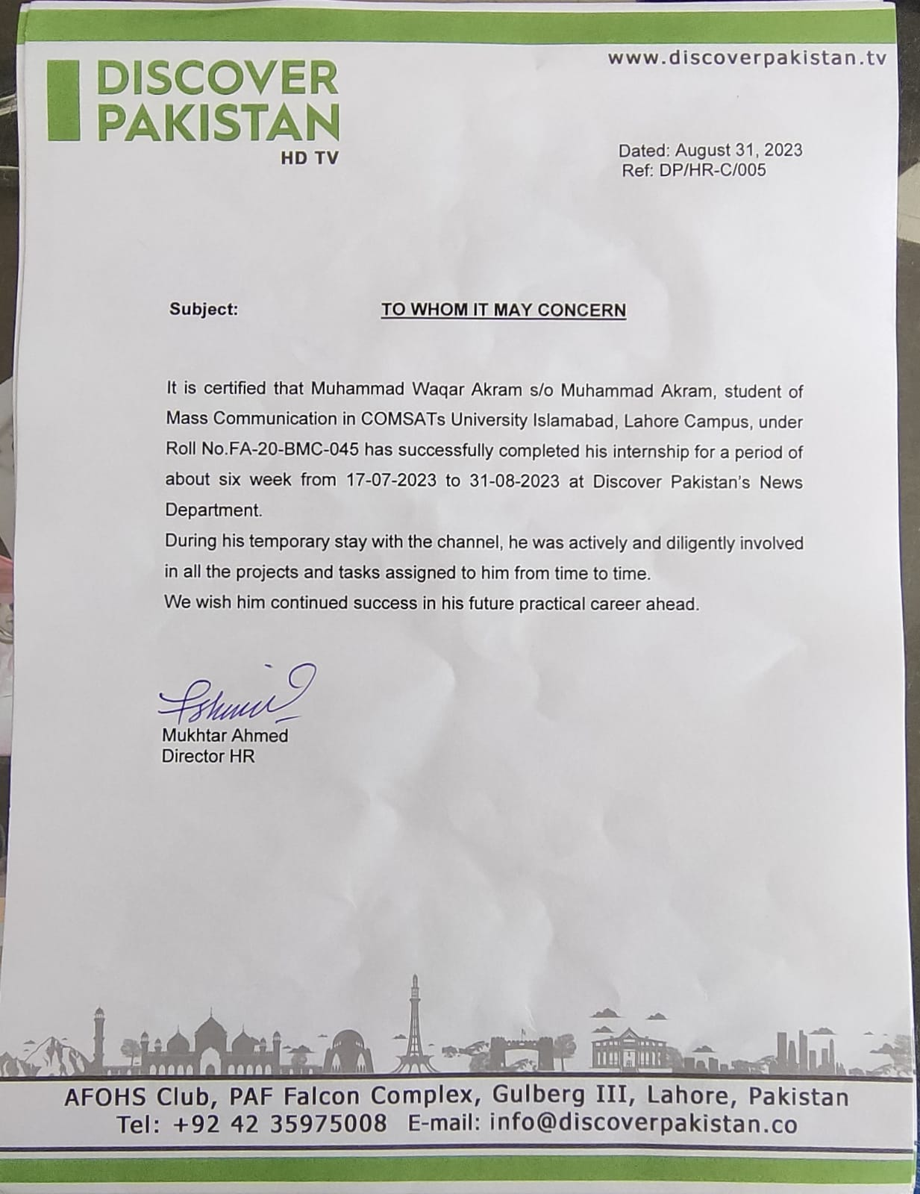

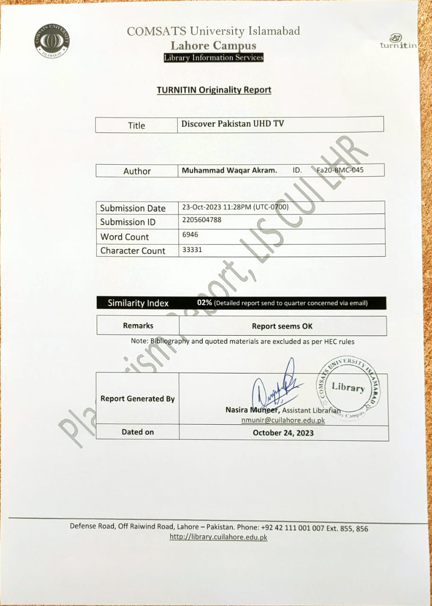
Acknowledgements

I offer all praise and glory to the Almighty Allah, the most kind and benevolent of all creatures, for giving me the capacity to do what I set out to accomplish and arrive at the location I had planned.
I am very grateful for this opportunity to show my appreciation to Mr. Sohail Riaz Raja, who serves as the head of the media studies department at my institution. Because of his generosity, I completed a six-week internship at Pakistan's only tourist media channel. In addition, I would like to express my gratitude to our supervisor, Ma'am Ayesha Mirza, for all of the direction and assistance she has provided.
Throughout my internship at Discover Pakistan, the team, including the News director, Mr. Imran Mahar sb, the News Head, Mr. Anwaar Sb and the News producers Mr. Shahzad sb, the News producers, and all the other employees, have been helpful and kind to me.

Executive summary
This is the internship report based on six-week internship program that I completed in the News department of Discover Pakistan starting from 17-07-2023 to 31-08-2023. The professional world was unfamiliar outside of the classroom, but I gained invaluable experience at Discover Pakistan in every hour I spent there. All the same, they served me well professionally and will continue to do so in the future.
Working in News allowed me to gain experience in virtually every facet of television production, including but not limited to news writing, reporting, packages, news broadcasting, and live reporting. The division's primary function is to produce broadcast-quality recordings of various shows. As the channel's primary division, it operates around the clock. In addition to the fundamentals of journalism, I am taught the ins and outs of video editing, camera operation, video lighting, news writing, ticker writing, headline writing, and reporting.
I was responsible for seeing how a news story is put together and providing several news tickers and reports to Pakistan Today. During the news headlines and Voce overs of various shows, I observed several staff roles from pre- to post-production. During and after filming, I spoke with various experts who taught me about the numerous moving parts of media production. In addition, I've learned a lot about the working world thanks to my internship.
Different SWOTs of 14 August and programs analysis of the organization allowed me to determine the channel's strengths and weaknesses and the steps that could be taken to increase the channel's potential for success and decrease any potential dangers it might face. The internship gave me invaluable experience in areas critical to being a successful media professional, including screenplay writing, news reading, and anchoring. In addition to the fundamentals of journalism, I am taught the ins and outs of video editing, camera operation, video lighting, news writing, ticker writing, headline writing, and reporting.

Table of contents

Contents

Overview of the organization 6
Organizational structure 8
Plan of internship program 11
Training program 11
Reflective journal: 13
Work samples 20
Critical analysis 23
SWOT analysis 25
Conclusion 27
Recommendations 28
References and sources: 29

Overview of the organization
History:
Pakistan's first satellite travel channel, launched on March 23, 2021, called Discover Pakistan TV. The channel's creator, Choices International SMC PVT LTD, is also its name creator. Mr. Kaiser Rafique is Discover Pakistan's Chief Executive Officer. The channel aims to increase domestic and worldwide interest in visiting Pakistan. Our prime minister's goal is to strengthen the tourism industry and give it priority in mainstream growth; thus, the government has helped the channel, and the administration is pushing it. The government's main goal in launching this initiative was to raise the money it gets from the tourism industry.
Discover Pakistan TV, Pakistan's first satellite travel channel, premiered on March 23, 2021. Choices International SMC PVT LTD, the firm that first conceived the channel, came up with the name. Mr. Kaiser Rafique leads discover Pakistan. The channel aims to showcase Pakistan's splendor and inspire more tourists to visit the country.

Introduction:
For the first time, Pakistan's stunning landscapes and natural attractions are being shown in 4K on Discover Pakistan. Everyone in Pakistan is familiar with the country's four distinct seasons, countless magnificent landscapes, spectacular valleys, series of natural lakes, fantastic beaches, and rich and varied historical history.
The station's single studio airs three identical programming blocks at regular intervals. Programming, production, creative, social media management, and content creation are just some of the channels' many in-house specialties.
Live and in high definition, Discover Pakistan airs a wide range of programming, from news and documentaries to outdoor adventures and in-depth interviews. Some of the programs that are launched lately are;
List of the programs:
- Pakistan Today
- Dekho Pakistan
- Paharon Ka Safar
- De Bikers
- Hotel for You
- Madventure
- Pardaid Mai Sais
- Meet the CEO
- Salam Pakistan
- Made in Pakistan
- Churches of Pakistan
- Kissan Ka akistan
- Street Food
- Travelogue of the Week
- Discovery Ride
- Gear Up
- Rewild
Motto:
The slogan/motto of the channel is ‘Sab Se Pyara Pakistan’ translated as ‘Pakistan, the best!’
The aim of the channel is to present a positive image of the country to the world by promoting tourism.
Competitors:
Only Discover Pakistan, a tourism satellite station, has made it their goal to market Pakistan as a tourist destination. However, this topic may get picked up by other major media outlets because of the present administration's focus on the tourism business.
More channels are being launched rapidly in the country and according to the sources some upcoming channels claim to be tourism channels such as;
CPEC TV
Urgent news TV Abbottabad
The company faces no significant competition in the media sector, but new technologies might change that.

Organizational structure
Main office:
There is only one office of discover Pakistan in Lahore which is located inside the building of Air force falcon club of air force housing society Gulberg Lahore. The falcon club is also a project of options industry. The office building consists of double story building with employees’ cabins, a studio, makeup room, kitchen and main office area.
The chief executive officer of the channel is Dr. Kaiser Rafique.
Address: AFOHS Club, Falcon Complex PAF Falcon Complex Gulberg 3, Lahore, Punjab 54000
Phone: 0340-1977777

Organizational hierarchy:

Organizational hierarchy chart

Departments in the organization:
Following are all the departments that are working in Discover Pakistan;
News department:
Imran Mahar
The news department compiles stories from various outlets and distributes them to the sub-editors, who then draft and rewrite scripts accordingly. Sub-editors are responsible for reviewing and revising news articles after they have been written and before they are forwarded to the output department.
Programing department:
Head: Rashid Saeed
Many programs that air at various times of the day are the responsibility of the programming team. This section coordinates the regular broadcast of several live and taped programs. The programming department of the channel is responsible for the recording and coverage of most of the shows of the channel including ‘Mera Pakistan’, 'The morning show', 'Invent Pakistan' and 'Meet the CEO'.
Two other departments come under the programing department including;
Transmission department:
Head: Hashmat Ali
All of the programming transmitted during the day must be planned and carried out by the Transmission department. Every day, they decide what shows will run, which ones will be replayed, and how often new shows will be broadcast.
Archive department:
Head: Ali Kashif
All historical records and archives are stored in the channel's Archive Department. Both digital and film cameras may be used for taking photographs.
Creative department:
Director: Haris Iqbal
The Creative Department also designs the show sets, as the name may imply. The art department of Discover Pakistan's Chroma production studio is responsible for designing and building the show's lavish sets and scenic backdrops.
Human resource:
HR manager: Ch, Mukhtair
As its name implies, the HR department is in charge of overseeing the organization's human resources. Employee management and recruitment are also part of its purview.
Accounts department:
In-charge: Syed Faisal Bukhari
Syed Faisal Bukhari, the leader
The department works closely with the marketing managers to keep the firm profitable.
Social media managers:
The social media department is in charge of boosting the channel's online visibility and expanding the company's social media following. A committed social media team might do wonders for a business's bottom line. The channel might benefit greatly from social media advertising and audience interaction through feedback collection.
Comments on organizational structure:
Discover Pakistan's administration is sophisticated and easy to understand. The channel's executive director is now the crew's ultimate boss. The channel was only released a few years ago, but its form is currently being debated.

Plan of internship program
Office branch:
I was placed in the only office of discover Pakistan in Lahore which is located inside the building of Air force falcon club of air force housing society Gulberg Lahore. The falcon club is also a project of options industry. The office building consists of double story building with employees’ cabins, a studio, makeup room, kitchen and main office area. The chief executive officer of the channel is Dr. Kaiser Rafique.
Internship period:
It was a six-week long internship program starting from July 17, 2023 to August 31, 2023. I worked five to six hours a day and 5 to 6 days a week from Monday to Saturday.
The departments in which I got training:
Discover Pakistan's several departments allowed me to spend as much time exploring its many fascinating exhibits. I've learned a lot about how a media company functions by talking to regular employees and watching how things are done when the cameras aren't rolling.
News department:
I was working with the channel's reporting on major news items after being transferred to the News department. Show and program clips, as well as news and report packages, were included. It mirrored the format of other major Pakistani media outlets' daily newscasts.

Training program
Analysis of the organization:
Many individuals and departments worked together to create the show you see on television. The channel was in its infancy during my internship, yet it had a fully working structure on par with established media outlets.
Putting together a TV program is a challenging task. The program resulted from collaborative efforts by those responsible for scripting, pre-production, recording, voice-over, and editing.
Objectives:
My objectives from this internship are;
- Attain knowledge of the field of media
- Learning about news writing, news reporting
- How I enhance my personal skills by working in front of camera
- Learning about techniques which are used in media industry in varies department
- Learning communication skills which help me in media filed
- Learn camera operating, and line producing
- Learn Editing techniques of different software
- Attain knowledge social media posting process and so much more…

Activities performed by the Departments:
My most recent position allowed me to help by creating original content, including news articles, feature packages, and reports. I could attract and hold the attention of our target demographic by integrating my analytical and aesthetic abilities.
As a part of the news team, I produced content on various topics, from instant responses to breaking events to in-depth studies of market patterns.
My extremely glad to find a career that combines my interests in writing, reading, and teaching. By writing news articles, multimedia packages, and in-depth reports that both informed and delighted our readers, I contributed to the department's success. Thanks to my internship, I've come to appreciate the importance of well-written material in today's information-packed workplace.

Reflective journal

During my six weeks of internship at Discover Pakistan TV, I work and I learn a lot about Media Channel. I also learn social media monitoring, ticker writing, breaking writing, news writing, headlines writing, documentary writing, news reporting, camera operating, lighting techniques, audio editing, video editing, thumbnail designing, social media posting, hashtag usage and so much more.
I also discuss about my learning and work in detail by mention major skills which I learn during my internship of six weeks.
Social media monitoring and Breaking writing:
First of all, the head of news room assigned me for social media monitoring and for writing breaking. I watch different news channels and I practice by writing breaking.
Which are these:
نگران کابینہ کی حلف برداری آج ہوگی ،،،، شیڈول جاری کردیا گیا ہے ،حلف برداری آج شام 5 بجے ایوان صدر میں ہوگی

صدرڈاکٹرعارف علوی نگران کابینہ سے حلف لیں گے،حلف برداری تقریب میں اہم شخصیات شرکت کریں گی،سرفرازبگٹی سمیت دیگرکابینہ ارکان حلف اٹھائیں گے.

سر فراز بگٹی کو نگران وفاقی وزیر داخلہ بنانے کا فیصلہ کیا گیا ہے۔ وہ آج بطور وفاقی وزیر عہدے کا حلف اٹھائیں گے۔سر فراز بگٹی بلوچستان کے وزیر داخلہ بھی رہ چکے ہیں۔
میلسی پیڑول کا شارٹ فال شروع

میلسی مختلف پیڑول پمپ مالکان نے پیڑول کی قیمت میں اضافہ کے شبہ میں پیڑول کی سپلائی بند کر دی

میلسی پیڑول پمپ مالکان کی سپلائی بند کرنے سے غریب شہریوں کو شدید مشکلات کا سامنا
نواب شاہ۔سکھر کے صحافی جان محمد مہر کی قتل کے خلاف نواب شاہ پریس کلب کے سامنے احتجاجی دھرنا اور ریلی۔

نواب شاہ۔مختلف صحافی تنظیموں سمیت شہریوں کی بڑی تعداد احتجاج میں شریک۔
انسدادِ دہشت گردی عدالت (اے ٹی سی) اسلام آباد کی جانب سے چیئرمین پی ٹی آئی کے خلاف درج 3 مقدمات میں ضمانت خارج کر دی گئی۔

News Package Writing:
I learn about the process of package writing, which helps me to write good news package. I get brief details about montage, Vox pops and PTC. Most of news Packages were on-air at Discover Pakistan TV and Today Pakistan channel. I mentioned some of these:
Pkg 1
پنجاب یونیورسٹی شعبہ آرکیالوجی نے وسطی پنجاب کی تاریخ میں پہلی مرتبہ بدھ مت مذہب کے آثار دریافت کر لئے۔ دریافت کیے گئے آثار 2 ہزار سال پرانے ہیں۔ مزید تفصیلات حفصہ علی کی رپورٹ میں

پیکج وی او
شعبہ آرکیالوجی کی تحقیقاتی ٹیم نے چیئرمین ڈاکٹر محمد حمید کی سربراہی میں سرگودھا اور جھنگ کے درمیان واقع دریائے جہلم کی پرانی گزرگاہ پر بدھ مت مذہب کے آثار دریافت کیے ہیں۔
پاکٹ۔۔۔
چیئرمین ڈاکٹرحمید کے مطابق دریافت کیے گئے شواہد سے ثابت ہوتا ہے کہ اس علاقے میں بدھ مت مذہب کے پیروکاروں نے جگہ جگہ اپنے شہر آباد کئے ہوئے تھے۔ تحقیقاتی دورہ کے دوران ان گنت انسانی آبادیوں کے آثار ٹیلوں کی شکل میں ریکارڈ کئے گئے۔ نوادرات کی برآمدگی سے علاقے میں سٹوپا اور خانقاہوں کے شواہد ملتے ہیں۔ ڈاکٹرحمید نے مزید کہا کہ یہ آثار قدیم بدھ مت تہذیب کی عکاسی کرتے ہیں۔
SOT
پکی ہوئی مٹی سے بنی مورتیاں، سٹوپا کی باقیات، ٹیراکوٹا کی اینٹیں اور آٹا چکی بھی دریافت کی گئی۔۔ اس کے علاوہ یہاں سے روزمرہ گھریلو استعمال کی اشیا بھی ملی ہیں ۔
دریافت کیے گئے نمونوں پر انسانوں اور جانوروں کے پاؤں کے نشانات موجود ہیں۔
سائن آف
ڈاکٹر حمید نے کہا کہ ان آثار سے پنجاب کی تاریخ کا دھارا موڑا جا سکتا ہے۔ دریافت کیے گئے آثار میں کچھ ایسی اشیا بھی ہیں جو پوری دنیا میں کہیں موجود نہیں۔۔۔
PKG 2
Oc
شہدائے پاکستان کو سلام

وطن کیلئے جان کا نذرانہ پیش کرنے والے شہداء کے خاندانوں کو پوری قوم خراجِ عقیدت پیش کرتی ہے ،،، سپاہی محمد احمد شہید نہایت نڈر اور وطن پر مرمٹنے کا عزم رکھنے والے جانباز سپاہی تھے، جنہوں نے دفاع پاکستان کی خاطر شہادت کو گلے لگایا
PKG VO

سپاہی محمد احمد شہید کا تعلق تونسہ شریف سے تھا ،،،،، محمد احمد شہید نے سوگواران میں بیوہ، والدہ،پانچ بھائی اور دو بہنیں چھوڑیں ،،،،، سپاہی محمد احمد شہید نے 11 مئی 2009 کو سیاچن کے مقام پر دشمنوں کا مقابلہ دلیری اور بہادری سے کرتے ہوئےدفاع وطن کے لیے جام شہادت نوش کیا

اہلیہ سپاہی محمد احمد شہید کا کہنا ہے کہ "میرے شوہر نے ملک پاکستان کی خاطر جان دی" ،، "ہماری شادی کو صرف 20 دن ہوئے تھے تو وہ سیا چن گلیشیئر پر شہید ہو گئے"

شہید کی ماں نے کہا کہ "میرا بیٹا میرے دل کا ٹکڑا تھا مجھے اس کے بغیر چین نہیں آتا" ،،،،، "مجھے فخر ہے کہ میرے بیٹے نے پاکستان کے لیے جان دی"
بہن کا کہنا ہے کہ "میں جب خاندان میں جاتی ہوں تو لوگ مجھے کہتے ہیں کہ یہ شہید کی بہن ہے۔ یہ میرے لیے اعزاز کی بات ہے

شہید کے بھائی نے کہا کہ "سپاہی محمد احمد سیاچن گلیشیئر پر دشمن کے خلاف لڑتے ہوئے شہید ہوئے" ،،،،، "میرا ایک بھائی محمد احمد شہید ہوا ہے۔ اگر ملک کو ضرورت پڑی تو ہم سب کے سب قربان ہونے کے لیے تیار ہیں"
Pkg 4
OC
پاک فوج نے کنکورڈیا اور شگر میں پھنسے 5 غیرملکی کوہ پیماؤں کوریسکیو آپریشن کرتے ہوئے نکال لیا۔ برطانیہ اور پولیش کے کوہ پیما مہم جوئی کے دوران پھنس گئے تھے۔
VO
پاک فوج کے شعبہ تعلقات عامہ آئی ایس پی آر کے مطابق اطلاع ملنے پر پاک فوج نے فوری کاروائی عمل میں لاتے ہوئے پاکستان آرمی ایوی ایشن کے ہیلی کاپٹر وں کے ذریعے ریسکیو آپریشن شروع کیا۔ 4 برطانوی کوہ پیماؤں کو برف پوش پہاڑی سلسلہ کنکورڈیا کے مقام سے جبکہ 1 پولش کوہ پیما کو مقامی گائیڈ کے ہمراہ شگر کے مقام سے ریسکیو کیا گیا جو 17000 فٹ کی بلندی پر واقع ہے۔ تمام کوہ پیماؤں کو شدید زخمی حالت میں ریسکیو کیا گیا۔ انھیں سانس لینے میں شدید دشواری کا سامنا تھا۔ آئی ایس پی آر کے مطابق برطانوی کوہ پیماؤں میں جارج ہرسٹ، ڈیوڈ کوپ، سٹیفن ریان اور ڈیرن کوربی شامل ہیں جبکہ پولش کوہ پیما ایڈم کو مقامی گائیڈ محمد اقبال کے ہمراہ بچایا کیا گیا۔ ریسکیو آپریشن میں پاک فوج کے جوانوں نے بروقت طبی امداد پہنچاتے ہوئے غیر ملکی کوہ پیماؤں کو بچا کر ایک نئی مثال قائم کی ہے۔
Pkg 5
او سی
پاکستان کے دل لاہور میں مقیم کینیڈین نژاد سوشل ورکر ڈینئیل مارک گونگے، بہرے بچوں کی فلاح و بہبود کے لیے گزشتہ 25 برس سے سرکاری تعاون سے ڈیف ریچ سکول چلا رہے ہیں۔ یہ سکول قوت سماعت و گویائی سے محروم بچوں کیلئے تعلیم حاصل کرنے کیساتھ ٹیکنالوجی اور دیگر ہنر سیکھنے کیلئے بہترین مرکز ہے۔ ڈیف ریچ سکول کے بارے میں مزید جانتے ہیں حفصہ علی سے۔۔۔
وی او:
ڈیف ریچ سکول گزشتہ 25 سال سے گونگے اور بہرے بچوں کیلئے امید کا چراغ بنا ہوا ہے۔ اس سکول میں کے-جی کلاس سے لکر بی اے تک کی تعلیم دی جاتی ہے۔ یہاں بچوں کو ہنر مند اور معاشرے کا سود مند شہری بنانے کیلئے ان کو ہنر بھی سکھایا جاتا ہے۔ ڈیف ریچ سکول میں اس وقت تقریباً پندرہ سو سے زائد بچے زیر تعلیم ہیں۔ اس ادارے کی اہم بات یہ ہے کہ یہاں تربیت دینے والے اساتذہ میں سے 50 فیصد خود قوت سماعت و گویائی سے محروم ہیں۔ایک سکول ٹیچر کا کہنا تھا کہ ہم بچوں کی تخلیقی صلاحیتوں میں اضافہ کرنے کیلئے نا صرف تعلیم و تربیت فراہم کرتے ہیں، بلکہ مختلف ایکٹیویٹیز بھی کرواتے ہیں۔
Sot

ڈینئل کا کہنا تھا کہ وہ 37 سال پہلے اپنے دوست کے ساتھ پاکستان آئے اور یہیں کے ہو کر رہ گئے۔ پاکستان کے مختلف شہروں میں ڈیف ریچ سکول کے 8 کیمپس ہیں ،جہاں سپیشل بچے تعلیم کے ساتھ ساتھ خصوصی مہارتیں سیکھ کر خود کو معاشرے میں منوا رہے ہیں۔
Sot
Sign off
ڈیف ریچ سکول میں بچوں کو مفت تعلیم اور یونیفارم کے ساتھ ساتھ مفت پک اینڈ ڈراپ کی سہولت بھی دی جاتی ہے۔ سکول میں جدید سائنس اور کمپیوٹر لیب موجود ہے۔ اس کے علاوہ یہاں سکلز ٹریننگ لیب بھی موجود ہے ، جہاں مختلف ہنر سیکھائے جاتےہیں۔
Pkg 6
OC
ایجوکیشنل ٹورازم کو فروغ دینے کیلئےایجوکیشنل کنسلٹنگ ایکسپرٹس وک پاک کے زیراہتمام لاہورمیں ایجوکیشن ایکسپو کا انعقاد کیا گیا، جس میں طلبا و طالبات کو تعلیمی کیر ئیر کے حوالے سے معلومات اور رہنمائی فراہم کی گئی۔ مزید جانتے ہیں حفصہ علی کی رپورٹ میں۔۔۔
VO
ایجوکیشنل ٹورازم کو فروغ دینے کیلئے اوردنیا کی بہترین یونیورسٹیز میں تعلیم حاصل کرنے کےخواہشمند طلبا وطالبات کیلئے لاہور کے نجی ہوٹل میں ایجوکیشن ایکسپو کا اہتمام کیا گیا، جہاں آسٹریلیا، کینیڈا اور برطانیہ کی یونیورسٹیوں کے نمائندوں نے سٹالز لگائے،ان سٹالز پر طالب علموں نے بیرون ممالک بہترین یونیورسٹیز میں ایڈمیشن اور سکالر شپ حاصل کرنے کیلئے مفید معلومات حاصل کیں۔ اس ایجوکیشن ایکسپو کے مارکیٹنگ ہیڈ علی طاہر کا کہنا تھا کہ اس ایجوکیشن ایکسپو کا مقصد طلبا کو ایک پلیٹ فارم مہیا کرنا ہے، تاکہ وہ اپنے تعلیمی کیریئر کیلئے ضروری معلومات حاصل کر سکیں۔
SOT
اس ایجوکیشن ایکسپو میں 22 غیر ملکی تعلیمی اداروں نے اپنے سٹالز لگائے، اس موقع پر آسٹریلیا کی معروف یونیورسٹی کے نمائندے کا کہنا تھا کہ طالبعلم ہم سے اہم معلومات حاصل کر رہے ہیں اور ہمارے ادارے میں داخلہ لیکر تعلیم حاصل کرنے میں بڑی دلچسپی ظاہر کر رہے ہیں۔
SOT
اس ایجو کیشن ایکسپو میں آئے ہوئےطلبا و طالبات نے ایسی سرگرمیوں اور ایکسپو کے انعقاد کو اپنے تعلیمی کیر ئیر کیلئے انتہائی اہم قرار دیتے ہوئے کہا کہ ایسے پلیٹ فارمز ہمارے بہترین مستقبل کیلئے انتہائی معاون ثابت ہو سکتے ہیں۔
SIGN OFF
ایجوکیشنل کنسلٹنگ ایکسپرٹس کے زیر اہتمام منعقدہ اس ایجوکیشن ایکسپو میں مختلف یونیورسٹیوں اور کالجوں کے طلبا و طالبات کی بڑی تعداد نے شرکت کی۔ ایکسپو میں آئے ہوئے سٹوڈنٹس نے متعلقہ اداروں کے نمائندوں سے اہم معلومات لیں ۔ انہوں نے آسٹریلیا، کینیڈا اور برطانیہ سمیت دیگر ممالک کی انٹرنیشنل یونیورسٹیز میں داخلوں میں بہت دلچسپی ظاہر کی۔

News Report Writing:
I learn how to write a news report, news report pattern, and various steps and techniques which helps in writing a good news report. Here is the sample of my report:
زہریلے اور غیر زہریلے سانپ

براعظم انٹارکٹکا کے علاوہ پوری دنیا میں تقریبا 3500 اقسام کے سانپ پائے جاتے ہیں . جن میں سے صرف 600 اقسام کے سانپوں میں زہر ہوتا ہے اور ان 600 اقسام میں صرف 200 اقسام ایسے زہریلے سانپوں کے ہیں جنکے کاٹنے پر بروقت علاج نا ہونے کی صورت میں موت واقع ہو سکتی ہے. دنیا کا سب سے چھوٹا زہریلا سانپ سپوٹیڈ ( ڈراف ایڈر ) افریقہ میں پایا جاتا ہے جس کا سائز صرف 7 انچ سے 11 انچ تک ہوتا ہے . اور دنیا کا سب سے لمبا زہریلا سانپ کنگ کوبرا انڈیا سمیت جنوب مشرقی ایشیا کے مختلف ممالک میں پایا جاتا ہے ’ کنگ کوبرا کا سائزعام طور پر 12 فٹ تک ہوتا ہے مگر یہ 18 فٹ سے زیادہ لمبے ہو سکتے ہیں . دنیا کا سب سے چھوٹا غیر زہریلا سانپ جو باربادوس میں پایا جاتا ہے ’ اور دنیا کا سب سے لمبا غیر زہریلا سانپ اژدھا تین براعظموں ایشیا ’ افریقہ اور آسڑیلیا میں پایا جاتا ہے . اژدھا سانپوں کا سائز 2 فٹ سے لے کر 32 فٹ تک لمبا ہوتا ہے . سب سے زیادہ وزنی غیر زہریلا سانپ سبز اینا کونڈا ہے جسکا وزن 500 کلو کے قریب ہو سکتا ہے . سبزاینا کونڈا سانپ جنوبی امریکہ میں پایا جاتا ہے .

سانپ گوشت خور جانور ہیں .

سانپوں کی خوارک میں حشرات ’ کتر کر کھانے والے جانور ’ پرندے ’ انڈے ’ مینڈک ’ ممالیہ جانور ’ مچھلیاں وغیرہ شامل ہیں. خود سانپ بہت سے دوسرے جانوروں ’ پرندوں اور رینگنے والے جانوروں کی خوراک کا اہم حصہ ہیں

سانپوں کے بیرونی کان نہیں ہوتے ہیں مگر سانپ تھرتھراہٹ کو اچھی طرح محسوس کر سکتے ہیں. سانپوں کی کچھ اقسام کی عمر 10 سال سے 25 سال تک اور کچھ کی زیادہ سے زیادہ 40 سال تک ہوتی ہے ’ سانپوں کے پاؤں نہیں ہوتے مگر جسم میں لمبی ریڑھ کی ہڈی سے منسلک پسلیوں اور پٹھوں کی مدد سے انہیں رینگنے میں مدد ملتی ہے .
سانپ ڈنگ نہیں مارتے بلکہ کاٹتے ہیں ’ صرف زہریلے سانپوں کے منہ میں 2 زہر والے دانت ہوتے ہیں جو کہ خوراک والے دانتوں سے مختلف اور لمبے ہوتے ہیں . غیر زہریلے سانپوں میں یہ 2 زہر والے دانت نہیں ہوتے ہیں . زہریلے سانپ اپنا زہر شکار کو مارنے کے لیئے استعمال کرتے ہیں ’ باقی اپنا شکار دبوچ کر مارتے ہیں’ تمام سانپ اپنے شکار کو سالم نگلتے ہیں .
ڈبلیو ایچ او کے مطابق پوری دنیا میں ہر سال تقریبا 1.50.000 کے قریب لوگ زہریلے سانپوں کے کاٹنے سے بروقت علاج نا ہونے کی وجہ سے مرتے ہیں ’ اور براعظم ایشیا سب سے زیادہ اموات میں سرفہرست ہے
سانپ خود کبھی پہلے حملہ نہیں کرتا ’ سانپ کے بہت قریب جانے یا پکڑنے کی کوشش کرنے پر سانپ خطرہ محسوس کرتے ہیں اور اپنے بچاؤ کے لیئے کاٹتے ہیں . انسان سانپوں کی خوراک کا حصہ نہیں ہے ’ سانپ جب بھی انسان پر حملہ کرتا ہے اپنے دفاع میں کرتا ہے .

اب کچھ معلومات پاکستان میں پائے جانے والے سانپوں کے متعلق

پورے پاکستان میں 80 کے قریب سانپ پائے جاتے ہیں جن میں 14 سمندری زہریلے سانپ ہیں اور 14 ہی زمینی زہریلے سانپ ہیں ’ 14 زہریلے سانپوں میں 4 عام زہریلی اقسام تقریبا پورے پاکستان میں ملتی ہیں جن کے کاٹنے سے بر وقت علاج نا ہونے سے اموات ہوتی ہیں ’ ان چار زہریلی اقسام کو بگ فور کہا جاتا ہے یعنی برصغیر پاک و ہند میں یہ 4 اقسام سب سے زیادہ انسانوں کی اموات کی زمہ دار ہیں ’ صرف ان چار زہریلے سانپوں کی پہچان یاد رکھنے سے خود کو محفوظ رکھا جا سکتا ہے اور باقی غیر زہریلے سانپوں کا تحفظ بھی کیا جا سکتا ہے . پاکستان میں جنگلی حیات کے تحفظ کے قوانین کے مطابق غیر زہریلے سانپوں کو مارنا منع ہے .

Thumbnail line writing:
I learn how to write a catchy line for thumbnail, which helps to get more reach and views about targeted audience.
Documentary Writing:
Documentary writing were more interesting to me because I have also interest in documentary making. I also write a few documentaries for Discover Pakistan and Today Pakistan channel.

Video and Audio Editing:
I also learn Video and Audio Editing by using various software such as Adobe Premiere Pro and Adobe Audition. It helps me in removing unwanted voices, noise and video also. Due to this video become more attractive and we can get more reach.
Thumbnail Designing:
I also lean about techniques which are used in making creative thumbnail. I used Adobe Photoshop for designing and retouching and so much more.
Camera Operating and lighting setup:
Camera operating very interesting for me. I was work with camera man for few days during my internship. And I get more knowledge about camera angles, framing, camera setting for different location and lighting setup for various shoots. And now I am able to shoot any types of photography and videography.

Work Smples

Here I also attached some samples and pictures of my work which I have done durng six weeks of my internship at Discover Pakistn UHD TV.
I also mention some work sampe in reflective general portion.
IN FIRST WEEK, I learn about news reporting in front of camera. It was a great moment for me because it was my dream to work in front of camera.
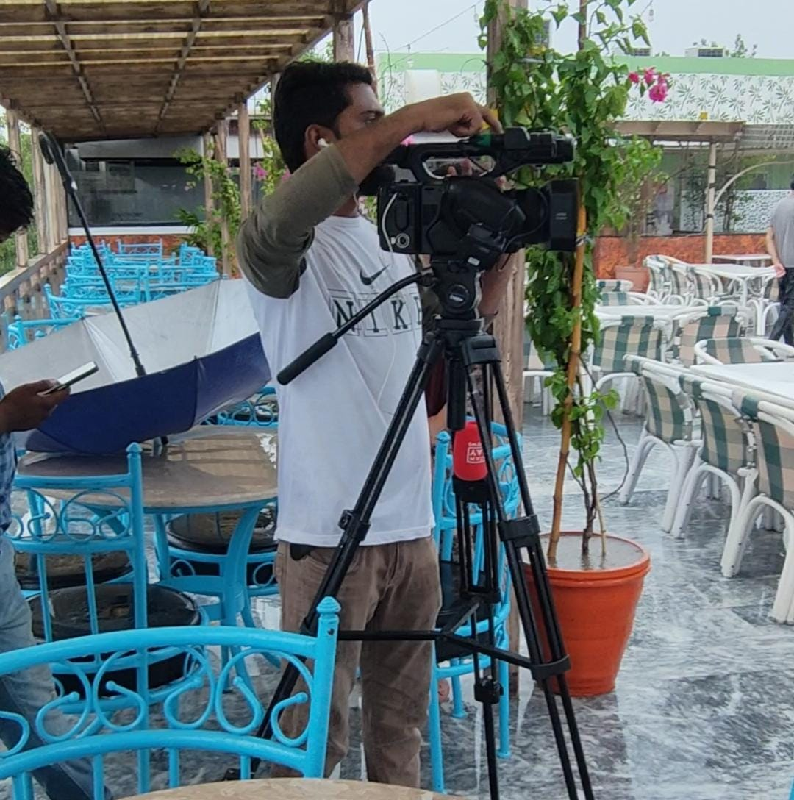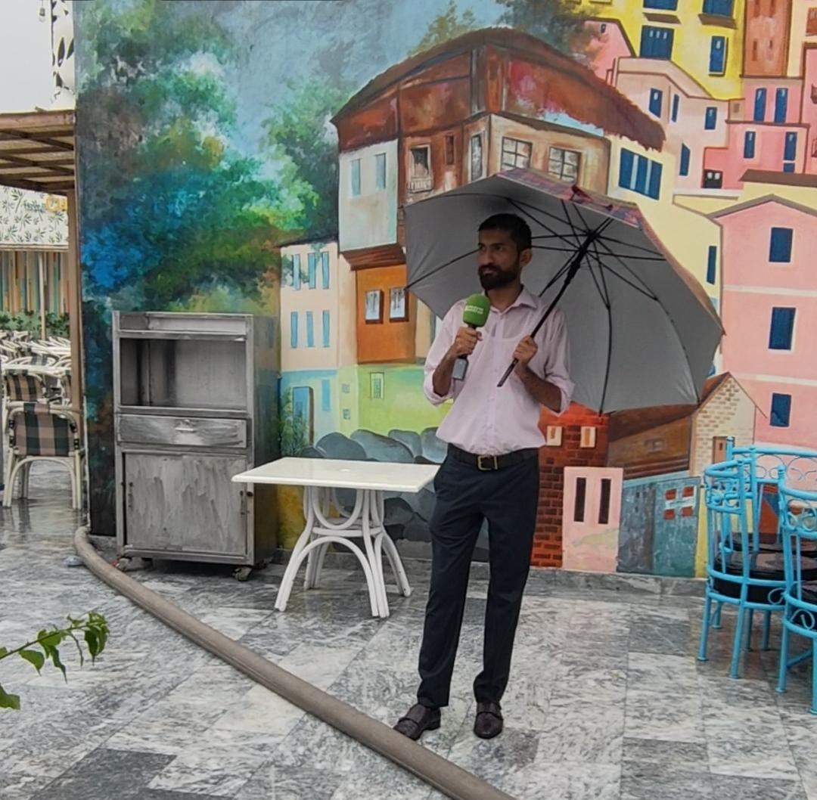

IN 2nd WEEK, I went with senior reporter Hafsa Ali for making a news package about Directrait General Punjab Food Authority for learning news reporting. And I aslo take pictures with DG of Punjab Food Authrity. I also mentioned above my work sample of package writing.
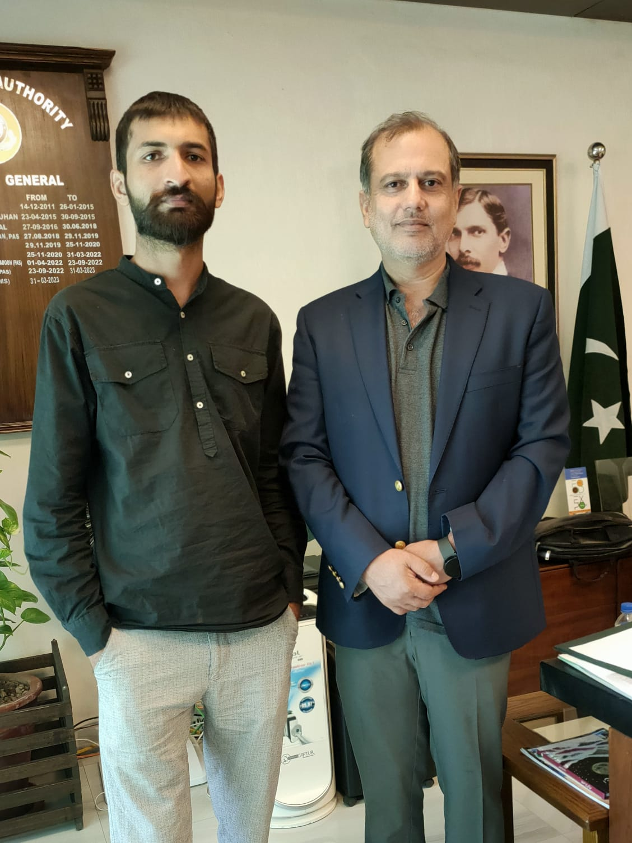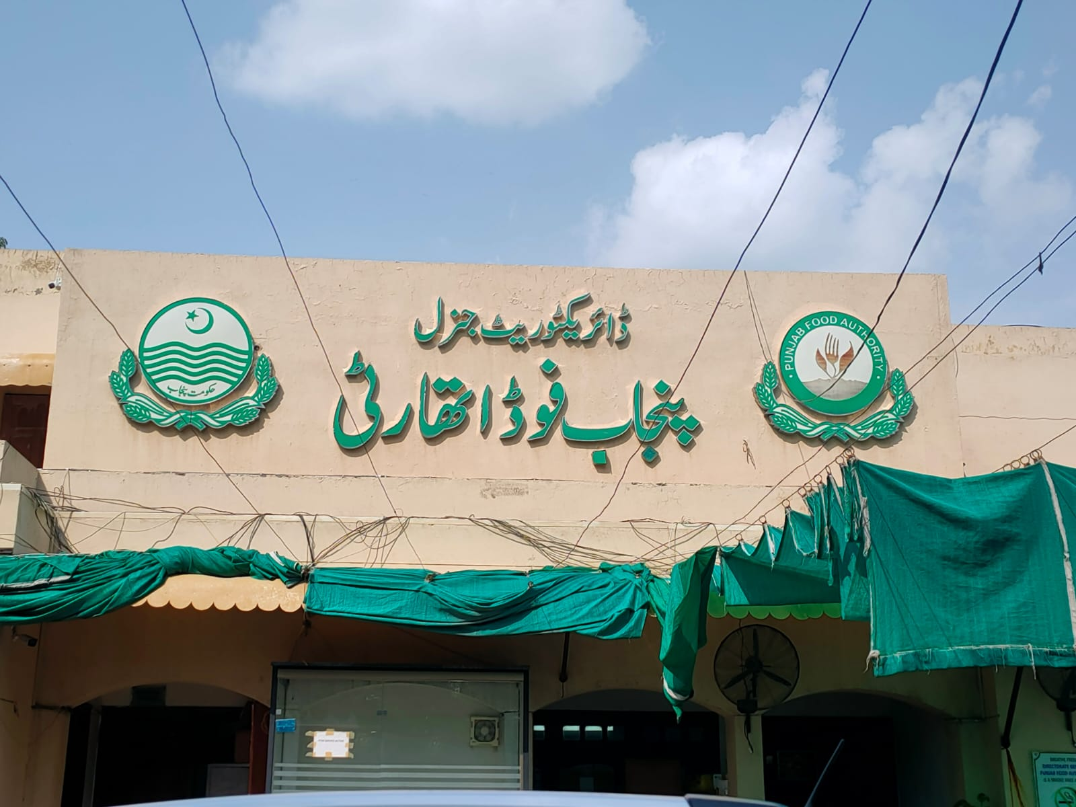
3rd WEEK I went with senior reporter for coverage and report about current issue of World Snocker Champion. 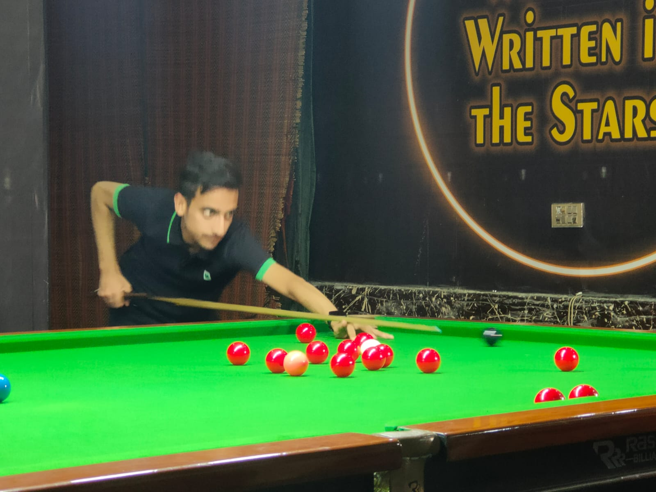
In 4th WEEK, I was able to editing video at high level. I also learn about audio mixing. Link of of my editing also attached.

In 5th WEEK, I also learn about social mdia management, use of hashtages. And all about the process and procedure about news.
In 6th WEEK, I almost learn all the things about news channel at advanced level from pre production to post production. I also practice a lot to enhance my skills.

NOW I AM ABLE TO WORK WITH NEWS CHANNEL. I CAN DO EVERYTHING FROM PRE PRODUCTION TO POST PRODUCTION

Critical analysis
When I got to know that I am placed in a TV channel for my internship program I was very excited and eager to go there as studying media studies for over past three years in university developed a keen interest of journalism and anchoring in me. I was happy to know that I will be able to see the actual working of a news channel in real time and develop observations on how things are done off the screen and how that appears on the screen.
The first few days were merely introduction and observation days but gradually I felt that I am actually a part of the channel and learning a lot more than that of ordinary bookish knowledge. Whatever we learn and study in our classrooms will only make sense if we have a practical implementation of it in field and by interacting with relevant people.
I studied various concept related to media channel and a media organization such as media theories, agendas, models of communication, media ethics and developmental role of media in different fields of life that I wanted to observe here in a media channel. The channel Discover Pakistan was a newly launched media channel and it was established on the mission of presenting a positive image of Pakistan through promoting tourism industry. Hence, I couldn’t experience things like agenda setting or media bias because the main focus of the owner of the channel was different as compared to the other traditional media channels. Hence I can say that the concepts studied as a subject are very much different when we talk about the practical experience.
As we stepped in the field everyone taught us things like how command over Urdu language is so important if one wants to succeed in a Pakistani media channel. I was lucky enough as I have studied two Urdu language courses in my second year of BS program. Even I have studied Urdu as a subject I realized how additional knowledge of language is necessary in order to appear on screen as a news anchor. Due to this initially I faced quite some difficulties while reading script as it included the use of formal vocabulary.
The major difference that I observed in Discover Pakistan as compared to other prominent mainstream media channels is that the main focus of other channels is the political agendas and current affairs, be it in the favor of government or against it.

Overall analysis of the organization
The environment of the Discover Pakistan office was very sophisticated and encouraging. Working in Discover Pakistan as an intern for six weeks was a great experience for me. The employees were all very cooperative and supported me whenever I needed help. The environment was not strict but very lenient and hence I had the opportunity to ask anyone for help and guidance at any time. I have observed the ways to work professionally in a news organization. I observed that apart from the assigned duties, a person should be a jack of all trades when working in a media outlet so that he or she could manage to do any sort of task in various situations.
During my internship I noticed that Discover Pakistan does not show inclination towards a specific party or occasion neither one of its transmission is against anybody. There is no specific plan that the channel work on subsequently and for the most part excludes political errors and consuming issues of the country during news broadcast.
The best thing I liked about the office was that everyone interacts with each other regardless of whatever the post is and even at lunch time everyone starting from the director programing to spot boys use to eat at same place. The organization has a centralized accountability system which means that the report of every event is given directly to the CEO hence no one can hold another employee accountable which ensures a peaceful working environment.

SWOT analysis
Strengths:
The only channel of its kind- Pakistan’s first tourism media channel UHD TV. It is one of the greatest strength of Discover Pakistan that it is one of its kinds. There are a lot of opportunities for DP to get support from major government officials as the aim of it is to promote the tourism industry of the country. There are a lot of media channels in the country but all of them, are working on traditional media agenda. The newly introduced Discover Pakistan has the ability to grab masses of audience as it is introduced with an entirely different perspective and an invigorating mission of showing a positive and soft image of Pakistan to the world.
The channel has the ability to introduce variety of programs rather than traditional broadcasting of news that other news channels cannot introduce and get off the track from their traditional broadcasting. People nowadays are tired of seeing disturbing news on TV and they want something refreshing and motivating. DP can and is planning to introduce a variety of shows related to culture of our country that will attract a large number of audiences and the channel can strengthen up with a positive image and reputation.
International recognition for being the only channel to highlight the positive image of country free from any political, cultural and national bias is an achievement of Discover Pakistan. The voice of America covered a special report on the channel for it being the only tourism satellite channel in the country. It will not only add to the strengths of the country but will also attract audience from around the world.
The channel provides employment opportunities to various people including youngsters and fresh graduates as it is a newly introduced channel. Young minds have better ideas and more innovation and hence it will help the organization to grow in terms of content and ideas. Similarly audiences usually like to see new faces on and variety of content on TV.
Weaknesses:
The most obvious deletion will be recent political and news developments. DP's concept places an outsized emphasis on tourism compared to a television network's typical function in conveying information and news.
If they had more high-profile connections to celebrities, public figures, and media professionals, they could better spread the news about their new media source. Morning shows may not do well in the ratings since nobody watches them except the hosts.
My main concern is that the need for more room will hamper the channel's expansion. There is just one recording studio in operation, but it will host around five different performances over the next four days. A schedule with five recording sessions per day for a single show would conflict with other shows' schedules. As a result, we'll have to record the morning program late at night. The studio is the only place in the building with complete stillness; thus, it is where the documentaries' voiceovers are recorded. Because all the performances must be recorded in the same studio, the production is generally hurried and has numerous delays.
Opportunities:
Producers of the channel are encouraged by the new government's interest in the tourism sector. Financial stability, public profile, legitimacy, and survival depend on government funding for the news company. Discover Pakistan was founded on the belief that Pakistan's tourism industry represents an unrealized opportunity that has to be seized. Discover Pakistan's position as the official presenter of government events relating to tourism and promoting the nation's beauty is a once-in-a-lifetime opportunity since the government is actively promoting the tourism sector and seeking meaningful coverage in this respect.
There is potential for improved customer service if companies with a vested interest in the tourism industry collaborate. When expanding one's business overseas, working together is beneficial.
Most people who go on vacation always stay in the country. Using famous sites in DP's future original films to boost tourism in Pakistan is a fantastic concept. Fans can send their itineraries for airing on the channel. If this plan is implemented, the channel's viewership will rise, encouraging the production of more programs.
Threats:
The channel's long-term success has been doubted because of inadequate advertising for its debut. Discover Pakistan would do well to prominently display commercials throughout its programming, given the importance of commercial support to the survival of any media organization. A news network is likely to continue without support from advertisers.
The channel's target demographic is those interested in visiting Pakistan or appreciating beautiful scenery. Very few people tune in to discover what's new in street cuisine and fashion. People who share your passion for the topic should make up most of your intended audience. This may make the audience bored and disinterested.
The public is correct, and Discover Pakistan concurs that COVID-19 poses a significant business risk. Covering documentaries and outdoor performances with a large crew proved challenging due to the COVID-19 restrictions and safety rules. Public places like cafés, businesses, and schools may have a no-videotaping policy in place for reasons of safety. The chances of the COVID-19 virus type 19 spreading in a crowded workplace are higher. Having numerous workers become unwell and miss significant time from work might be disastrous.

Conclusion

This report compiles all my work during my Discover Pakistan internship. My major responsibility was programming, although I interacted with workers from practically every department. Discover Pakistan is a cutting-edge media outlet with the audacious objective of internationally raising the country's visibility. Seeing everything from the recording studio and control room to the studio and script to the Chroma technology, cameras, lighting, and anchors was tremendously educational.
I applaud the station's promotion of the country and its attempts to attract more visitors. The internship made me much more prepared to enter the workforce. As a last thought, I want to stress how important my internship has been to my professional development. Thanks to the skills I honed during my internship, I am now more prepared for a career in the media industry, particularly in scriptwriting, news reading, and anchoring.
Discover Pakistan has an upbeat and competent crew. The atmosphere at the office was quite chill, so I never felt awkward when I needed help. The experience I gained while working for a news agency was invaluable. The success of a media company depends on its employees' versatility and willingness to take on responsibilities outside of their job descriptions.
While I agree that Discover Pakistan now has no formidable rivals, competing organizations might emerge in the future. Suppose the channel wants to maintain its current level of performance and grow its favorable image across the country and the world. In that case, it must fix its shortcomings and add additional programs.

Recommendations

After doing a SWOT analysis, I have some suggestions for Discover Pakistan that will help them strengthen their weak areas and get back on track. Certain tweaks must be performed since the channel is fresh and new to optimize the signal's transmission. Having a single individual juggle so many responsibilities at the channel makes it clear that more help is required. It is also possible to dispatch reporters from other big cities to cover events there.
Discover Pakistan has to get its brand out there so it reaches out to celebrities with a sizable following. The channel's profile and viewership would greatly benefit from this.
Doing everything possible to improve working conditions is also essential. Five programs are scheduled to record simultaneously in the same studio, which might cause scheduling conflicts. If there were more people and space in the studio, everyone could do their jobs better. There will be a drop in ratings and overall performance if these problems aren't fixed.
Intern interns might have more of an impact if they were given more responsibility beyond simply observing. Interns in the top internship programs learn about all aspects of the business, allowing them to make a well-informed decision about what to do after graduation.
Discover Pakistan might make up for its shortcomings and seize new chances using its social media platforms. It's impossible to overstate the significance of a strong social media team. It would be beneficial to advertise the channel on social media and collect public feedback through comments.

References and sources:

https://www.discoverpakistan.tv/
https://www.facebook.com/DiscoverPakistan.TV/
https://wikitia.com/wiki/Discover_Pakistan
Information regarding the organizational structure was gathered from HR department of the channel.
The End

